Homework Ch2
Exercises 2.1
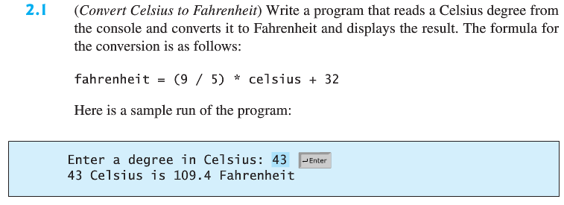
Exercise 2.7
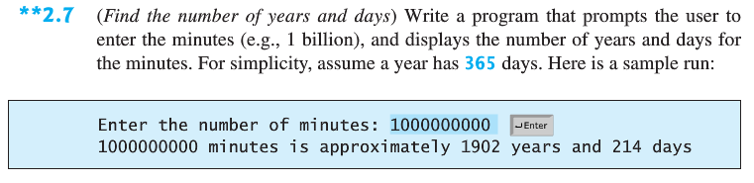
Exercise 2.13
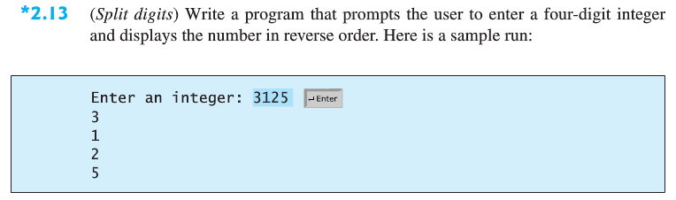
Exercise 2.21
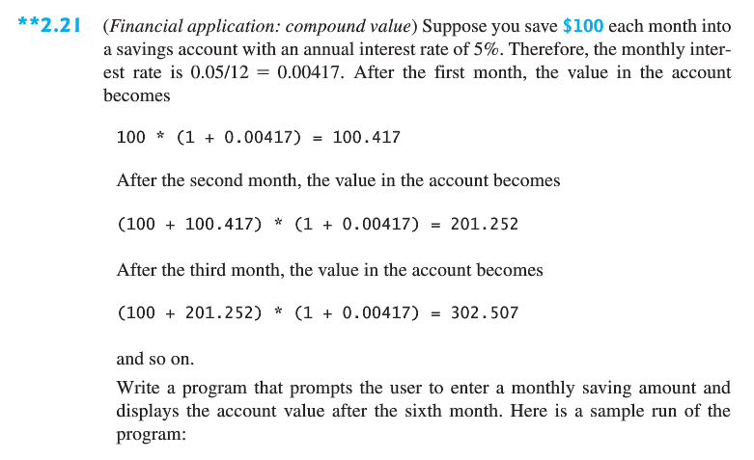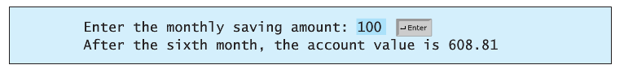
Exercise 2.23
