Homework Ch3
Exercise 3.5
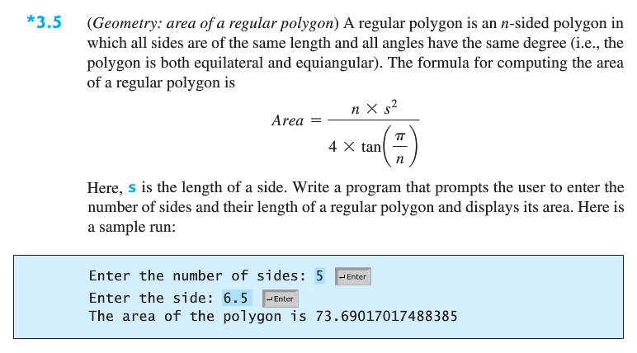
Exercise 3.6
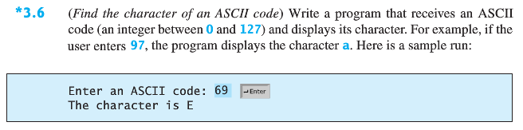Exercise 3.11
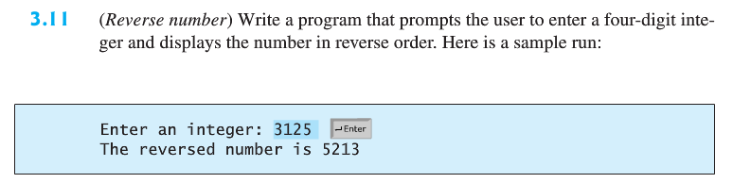
Exercise 3.15
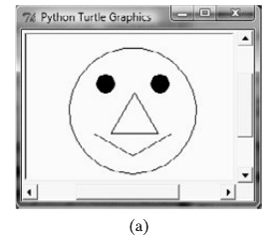
Exercise 3.19
