Lab 4-1: Geometry: point in a rectangle?

Problem Description:

Write a program that prompts the user to enter a point (x, y) and checks whether the point is within the rectangle centered at (0, 0) with width 10 and height 5. For example, (2, 2) is inside the rectangle and (6, 4) is outside the rectangle, as shown in the Figure.

(Hint: A point is in the rectangle if its horizontal distance to (0, 0) is less than or equal to 10 / 2 and its vertical distance to (0, 0) is less than or equal to 5 / 2.)

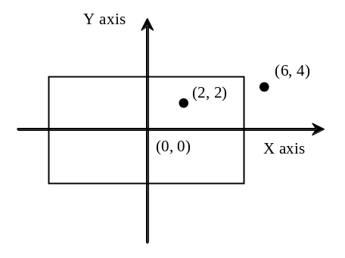

Here are sample runs of the program:

Sample 1:
Enter a point with two coordinates: 2, 2
Point (2.0, 2.0) is in the rectangle

Sample 2:
Enter a point with two coordinates: 6, 4
Point (6.0, 4.0) is not in the rectangle

Lab 4-2: Computing Tax

The United States federal personal income tax is calculated based on filing status and taxable income. There are four filing statuses: single filers, married filing jointly, married filing separately, and head of household. The tax rates vary every year. Table 3.2 shows the rates for 2009. If you are, say, single with a taxable income of $10,000, the first $8,350 is taxed at 10% and the other $1,650 is taxed at 15%. So, your tax is $1,082.5.

Table 1
2009 U.S. Federal Personal Tax Rates
Marginal Tax Rate | Single | Married Filing Jointly or Qualified Widow(er) | Married Filing Separately | Head of Household
10% | $0 – $8,350 | $0 – $16,700 | $0 – $8,350 | $0 – $11,950
15% | $8,351– $33,950 | $16,701 – $67,900 | $8,351 – $33,950 | $11,951 – $45,500
25% | $33,951 – $82,250 | $67,901 – $137,050 | $33,951 – $68,525 | $45,501 – $117,450
28% | $82,251 – $171,550 | $137,051 – $208,850 | $68,525 – $104,425 | $117,451 – $190,200
33% | $171,551 – $372,950 | $208,851 – $372,950 | $104,426 – $186,475 | $190,201 - $372,950
35% | $372,951+ | $372,951+ | $186,476+ | $372,951+

You are to write a program to compute personal income tax. Your program should prompt the user to enter the filing status and taxable income and compute the tax. Enter 0 for single filers, 1 for married filing jointly, 2 for married filing separately, and 3 for head of household.

Here are sample runs of the program:

Sample 1:
Enter the filing status: 0
Enter the taxable income: 100000
Tax is 21720.0

Sample 2:
Enter the filing status: 1
Enter the taxable income: 300339
Tax is 76932.87

Sample 3:
Enter the filing status: 2
Enter the taxable income: 123500
Tax is 29665.5

Sample 4:
Enter the filing status: 3
Enter the taxable income: 4545402
Tax is 1565250.7

