Homework Ch5
Exercise 5.7
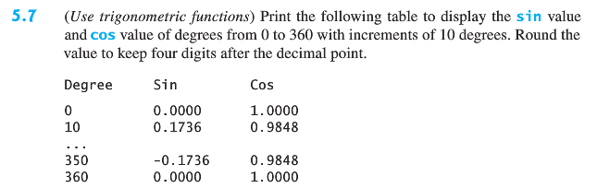
Exercise 5.11
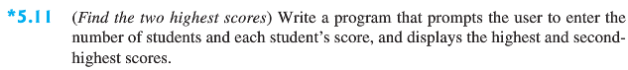
Exercise 5.29
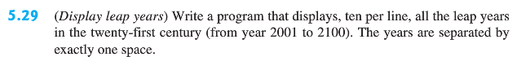
Exercise 5.33
