Homework Ch6
Exercise 6.3
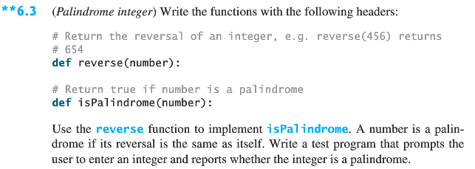
Exercise 6.13
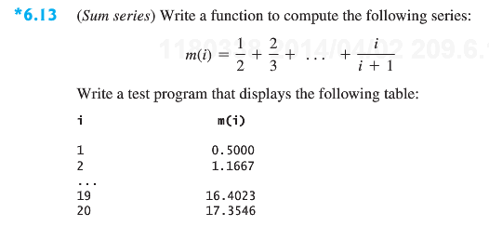
Exercise 6.17
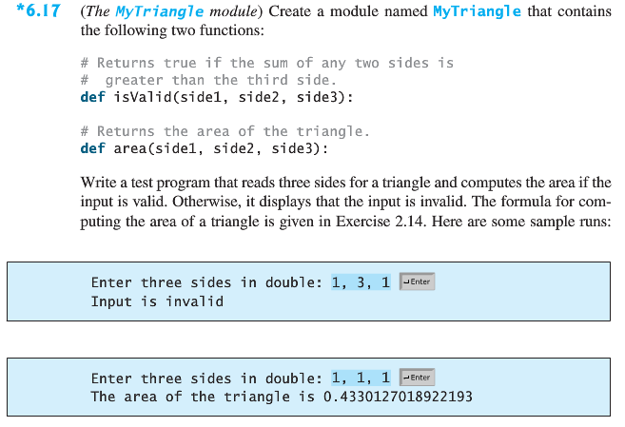
Exercise 6.27 (Bonus, 50 points)
