
Requester Identifier:
Favourite regular expression:
Least favourite food:
Beverage selection:
□ 330 ml can
□ 500 ml bottle – SOLD OUT
□ 2L bottle – SOLD IN
Additional parameters:
□ Confidential □ For Internal Delivery □ Additional stamp □ Do not distribute past 10PM

Section II
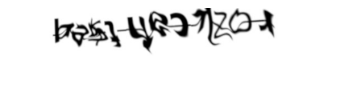This section is mandatory, to be completed for monitoring purposes only. Please solve one of the following captchas, to prove that you are not a robot for electrical safety purposes.


