**I. Pen-and-paper**

**1)**

**2)**

**3)**

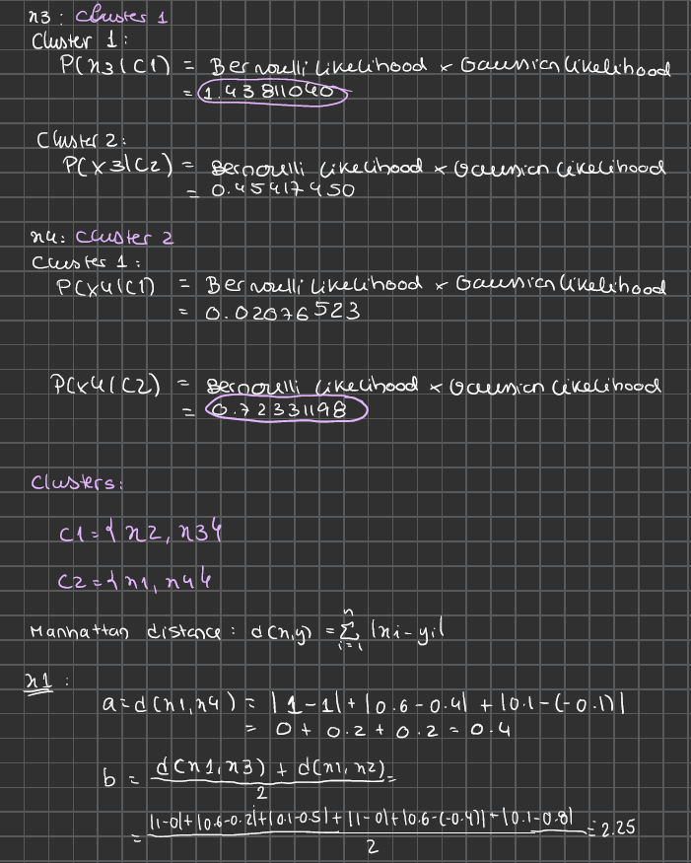

**4)**

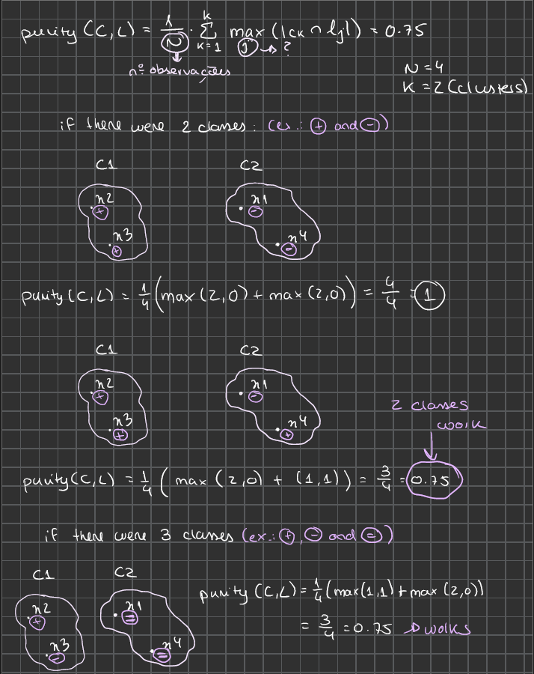

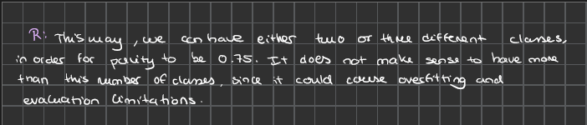

**II. Programming and critical analysis**

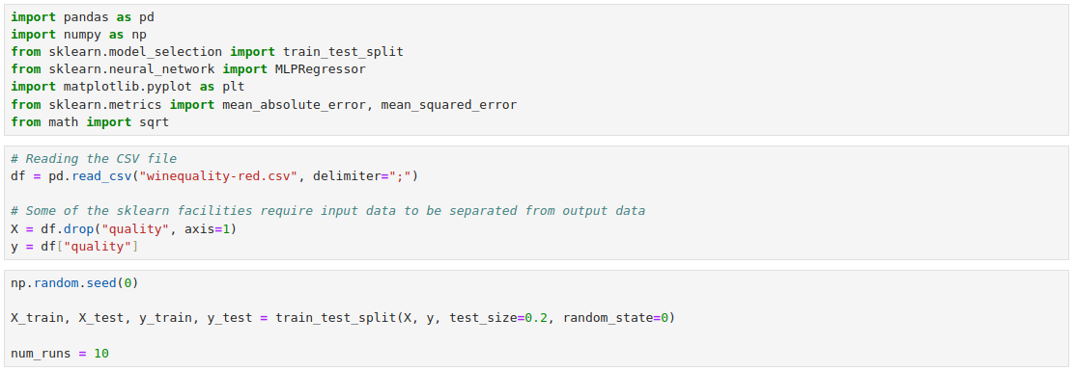

**1)**

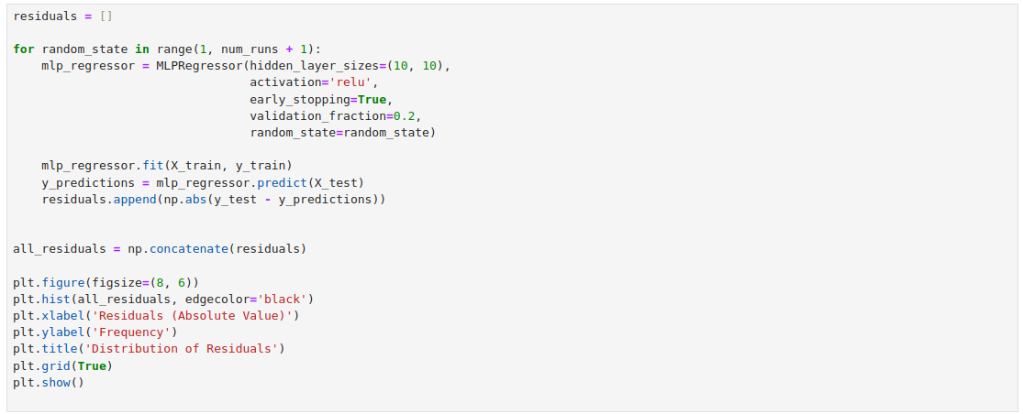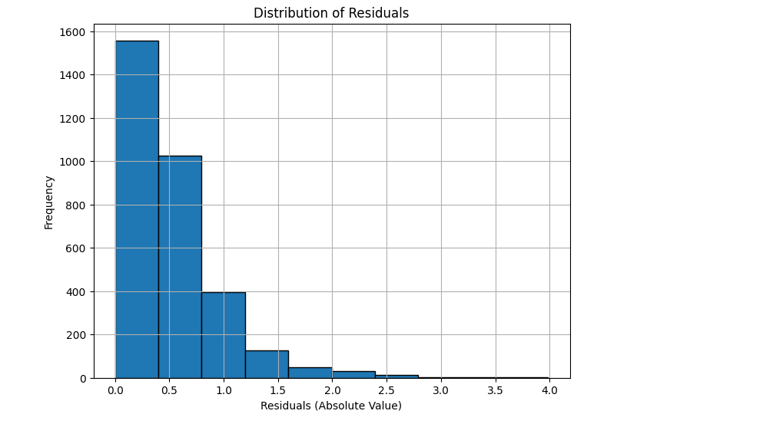

**2)**

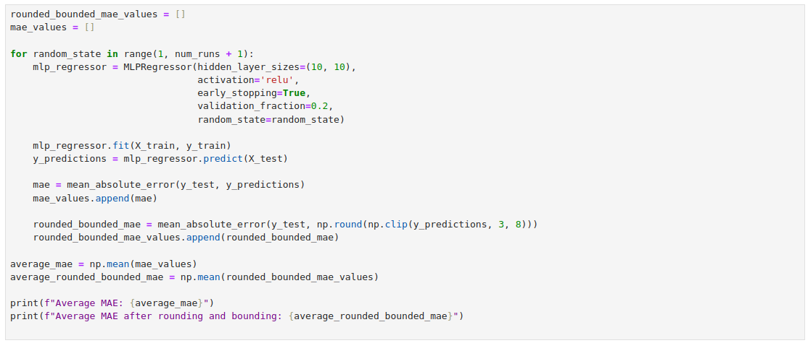

**3)**

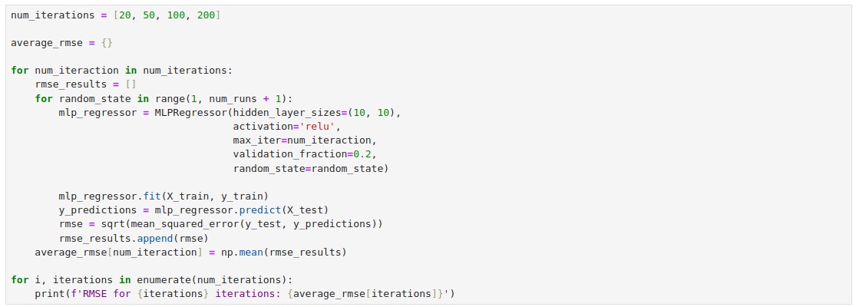

**4)**

In general, early stopping favors performance by preventing overfitting, where the model has over-adapted to the training data, essentially memorizing it rather than actually learning its underlying patterns, thus losing its ability to generalize.

However, as we can observe from the results obtained in the previous question, it is crucial to balance the number of iterations to avoid worsened performance. The RMSE value consistently decreases as the number of iterations increases, indicating that too few iterations lead to underfitting.

**END**