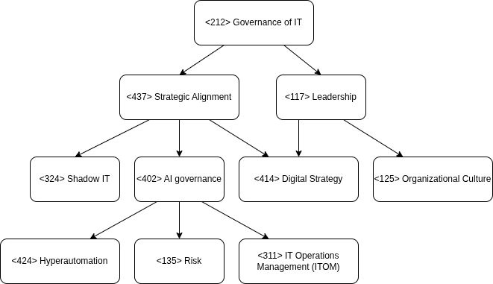
1. Organizations, Governance, and Management
CIOs face declining trust from fellow executives, with IT often perceived as a cost center rather than a value driver. The split between IT and R\&D reflects a broader governance issue where IT is excluded from strategic decision-making. To counter this, CIOs must adopt a business-centric approach, improve communication with stakeholders, and reposition IT as a strategic enabler.

2. Governance of IT and IT Management
The erosion of centralized IT control—exacerbated by shadow IT and rapid tech evolution—calls for stronger governance frameworks. CIOs are now responsible for AI ethics, risk management, and cloud cost control. Modern IT governance emphasizes agility, alignment with business risk appetite, and proactive leadership in emerging technologies.

3. IT Operations Management
Legacy systems, talent shortages, and growing complexity have strained traditional IT operations. Yet, expectations for uptime and innovation persist. The shift toward “zero-touch” infrastructure and AI-driven automation reflects a strategic need to modernize IT operations for speed, resilience, and cost efficiency.

4. IT, Strategy, and Change
CIOs are expected to lead digital transformation, especially in AI adoption. Strategic thinking now involves balancing CapEx, OpEx, and innovation investments. Upskilling and preparing for a hybrid human-AI workforce are essential. CIOs must drive change, not just support it.

Integrated View
IT is at a crossroads. To regain relevance, CIOs must align IT with business value, lead transformation, and rebuild trust through measurable impact. Success depends on governance reform, operational modernization, strategic foresight, and cultural change.

