Sheet 1 – Concept Map:
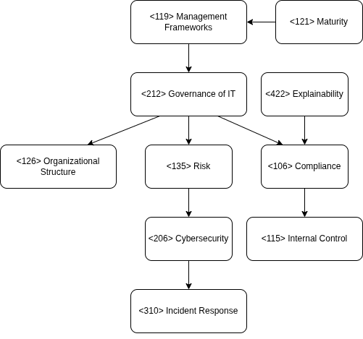

Sheet 2 – Concept Map:
