Narrative:
After completing the SGSI course, I became a senior consultant at a leading IT services firm specialized in healthcare digital transformation. Recently, I led a project for a regional health authority aiming to integrate local electronic health record (EHR) systems into a national interoperable platform.

Early in the project, a junior team member, André, bypassed change management protocols and implemented a system update directly into production without approval. This caused a 6-hour service disruption affecting patient data availability in two hospitals. Although incident response and IT service continuity plans were in place, I had to personally intervene to manage client communication, escalate recovery operations, and report the root cause. This highlighted weaknesses in internal control and organisational culture related to operational discipline.

In contrast, Sofia, another junior analyst, proved essential in overcoming a complex legal challenge. During our due diligence, she identified a risk of non-compliance with GDPR Article 28 regarding data processor agreements with private subcontractors. Drawing on knowledge from the SGSI course, she drafted a compliant data processing agreement template and coordinated with the client’s legal team to implement it. Her initiative avoided costly delays and positioned us as a trusted advisor.

Concept Map:
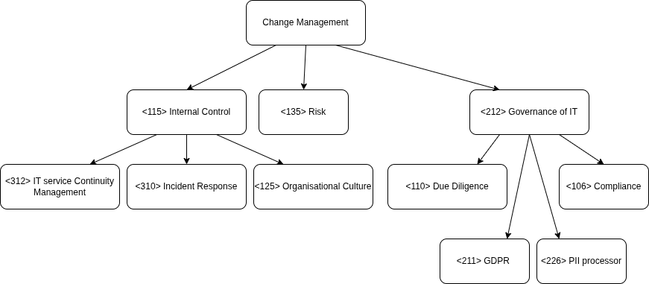
This scenario illustrates how core concepts from the SGSI course are deeply relevant in professional contexts. The first episode reflects a breakdown in <115> internal control and change management, resulting in operational risk. It also underscores the importance of <312> IT service continuity management and a resilient <310> incident response plan. From a governance perspective, it revealed weaknesses in <125> organisational culture regarding procedural discipline.

The second part shows the importance of <110> due diligence and <106> compliance, especially in data protection. By identifying risks under <211> GDPR and addressing them through a proper <226> PII processor contract, Sofia demonstrated practical application of consulting and risk management skills. This supported the client's broader <212> Governance of IT strategy and reinforced the strategic role of our team.

