**Creating physiology regressors using the PhysIO toolbox**

*October 2023*; additional info and further read: <https://www.sciencedirect.com/science/article/pii/S016502701630259X?via%3Dihub>

Required:

* Json- files of functional data for each run
* Physiology log-files, one for all runs (.resp and .puls files)

**Figure 1.** Puls and resp-file.

* Script: /storage/nv_shared/PhysIO_excitex/PhysIO_get_regressors.m

Before running the script:

* Always check if on path:

SPM: /usr/local/spm12/

Toolbox-code modified for our scanner model: /storage/nv_shared/software/PhysIO/tapas-master/PhysIO/code

* Individual parameter settings in the script:
* physio.log_files.vendor = 'Siemens_xa20'; *% specific for our scanner model.*
* physio.log_files.resp_type = 'spine'; *% set to* ***spine*** *or* ***belt****, depending on type of physiology correction.*
* physio.model.orthogonalise = 'RETROICOR'; *% select depending on physiology model used, e.g. 'RETROICOR', or c, r; to avoid correlations between regressors.*
* physio.model.retroicor.include = true; *% select physiology model here: RETROICOR, RVT or HVT.*

physio.model.retroicor.order.c = 3;

physio.model.retroicor.order.r = 4;

physio.model.retroicor.order.cr = 1;

* *% select orders for RETROICOR model; here the default option based on Glover et al., 2000 is set.*
* physio.model.rvt.include = false; *% select physiology model here.*
* physio.model.hrv.include = false; *% select physiology model here.*
* physio.model.other.include = false; *% select physiology model here.*
* physio.verbose.level = 3; *% 2 or 3, will produce control plots – useful to check quality of data and if synchronization has worked; when analyzing several participants it’s best to set to 0.*

After running the script:

* Validation of results 🡪 Check the diagnostic plots the toolbox delivers:
* Check the raw time series for artifacts/ detachments (4A)
* Check distribution of raw physiological data (should be left-skewed, 4B), are there any indications for ceiling effects or temporary detachment (2)?
* Check period used for synchronization, does it fit? (4C)
* Check filtered time series (are there still severe artifacts?)
* Check regressor file (3): regressors should have a value for each slice and 18 regressors if you specified RETROICOR (i.e., 6 cardiac phase regressors, 8 respiratory phase regressors, and 4 interaction terms).
* Regressors can then be added to a GLM.

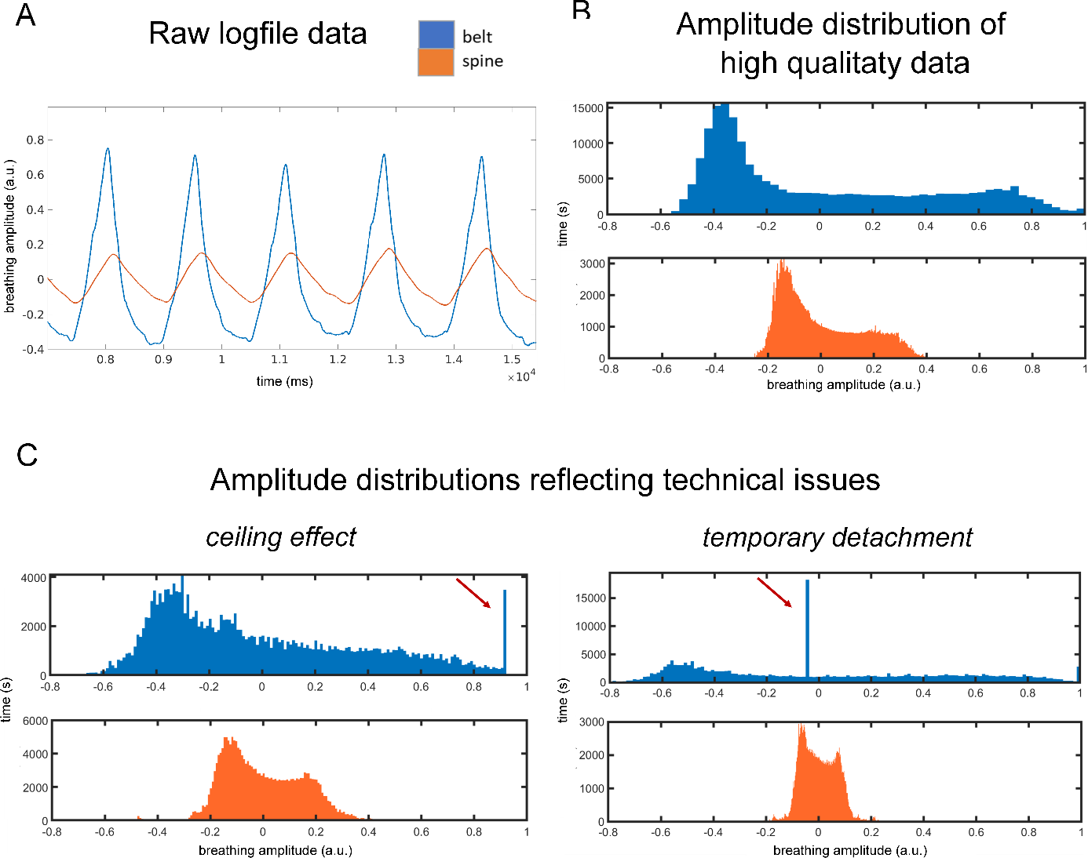**Figure 2:** Artifacts in raw respiratory signal due to issues during recording with the breathing belt.

**Figure 3.** Final output (RETROICOR regressors)

**Figure 4**: Steps from raw data to the final regressors.

