Function generator

Date: Jun 2024



RTL

Description
Function generator module. The module has a selector to choose between the following four functions:
- Sine
- Cosine
- Triangular
- Square

- It is possible to set the output signal amplitude with a integer range from 1 to 7. When amplitude is change, the function is reset. When the amplitude takes negative values , it allows the output signal to be inverted.
- To modify the amplitude, the configuration enable must be set to 1. During the period that enh_conf_i is set, no signal will be generated and wr_en_o will be disabled.
- The function period is 256 clock cycles. Considering a clock frequency of 100MHz (Period = 10ns), each period of the generated function would be 2.56us and its frequency would be approximately 390.6 KHz.
- When the reset is activated all the signals are initialized at the position 0 of their respective LUT, which for each signal is as follows:
- Sine = 0
- Cosine = Amplitude
- Square = Amplitude
- Triangular = 0
- When the enable is activated the signal at the output will continue at the point where it stopped previously, if a different function is selected, the new waveform will continue in the direction of the LUT where the previous function stopped since all four functions will use the same direction.
- The format used to represent the values of the functions is fixed point 4.28. Where QI=4 and QF=28. This analysis was performed with Matlab and the code is shown in the corresponding section below. Representation of negative numbers was implemented with 2’s complement.
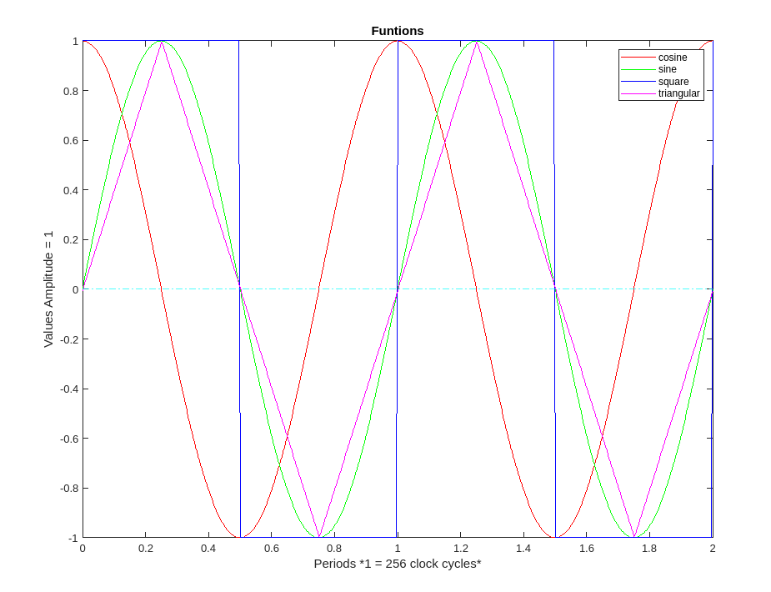

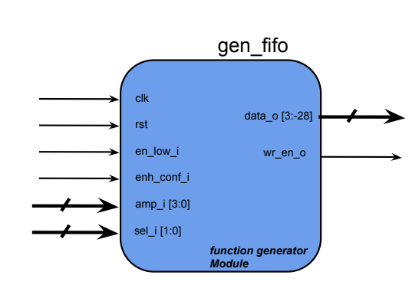

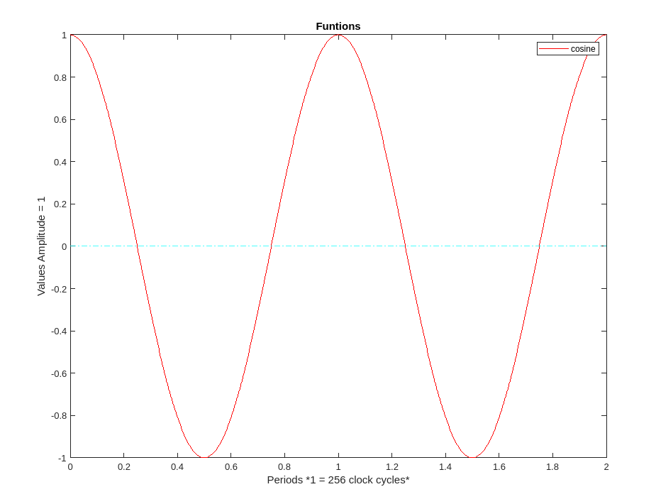 | 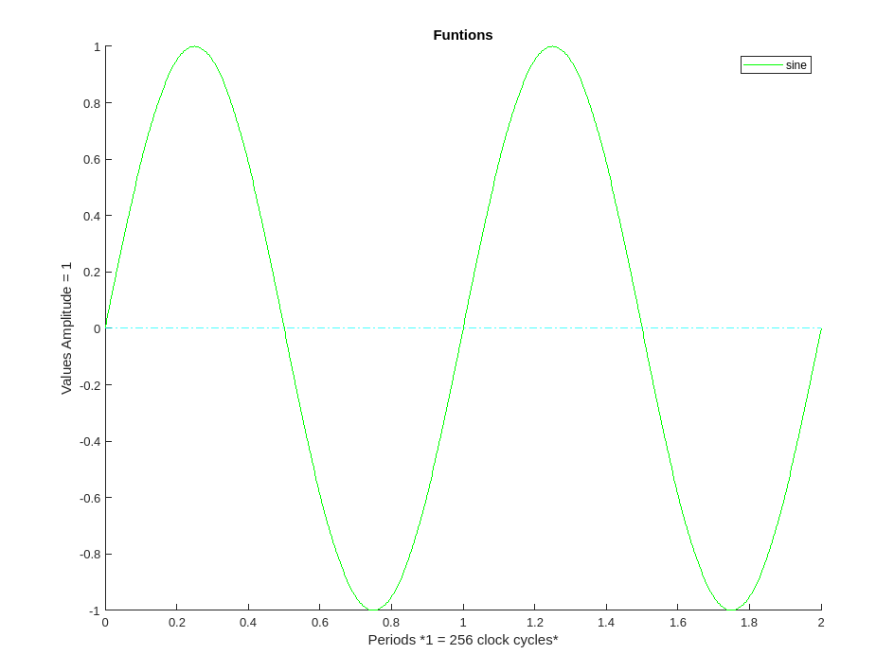
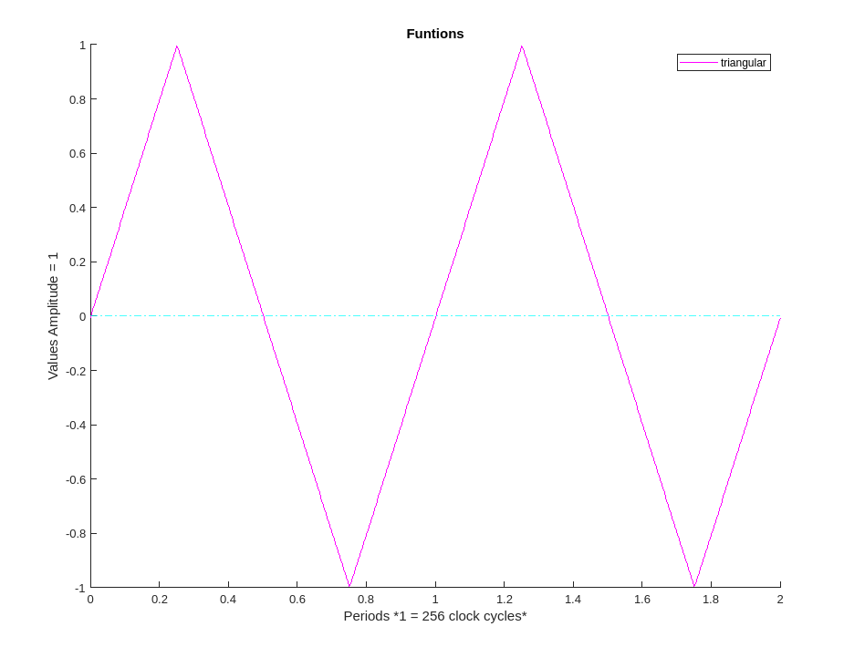
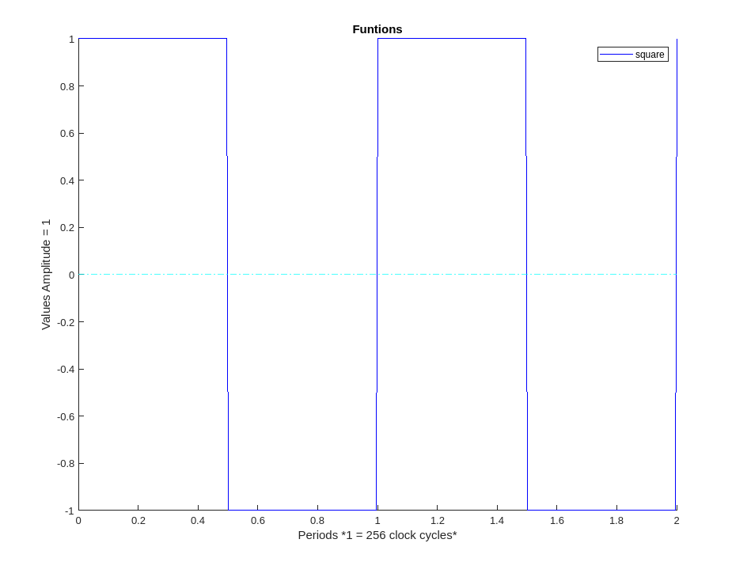

Input | Size | Description | Source
clk | 1 | Clock | Clock source
rst | 1 | Asynchronous reset activated | Main input
en_low_i | 1 | Operation enable. This enable activates the operation of the module when it is set to zero. When en_low_i = 1, the module stops its operation at the point where it was and data_o retain their value until the enable is re-asserted. | Main input  (full / FIFO)
enh_conf_i | 1 | Configuration enable. This signal enables the amplitud change. | Main inout
amp_i | 4 | Amplitude of the function. It can take the integer values -7, -6, -5, -4, -3, -2, -1, 1, 2, 3, 4, 5, 6 and 7 in a 2’s complement format. It determines the amplitude of the output signal. Binary values 0000 and 1000 are forbiden, whwn the input takes these values and enh_config_i=1, the amplitud will not be modified. | Main input
sel_i | 2 | Function selector Allows to select which waveform is the one we want to obtain in the output of the module. The function of each value of this signal is described in a table below. | Main input
Output | Size | Description | Source
data_o | 32 | Data of the generated function | Top module
wr_en_o | 1 | This signal indicates that the data at the output are valid and will be written to a destination memory. | Top module
Table 1: Inputs/Outputs description

Internal sub-modules:
- Adder module
- Multiplication module
- Register module
- LUT
- FSM module
- Mux module

Sub-modules

- Adder: 3-input adder with enable and clear. The addition is performed combinationally when the enable is active. The output is zero when the clear is activated. The clear signal has priority.

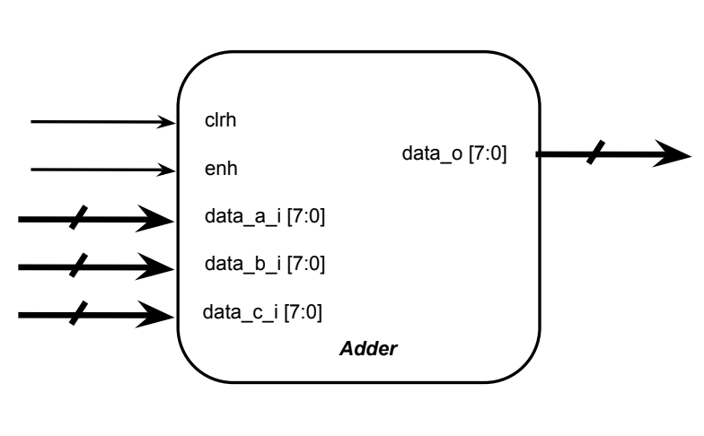

- Multiplier: 2-input multiplier with enable. Multiplication is performed combinationally when the enable is active.

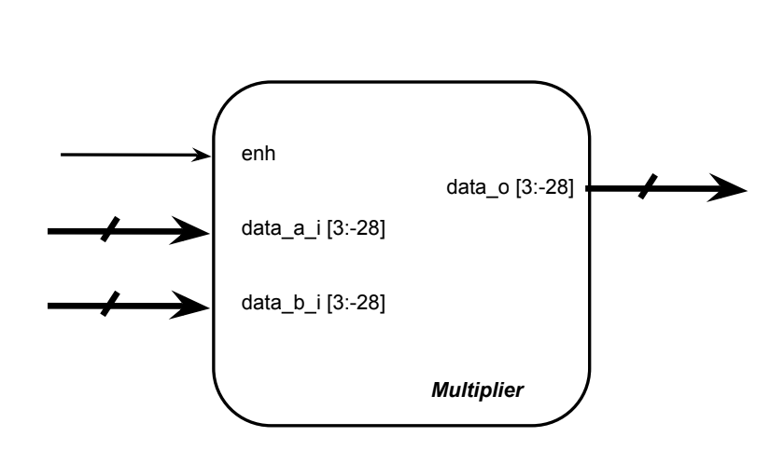

- Register: Type D flip flop register activated on positive clock edge with enable active high and clear active high

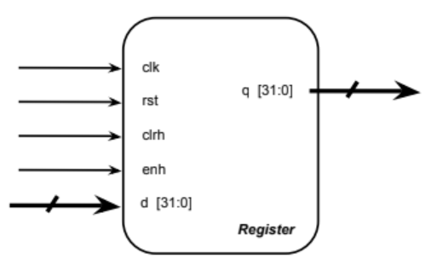

- FSM: The state machine will control the enable of the internal modules, when to clear the information from the registers and the sequential operation of the whole RTL.

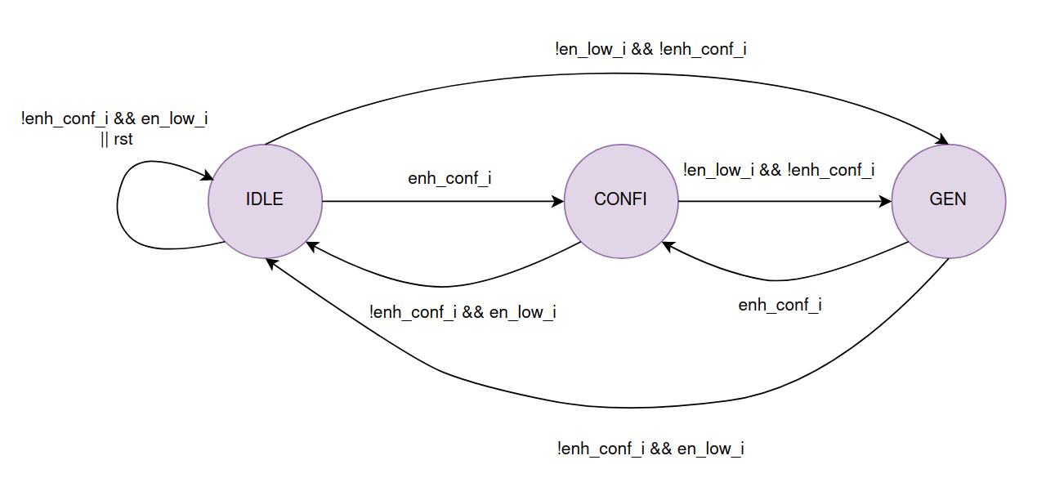

State | Signals
IDLE | clrh_addr_fsm = 1  enh_gen_fsm = 0  enh_config_fsm = 0
CONFI | clrh_addr_fsm = 1  enh_gen_fsm = 0  enh_config_fsm = 1
GEN | clrh_addr_fsm = 0  enh_gen_fsm = 1  enh_config_fsm = 0

- Mux: 4-input 1-output multiplexer with a 2-bit selector switch. The output signal corresponds to the selector value (0 to 3). Inputs and outputs are signed.
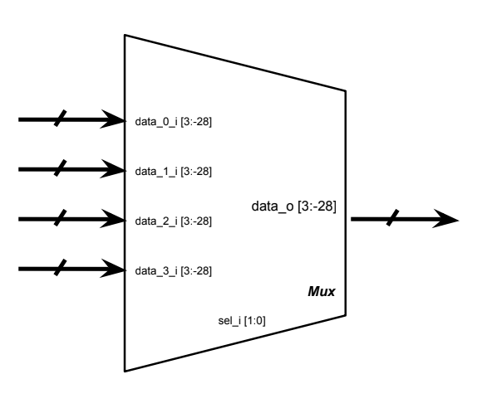

sel_i value | Output signal
0 | Sine
1 | Cosine
2 | Triangular
3 | Square

- LUT: Stores the values of the functions. It only has the operation of reading by means of an address. Its content is loaded by means of a txt file in hexadecimal. The reading is sequential on the positive edge of the clock. Information on each function can be found in the annexes section.
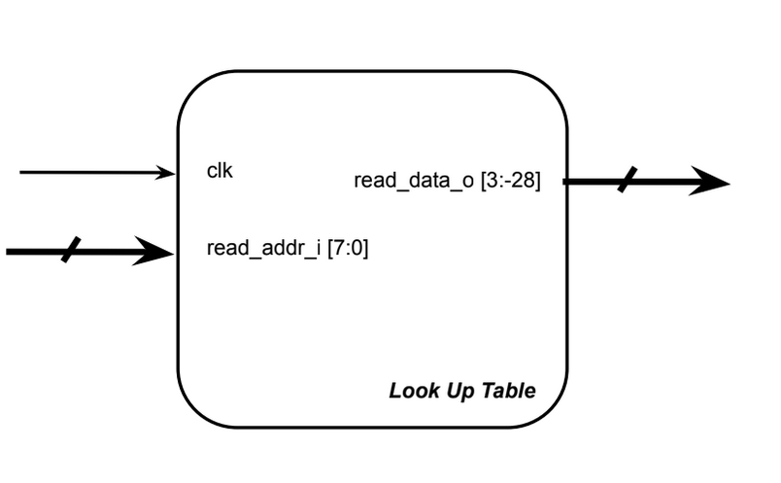

Fixed point analysis
To obtain the values of the functions in their fixed point representation, the following code was implemented in Matlab, which results in the 256 values of each function in decimal and binary.
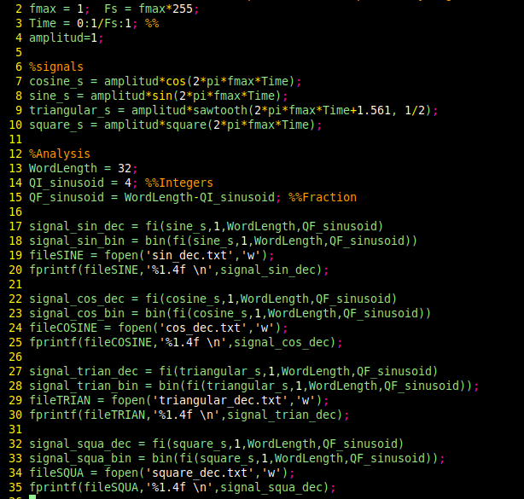

With the fixed point representation 4.28, the minimum fraction that can be represented is 0.00000000372529029846 both positive and negative. The range of 4-bits 2’s complement integers is -8 to 7.
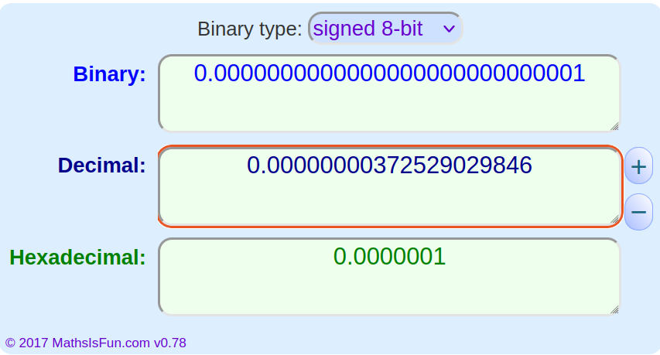

Results
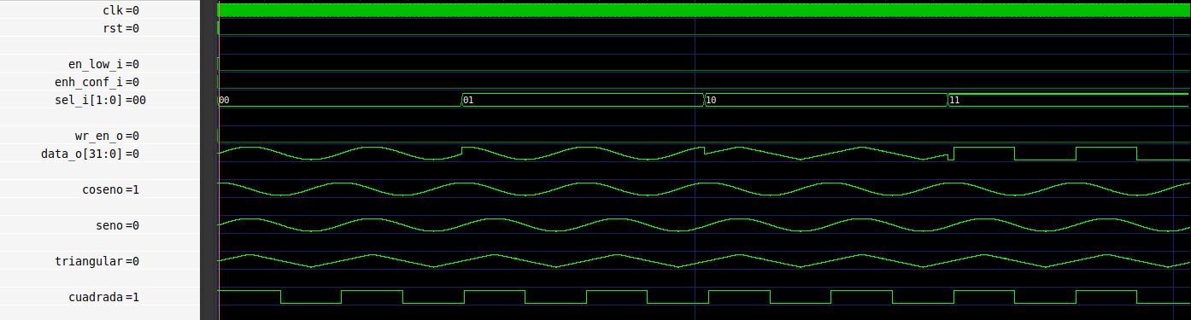
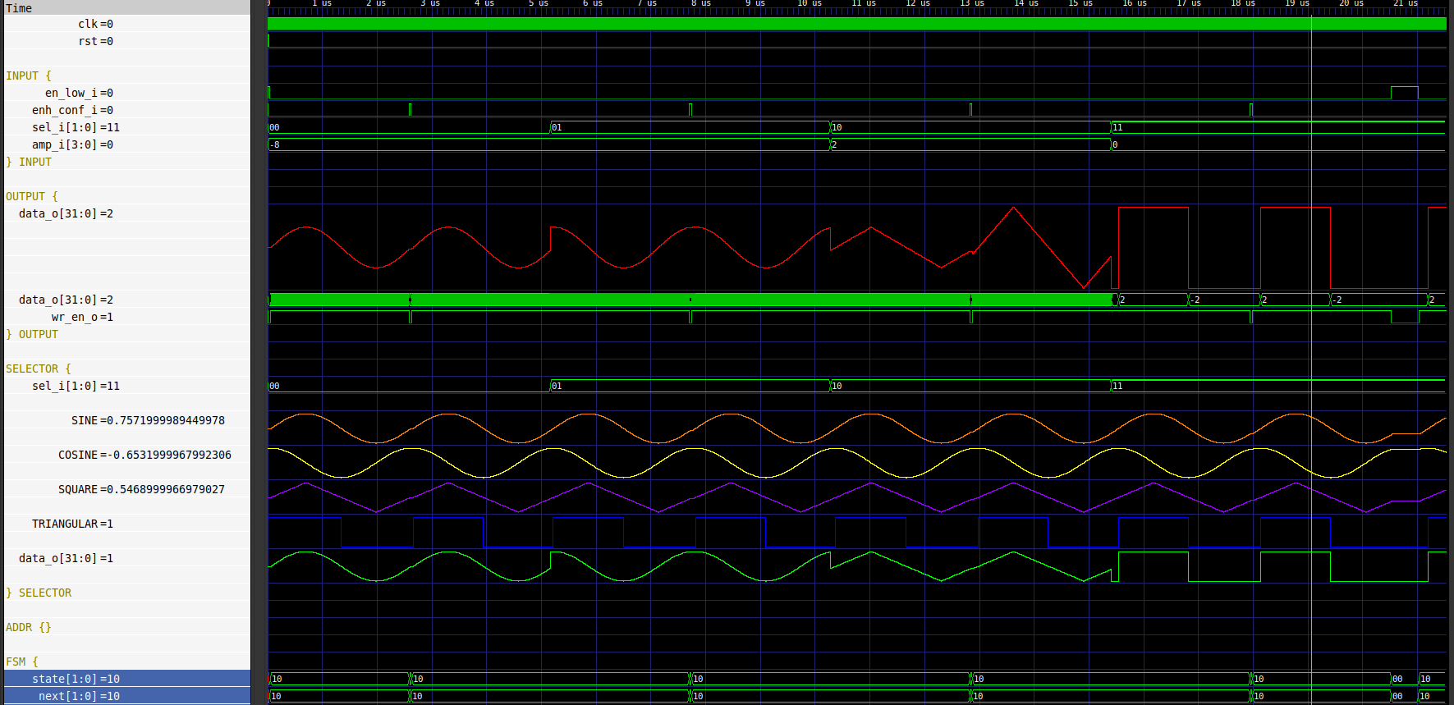

Anexos:

LUT data
LUT | Square |  |  | Triangular
LUT | Dec | Bin | Hex | Dec | Bin | Hex
0  1  2  3  4  5  6  7  8  9  10  11  12  13  14  15  16  17  18  19  20  21  22  23  24  25  26  27  28  29  30  31  32  33  34  35  36  37  38  39  40  41  42  43  44  45  46  47  48  49  50  51  52  53  54  55  56  57  58  59  60  61  62  63  64  65  66  67  68  69  70  71  72  73  74  75  76  77  78  79  80  81  82  83  84  85  86  87  88  89  90  91  92  93  94  95  96  97  98  99  100  101  102  103  104  105  106  107  108  109  110  111  112  113  114  115  116  117  118  119  120  121  122  123  124  125  126  127  128  129  130  131  132  133  134  135  136  137  138  139  140  141  142  143  144  145  146  147  148  149  150  151  152  153  154  155  156  157  158  159  160  161  162  163  164  165  166  167  168  169  170  171  172  173  174  175  176  177  178  179  180  181  182  183  184  185  186  187  188  189  190  191  192  193  194  195  196  197  198  199  200  201  202  203  204  205  206  207  208  209  210  211  212  213  214  215  216  217  218  219  220  221  222  223  224  225  226  227  228  229  230  231  232  233  234  235  236  237  238  239  240  241  242  243  244  245  246  247  248  249  250  251  252  253  254  255 | 1.0000  1.0000  1.0000  1.0000  1.0000  1.0000  1.0000  1.0000  1.0000  1.0000  1.0000  1.0000  1.0000  1.0000  1.0000  1.0000  1.0000  1.0000  1.0000  1.0000  1.0000  1.0000  1.0000  1.0000  1.0000  1.0000  1.0000  1.0000  1.0000  1.0000  1.0000  1.0000  1.0000  1.0000  1.0000  1.0000  1.0000  1.0000  1.0000  1.0000  1.0000  1.0000  1.0000  1.0000  1.0000  1.0000  1.0000  1.0000  1.0000  1.0000  1.0000  1.0000  1.0000  1.0000  1.0000  1.0000  1.0000  1.0000  1.0000  1.0000  1.0000  1.0000  1.0000  1.0000  1.0000  1.0000  1.0000  1.0000  1.0000  1.0000  1.0000  1.0000  1.0000  1.0000  1.0000  1.0000  1.0000  1.0000  1.0000  1.0000  1.0000  1.0000  1.0000  1.0000  1.0000  1.0000  1.0000  1.0000  1.0000  1.0000  1.0000  1.0000  1.0000  1.0000  1.0000  1.0000  1.0000  1.0000  1.0000  1.0000  1.0000  1.0000  1.0000  1.0000  1.0000  1.0000  1.0000  1.0000  1.0000  1.0000  1.0000  1.0000  1.0000  1.0000  1.0000  1.0000  1.0000  1.0000  1.0000  1.0000  1.0000  1.0000  1.0000  1.0000  1.0000  1.0000  1.0000  1.0000  1.0000  -1.0000  -1.0000  -1.0000  -1.0000  -1.0000  -1.0000  -1.0000  -1.0000  -1.0000  -1.0000  -1.0000  -1.0000  -1.0000  -1.0000  -1.0000  -1.0000  -1.0000  -1.0000  -1.0000  -1.0000  -1.0000  -1.0000  -1.0000  -1.0000  -1.0000  -1.0000  -1.0000  -1.0000  -1.0000  -1.0000  -1.0000  -1.0000  -1.0000  -1.0000  -1.0000  -1.0000  -1.0000  -1.0000  -1.0000  -1.0000  -1.0000  -1.0000  -1.0000  -1.0000  -1.0000  -1.0000  -1.0000  -1.0000  -1.0000  -1.0000  -1.0000  -1.0000  -1.0000  -1.0000  -1.0000  -1.0000  -1.0000  -1.0000  -1.0000  -1.0000  -1.0000  -1.0000  -1.0000  -1.0000  -1.0000  -1.0000  -1.0000  -1.0000  -1.0000  -1.0000  -1.0000  -1.0000  -1.0000  -1.0000  -1.0000  -1.0000  -1.0000  -1.0000  -1.0000  -1.0000  -1.0000  -1.0000  -1.0000  -1.0000  -1.0000  -1.0000  -1.0000  -1.0000  -1.0000  -1.0000  -1.0000  -1.0000  -1.0000  -1.0000  -1.0000  -1.0000  -1.0000  -1.0000  -1.0000  -1.0000  -1.0000  -1.0000  -1.0000  -1.0000  -1.0000  -1.0000  -1.0000  -1.0000  -1.0000  -1.0000  -1.0000  -1.0000  -1.0000  -1.0000  -1.0000  -1.0000  -1.0000  -1.0000  -1.0000  -1.0000  -1.0000  -1.0000  -1.0000  -1.0000  -1.0000  -1.0000  -1.0000 | 0001 0000000000000000000000000000  0001 0000000000000000000000000000  0001 0000000000000000000000000000  0001 0000000000000000000000000000  0001 0000000000000000000000000000  0001 0000000000000000000000000000  0001 0000000000000000000000000000  0001 0000000000000000000000000000  0001 0000000000000000000000000000  0001 0000000000000000000000000000  0001 0000000000000000000000000000  0001 0000000000000000000000000000  0001 0000000000000000000000000000  0001 0000000000000000000000000000  0001 0000000000000000000000000000  0001 0000000000000000000000000000  0001 0000000000000000000000000000  0001 0000000000000000000000000000  0001 0000000000000000000000000000  0001 0000000000000000000000000000  0001 0000000000000000000000000000  0001 0000000000000000000000000000  0001 0000000000000000000000000000  0001 0000000000000000000000000000  0001 0000000000000000000000000000  0001 0000000000000000000000000000  0001 0000000000000000000000000000  0001 0000000000000000000000000000  0001 0000000000000000000000000000  0001 0000000000000000000000000000  0001 0000000000000000000000000000  0001 0000000000000000000000000000  0001 0000000000000000000000000000  0001 0000000000000000000000000000  0001 0000000000000000000000000000  0001 0000000000000000000000000000  0001 0000000000000000000000000000  0001 0000000000000000000000000000  0001 0000000000000000000000000000  0001 0000000000000000000000000000  0001 0000000000000000000000000000  0001 0000000000000000000000000000  0001 0000000000000000000000000000  0001 0000000000000000000000000000  0001 0000000000000000000000000000  0001 0000000000000000000000000000  0001 0000000000000000000000000000  0001 0000000000000000000000000000  0001 0000000000000000000000000000  0001 0000000000000000000000000000  0001 0000000000000000000000000000  0001 0000000000000000000000000000  0001 0000000000000000000000000000  0001 0000000000000000000000000000  0001 0000000000000000000000000000  0001 0000000000000000000000000000  0001 0000000000000000000000000000  0001 0000000000000000000000000000  0001 0000000000000000000000000000  0001 0000000000000000000000000000  0001 0000000000000000000000000000  0001 0000000000000000000000000000  0001 0000000000000000000000000000  0001 0000000000000000000000000000  0001 0000000000000000000000000000  0001 0000000000000000000000000000  0001 0000000000000000000000000000  0001 0000000000000000000000000000  0001 0000000000000000000000000000  0001 0000000000000000000000000000  0001 0000000000000000000000000000  0001 0000000000000000000000000000  0001 0000000000000000000000000000  0001 0000000000000000000000000000  0001 0000000000000000000000000000  0001 0000000000000000000000000000  0001 0000000000000000000000000000  0001 0000000000000000000000000000  0001 0000000000000000000000000000  0001 0000000000000000000000000000  0001 0000000000000000000000000000  0001 0000000000000000000000000000  0001 0000000000000000000000000000  0001 0000000000000000000000000000  0001 0000000000000000000000000000  0001 0000000000000000000000000000  0001 0000000000000000000000000000  0001 0000000000000000000000000000  0001 0000000000000000000000000000  0001 0000000000000000000000000000  0001 0000000000000000000000000000  0001 0000000000000000000000000000  0001 0000000000000000000000000000  0001 0000000000000000000000000000  0001 0000000000000000000000000000  0001 0000000000000000000000000000  0001 0000000000000000000000000000  0001 0000000000000000000000000000  0001 0000000000000000000000000000  0001 0000000000000000000000000000  0001 0000000000000000000000000000  0001 0000000000000000000000000000  0001 0000000000000000000000000000  0001 0000000000000000000000000000  0001 0000000000000000000000000000  0001 0000000000000000000000000000  0001 0000000000000000000000000000  0001 0000000000000000000000000000  0001 0000000000000000000000000000  0001 0000000000000000000000000000  0001 0000000000000000000000000000  0001 0000000000000000000000000000  0001 0000000000000000000000000000  0001 0000000000000000000000000000  0001 0000000000000000000000000000  0001 0000000000000000000000000000  0001 0000000000000000000000000000  0001 0000000000000000000000000000  0001 0000000000000000000000000000  0001 0000000000000000000000000000  0001 0000000000000000000000000000  0001 0000000000000000000000000000  0001 0000000000000000000000000000  0001 0000000000000000000000000000  0001 0000000000000000000000000000  0001 0000000000000000000000000000  0001 0000000000000000000000000000  0001 0000000000000000000000000000  0001 0000000000000000000000000000  1111 0000000000000000000000000000  1111 0000000000000000000000000000  1111 0000000000000000000000000000  1111 0000000000000000000000000000  1111 0000000000000000000000000000  1111 0000000000000000000000000000  1111 0000000000000000000000000000  1111 0000000000000000000000000000  1111 0000000000000000000000000000  1111 0000000000000000000000000000  1111 0000000000000000000000000000  1111 0000000000000000000000000000  1111 0000000000000000000000000000  1111 0000000000000000000000000000  1111 0000000000000000000000000000  1111 0000000000000000000000000000  1111 0000000000000000000000000000  1111 0000000000000000000000000000  1111 0000000000000000000000000000  1111 0000000000000000000000000000  1111 0000000000000000000000000000  1111 0000000000000000000000000000  1111 0000000000000000000000000000  1111 0000000000000000000000000000  1111 0000000000000000000000000000  1111 0000000000000000000000000000  1111 0000000000000000000000000000  1111 0000000000000000000000000000  1111 0000000000000000000000000000  1111 0000000000000000000000000000  1111 0000000000000000000000000000  1111 0000000000000000000000000000  1111 0000000000000000000000000000  1111 0000000000000000000000000000  1111 0000000000000000000000000000  1111 0000000000000000000000000000  1111 0000000000000000000000000000  1111 0000000000000000000000000000  1111 0000000000000000000000000000  1111 0000000000000000000000000000  1111 0000000000000000000000000000  1111 0000000000000000000000000000  1111 0000000000000000000000000000  1111 0000000000000000000000000000  1111 0000000000000000000000000000  1111 0000000000000000000000000000  1111 0000000000000000000000000000  1111 0000000000000000000000000000  1111 0000000000000000000000000000  1111 0000000000000000000000000000  1111 0000000000000000000000000000  1111 0000000000000000000000000000  1111 0000000000000000000000000000  1111 0000000000000000000000000000  1111 0000000000000000000000000000  1111 0000000000000000000000000000  1111 0000000000000000000000000000  1111 0000000000000000000000000000  1111 0000000000000000000000000000  1111 0000000000000000000000000000  1111 0000000000000000000000000000  1111 0000000000000000000000000000  1111 0000000000000000000000000000  1111 0000000000000000000000000000  1111 0000000000000000000000000000  1111 0000000000000000000000000000  1111 0000000000000000000000000000  1111 0000000000000000000000000000  1111 0000000000000000000000000000  1111 0000000000000000000000000000  1111 0000000000000000000000000000  1111 0000000000000000000000000000  1111 0000000000000000000000000000  1111 0000000000000000000000000000  1111 0000000000000000000000000000  1111 0000000000000000000000000000  1111 0000000000000000000000000000  1111 0000000000000000000000000000  1111 0000000000000000000000000000  1111 0000000000000000000000000000  1111 0000000000000000000000000000  1111 0000000000000000000000000000  1111 0000000000000000000000000000  1111 0000000000000000000000000000  1111 0000000000000000000000000000  1111 0000000000000000000000000000  1111 0000000000000000000000000000  1111 0000000000000000000000000000  1111 0000000000000000000000000000  1111 0000000000000000000000000000  1111 0000000000000000000000000000  1111 0000000000000000000000000000  1111 0000000000000000000000000000  1111 0000000000000000000000000000  1111 0000000000000000000000000000  1111 0000000000000000000000000000  1111 0000000000000000000000000000  1111 0000000000000000000000000000  1111 0000000000000000000000000000  1111 0000000000000000000000000000  1111 0000000000000000000000000000  1111 0000000000000000000000000000  1111 0000000000000000000000000000  1111 0000000000000000000000000000  1111 0000000000000000000000000000  1111 0000000000000000000000000000  1111 0000000000000000000000000000  1111 0000000000000000000000000000  1111 0000000000000000000000000000  1111 0000000000000000000000000000  1111 0000000000000000000000000000  1111 0000000000000000000000000000  1111 0000000000000000000000000000  1111 0000000000000000000000000000  1111 0000000000000000000000000000  1111 0000000000000000000000000000  1111 0000000000000000000000000000  1111 0000000000000000000000000000  1111 0000000000000000000000000000  1111 0000000000000000000000000000  1111 0000000000000000000000000000  1111 0000000000000000000000000000  1111 0000000000000000000000000000  1111 0000000000000000000000000000  1111 0000000000000000000000000000  1111 0000000000000000000000000000  1111 0000000000000000000000000000 | 10000000  10000000  10000000  10000000  10000000  10000000  10000000  10000000  10000000  10000000  10000000  10000000  10000000  10000000  10000000  10000000  10000000  10000000  10000000  10000000  10000000  10000000  10000000  10000000  10000000  10000000  10000000  10000000  10000000  10000000  10000000  10000000  10000000  10000000  10000000  10000000  10000000  10000000  10000000  10000000  10000000  10000000  10000000  10000000  10000000  10000000  10000000  10000000  10000000  10000000  10000000  10000000  10000000  10000000  10000000  10000000  10000000  10000000  10000000  10000000  10000000  10000000  10000000  10000000  10000000  10000000  10000000  10000000  10000000  10000000  10000000  10000000  10000000  10000000  10000000  10000000  10000000  10000000  10000000  10000000  10000000  10000000  10000000  10000000  10000000  10000000  10000000  10000000  10000000  10000000  10000000  10000000  10000000  10000000  10000000  10000000  10000000  10000000  10000000  10000000  10000000  10000000  10000000  10000000  10000000  10000000  10000000  10000000  10000000  10000000  10000000  10000000  10000000  10000000  10000000  10000000  10000000  10000000  10000000  10000000  10000000  10000000  10000000  10000000  10000000  10000000  10000000  10000000  10000000  F0000000  F0000000  F0000000  F0000000  F0000000  F0000000  F0000000  F0000000  F0000000  F0000000  F0000000  F0000000  F0000000  F0000000  F0000000  F0000000  F0000000  F0000000  F0000000  F0000000  F0000000  F0000000  F0000000  F0000000  F0000000  F0000000  F0000000  F0000000  F0000000  F0000000  F0000000  F0000000  F0000000  F0000000  F0000000  F0000000  F0000000  F0000000  F0000000  F0000000  F0000000  F0000000  F0000000  F0000000  F0000000  F0000000  F0000000  F0000000  F0000000  F0000000  F0000000  F0000000  F0000000  F0000000  F0000000  F0000000  F0000000  F0000000  F0000000  F0000000  F0000000  F0000000  F0000000  F0000000  F0000000  F0000000  F0000000  F0000000  F0000000  F0000000  F0000000  F0000000  F0000000  F0000000  F0000000  F0000000  F0000000  F0000000  F0000000  F0000000  F0000000  F0000000  F0000000  F0000000  F0000000  F0000000  F0000000  F0000000  F0000000  F0000000  F0000000  F0000000  F0000000  F0000000  F0000000  F0000000  F0000000  F0000000  F0000000  F0000000  F0000000  F0000000  F0000000  F0000000  F0000000  F0000000  F0000000  F0000000  F0000000  F0000000  F0000000  F0000000  F0000000  F0000000  F0000000  F0000000  F0000000  F0000000  F0000000  F0000000  F0000000  F0000000  F0000000  F0000000  F0000000  F0000000  F0000000 | 0.0000  0.0156  0.0312  0.0469  0.0625  0.0781  0.0938  0.1094  0.1250  0.1406  0.1562  0.1719  0.1875  0.2031  0.2188  0.2344  0.2500  0.2656  0.2812  0.2969  0.3125  0.3281  0.3438  0.3594  0.3750  0.3906  0.4062  0.4219  0.4375  0.4531  0.4688  0.4844  0.5000  0.5156  0.5312  0.5469  0.5625  0.5781  0.5938  0.6094  0.6250  0.6406  0.6562  0.6719  0.6875  0.7031  0.7188  0.7344  0.7500  0.7656  0.7812  0.7969  0.8125  0.8281  0.8438  0.8594  0.8750  0.8906  0.9062  0.9219  0.9375  0.9531  0.9688  0.9844  1.0000  0.9844  0.9688  0.9531  0.9375  0.9219  0.9062  0.8906  0.8750  0.8594  0.8438  0.8281  0.8125  0.7969  0.7812  0.7656  0.7500  0.7344  0.7188  0.7031  0.6875  0.6719  0.6562  0.6406  0.6250  0.6094  0.5938  0.5781  0.5625  0.5469  0.5312  0.5156  0.5000  0.4844  0.4688  0.4531  0.4375  0.4219  0.4062  0.3906  0.3750  0.3594  0.3438  0.3281  0.3125  0.2969  0.2812  0.2656  0.2500  0.2344  0.2188  0.2031  0.1875  0.1719  0.1562  0.1406  0.1250  0.1094  0.0938  0.0781  0.0625  0.0469  0.0312  0.0156  0.0000  -0.0156  -0.0312  -0.0469  -0.0625  -0.0781  -0.0938  -0.1094  -0.1250  -0.1406  -0.1562  -0.1719  -0.1875  -0.2031  -0.2188  -0.2344  -0.2500  -0.2656  -0.2812  -0.2969  -0.3125  -0.3281  -0.3438  -0.3594  -0.3750  -0.3906  -0.4062  -0.4219  -0.4375  -0.4531  -0.4688  -0.4844  -0.5000  -0.5156  -0.5312  -0.5469  -0.5625  -0.5781  -0.5938  -0.6094  -0.6250  -0.6406  -0.6562  -0.6719  -0.6875  -0.7031  -0.7188  -0.7344  -0.7500  -0.7656  -0.7812  -0.7969  -0.8125  -0.8281  -0.8438  -0.8594  -0.8750  -0.8906  -0.9062  -0.9219  -0.9375  -0.9531  -0.9688  -0.9844  -1.0000  -0.9844  -0.9688  -0.9531  -0.9375  -0.9219  -0.9062  -0.8906  -0.8750  -0.8594  -0.8438  -0.8281  -0.8125  -0.7969  -0.7812  -0.7656  -0.7500  -0.7344  -0.7188  -0.7031  -0.6875  -0.6719  -0.6562  -0.6406  -0.6250  -0.6094  -0.5938  -0.5781  -0.5625  -0.5469  -0.5312  -0.5156  -0.5000  -0.4844  -0.4688  -0.4531  -0.4375  -0.4219  -0.4062  -0.3906  -0.3750  -0.3594  -0.3438  -0.3281  -0.3125  -0.2969  -0.2812  -0.2656  -0.2500  -0.2344  -0.2188  -0.2031  -0.1875  -0.1719  -0.1562  -0.1406  -0.1250  -0.1094  -0.0938  -0.0781  -0.0625  -0.0469  -0.0312  -0.0156 | 0000 0000000000000000000000000000  0000 0000001111111110010111001001  0000 0000011111111100101110010010  0000 0000110000000001101000110110  0000 0001000000000000000000000000  0000 0001001111111110010111001001  0000 0001100000000011010001101101  0000 0001110000000001101000110110  0000 0010000000000000000000000000  0000 0010001111111110010111001001  0000 0010011111111100101110010010  0000 0010110000000001101000110110  0000 0011000000000000000000000000  0000 0011001111111110010111001001  0000 0011100000000011010001101101  0000 0011110000000001101000110110  0000 0100000000000000000000000000  0000 0100001111111110010111001001  0000 0100011111111100101110010010  0000 0100110000000001101000110110  0000 0101000000000000000000000000  0000 0101001111111110010111001001  0000 0101100000000011010001101101  0000 0101110000000001101000110110  0000 0110000000000000000000000000  0000 0110001111111110010111001001  0000 0110011111111100101110010010  0000 0110110000000001101000110110  0000 0111000000000000000000000000  0000 0111001111111110010111001001  0000 0111100000000011010001101101  0000 0111110000000001101000110110  0000 1000000000000000000000000000  0000 1000001111111110010111001001  0000 1000011111111100101110010010  0000 1000110000000001101000110110  0000 1001000000000000000000000000  0000 1001001111111110010111001001  0000 1001100000000011010001101101  0000 1001110000000001101000110110  0000 1010000000000000000000000000  0000 1010001111111110010111001001  0000 1010011111111100101110010010  0000 1010110000000001101000110110  0000 1011000000000000000000000000  0000 1011001111111110010111001001  0000 1011100000000011010001101101  0000 1011110000000001101000110110  0000 1100000000000000000000000000  0000 1100001111111110010111001001  0000 1100011111111100101110010010  0000 1100110000000001101000110110  0000 1101000000000000000000000000  0000 1101001111111110010111001001  0000 1101100000000011010001101101  0000 1101110000000001101000110110  0000 1110000000000000000000000000  0000 1110001111111110010111001001  0000 1110011111111100101110010010  0000 1110110000000001101000110110  0000 1111000000000000000000000000  0000 1111001111111110010111001001  0000 1111100000000011010001101101  0000 1111110000000001101000110110  0001 0000000000000000000000000000  0000 1111110000000001101000110110  0000 1111100000000011010001101101  0000 1111001111111110010111001001  0000 1111000000000000000000000000  0000 1110110000000001101000110110  0000 1110011111111100101110010010  0000 1110001111111110010111001001  0000 1110000000000000000000000000  0000 1101110000000001101000110110  0000 1101100000000011010001101101  0000 1101001111111110010111001001  0000 1101000000000000000000000000  0000 1100110000000001101000110110  0000 1100011111111100101110010010  0000 1100001111111110010111001001  0000 1100000000000000000000000000  0000 1011110000000001101000110110  0000 1011100000000011010001101101  0000 1011001111111110010111001001  0000 1011000000000000000000000000  0000 1010110000000001101000110110  0000 1010011111111100101110010010  0000 1010001111111110010111001001  0000 1010000000000000000000000000  0000 1001110000000001101000110110  0000 1001100000000011010001101101  0000 1001001111111110010111001001  0000 1001000000000000000000000000  0000 1000110000000001101000110110  0000 1000011111111100101110010010  0000 1000001111111110010111001001  0000 1000000000000000000000000000  0000 0111110000000001101000110110  0000 0111100000000011010001101101  0000 0111001111111110010111001001  0000 0111000000000000000000000000  0000 0110110000000001101000110110  0000 0110011111111100101110010010  0000 0110001111111110010111001001  0000 0110000000000000000000000000  0000 0101110000000001101000110110  0000 0101100000000011010001101101  0000 0101001111111110010111001001  0000 0101000000000000000000000000  0000 0100110000000001101000110110  0000 0100011111111100101110010010  0000 0100001111111110010111001001  0000 0100000000000000000000000000  0000 0011110000000001101000110110  0000 0011100000000011010001101101  0000 0011001111111110010111001001  0000 0011000000000000000000000000  0000 0010110000000001101000110110  0000 0010011111111100101110010010  0000 0010001111111110010111001001  0000 0010000000000000000000000000  0000 0001110000000001101000110110  0000 0001100000000011010001101101  0000 0001001111111110010111001001  0000 0001000000000000000000000000  0000 0000110000000001101000110110  0000 0000011111111100101110010010  0000 0000001111111110010111001001  0000 0000000000000000000000000000  1111 1111110000000001101000110111  1111 1111100000000011010001101110  1111 1111001111111110010111001010  1111 1111000000000000000000000000  1111 1110110000000001101000110111  1111 1110011111111100101110010101  1111 1110001111111110010111001010  1111 1110000000000000000000000000  1111 1101110000000001101000110111  1111 1101100000000011010001101110  1111 1101001111111110010111001010  1111 1101000000000000000000000000  1111 1100110000000001101000110111  1111 1100011111111100101110010011  1111 1100001111111110010111001010  1111 1100000000000000000000000000  1111 1011110000000001101000110111  1111 1011100000000011010001101110  1111 1011001111111110010111001010  1111 1011000000000000000000000000  1111 1010110000000001101000110111  1111 1010011110111100101110010011  1111 1010001111111110010111001010  1111 1010000000000000000000000000  1111 1001110000000001101000110111  1111 1001100000000011010001101110  1111 1001001111111110010111001010  1111 1001000000000000000000000000  1111 1000110000000001101000110111  1111 1000011111111100101110010011  1111 1000001111111110010111001010  1111 1000000000000000000000000000  1111 0111110000000001101000110111  1111 0111100000000011010001101110  1111 0111001111111110010111001010  1111 0111000000000000000000000000  1111 0110110000000001101000110111  1111 0110011111111100101110010011  1111 0110001111111110010111001010  1111 0110000000000000000000000000  1111 0101110000000001101000110111  1111 0101100000000011010001101110  1111 0101001111111110010111001010  1111 0101000000000000000000000000  1111 0100110000000001101000110111  1111 0100011111111100101110010011  1111 0100001111111110010111001010  1111 0100000000000000000000000000  1111 0011110000000001101000110111  1111 0011100000000011010001101110  1111 0011001111111110010111001010  1111 0011000000000000000000000000  1111 0010110000000001101000110111  1111 0010011111111100101110010011  1111 0010001111111110010111001010  1111 0010000000000000000000000000  1111 0001110000000001101000110111  1111 0001100000000011010001101110  1111 0001001111111110010111001010  1111 0001000000000000000000000000  1111 0000110000000001101000110111  1111 0000011111111100101110010011  1111 0000001111111110010111001010  1111 0000000000000000000000000000  1111 0000001111111110010111001010  1111 0000011111111100101110010011  1111 0000110000000001101000110111  1111 0001000000000000000000000000  1111 0001001111111110010111001010  1111 0001100000000011010001101110  1111 0001110000000001101000110111  1111 0010000000000000000000000000  1111 0010001111111110010111001010  1111 0010011111111100101110010011  1111 0010110000000001101000110111  1111 0011000000000000000000000000  1111 0011001111111110010111001010  1111 0011100000000011010001101110  1111 0011110000000001101000110111  1111 0100000000000000000000000000  1111 0100001111111110010111001010  1111 0100011111111100101110010011  1111 0100110000000001101000110111  1111 0101000000000000000000000000  1111 0101001111111110010111001010  1111 0101100000000011010001101110  1111 0101110000000001101000110111  1111 0110000000000000000000000000  1111 0110001111111110010111001010  1111 0110011111111100101110010011  1111 0110110000000001101000110111  1111 0111000000000000000000000000  1111 0111001111111110010111001010  1111 0111100000000011010001101110  1111 0111110000000001101000110111  1111 1000000000000000000000000000  1111 1000001111111110010111001010  1111 1000011111111100101110010011  1111 1000110000000001101000110111  1111 1001000000000000000000000000  1111 1001001111111110010111001010  1111 1001100000000011010001101110  1111 1001110000000001101000110111  1111 1010000000000000000000000000  1111 1010001111111110010111001010  1111 1010011110111100101110010011  1111 1010110000000001101000110111  1111 1011000000000000000000000000  1111 1011001111111110010111001010  1111 1011100000000011010001101110  1111 1011110000000001101000110111  1111 1100000000000000000000000000  1111 1100001111111110010111001010  1111 1100011111111100101110010011  1111 1100110000000001101000110111  1111 1101000000000000000000000000  1111 1101001111111110010111001010  1111 1101100000000011010001101110  1111 1101110000000001101000110111  1111 1110000000000000000000000000  1111 1110001111111110010111001010  1111 1110011111111100101110010101  1111 1110110000000001101000110111  1111 1111000000000000000000000000  1111 1111001111111110010111001010  1111 1111100000000011010001101110  1111 1111110000000001101000110111 | 00000000  003FE5C9  007FCB92  00C01A36  01000000  013FE5C9  0180346D  01C01A36  02000000  023FE5C9  027FCB92  02C01A36  03000000  033FE5C9  0380346D  03C01A36  04000000  043FE5C9  047FCB92  04C01A36  05000000  053FE5C9  0580346D  05C01A36  06000000  063FE5C9  067FCB92  06C01A36  07000000  073FE5C9  0780346D  07C01A36  08000000  083FE5C9  087FCB92  08C01A36  09000000  093FE5C9  0980346D  09C01A36  0A000000  0A3FE5C9  0A7FCB92  0AC01A36  0B000000  0B3FE5C9  0B80346D  0BC01A36  0C000000  0C3FE5C9  0C7FCB92  0CC01A36  0D000000  0D3FE5C9  0D80346D  0DC01A36  0E000000  0E3FE5C9  0E3FE5C9  0EC01A36  0F000000  0F3FE5C9  0F80346D  0FC01A36  10000000  0FC01A36  0F80346D  0F3FE5C9  0F000000  0EC01A36  0E7FCB92  0E3FE5C9  0E000000  0DC01A36  0D80346D  0D3FE5C9  0D000000  0CC01A36  0C7FCB92  0C3FE5C9  0C000000  0BC01A36  0B80346D  0B3FE5C9  0B000000  0AC01A36  0A7BCB92  0A3FE5C9  0A000000  09C01A36  0980346D  093FE5C9  09000000  08C01A36  087FCB92  083FE5C9  08000000  07C01A36  0780346D  073FE5C9  07000000  06C01A36  067FCB92  063FE5C9  05000000  05C01A36  0580346D  053FE5C9  06000000  04C01A36  047FCB92  043FE5C9  04000000  03C01A36  0380346D  033FE5C9  03000000  02C01A36  027FCB92  023FE5C9  02000000  01C01A36  0180346D  013FE5C9  01000000  00C01A36  007FCB92  003FE5C9  00000000  FFC01A37  FF80346E  FF3FE5CA  FF000000  FEC01A37  FE7FCB93  FE3FE5CA  FE000000  FDC01A37  FD80346E  FD3FE5CA  FD000000  FCC01A37  FC7FCB93  FC3FE5CA  FC000000  FBC01A37  FB80346E  FB3FE5CA  FB000000  FAC01A37  FA7BCB93  FA3FE5CA  FA000000  F9C01A37  F980346E  F93FE5CA  F9000000  F8C01A37  F87FCB93  F83FE5CA  F8000000  F7C01A37  F780346E  F73FE5CA  F7000000  F6C01A37  F67FCB93  F63FE5CA  F6000000  F5C01A37  F580346E  F53FE5CA  F5000000  F4C01A37  F47FCB93  F43FE5CA  F4000000  F3C01A37  F380346E  F33FE5CA  F3000000  F2C01A37  F27FCB93  F23FE5CA  F2000000  F1C01A37  F180346E  F13FE5CA  F1000000  F0C01A37  F07FCB93  F03FE5CA  F0000000  F03FE5CA  F07FCB93  F0C01A37  F1000000  F13FE5CA  F180346E  F1C01A37  F2000000  F23FE5CA  F27FCB93  F2C01A37  F3000000  F33FE5CA  F380346E  F3C01A37  F4000000  F43FE5CA  F47FCB93  F4C01A37  F5000000  F53FE5CA  F580346E  F5C01A37  F6000000  F63FE5CA  F67FCB93  F6C01A37  F7000000  F73FE5CA  F780346E  F7C01A37  F8000000  F83FE5CA  F87FCB93  F8C01A37  F9000000  F93FE5CA  F980346E  F9C01A37  FA000000  FA3FE5CA  FA7FCB93  FAC01A37  FB000000  FB3FE5CA  FB80346E  FBC01A37  FC000000  FC3FE5CA  FC7FCB93  FCC01A37  FD000000  FD3FE5CA  FD80346E  FDC01A37  FE000000  FE3FE5CA  FE7FCB93  FEC01A37  FF000000  FF3FE5CA  FF80346E  FFC01A37

LUT | Sine |  |  | Cosine
LUT | Dec | Bin | Hex | Dec | Bin | Hex
0  1  2  3  4  5  6  7  8  9  10  11  12  13  14  15  16  17  18  19  20  21  22  23  24  25  26  27  28  29  30  31  32  33  34  35  36  37  38  39  40  41  42  43  44  45  46  47  48  49  50  51  52  53  54  55  56  57  58  59  60  61  62  63  64  65  66  67  68  69  70  71  72  73  74  75  76  77  78  79  80  81  82  83  84  85  86  87  88  89  90  91  92  93  94  95  96  97  98  99  100  101  102  103  104  105  106  107  108  109  110  111  112  113  114  115  116  117  118  119  120  121  122  123  124  125  126  127  128  129  130  131  132  133  134  135  136  137  138  139  140  141  142  143  144  145  146  147  148  149  150  151  152  153  154  155  156  157  158  159  160  161  162  163  164  165  166  167  168  169  170  171  172  173  174  175  176  177  178  179  180  181  182  183  184  185  186  187  188  189  190  191  192  193  194  195  196  197  198  199  200  201  202  203  204  205  206  207  208  209  210  211  212  213  214  215  216  217  218  219  220  221  222  223  224  225  226  227  228  229  230  231  232  233  234  235  236  237  238  239  240  241  242  243  244  245  246  247  248  249  250  251  252  253  254  255 | 0.0000  0.0245  0.0491  0.0736  0.0980  0.1224  0.1467  0.1710  0.1951  0.2191  0.2430  0.2667  0.2903  0.3137  0.3369  0.3599  0.3827  0.4052  0.4276  0.4496  0.4714  0.4929  0.5141  0.5350  0.5556  0.5758  0.5957  0.6152  0.6344  0.6532  0.6716  0.6895  0.7071  0.7242  0.7410  0.7572  0.7730  0.7883  0.8032  0.8176  0.8315  0.8449  0.8577  0.8701  0.8819  0.8932  0.9040  0.9142  0.9239  0.9330  0.9415  0.9495  0.9569  0.9638  0.9700  0.9757  0.9808  0.9853  0.9892  0.9925  0.9952  0.9973  0.9988  0.9997  1.0000  0.9997  0.9988  0.9973  0.9952  0.9925  0.9892  0.9853  0.9808  0.9757  0.9700  0.9638  0.9569  0.9495  0.9415  0.9330  0.9239  0.9142  0.9040  0.8932  0.8819  0.8701  0.8577  0.8449  0.8315  0.8176  0.8032  0.7883  0.7730  0.7572  0.7410  0.7242  0.7071  0.6895  0.6716  0.6532  0.6344  0.6152  0.5957  0.5758  0.5556  0.5350  0.5141  0.4929  0.4714  0.4496  0.4276  0.4052  0.3827  0.3599  0.3369  0.3137  0.2903  0.2667  0.2430  0.2191  0.1951  0.1710  0.1467  0.1224  0.0980  0.0736  0.0491  0.0245  0.0000  -0.0245  -0.0491  -0.0736  -0.0980  -0.1224  -0.1467  -0.1710  -0.1951  -0.2191  -0.2430  -0.2667  -0.2903  -0.3137  -0.3369  -0.3599  -0.3827  -0.4052  -0.4276  -0.4496  -0.4714  -0.4929  -0.5141  -0.5350  -0.5556  -0.5758  -0.5957  -0.6152  -0.6344  -0.6532  -0.6716  -0.6895  -0.7071  -0.7242  -0.7410  -0.7572  -0.7730  -0.7883  -0.8032  -0.8176  -0.8315  -0.8449  -0.8577  -0.8701  -0.8819  -0.8932  -0.9040  -0.9142  -0.9239  -0.9330  -0.9415  -0.9495  -0.9569  -0.9638  -0.9700  -0.9757  -0.9808  -0.9853  -0.9892  -0.9925  -0.9952  -0.9973  -0.9988  -0.9997  -1.0000  -0.9997  -0.9988  -0.9973  -0.9952  -0.9925  -0.9892  -0.9853  -0.9808  -0.9757  -0.9700  -0.9638  -0.9569  -0.9495  -0.9415  -0.9330  -0.9239  -0.9142  -0.9040  -0.8932  -0.8819  -0.8701  -0.8577  -0.8449  -0.8315  -0.8176  -0.8032  -0.7883  -0.7730  -0.7572  -0.7410  -0.7242  -0.7071  -0.6895  -0.6716  -0.6532  -0.6344  -0.6152  -0.5957  -0.5758  -0.5556  -0.5350  -0.5141  -0.4929  -0.4714  -0.4496  -0.4276  -0.4052  -0.3827  -0.3599  -0.3369  -0.3137  -0.2903  -0.2667  -0.2430  -0.2191  -0.1951  -0.1710  -0.1467  -0.1224  -0.0980  -0.0736  -0.0491  -0.0245 | 0000 0000000000000000000000000000  0000 0000011001000101101000011100  0000 0000110010010001110100010100  0000 0001001011010111011100110001  0000 0001100100010110100001110010  0000 0001111101010101100110110011  0000 0010010110001110001000011001  0000 0010101111000110101001111110  0000 0011000111110010000100101101  0000 0011100000010110111100000000  0000 0011111000110101001111110111  0000 0100010001000110011100111000  0000 0100101001010001000110011100  0000 0101000001001110101001001010  0000 0101011000111111000101000001  0000 0101110000100010011010000000  0000 0110000111111000101000001001  0000 0110011110111011001011111110  0000 0110110101110111001100011000  0000 0111001100011000111111000101  0000 0111100010101101101010111001  0000 0111111000101110101100011100  0000 1000001110011100000011101011  0000 1000100011110101110000101000  0000 1000111000111011110011010011  0000 1001001101100111101000001111  0000 1001100001111111110010111001  0000 1001110101111101101111110100  0000 1010001001101000000010011101  0000 1010011100111000000111010111  0000 1010101111101101111110100100  0000 1011000010000011000100100110  0000 1011010100000100100000010110  0000 1011100101100101001010111101  0000 1011110110110010001011010000  0000 1100000111010111110110111111  0000 1100010111100011010100111111  0000 1100100111001110000001110101  0000 1100110110011110100000111110  0000 1101000101001110001110111100  0000 1101010011011101001011110001  0000 1101100001001011010111011100  0000 1101101110010010001110100010  0000 1101111010111110110111111010  0000 1110000111000100001100101100  0000 1110010010101000110000010101  0000 1110011101101100100010110100  0000 1110101000001001000000101101  0000 1110110010000100101101011101  0000 1110111011011001000101101000  0000 1111000100000110001001001101  0000 1111001100010010011011101001  0000 1111010011110111011001011111  0000 1111011010111011100110001100  0000 1111100001010001111010111000  0000 1111100111000111011110011010  0000 1111101100010101101101010111  0000 1111110000111100100111101110  0000 1111110100111100001101100001  0000 1111111000010100011110101110  0000 1111111011000101011011010101  0000 1111111101001111000011011000  0000 1111111110110001010110110101  0000 1111111111101100010101101101  0001 0000000000000000000000000000  0000 1111111111101100010101101101  0000 1111111110110001010110110101  0000 1111111101001111000011011000  0000 1111111011000101011011010101  0000 1111111000010100011110101110  0000 1111110100111100001101100001  0000 1111110000111100100111101110  0000 1111101100010101101101010111  0000 1111100111000111011110011010  0000 1111100001010001111010111000  0000 1111011010111011100110001100  0000 1111010011110111011001011111  0000 1111001100010010011011101001  0000 1111000100000110001001001101  0000 1110111011011001000101101000  0000 1110110010000100101101011101  0000 1110101000001001000000101101  0000 1110011101101100100010110100  0000 1110010010101000110000010101  0000 1110000111000100001100101100  0000 1101111010111110110111111010  0000 1101101110010010001110100010  0000 1101100001001011010111011100  0000 1101010011011101001011110001  0000 1101000101001110001110111100  0000 1100110110011110100000111110  0000 1100100111001110000001110101  0000 1100010111100011010100111111  0000 1100000111010111110110111111  0000 1011110110110010001011010000  0000 1011100101100101001010111101  0000 1011010100000100100000010110  0000 1011000010000011000100100110  0000 1010101111101101111110100100  0000 1010011100111000000111010111  0000 1010001001101000000010011101  0000 1001110101111101101111110100  0000 1001100001111111110010111001  0000 1001001101100111101000001111  0000 1000111000111011110011010011  0000 1000100011110101110000101000  0000 1000001110011100000011101011  0000 0111111000101110101100011100  0000 0111100010101101101010111001  0000 0111001100011000111111000101  0000 0110110101110111001100011000  0000 0110011110111011001011111110  0000 0110000111111000101000001001  0000 0101110000100010011010000000  0000 0101011000111111000101000001  0000 0101000001001110101001001010  0000 0100101001010001000110011100  0000 0100010001000110011100111000  0000 0011111000110101001111110111  0000 0011100000010110111100000000  0000 0011000111110010000100101101  0000 0010101111000110101001111110  0000 0010010110001110001000011001  0000 0001111101010101100110110011  0000 0001100100010110100001110010  0000 0001001011010111011100110001  0000 0000110010010001110100010100  0000 0000011001000101101000011100  0000 0000000000000000000000000000  1111 1111100110111010010111100100  1111 1111001101101110001011101100  1111 1110110100101000100011001111  1111 1110011011101001011110001110  1111 1110000010101010011001001101  1111 1101101001110001110111100111  1111 1101010000111001010110000010  1111 1100111000001101111011010011  1111 1100011111101001000111111111  1111 1100000111001010110000001001  1111 1011101110111001100011001000  1111 1011010110101110111001100100  1111 1010111110110001010110110110  1111 1010100111000000111010111111  1111 1010001111011101100110000000  1111 1001111000000111010111110111  1111 1001100001000100110100000010  1111 1001001010001000110011101000  1111 1000110011100111000000111011  1111 1000011101010010010101000111  1111 1000000111010001010011100100  1111 0111110001100011111100010101  1111 0111011100001010001111011000  1111 0111000111000100001100101101  1111 0110110010011000010111110001  1111 0110011110000000001101000111  1111 0110001010000010010000001100  1111 0101110110010111111101100011  1111 0101100011000111111000101001  1111 0101010000010010000001011100  1111 0100111101111100111011011010  1111 0100101011111011011111101010  1111 0100011010011010110101000011  1111 0100001001001101110100110000  1111 0011111000101000001001000001  1111 0011101000011100101011000001  1111 0011011000110001111110001011  1111 0011001001100001011111000010  1111 0010111010110001110001000100  1111 0010101100100010110100001111  1111 0010011110110100101000100100  1111 0010010001101101110001011110  1111 0010000101000001001000000110  1111 0001111000111011110011010100  1111 0001101101010111001111101011  1111 0001100010010011011101001100  1111 0001010111110110111111010011  1111 0001001101111011010010100011  1111 0001000100100110111010011000  1111 0000111011111001110110110011  1111 0000110011101101100100010111  1111 0000101100001000100110100001  1111 0000100101000100011001110100  1111 0000011110101110000101001000  1111 0000011000111000100001100110  1111 0000010011101010010010101001  1111 0000001111000011011000010010  1111 0000001011000011110010011111  1111 0000000111101011100001010010  1111 0000000100111010100100101011  1111 0000000010110000111100101000  1111 0000000001001110101001001011  1111 0000000000010011101010010011  1111 0000000000000000000000000000  1111 0000000000010011101010010011  1111 0000000001001110101001001011  11110000000010110000111100101000  1111 0000000100111010100100101011  1111 0000000111101011100001010010  1111 0000001011000011110010011111  1111 0000001111000011011000010010  1111 0000010011101010010010101001  1111 0000011000111000100001100110  1111 0000011110101110000101001000  1111 0000100101000100011001110100  1111 0000101100001000100110100001  1111 0000110011101101100100010111  1111 0000111011111001110110110011  1111 0001000100100110111010011000  1111 0001001101111011010010100011  1111 0001010111110110111111010011  1111 0001100010010011011101001100  1111 0001101101010111001111101011  1111 0001111000111011110011010100  1111 0010000101000001001000000110  1111 0010010001101101110001011110  1111 0010011110110100101000100100  1111 0010101100100010110100001111  1111 0010111010110001110001000100  1111 0011001001100001011111000010  1111 0011011000110001111110001011  1111 0011101000011100101011000001  1111 0011111000101000001001000001  1111 0100001001001101110100110000  1111 0100011010011010110101000011  1111 0100101011111011011111101010  1111 0100111101111100111011011010  1111 0101010000010010000001011100  1111 0101100011000111111000101001  1111 0101110110010111111101100011  1111 0110001010000010010000001100  1111 0110011110000000001101000111  1111 0110110010011000010111110001  1111 0111000111000100001100101101  1111 0111011100001010001111011000  1111 0111110001100011111100010101  1111 1000000111010001010011100100  1111 1000011101010010010101000111  1111 1000110011100111000000111011  1111 1001001010001000110011101000  1111 1001100001000100110100000010  1111 1001111000000111010111110111  1111 1010001111011101100110000000  1111 1010100111000000111010111111  1111 1010111110110001010110110110  1111 1011010110101110111001100100  1111 1011101110111001100011001000  1111 1100000111001010110000001001  1111 1100011111101001000111111111  1111 1100111000001101111011010011  11111101010000111001010110000010  1111 1101101001110001110111100111  1111 1110000010101010011001001101  1111 1110011011101001011110001110  1111 1110110100101000100011001111  1111 1111001101101110001011101100  1111 1111100110111010010111100100 | 00000000  00645A1C  00C91D14  012D7731  01916872  01F559B3  0258E219  02BC6A7E  031F212D  03816F00  03E353F7  04446738  04A5119C  0504EA4A  0563F141  05C22680  061F8A09  067BB2FE  06D77318  07318FC5  078ADAB9  07E2EB1C  0839C0EB  088F5C28  08E3BCD3  09367A0F  0987FCB9  09D7DBF4  0A26809D  0A7381D7  0ABEDFA4  0B083126  0B504816  0B9652BD  0BDB22D0  0C1D7DBF  0C5E353F  0C9CE075  0CD9E83E  0D14E3BC  0D4DD2F1  0D84B5DC  0DB923A2  0DEBEDFA  0E1C432C  0E4A8C15  0E76C8B4  0EA0902D  0EC84B5D  0EED9168  0F10624D  0F3126E9  0F4F765F  0F6BB98C  0F851EB8  0F9C779A  0FB15B57  0FC3C9EE  0FD3C361  0FE147AE  0FEC56D5  0FF4F0D8  0FFB15B5  0FFEC56D  10000000  0FFEC56D  0FFB15B5  0FF4F0D8  0FEC56D5  0FE147AE  0FD3C361  0FC3C9EE  0FB15B57  0F9C779A  0F851EB8  0F6BB98C  0F4F765F  0F3126E9  0F10624D  0EED9168  0EC84B5D  0EA0902D  0E76C8B4  0E4A8C15  0E1C432C  0DEBEDFA  0DB923A2  0D84B5DC  0D4DD2F1  0D14E3BC  0CD9E83E  0C9CE075  0C5E353F  0C1D7DBF  0BDB22D0  0B9652BD  0B504816  0B083126  0ABEDFA4  0A7381D7  0A26809D  09D7DBF4  0987FCB9  09367A0F  08E3BCD3  088F5C28  0839C0EB  07E2EB1C  078ADAB9  07318FC5  06D77318  067BB2FE  061F8A09  05C22680  0563F141  0504EA4A  04A5119C  04446738  03E353F7  03816F00  031F212D  02BC6A7E  0258E219  01F559B3  01916872  012D7731  00C91D14  00645A1C  00000000  FF9BA5E4  FF36E2EC  FED288CF  FE6E978E  FE0AA64D  FDA71DE7  FD439582  FCE0DED3  FC7E91FF  FC1CAC09  FBBB98C8  FB5AEE64  FAFB15B6  FA9C0EBF  FA3DD980  F9E075F7  F9844D02  F9288CE8  F8CE703B  F8752547  F81D14E4  F7C63F15  F770A3D8  F71C432D  F6C985F1  F6780347  F628240C  F5D97F63  F58C7E29  F541205C  F4F7CEDA  F4AFB7EA  F469AD43  F424DD30  F3E28241  F3A1CAC1  F3631F8B  F32617C2  F2EB1C44  F2B22D0F  F27B4A24  F246DC5E  F2141206  F1E3BCD4  F1B573EB  F189374C  F15F6FD3  F137B4A3  F1126E98  F0EF9DB3  F0CED917  F0B089A1  F0944674  F07AE148  F0638866  F04EA4A9  F03C3612  F02C3C9F  F01EB852  F013A92B  F00B0F28  F004EA4B  F0013A93  F0000000  F0013A93  F004EA4B  F00B0F28  F013A92B  F01EB852  F02C3C9F  F03C3612  F04EA4A9  F0638866  F07AE148  F0944674  F0B089A1  F0CED917  F0EF9DB3  F1126E98  F137B4A3  F15F6FD3  F189374C  F1B573EB  F1E3BCD4  F2141206  F246DC5E  F27B4A24  F2B22D0F  F2EB1C44  F32617C2  F3631F8B  F3A1CAC1  F3E28241  F424DD30  F469AD43  F4AFB7EA  F4F7CEDA  F541205C  F58C7E29  F5D97F63  F628240C  F6780347  F6C985F1  F71C432D  F770A3D8  F7C63F15  F81D14E4  F8752547  F8CE703B  F9288CE8  F9844D02  F9E075F7  FA3DD980  FA9C0EBF  FAFB15B6  FB5AEE64  FBBB98C8  FC1CAC09  FC7E91FF  FCE0DED3  FD439582  FDA71DE7  FE0AA64D  FE6E978E  FED288CF  FF36E2EC  FF9BA5E4 | 1.0000  0.9997  0.9988  0.9973  0.9952  0.9925  0.9892  0.9853  0.9808  0.9757  0.9700  0.9638  0.9569  0.9495  0.9415  0.9330  0.9239  0.9142  0.9040  0.8932  0.8819  0.8701  0.8577  0.8449  0.8315  0.8176  0.8032  0.7883  0.7730  0.7572  0.7410  0.7242  0.7071  0.6895  0.6716  0.6532  0.6344  0.6152  0.5957  0.5758  0.5556  0.5350  0.5141  0.4929  0.4714  0.4496  0.4276  0.4052  0.3827  0.3599  0.3369  0.3137  0.2903  0.2667  0.2430  0.2191  0.1951  0.1710  0.1467 0.1224  0.0980  0.0736  0.0491  0.0245  0.0000  -0.0245  -0.0491  -0.0736  -0.0980  -0.1224  -0.1467  -0.1710  -0.1951  -0.2191  -0.2430  -0.2667  -0.2903  -0.3137  -0.3369  -0.3599  -0.3827  -0.4052  -0.4276  -0.4496  -0.4714  -0.4929  -0.5141  -0.5350  -0.5556  -0.5758  -0.5957  -0.6152  -0.6344  -0.6532  -0.6716  -0.6895  -0.7071  -0.7242  -0.7410  -0.7572  -0.7730  -0.7883  -0.8032  -0.8176  -0.8315  -0.8449  -0.8577  -0.8701  -0.8819  -0.8932  -0.9040  -0.9142  -0.9239  -0.9330  -0.9415  -0.9495  -0.9569  -0.9638  -0.9700  -0.9757  -0.9808  -0.9853  -0.9892  -0.9925  -0.9952  -0.9973  -0.9988  -0.9997  -1.0000  -0.9997  -0.9988  -0.9973  -0.9952  -0.9925  -0.9892  -0.9853  -0.9808  -0.9757  -0.9700  -0.9638  -0.9569  -0.9495  -0.9415  -0.9330  -0.9239  -0.9142  -0.9040  -0.8932  -0.8819  -0.8701  -0.8577  -0.8449  -0.8315  -0.8176  -0.8032  -0.7883  -0.7730  -0.7572  -0.7410  -0.7242  -0.7071  -0.6895  -0.6716  -0.6532  -0.6344  -0.6152  -0.5957  -0.5758  -0.5556  -0.5350  -0.5141  -0.4929  -0.4714  -0.4496  -0.4276  -0.4052  -0.3827  -0.3599  -0.3369  -0.3137  -0.2903  -0.2667  -0.2430  -0.2191  -0.1951  -0.1710  -0.1467  -0.1224  -0.0980  -0.0736  -0.0491  -0.0245  0.0000  0.0245  0.0491  0.0736  0.0980  0.1224  0.1467  0.1710  0.1951  0.2191  0.2430  0.2667  0.2903  0.3137  0.3369  0.3599  0.3827  0.4052  0.4276  0.4496  0.4714  0.4929  0.5141  0.5350  0.5556  0.5758  0.5957  0.6152  0.6344  0.6532  0.6716  0.6895  0.7071  0.7242  0.7410  0.7572  0.7730  0.7883  0.8032  0.8176  0.8315  0.8449  0.8577  0.8701  0.8819  0.8932  0.9040  0.9142  0.9239  0.9330  0.9415  0.9495  0.9569  0.9638  0.9700  0.9757  0.9808  0.9853  0.9892  0.9925  0.9952  0.9973  0.9988  0.9997 | 0001 0000000000000000000000000000  0000 1111111111101100010101101101  0000 1111111110110001010110110101  0000 1111111101001111000011011000  0000 1111111011000101011011010101  0000 1111111000010100011110101110  0000 1111110100111100001101100001  0000 1111110000111100100111101110  0000 1111101100010101101101010111  0000 1111100111000111011110011010  0000 1111100001010001111010111000  0000 1111011010111011100110001100  0000 1111010011110111011001011111  0000 1111001100010010011011101001  0000 1111000100000110001001001101  0000 1110111011011001000101101000  0000 1110110010000100101101011101  0000 1110101000001001000000101101  0000 1110011101101100100010110100  0000 1110010010101000110000010101  0000 1110000111000100001100101100  0000 1101111010111110110111111010  0000 1101101110010010001110100010  0000 1101100001001011010111011100  0000 1101010011011101001011110001  0000 1101000101001110001110111100  0000 1100110110011110100000111110  0000 1100100111001110000001110101  0000 1100010111100011010100111111  0000 1100000111010111110110111111  0000 1011110110110010001011010000  0000 1011100101100101001010111101  0000 1011010100000100100000010110  0000 1011000010000011000100100110  0000 1010101111101101111110100100  0000 1010011100111000000111010111  0000 1010001001101000000010011101  0000 1001110101111101101111110100  0000 1001100001111111110010111001  0000 1001001101100111101000001111  0000 1000111000111011110011010011  0000 1000100011110101110000101000  0000 1000001110011100000011101011  0000 0111111000101110101100011100  0000 0111100010101101101010111001  0000 0111001100011000111111000101  0000 0110110101110111001100011000  0000 0110011110111011001011111110  0000 0110000111111000101000001001  0000 0101110000100010011010000000  0000 0101011000111111000101000001  0000 0101000001001110101001001010  0000 0100101001010001000110011100  0000 0100010001000110011100111000  0000 0011111000110101001111110111  0000 0011100000010110111100000000  0000 0011000111110010000100101101  0000 0010101111000110101001111110  0000 0010010110001110001000011001  0000 0001111101010101100110110011  0000 0001100100010110100001110010  0000 0001001011010111011100110001  0000 0000110010010001110100010100  0000 0000011001000101101000011100  0000 0000000000000000000000000000  1111 1111100110111010010111100100  1111 1111001101101110001011101100  1111 1110110100101000100011001111  1111 1110011011101001011110001110  1111 1110000010101010011001001101  1111 1101101001110001110111100111  11111101010000111001010110000010  1111 1100111000001101111011010011  1111 1100011111101001000111111111  1111 1100000111001010110000001001  1111 1011101110111001100011001000  1111 1011010110101110111001100100  1111 1010111110110001010110110110  1111 1010100111000000111010111111  1111 1010001111011101100110000000  1111 1001111000000111010111110111  1111 1001100001000100110100000010  11111001001010001000110011101000  1111 1000110011100111000000111011  1111 1000011101010010010101000111  1111 1000000111010001010011100100  1111 0111110001100011111100010101  1111 0111011100001010001111011000  1111 0111000111000100001100101101  1111 0110110010011000010111110001  1111 0110011110000000001101000111  1111 0110001010000010010000001100  1111 0101110110010111111101100011  1111 0101100011000111111000101001  1111 0101010000010010000001011100  1111 0100111101111100111011011010  1111 0100101011111011011111101010  1111 0100011010011010110101000011  1111 0100001001001101110100110000  1111 0011111000101000001001000001  1111 0011101000011100101011000001  1111 0011011000110001111110001011  1111 0011001001100001011111000010  1111 0010111010110001110001000100  1111 0010101100100010110100001111  11110010011110110100101000100100  1111 0010010001101101110001011110  1111 0010000101000001001000000110  1111 0001111000111011110011010100  1111 0001101101010111001111101011  1111 0001100010010011011101001100  1111 0001010111110110111111010011  1111 0001001101111011010010100011  1111 0001000100100110111010011000  1111 0000111011111001110110110011  1111 0000110011101101100100010111  1111 0000101100001000100110100001  1111 0000100101000100011001110100  1111 0000011110101110000101001000  1111 0000011000111000100001100110  1111 0000010011101010010010101001  1111 0000001111000011011000010010  1111 0000001011000011110010011111  1111 0000000111101011100001010010  1111 0000000100111010100100101011  11110000000010110000111100101000  1111 0000000001001110101001001011  1111 0000000000010011101010010011  1111 0000000000000000000000000000  1111 0000000000010011101010010011  1111 0000000001001110101001001011  11110000000010110000111100101000  1111 0000000100111010100100101011  1111 0000000111101011100001010010  1111 0000001011000011110010011111  1111 0000001111000011011000010010  1111 0000010011101010010010101001  1111 0000011000111000100001100110  1111 0000011110101110000101001000  1111 0000100101000100011001110100  1111 0000101100001000100110100001  1111 0000110011101101100100010111  1111 0000111011111001110110110011  1111 0001000100100110111010011000  1111 0001001101111011010010100011  1111 0001010111110110111111010011  1111 0001100010010011011101001100  1111 0001101101010111001111101011  1111 0001111000111011110011010100  1111 0010000101000001001000000110  1111 0010010001101101110001011110  1111 0010011110110100101000100100  1111 0010101100100010110100001111  1111 0010111010110001110001000100  1111 0011001001100001011111000010  1111 0011011000110001111110001011  1111 0011101000011100101011000001  1111 0011111000101000001001000001  1111 0100001001001101110100110000  1111 0100011010011010110101000011  1111 0100101011111011011111101010  1111 0100111101111100111011011010  1111 0101010000010010000001011100  1111 0101100011000111111000101001  1111 0101110110010111111101100011  1111 0110001010000010010000001100  1111 0110011110000000001101000111  1111 0110110010011000010111110001  1111 0111000111000100001100101101  1111 0111011100001010001111011000  1111 0111110001100011111100010101  1111 1000000111010001010011100100  1111 1000011101010010010101000111  1111 1000110011100111000000111011  1111 1001001010001000110011101000  1111 1001100001000100110100000010  1111 1001111000000111010111110111  1111 1010001111011101100110000000  1111 1010100111000000111010111111  1111 1010111110110001010110110110  1111 1011010110101110111001100100  1111 1011101110111001100011001000  1111 1100000111001010110000001001  1111 1100011111101001000111111111  1111 1100111000001101111011010011  11111101010000111001010110000010  1111 1101101001110001110111100111  1111 1110000010101010011001001101  1111 1110011011101001011110001110  1111 1110110100101000100011001111  1111 1111001101101110001011101100  1111 1111100110111010010111100100  0000 0000000000000000000000000000  0000 0000011001000101101000011100  0000 0000110010010001110100010100  0000 0001001011010111011100110001  0000 0001100100010110100001110010  0000 0001111101010101100110110011  0000 0010010110001110001000011001  0000 0010101111000110101001111110  0000 0011000111110010000100101101  0000 0011100000010110111100000000  0000 0011111000110101001111110111  0000 0100010001000110011100111000  0000 0100101001010001000110011100  0000 0101000001001110101001001010  0000 0101011000111111000101000001  0000 0101110000100010011010000000  0000 0110000111111000101000001001  0000 0110011110111011001011111110  0000 0110110101110111001100011000  0000 0111001100011000111111000101  0000 0111100010101101101010111001  0000 0111111000101110101100011100  0000 1000001110011100000011101011  0000 1000100011110101110000101000  0000 1000111000111011110011010011  0000 1001001101100111101000001111  0000 1001100001111111110010111001  0000 1001110101111101101111110100  0000 1010001001101000000010011101  0000 1010011100111000000111010111  0000 1010101111101101111110100100  0000 1011000010000011000100100110  0000 1011010100000100100000010110  0000 1011100101100101001010111101  0000 1011110110110010001011010000  0000 1100000111010111110110111111  0000 1100010111100011010100111111  0000 1100100111001110000001110101  0000 1100110110011110100000111110  0000 1101000101001110001110111100  0000 1101010011011101001011110001  0000 1101100001001011010111011100  0000 1101101110010010001110100010  0000 1101111010111110110111111010  0000 1110000111000100001100101100  0000 1110010010101000110000010101  0000 1110011101101100100010110100  0000 1110101000001001000000101101  0000 1110110010000100101101011101  0000 1110111011011001000101101000  0000 1111000100000110001001001101  0000 1111001100010010011011101001  0000 1111010011110111011001011111  0000 1111011010111011100110001100  0000 1111100001010001111010111000  0000 1111100111000111011110011010  0000 1111101100010101101101010111  0000 1111110000111100100111101110  0000 1111110100111100001101100001  0000 1111111000010100011110101110  0000 1111111011000101011011010101  0000 1111111101001111000011011000  0000 1111111110110001010110110101  0000 1111111111101100010101101101 | 10000000  0FFEC56D  0FFB15B5  0FF4F0D8  0FEC56D5  0FE147AE  0FD3C361  0FC3C9EE  0FB15B57  0F9C779A  0F851EB8  0F6BB98C  0F4F765F  0F3126E9  0F10624D  0EED9168  0EC84B5D  0EA0902D  0E76C8B4  0E4A8C15  0E1C432C  0DEBEDFA  0DB923A2  0D84B5DC  0D4DD2F1  0D14E3BC  0CD9E83E  0C9CE075  0C5E353F  0C1D7DBF  0BDB22D0  0B9652BD  0B504816  0B083126  0ABEDFA4  0A7381D7  0A26809D  09D7DBF4  0987FCB9  09367A0F  08E3BCD3  088F5C28  0839C0EB  07E2EB1C  078ADAB9  07318FC5  06D77318  067BB2FE  061F8A09  05C22680  0563F141  0504EA4A  04A5119C  04446738  03E353F7  03816F00  031F212D  02BC6A7E  0258E219  01F559B3  01916872  012D7731  00C91D14  00645A1C  00000000  FF9BA5E4  FF36E2EC  FED288CF  FE6E978E  FE0AA64D  FDA71DE7  FD439582  FCE0DED3  FC7E91FF  FC1CAC09  FBBB98C8  FB5AEE64  FAFB15B6  FA9C0EBF  FA3DD980  F9E075F7  F9844D02  F9288CE8  F8CE703B  F8752547  F81D14E4  F7C63F15  F770A3D8  F71C432D  F6C985F1  F6780347  F628240C  F5D97F63  F58C7E29  F541205C  F4F7CEDA  F4AFB7EA  F469AD43  F424DD30  F3E28241  F3A1CAC1  F3631F8B  F32617C2  F2EB1C44  F2B22D0F  F27B4A24  F246DC5E  F2141206  F1E3BCD4  F1B573EB  F189374C  F15F6FD3  F137B4A3  F1126E98  F0EF9DB3  F0CED917  F0B089A1  F0944674  F07AE148  F0638866  F04EA4A9  F03C3612  F02C3C9F  F01EB852  F013A92B  F00B0F28  F004EA4B  F0013A93  F0000000  F0013A93  F004EA4B  F00B0F28  F013A92B  F01EB852  F02C3C9F  F03C3612  F04EA4A9  F0638866  F07AE148  F0944674  F0B089A1  F0CED917  F0EF9DB3  F1126E98  F137B4A3  F15F6FD3  F189374C  F1B573EB  F1E3BCD4  F2141206  F246DC5E  F27B4A24  F2B22D0F  F2EB1C44  F32617C2  F3631F8B  F3A1CAC1  F3E28241  F424DD30  F469AD43  F4AFB7EA  F4F7CEDA  F541205C  F58C7E29  F5D97F63  F628240C  F6780347  F6C985F1  F71C432D  F770A3D8  F7C63F15  F81D14E4  F8752547  F8CE703B  F9288CE8  F9844D02  F9E075F7  FA3DD980  FA9C0EBF  FAFB15B6  FB5AEE64  FBBB98C8  FC1CAC09  FC7E91FF  FCE0DED3  FD439582  FDA71DE7  FE0AA64D  FE6E978E  FED288CF  FF36E2EC  FF9BA5E4  00000000  00645A1C  00C91D14  012D7731  01916872  01F559B3  0258E219  02BC6A7E  031F212D  03816F00  03E353F7  04446738  04A5119C  0504EA4A  0563F141  05C22680  061F8A09  067BB2FE  06D77318  07318FC5  078ADAB9  07E2EB1C  0839C0EB  088F5C28  08E3BCD3  09367A0F  0987FCB9  09D7DBF4  0A26809D  0A7381D7  0ABEDFA4  0B083126  0B504816  0B9652BD  0BDB22D0  0C1D7DBF  0C5E353F  0C9CE075  0CD9E83E  0D14E3BC  0D4DD2F1  0D84B5DC  0DB923A2  0DEBEDFA  0E1C432C  0E4A8C15  0E76C8B4  0EA0902D  0EC84B5D  0EED9168  0F10624D  0F3126E9  0F4F765F  0F6BB98C  0F851EB8  0F9C779A  0FB15B57  0FC3C9EE  0FD3C361  0FE147AE  0FEC56D5  0FF4F0D8  0FFB15B5  0FFEC56D

