Tower Name: Tower A
Address: 123 Main St, Los Angeles, CA
Latitude: 34.0522
Longitude: -118.2437
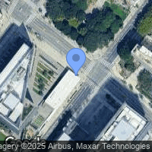
Tower Name: Tower B
Address: 456 Oak St, Fresno, CA
Latitude: 36.7783
Longitude: -119.4179
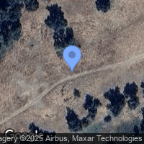
Tower Name: Tower C
Address: 789 Broadway, New York, NY
Latitude: 40.7128
Longitude: -74.006
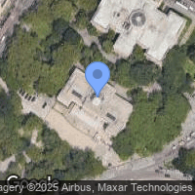
Tower Name: Tower D
Address: 101 Ocean Dr, Miami, FL
Latitude: 25.7617
Longitude: -80.1918
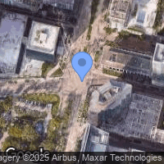
Tower Name: Tower E
Address: 202 Lake Shore Dr, Chicago, IL
Latitude: 41.8781
Longitude: -87.6298
