**Challenge #1**

A 3-tier environment is a common setup. Use a tool of your choosing/familiarity create these resources on a cloud environment (Azure/AWS/GCP). Please remember we will not be judged on the outcome but more focusing on the approach, style and reproducibility.

**Solutions 1:**

*To create a 3-tier environment on Azure, we are using Azure CLI, which is a command-line tool that we can use to manage Azure resources. The Azure CLI is available on Windows, macOS, and Linux, and it can be installed using the following command:*

***# Install the Azure CLI on Windows***

*Invoke-WebRequest -Uri https://aka.ms/installazurecliwindows -OutFile .\AzureCLI.msi; Start-Process msiexec.exe -Wait -ArgumentList '/I AzureCLI.msi /quiet'; rm .\AzureCLI.msi*

*To create a 3-tier environment on Azure, we will need to create the following resources:*

***A resource group:*** *A resource group is a logical container for Azure resources. We can create a resource group using the az group create command.*

***A virtual network:*** *A virtual network is a logical network in Azure that we can use to connect your resources. We can create a virtual network using the az network vnet create command.*

***Subnets****: Subnets are segments of a virtual network that you can use to isolate resources. We can create subnets using the az network vnet subnet create command.*

***Network security groups:*** *Network security groups are used to control inbound and outbound traffic to resources in a virtual network. We can create network security groups using the az network nsg create command.*

***Virtual machines:*** *Virtual machines are the compute resources in a 3-tier environment. We can create virtual machines using the az vm create command.*

***# Create a resource group***

*az group create --name my-resource-group --location eastus*

***# Create a virtual network***

*az network vnet create --name my-vnet --resource-group my-resource-group --address-prefixes 10.0.0.0/16*

***# Create subnets***

*az network vnet subnet create --name my-subnet-1 --resource-group my-resource-group --vnet-name my-vnet --address-prefix 10.0.0.0/24*

*az network vnet subnet create --name my-subnet-2 --resource-group my-resource-group --vnet-name my-vnet --address-prefix 10.0.1.0/24*

***# Create network security groups***

*az network nsg create --name my-nsg-1 --resource-group my-resource-group*

*az network nsg create --name my-nsg-2 --resource-group my-resource-group*

***# Create virtual machines***

*az vm create --name my-vm-1 --resource-group my-resource-group --vnet-name my-vnet --subnet my-subnet-1 --nsg my-nsg-1 --image UbuntuLTS --admin-username azureuser --generate-ssh-keys*

*az vm create --name my-vm-2 --resource-group my-resource-group --vnet-name my-vnet --subnet my-subnet-2 --nsg my-nsg-2 --image UbuntuLTS --admin-username azureuser –*

***Solution 2:***

***Terraform Installation:***

1. First, I downloaded terraform for my local system from the website (<https://developer.hashicorp.com/terraform/downloads?product_intent=terraform>)
2. Select windows - Version: 1.3.6
3. Extract the file and create a folder on C drive with the name Terraform, pasted the terraform.exe into C:\Terraform
4. Configure the system environment variable

* Search the System Environment variable
* 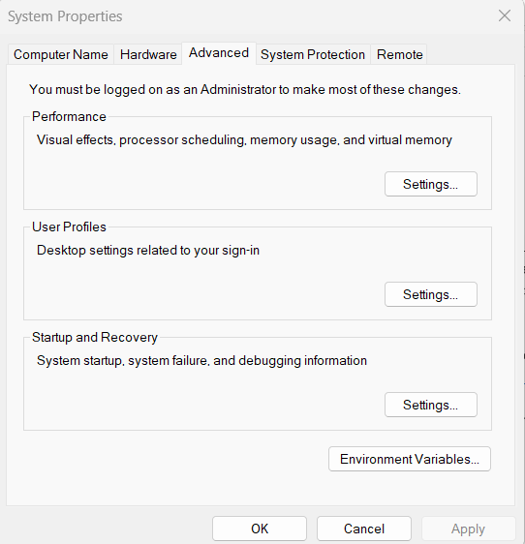
* Click on the Environment variable
* Edit Path for User Variable and Add the System variable

***Code Development in the Visual Studio Code:***

1. ***Downloaded the Extensions – Terraform, Hashicorp Terraform, Azure Account, Azure***

***Resource Manager, Azure Resources***

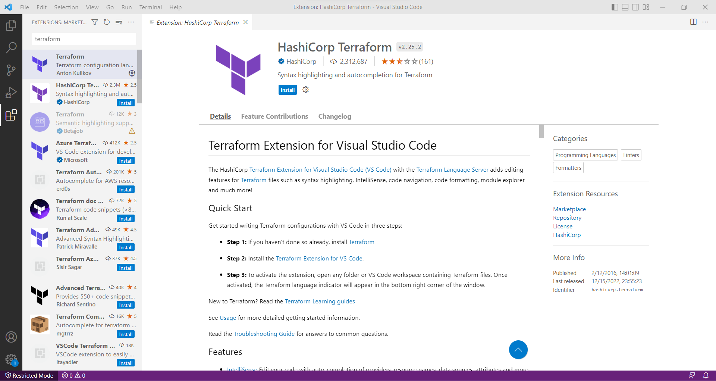

1. ***Downloaded the GIT (***[Git - Downloading Package (git-scm.com)](https://git-scm.com/download/win))
2. ***Setup up Connectivity to Azure (Services Principal Needs to be created)***

* *Az Login*
* *Az Account Set –Subscription (Subscription Detail)*
* *Az login services principal (Username, Password & Tenant ID)*
* *CD Terraform*

*To create a 3-tier environment on Azure using Terraform, we will need to define the following resources:*

*A resource group: We can define a resource group using the azurerm_resource_group resource.*

*A virtual network: We can define a virtual network using the azurerm_virtual_network resource.*

*Subnets: We can define subnets using the azurerm_subnet resource.*

*Network security groups: We can define network security groups using the azurerm_network_security_group resource.*

*Virtual machines: We can define virtual machines using the azurerm_virtual_machine resource.*

***3-tier environment on Azure using Terraform:***

***# Configure the Azure provider***

*provider "azurerm" {*

*version = "2.36.0"*

*}*

***# Create a resource group***

*resource "azurerm_resource_group" "my-resource-group" {*

*name = "my-resource-group"*

*location = "eastus"*

*}*

***# Create a virtual network***

*resource "azurerm_virtual_network" "my-vnet" {*

*name = "my-vnet"*

*resource_group_name = azurerm_resource_group.my-resource-group.name*

*address_space = ["10.0.0.0/16"]*

*}*

***# Create subnets***

*resource "azurerm_subnet" "my-subnet-1" {*

*name = "my-subnet-1"*

*resource_group_name = azurerm_resource_group.my-resource-group.name*

*virtual_network_name = azurerm_virtual_network.my-vnet.name*

*address_prefix = "10.0.0.0/24"*

*}*

*resource "azurerm_subnet" "my-subnet-2" {*

*name = "my-subnet-2"*

*resource_group_name = azurerm_resource_group.my-resource-group.name*

*virtual_network_name = azurerm_virtual_network.my-vnet.name*

*address_prefix = "10.0.1.0/24"*

*}*

***# Create network security groups***

*resource "azurerm_network_security_group" "my-nsg-1" {*

*name = "my-nsg-1"*

*resource_group_name = azurerm_resource_group.my-resource-group.name*

*}*

*resource "azurerm_network_security_group" "my-nsg-2" {*

*name = "my-nsg-2"*

*resource_group_name = azurerm_resource_group.my-resource-group.name*

*}*

***# Create virtual machines***

*resource "azurerm_virtual_machine" "my-vm-1" {*

*name = "my-vm-1"*

*resource_group_name = azurerm_resource_group.my-resource-group.name*

*location = azurerm_resource_group.my-resource-group.location*

*network_interface_ids = [azurerm_network_interface.*

*Challenge #2*

*We need to write code that will query the meta data of an instance within AWS or Azure or GCP*

*and provide a json formatted output.*

*The choice of language and implementation is up to you.*

1. *Library will be azure-sdk-for-python*
2. *pip install azure-sdk-for-python*

*import json*

*from azure.mgmt.compute import ComputeManagementClient*

*from azure.common.credentials import ServicePrincipalCredentials*

***# Create a compute management client***

*credentials = ServicePrincipalCredentials(*

*client_id='your-client-id',*

*secret='your-client-secret',*

*tenant='your-tenant-id'*

*)*

*client = ComputeManagementClient(credentials, 'your-subscription-id')*

***# Call the virtual_machines method to get the metadata of the instance***

*vm = client.virtual_machines.get('your-resource-group', 'your-vm-name')*

***# Print the metadata in JSON format***

*print(json.dumps(vm.as_dict(), indent=2))*

3.We have a nested object. We would like a function where you pass in the object and a key and

*get back the value.*

*Example Inputs*

*object = {“a”:{“b”:{“c”:”d”}}}*

*key = a/b/c*

*object = {“x”:{“y”:{“z”:”a”}}}*

*key = x/y/z*

*value = a*

*Answer:*

def exam_get_value(obj, key):

keys = key.split('/')

for k in keys:

if k in obj:

obj = obj[k]

else:

return None

return obj

obj1 = {'a': {'b': {'c': 'd'}}}

key1 = 'a/b/c'

print(exam_get_value(obj1, key1))

obj2 = {'x': {'y': {'z': 'a'}}}

key2 = 'x/y/z'

print(exam_get_value(obj2, key2))