https://github.com/ana029/Cryptography_Midtherm_Projects.git
Task 1A: Encrypt a file using AES-128-CBC
1. Create a text file: secret.txt with the line: This file contains top secret information.
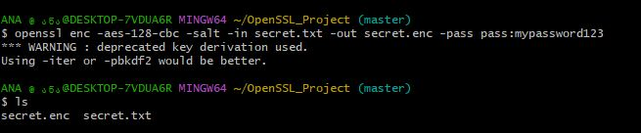
Command: echo "This file contains top secret information." > secret.txt

2. Use OpenSSL to encrypt it with a passphrase of your choice.
3. Save the encrypted file as secret.enc.
Command: openssl enc -aes-128-cbc -salt -in secret.txt -out secret.enc -pass pass:mypassword123
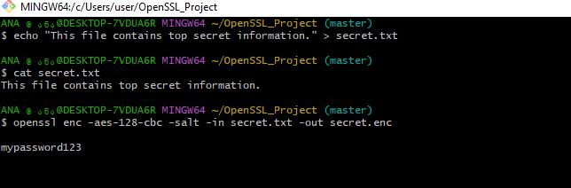

Task 1B: Decrypt secret.enc
1. Decrypt the file.
Command: openssl enc -aes-128-cbc -d -in secret.enc -out decrypted.txt -pass pass:mypassword123
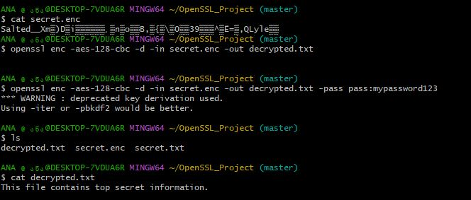

2. Show that it matches the original.
Command:
- diff secret.txt decrypted.txt && echo "Match" || echo "Different" Match

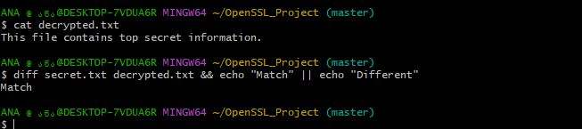

Insert screenshots showing the results of each OpenSSL command executed in Git Bash.
You can also find a Python file in the GitHub repository that performs the given task as well.

Task 2A: Generate ECC keys (1.5 pts)
1. Use the prime256v1 curve.
2. Save private and public keys.
Step 1. create the message file
- echo "Elliptic Curves are efficient." > ecc.txt
- cat ecc.txt
step 2. generate private key (prime256v1)
- openssl ecparam -name prime256v1 -genkey -noout -out ecc_private.pem
step 3. Extract the corresponding public key:
- openssl ec -in ecc_private.pem -pubout -out ecc_public.pem
step 4: protect private key file (optional but good)
- chmod 600 ecc_private.pem
- ls -l ecc_private.pem ecc_public.pem

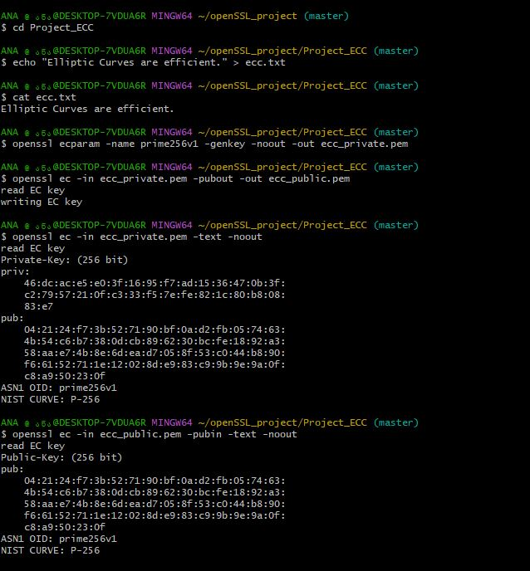

Task 2B: Sign and verify a message (3 pts)
1. Create ecc.txt with Elliptic Curves are efficient.
2. Sign it with your private key.
3. Verify it using your public key.
Step 5: sign the message (binary signature)
- openssl dgst -sha256 -sign ecc_private.pem -out ecc.sig ecc.txt
- ls -l ecc.sig
step 6: verify the signature
- openssl dgst -sha256 -verify ecc_public.pem -signature ecc.sig ecc.txt
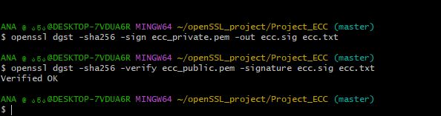

Task 3A: SHA-256 Hash (2 pts)
1. Create data.txt with: Never trust, always verify.
2. Hash it using Python or CLI.
3. Submit hash output and code/command.
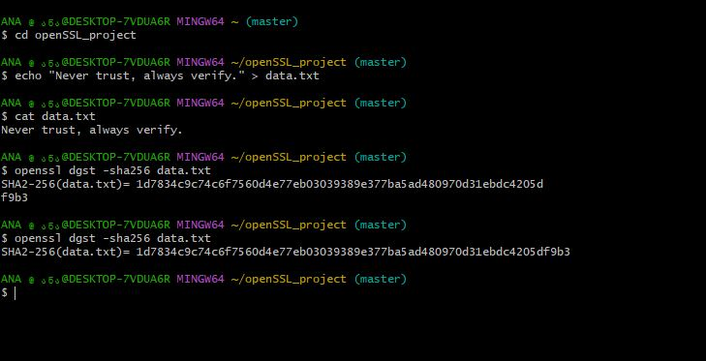
Task 3B: HMAC using SHA-256 (2 pts)
1. Use the key: secretkey123
2. Create an HMAC for data.txt.
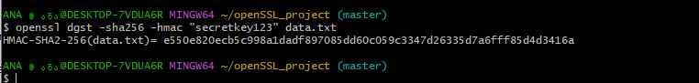
Task 3C: Integrity Check (2 pts)
1. Change one letter in data.txt.
2. Recompute HMAC. 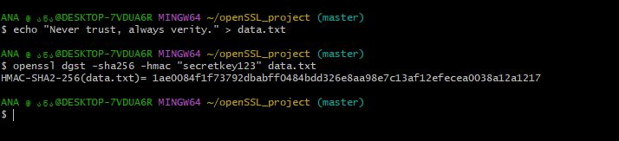

3. Explain what happens and why HMAC is important.
When one letter in the file was changed, the recomputed HMAC became completely different from the original HMAC. This demonstrates that even a small change in the file is immediately detectable.
HMAC is important because it provides data integrity and authenticity. It ensures that the data has not been modified and that it comes from a trusted source (using the secret key). If the HMACs match, the data is verified; if they differ, it signals that the file was altered or tampered with.

The task also was fully completed using Python, and the code is provided below.
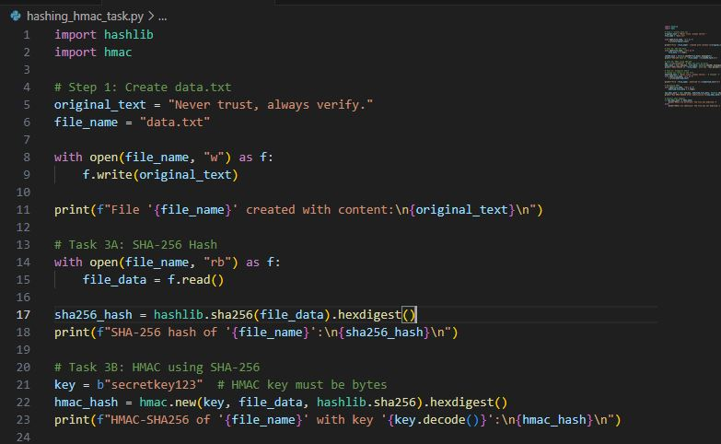
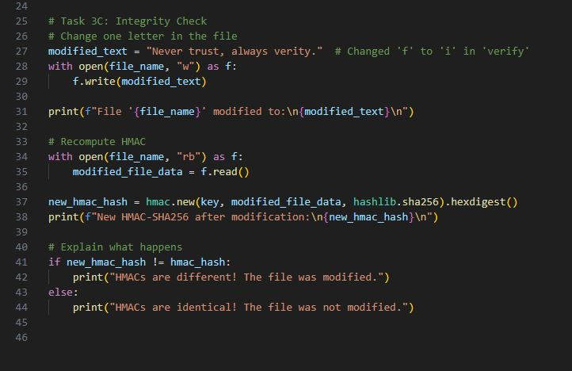
The results obtained after running the code:
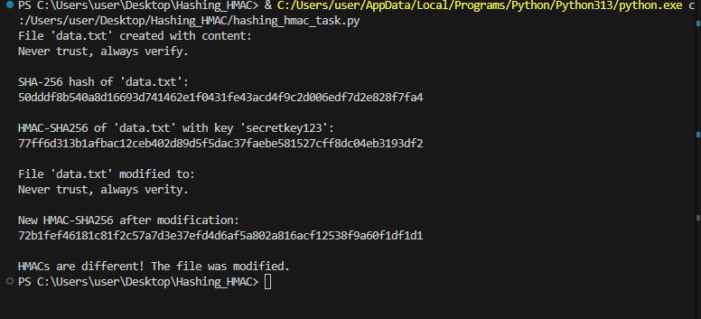

Task 4A: Simulate DH Key Exchange (2 pts)
1. Use Python or OpenSSL CLI to simulate the Diffie-Hellman key exchange between Alice and Bob.
2. Show the following: ○ Alice’s public key
○ Bob’s public key
○ Shared secret key derived by both
3. Ensure that both shared keys are identical.

Python code: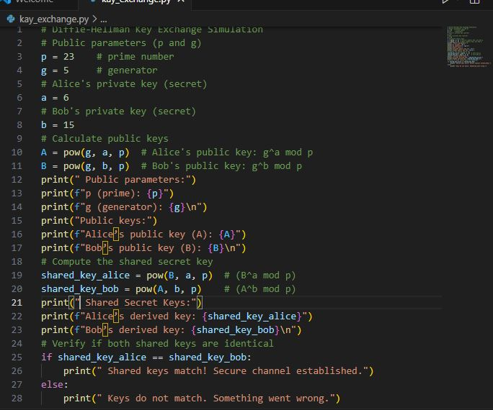
Results:
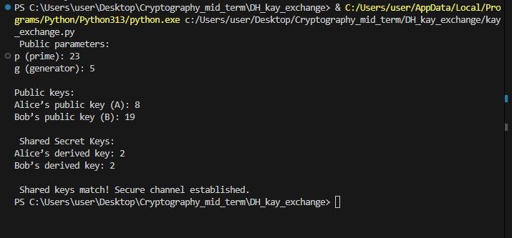
Task 4B: Real-Life Application (2.5 pts)
1. In a short paragraph, explain where Diffie-Hellman is used in practice, such as: ○ TLS handshake
○ Secure messaging (e.g., Signal Protocol)
Diffie-Hellman key exchange is widely used in modern secure communication protocols such as TLS (used in HTTPS websites) and secure messaging apps like Signal and WhatsApp. One common example is the TLS handshake, which is part of the HTTPS protocol used to secure websites. During a TLS handshake, Diffie-Hellman (or its elliptic-curve version, ECDH) allows the client and server to establish a shared secret key that is later used for encrypting data exchanged between them.
It is also used in secure messaging applications such as the Signal Protocol, which powers apps like WhatsApp and Signal. In these systems, Diffie-Hellman enables end-to-end encryption, ensuring that only the sender and receiver can read the messages — even the service provider cannot.

2. Mention why it’s important for secure communication.
The Diffie-Hellman algorithm is important because it allows two parties to securely create a shared encryption key over an insecure network, without ever transmitting the key itself.
Even if an attacker intercepts all messages exchanged during the key setup, they cannot compute the secret key. This property ensures confidentiality, integrity, and protection against eavesdropping, forming the foundation of most modern cryptographic protocols.

