Re-take project for numerical programming
Ana Balukhashvili
17.02.2026

Task 1 — Single Robot Path Following (IVP + RK4)
Objective:
The goal of Task 1 is to simulate a single robot navigating along a predefined path on a 2D map image. The robot must move smoothly from a start point $A$to a target point $B$, following the road centerline, while respecting speed limits and staying within road boundaries. This task demonstrates how continuous-time robot dynamics (an initial value problem, IVP) can be solved numerically using the classical fourth-order Runge–Kutta (RK4) method, and how image processing can be used to extract navigable paths from real map images.
Methodology:
- Image Processing Pipeline
  - Input: A map image (e.g., PNG or JPG) where the road/path is visually distinct from the background.
  - Grayscale Conversion: The RGB image is converted to grayscale using the standard luminance formula to simplify intensity analysis.
  - Gaussian Blur: A Gaussian filter is applied to smooth noise and reduce small artifacts.
  - Otsu Thresholding (Inverted): An automatic threshold is computed to segment the road from the background. Because the road is lighter than the surrounding areas, pixels brighter than the threshold are considered part of the road.
  - Skeletonization: The segmented road is reduced to its medial axis using Zhang–Suen skeletonization. This creates a one-pixel-wide representation of the road centerline, which serves as a graph for path extraction.
- Path Extraction
  - Interactive Selection of Points A and B: The user selects the start and end points on the map. These points are snapped to the nearest skeleton pixels to ensure they lie on the road centerline.
  - Graph Construction: An 8-connected adjacency graph is built from the skeleton pixels, where each pixel is a node connected to its immediate neighbors.
  - Shortest Path Search: A Breadth-First Search (BFS) algorithm finds the shortest path along the skeleton from $A$to $B$. The resulting discrete path points are then decimated and fitted with an arc-length parametrized cubic spline. This spline provides a smooth, continuous trajectory suitable for robot control and simulation.
- Robot Dynamics
  - State Representation: The robot state is defined as $\left[x , y , v_{x} , v_{y}\right]$, combining 2D position and velocity.
  - Governing Equations:
$$\dot{x}=v_{\text{sat}}(v),\dot{v}=\frac{1}{m}[K_{P}(T(t)-x)-K_{D}v+f_{\text{bound}}]$$
    - $v_{\text{sat}}$is the velocity with saturation applied to respect the maximum speed $V_{\text{max}}$.
    - $K_{P}$and $K_{D}$are proportional and damping gains for PD control towards the target.
    - $f_{\text{bound}}$is a soft lateral restoring force that keeps the robot within road boundaries.
    - $T(t)$is a moving target along the spline, representing the desired position as a function of time.
  - Numerical Integration: The IVP is solved using the classical RK4 method with a fixed timestep $Δt$. RK4 provides high accuracy ($O(Δt^{4})$) and stability for the chosen parameters.
- Visualization and Animation
  - The robot trajectory, road boundaries, and spline are plotted for verification.
  - An animated GIF shows the robot moving from start to goal along the extracted path, with the trace, speed, and position dynamically updated.
  - Metrics such as position error, speed, and lateral deviation are also plotted to evaluate performance.
Screenshots of how it works:
example where the code works perfectly:
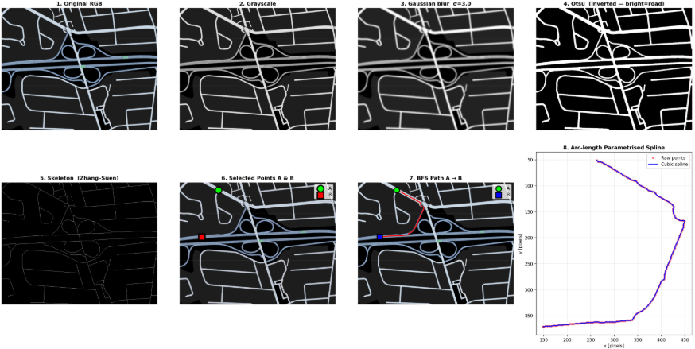
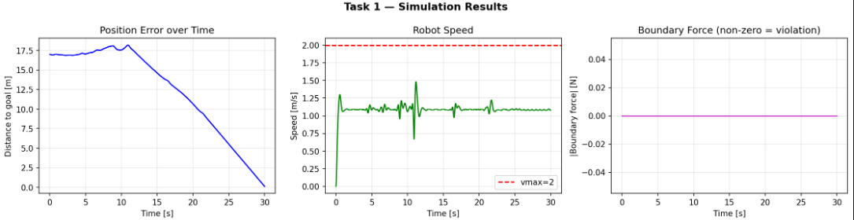
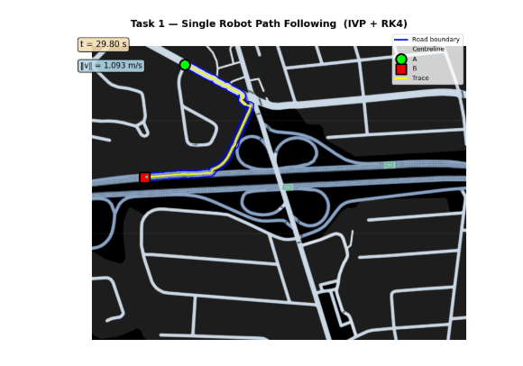
Failure Case:
The primary failure occurs when the map background is lighter than the road. Because the segmentation step relies on brightness (pixels brighter than the threshold are considered part of the road), the algorithm can misinterpret the background as the road. This results in:
- Skeletonization extracting incorrect paths.
- BFS failing to find a path between the selected points A and B.
- Overall simulation failure, since the robot has no valid trajectory to follow.
Example:
If a map has a white or light gray background and dark roads, the inverted Otsu threshold mislabels the background as navigable area. The system then cannot generate a valid skeleton or path, leading to failure
Example where it fails:
I use this map -
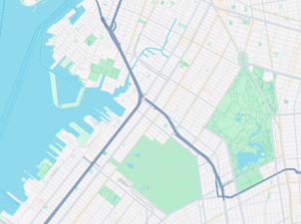
And after running the code the output says that the path doesn’t exist between A and B, since it has light background the robot thinks that is path and that is the reason if fails.
Conclusion:
Task 1 successfully demonstrates a combination of computer vision, graph theory, and numerical simulation to guide a robot along a map-defined path. While robust for standard maps with light roads on dark backgrounds, the method is sensitive to the intensity polarity of the input image. Addressing this limitation would require adaptive thresholding or color-based segmentation to handle diverse map styles

Task 2 — Bidirectional Swarm Navigation
Objective:
The goal of Task 2 is to simulate the movement of a swarm of robots along a defined path in a constrained environment, ensuring collision avoidance between robots and adherence to road boundaries while traveling back and forth between two points.
1. Input and Image Processing
- Map Input:
The system takes a map image (map1.png) as input, representing the environment. The roads are distinguished by their brightness.
- Grayscale Conversion:
The RGB image is converted to grayscale using standard luminance weighting:
$\text{gray}=0.299R+0.587G+0.114B$.
- Gaussian Smoothing:
A Gaussian filter with a standard deviation (BLUR_SIGMA) is applied to reduce noise and smooth the image.
- Otsu Thresholding:
The smoothed grayscale image is thresholded using Otsu’s method to segment the path from the background. Bright pixels are treated as the navigable path.
- Skeletonization:
The binary path image is reduced to a single-pixel wide skeleton, representing the centerline of the path, which will be used for navigation.
- Start and End Selection:
The user selects points A (start) and B (end) on the map. The system snaps these points to the closest pixel on the skeleton to ensure alignment with the navigable path.
2. Path Planning
- Graph Construction:
Each skeleton pixel is treated as a node in a graph, with edges connecting adjacent pixels. This allows efficient traversal across the path.
- BFS Pathfinding:
A Breadth-First Search (BFS) is used to find a discrete path between A and B along the skeleton nodes.
- Path Smoothing (Spline):
The BFS path is converted to a cubic spline, producing a smooth, continuous trajectory suitable for robot motion.
The spline also calculates tangents and normals, which are used for boundary forces and lateral error computations.
3. Robot Dynamics and Swarm Simulation
- Robot Model:
  - Each robot has mass M, a maximum velocity VMAX, and radius ROBOT_R.
  - Robot motion is governed by Proportional-Derivative (PD) control to track the spline centerline:
$$F=K_{P}(target-position)-K_{D}⋅velocity$$
- Inter-Robot Repulsion:
  - Robots repel each other if they come within a safety radius (RSAFE) to prevent collisions.
  - Repulsion force decays with distance (inverse cubic law).
- Boundary Forces:
  - If a robot moves outside the safe corridor (±half road width minus robot radius), a stiff virtual wall force pushes it back toward the center.
- Time Integration:
  - Robot positions and velocities are updated using RK4 (Runge-Kutta 4th order) integration with timestep DT.
  - The simulation allows bidirectional motion: half the robots move from A→B, the other half from B→A, then reverse after completing the first leg.
4. Metrics and Visualization
- Collision Metrics:
  - Minimum inter-robot distance is tracked over time.
  - Boundary violations (robots leaving the road) are counted.
  - These metrics are plotted for analysis (task2_metrics.png).
- Animation:
  - The robot swarm is visualized on the original map.
  - Trails show robot paths, colors distinguish direction, and labels mark points A and B.
  - The animation is saved as task2_swarm.gif.
- Pipeline Visualization:
  - Shows original image → thresholded binary → skeleton → BFS path → spline.
  - Saved as task2_pipeline.png.
Screenshot of visualization how it is working:
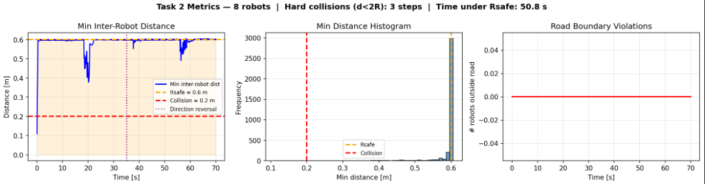
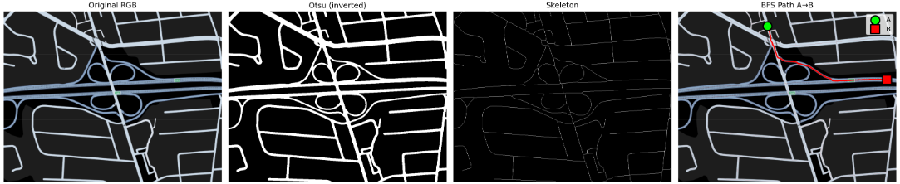
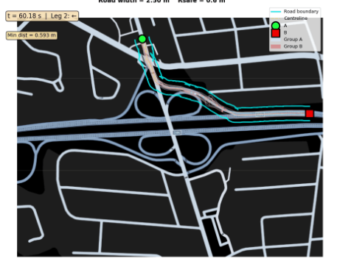
5. Fail Case
- The simulation assumes that the road is brighter than the background.
- If the input map has a light background (e.g., white) and darker roads, the Otsu thresholding incorrectly identifies the background as the road.
- In such cases:
  - Skeletonization produces a disconnected or empty path.
  - BFS fails to find a path from A to B.
  - As a result, the simulation cannot initialize and exits with an error:
"ERROR: No path found between A and B."


Conclusion:
Task 2 demonstrates how image processing, graph search, spline interpolation, and physics-based swarm dynamics can be combined to simulate a safe, coordinated swarm of robots in a constrained environment. Its limitation is the dependency on proper image contrast for correct path extraction.

Task 3 — Robot Navigation in a Pedestrian Flow
Objective:
The goal of Task 3 is to simulate a robot navigating through a dynamic environment populated by pedestrians. The robot must move from a start point to a target point while avoiding collisions with humans, using real-time pedestrian detection from a video. This task demonstrates how vision-based dynamic obstacle detection can be combined with repulsive-force navigation to achieve safe path planning in crowded environments.
Methodology:
- Video Processing and Pedestrian Detection
  - Input: A video capturing pedestrians walking (e.g., gettyimages-1944915243-640_adpp.mp4).
  - Background Subtraction: A running Gaussian Mixture Model (MOG2) is applied to segment moving objects (pedestrians) from the static background.
  - Foreground Filtering: The foreground mask is refined using median filtering, thresholding, and morphological opening to reduce noise.
  - Contour Detection: Each detected pedestrian is approximated by a circular region based on the contour’s minimal enclosing circle.
  - Zones for Repulsion: Each pedestrian’s location and radius define a “repulsive zone” for collision avoidance.
- Robot Dynamics and Control
  - State Representation: The robot state is defined as $\left[x , y , v_{x} , v_{y}\right]$, with 2D position and velocity.
  - Forces Acting on the Robot:
    - Attractive Force: A proportional force pulls the robot toward the target.
    - Damping Force: A velocity-dependent term prevents overshoot and smooths motion.
    - Repulsive Force: Each detected pedestrian applies a repulsive force inversely proportional to the cube of the distance when the robot is within a safety radius ($r_{\text{safe}}$).
  - Numerical Integration: The robot trajectory is updated at each frame using Euler integration with a fixed timestep derived from the video frame rate.
  - Velocity Saturation: The robot’s speed is capped to prevent unrealistic movement and ensure smooth motion.
- Simulation and Visualization
  - The robot trajectory is simulated from start → goal and goal → start to evaluate bidirectional navigation.
  - For each frame:
    - Pedestrian positions are detected.
    - The robot’s position, velocity, and minimum distance to pedestrians are updated.
  - Outputs:
    - Animated GIFs (task3_AtoB.gif, task3_BtoA.gif) showing robot motion over the video background.
    - Metrics plot (task3_metrics.png) showing speed over time and minimum effective distance to pedestrians.
Representation of how it works, screenshots:
Path from A to B
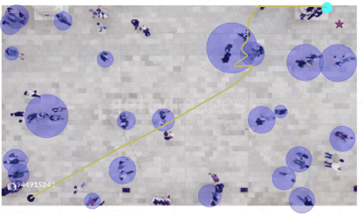
Path from B to A
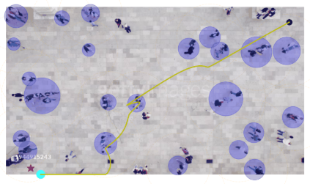

Failure Case:
The primary limitation of this approach arises when pedestrians are stationary or not moving. The system relies on motion-based detection (background subtraction) to locate humans. If a pedestrian is standing still, the algorithm does not detect them as a dynamic object, resulting in:
- The robot being unaware of the stationary human.
- Potential collisions or “walking over” the human in the simulation.
This highlights that motion-based detection alone is insufficient in scenarios with static obstacles. Incorporating static object detection (e.g., person detection using object detectors) would be necessary to address this limitation.
Representation screenshot:
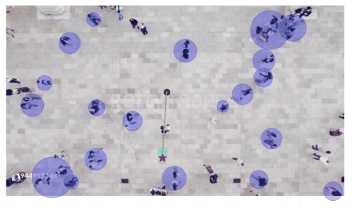
In this case the robot walked over human because human wasn’t walking and he/she wasn’t detected so robot couldn’t see and thought that was path to go.

Conclusion:
Task 3 demonstrates dynamic obstacle avoidance in a visually rich environment. It combines real-time pedestrian detection, repulsive-force navigation, and trajectory simulation to safely guide a robot. While effective in crowded, moving environments, the approach fails when humans are stationary, emphasizing the need for hybrid detection methods for fully reliable navigation.

