Programming Lab 3

Assignment 08

Operations on MongoDB

Name : [Shantanu kantak](mailto:kantakshantanu20@gmail.com)

PRN : 21510001

Batch : T-8

Problem Statement 01:

Create Database collection and do the following operations:

o Group by a Single Field in MongoDB.

o Group by Multiple Fields in MongoDB

o Group by the Multiple Expressions

o Group by the Conditional Statements in MongoDB

o Group by a Nested Field in MongoDB

Ans :

Commands given to Mongosh:

1]use Student

2]db.createCollection(“student”)

3]db.insertMany([{ id:1,firstname:”Candice”

])Insert command.

Operations:

1]Group by single field:

Command:

db.student.aggregate([

{

$group: {

_id: "$age",

averageExamMarks: { $avg: "$examMarks" }

}

}

])

Output:

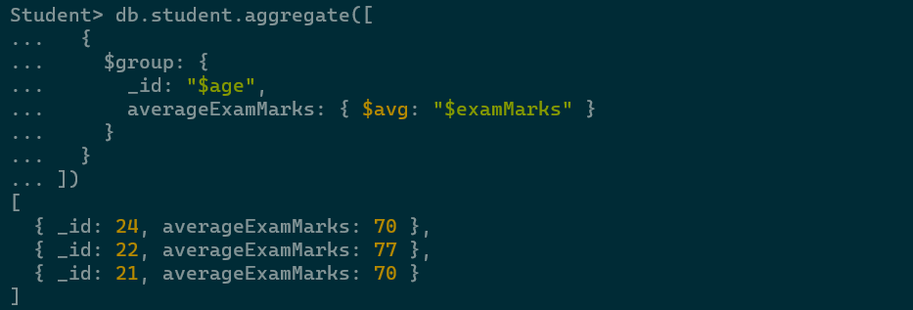

1]Group by multiple fields:

Command:

db.student.aggregate([

{

$group: {

_id: { firstName: "$firstName", lastName: "$lastName" },

count: { $sum: 1 }

}

}

])db.student.aggregate([

{

$group: {

_id: "$age",

averageExamMarks: { $avg: "$examMarks" }

}

}

])

Output:

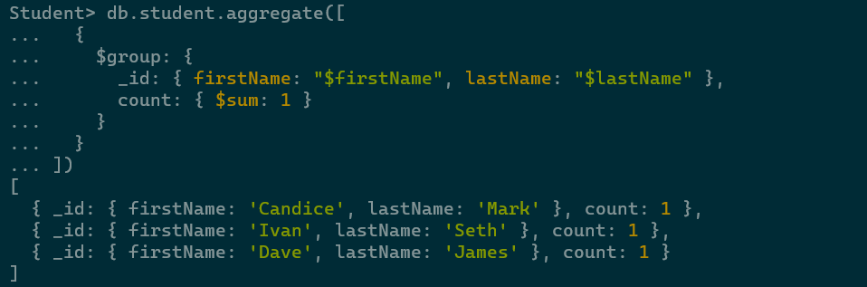

1]Group by Multiple Expressions:

Command:

db.student.aggregate([

{

$group: {

_id: { project: "$projectMarks", assignment: "$assignmentMarks" },

count: { $sum: 1 }

}

}

])db.student.aggregate([

{

$group: {

_id: "$age

",

averageExamMarks: { $avg: "$examMarks" }

}

}

])

Output:

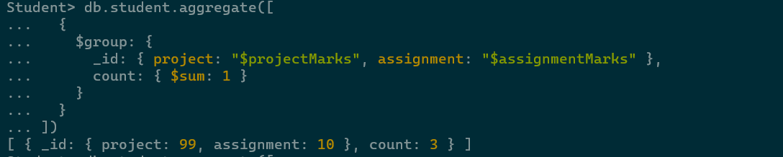

1]Group by conditional statements:

Command:

db.student.aggregate([

{

$group: {

_id: {

$cond: {

if: { $lt: ["$age", 18] },

then: "Under 18",

else: { $cond: { if: { $lte: ["$age", 25] }, then: "18-25", else: "Over 25" } }

}

},

averageProjectMarks: { $avg: "$projectMarks" }

}

}

])db.student.aggregate([

{

$group: {

_id: "$age",

averageExamMarks: { $avg: "$examMarks" }

}

}

])

Output:

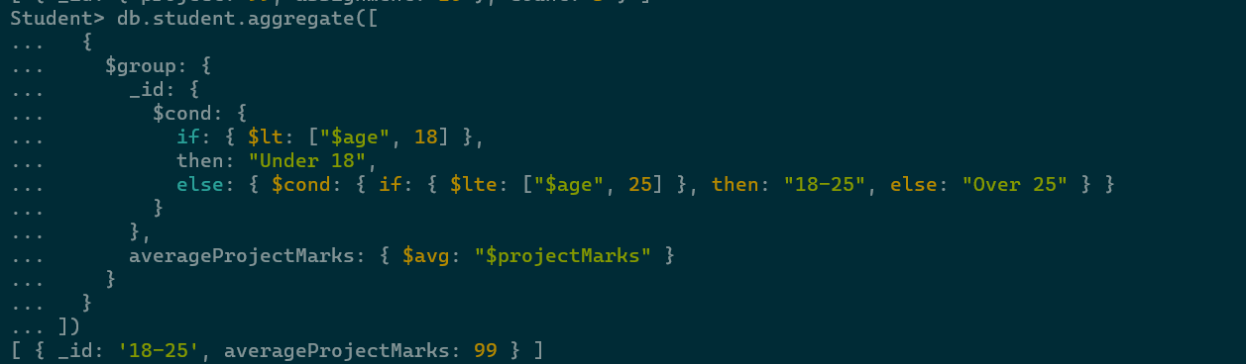

1]Group by Nested field:

Command:

db.student.aggregate([

{

$group: {

_id: "$projectMarks.subject",

averageExamMarks: { $avg: "$examMarks" }

}

}

])

Output:

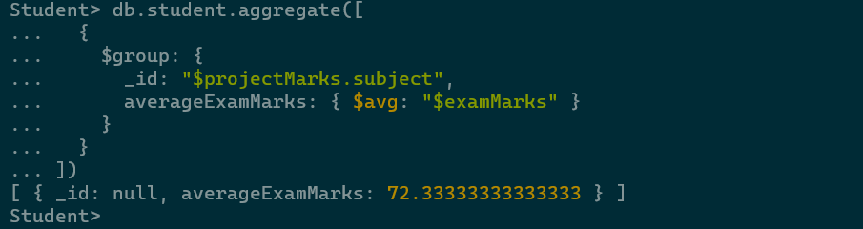

End of Assignment…