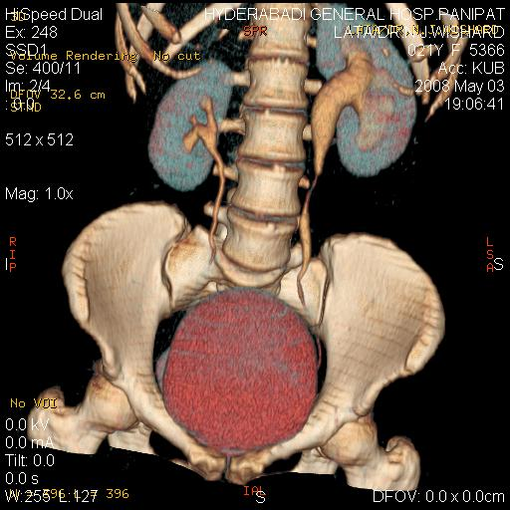

IMAGING THE IMAGINATION

DEAR FRIENDS,

- Hyderabadi General Hospital Feels proud to intimate all concerned that
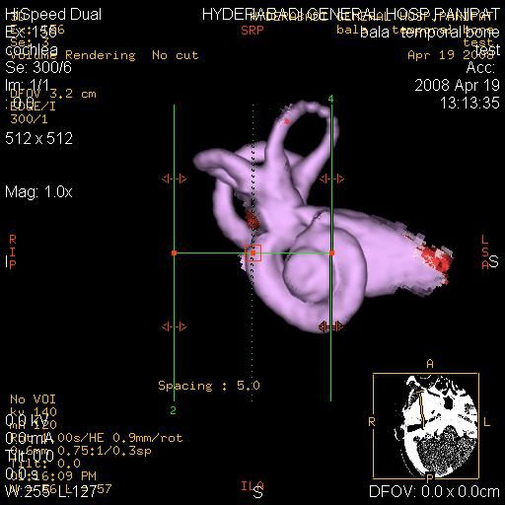
- the hospital has installed State of art multislice subsecond/ submilli-meter GE CT scan machine for the first time in this region .THIS MACHINE IS EQUIPPED WITH ALL LATEST SOFTWARE WITH 3D VOLUME RENDERING CAPABLE OF PERFO-RMING PERIPHERAL /CEREBRAL ANGIOGRAPHY, VIRTUAL ENDOSCOPY, CT UROGRAPHY, LIFE LIKE ORTHOPAEDIC SCANS WITH 3D
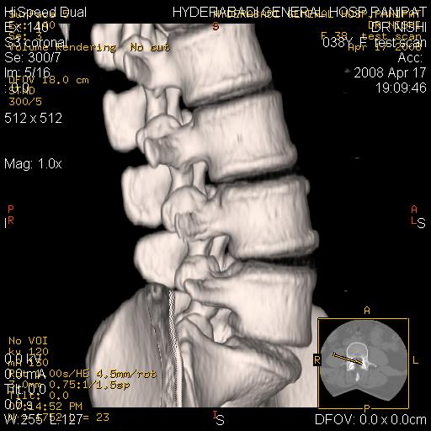

- REFORMATIONS . IT IS GOING TO BE A BOON FOR PATI-ENTS AND CONCERNED DOCTORS .FREE AMBULANCE SERVICE WOULD BE PROVIDED FOR THE PATIENT .ALL INTRESTED DOCTORS ARE WELCOME TO VISIT CT SCAN ROOM AND DISCUSS IN DETAILS benefit FOR THEIR FIELD. FOR THEIR FIELD. A CME IS BEING ORGANISED ON 25TH MAY WITH DISTUINGSHED GUEST SPEAKERS FROM DELH I FOLLOWED BY COCKTAIL & DINNER .ALL ARE CORDIALLY INVITED AND GRACE THE OCCASION.
- date/time: 25th may(sunday) 7:30 sharp
- topics: role of ultrasound in reducing perinatal mortality &
MORBIDITY (dr ashok khurana)
- (practical tips) ultrasound in infertilty (col dr r.k sharma)
- multislice ct a new approach (dr rakesh vohra)

regards .dr rahul gera
consultant radiologist
hyderabadi general hospital panipat

