Popularity and Obsolescence

In the age of Moore’s Law (Gone Wild)

Anagha Uppal

January 16, 2019

*How is the pace of technology influencing how we utilize the public library?*

**Moore’s law** states that the number of transistors in an integrated circuit is expected to double every two years. This represents the power of a computer – the greater the number of transistors, the greater the processing speeds, memory capacity, etc. Computing is faster, cheaper, better, smaller. Today, that rate of doubling has increased to a timespan of only one and a half years.

(Siegel, University of Missouri – St. Louis)

At the Seattle Public Library, **what has been the change in use of various media formats over time** with the rapid advancement of technology?

To explore this, we browsed the checkouts from 2006-2018 to find some patterns in our data.

The following was the initial SQL query used:

(Note we excluded 2019 from our query. Because the entire data for 2019 is not yet produced and not yet available, it would significantly influence any visualization we made using the count totals.)

SELECT YEAR(cout), itemtype, count(id)

FROM spl_2016.outraw

WHERE YEAR(cout) < '2019'

GROUP BY YEAR(cout), itemtype

This gives us an exportable file that of 604 rows of data that looks like this:

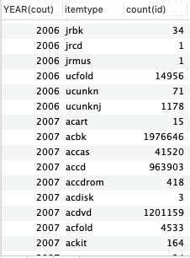

Because there are many subdivided itemtypes for the same or similar medium (e.g. Adult/YA, Reference Adult/YA, No Fine, Juvenile Circulating and Reference Juvenile all for DVDs), I decided to narrow my focus to Adult subtype of all media.

In order to ask more questions, I first had to perform a quick visualization of the data.

I could have used SQL to produce a few tables like this:

SELECT YEAR(cout), itemtype, count(id)

FROM spl_2016.outraw

WHERE YEAR(cout) < '2019' AND itemtype = “accas”

GROUP BY YEAR(cout), itemtype

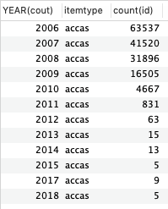

However, because I planned to use R to produce a few line graphs, it made more sense to create these tables in R:

dat<-read.csv("combined_fin.csv",head=T,col.names=c("Year", "itemtype","Count"))

aat <- dat[dat$itemtype == "accas",c("Year","Count")]

acbk <- dat[dat$itemtype == "acbk",c("Year","Count")]

acdvd <- dat[dat$itemtype == "acdvd",c("Year","Count")]

acvhs <- dat[dat$itemtype == "acvhs",c("Year","Count")]

accdrom <- dat[dat$itemtype == "accdrom",c("Year","Count")]

acper <- dat[dat$itemtype == "acper",c("Year","Count")]

par(mfrow=c(2,3))

plot(Count~Year, aat,main="Adult Audiotape Use", xlab="Year",ylab="Number of Checkouts",pch=19,cex=1.5,col="royalblue1")

plot(Count~Year, acbk,main="Adult Book Use", xlab="Year",ylab="Number of Checkouts",pch=19,cex=1.5,col="orangered1")

plot(Count~Year, acdvd,main="Adult DVD Use", xlab="Year",ylab="Number of Checkouts",pch=19,cex=1.5,col="green4")

plot(Count~Year, acvhs,main="Adult VHS Use", xlab="Year",ylab="Number of Checkouts",pch=19,cex=1.5,col="gray20")

plot(Count~Year, accdrom,main="Adult CD-ROM Use", xlab="Year",ylab="Number of Checkouts",pch=19,cex=1.5,col="violetred3")

plot(Count~Year, acper,main="Adult Magazine Use", xlab="Year",ylab="Number of Checkouts",pch=19,cex=1.5,col="burlywood4")

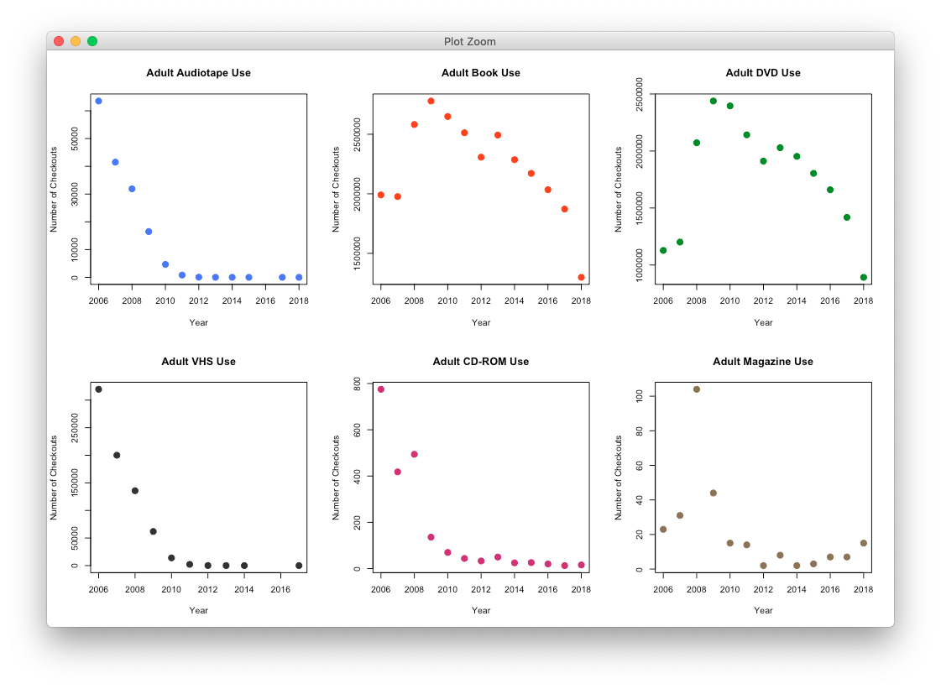

Some of these graphs are unsurprising; others are quite interesting. People no longer like to listen to audiotapes and watch VHS tapes. Their use steadily decreased to almost 0 in 2010. Around the same time, in the years between 2007 and 2009, one had begun to see sharp spikes in both book and DVD usage. The pattern with books and DVDs look almost identical! Suddenly, in 2009, the rate of both dropped – and has continued to drop.

CD-ROMs and magazines are less straightforward to describe or explain. Overall, CDs act like audiotapes and VHS, although there was a slight uptick in 2008. The real uptick, however, we see in magazine check-outs in 2008 – almost 120% more than 2007 levels – that then drop back to 2007 levels in 2009 and decrease afterward.

There’s much insight to be had about culture here. Was the increase in magazine usage due to Obama’s election? Was the drop in checkouts of books after 2009 due to the release of Kindles? Or could this have been due to the recession?

Let’s explore book use and DVD use month-by-month to see if we can validate any theory.

SELECT MONTH(cout), count(id)

FROM spl_2016.outraw

WHERE YEAR(cout) = '2009' AND itemtype = 'acbk'

GROUP BY MONTH(cout)

As well as

SELECT MONTH(cout), count(id)

FROM spl_2016.outraw

WHERE YEAR(cout) = '2009' AND itemtype = 'acdvd'

GROUP BY MONTH(cout)

We return to R:

acbk2009<-read.csv("acbk2009.csv",head=T,col.names=c("Month", "Count"))

acdvd2009<-read.csv("acdvd2009.csv",head=T,col.names=c("Month", "Count"))

par(mfrow=c(1,2))

plot(Count~Month, acbk2009,main="Adult Books in 2009", xlab="Month",ylab="Number of Checkouts",pch=19,cex=1.5,col="royalblue1")

plot(Count~Month, acdvd2009,main="Adult DVDs in 2009", xlab="Month",ylab="Number of Checkouts",pch=19,cex=1.5,col="orangered1")

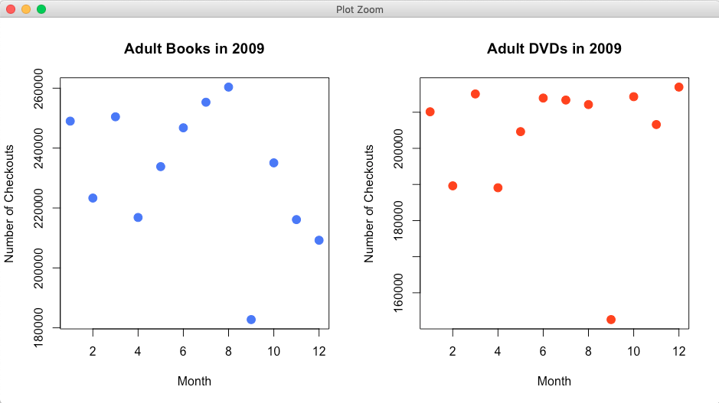

It’s spectacular – in September 2009, both checkouts of books and DVDs experienced a sharp drop. I did not do a statistical analysis, but I suspect I would find statistically significant results. Why? It’s hard to say. According to [ebookfriendly](https://ebookfriendly.com/timeline-kindle-history/), the Kindle 2 started shipping in February 2009, the Kindle app became available in March, a Kindle store for iPhones was launched in May and the Kindle DX began shipping in June. None of these occur close enough to September to suggest that this was the cause. Nothing in Wikipedia’s collection of September 2009 events seem to big enough.

Out of curiosity, I also looked at the month-to-month magazine

SELECT MONTH(cout), count(id)

FROM spl_2016.outraw

WHERE YEAR(cout) = '2008' AND itemtype = 'acper'

GROUP BY MONTH(cout)

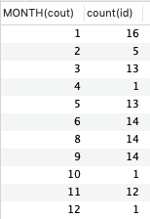

Ultimately, however (and unfortunately), I think these numbers are too small to tell a story about the sudden interest of patrons in magazines in 2008.

*What sorts of books were people interested in before 2009, during it and after?*

|  |  |  |  |
| --- | --- | --- | --- |
| 2007 | 2008 | 2009 | 2010 |
| SELECT deweyClass, count(deweyClass)  FROM spl_2016.outraw  WHERE YEAR(cout) = '2007' AND itemtype = 'acbk'  GROUP BY deweyClass | SELECT deweyClass, count(deweyClass)  FROM spl_2016.outraw  WHERE YEAR(cout) = '2008' AND itemtype = 'acbk'  GROUP BY deweyClass | SELECT deweyClass, count(deweyClass)  FROM spl_2016.outraw  WHERE YEAR(cout) = '2009' AND itemtype = 'acbk'  GROUP BY deweyClass | SELECT deweyClass, count(deweyClass)  FROM spl_2016.outraw  WHERE YEAR(cout) = '2010' AND itemtype = 'acbk'  GROUP BY deweyClass |
|  |  |  |  |
| 700s and 800s (741.59, 746.43, 895) | 700s & 800s (741.59, 746.43, 895) | 700 and 600s (741.59, 746.43, 641.5) | 700s and 600s (741.59, 746.43, 641.5) |
| Cartoons and Comics (Asian and North American), Yarn Crafts, Vietnamese language | Cartoons and Comics (Asian and North American), Yarn Crafts, Chinese fiction | Cartoons and Comics (Asian and North American), Yarn Crafts, Cookbooks | Cartoons and Comics (Asian and North American), Yarn Crafts, Cookbooks, Vegetarian cookbooks |

*The analysis is a bit lacking because most books (on the order of 10) are unclassified by the Dewey system. However, I do see that after 2008, people’s attention moves from international consumption (especially East Asian language and fiction) to home cooking, and increasingly, vegetarian cooking. I wonder if the market crash forces families to eat at home, and thus become interested in cooking.*