Criterion B: Design

Client Webpage
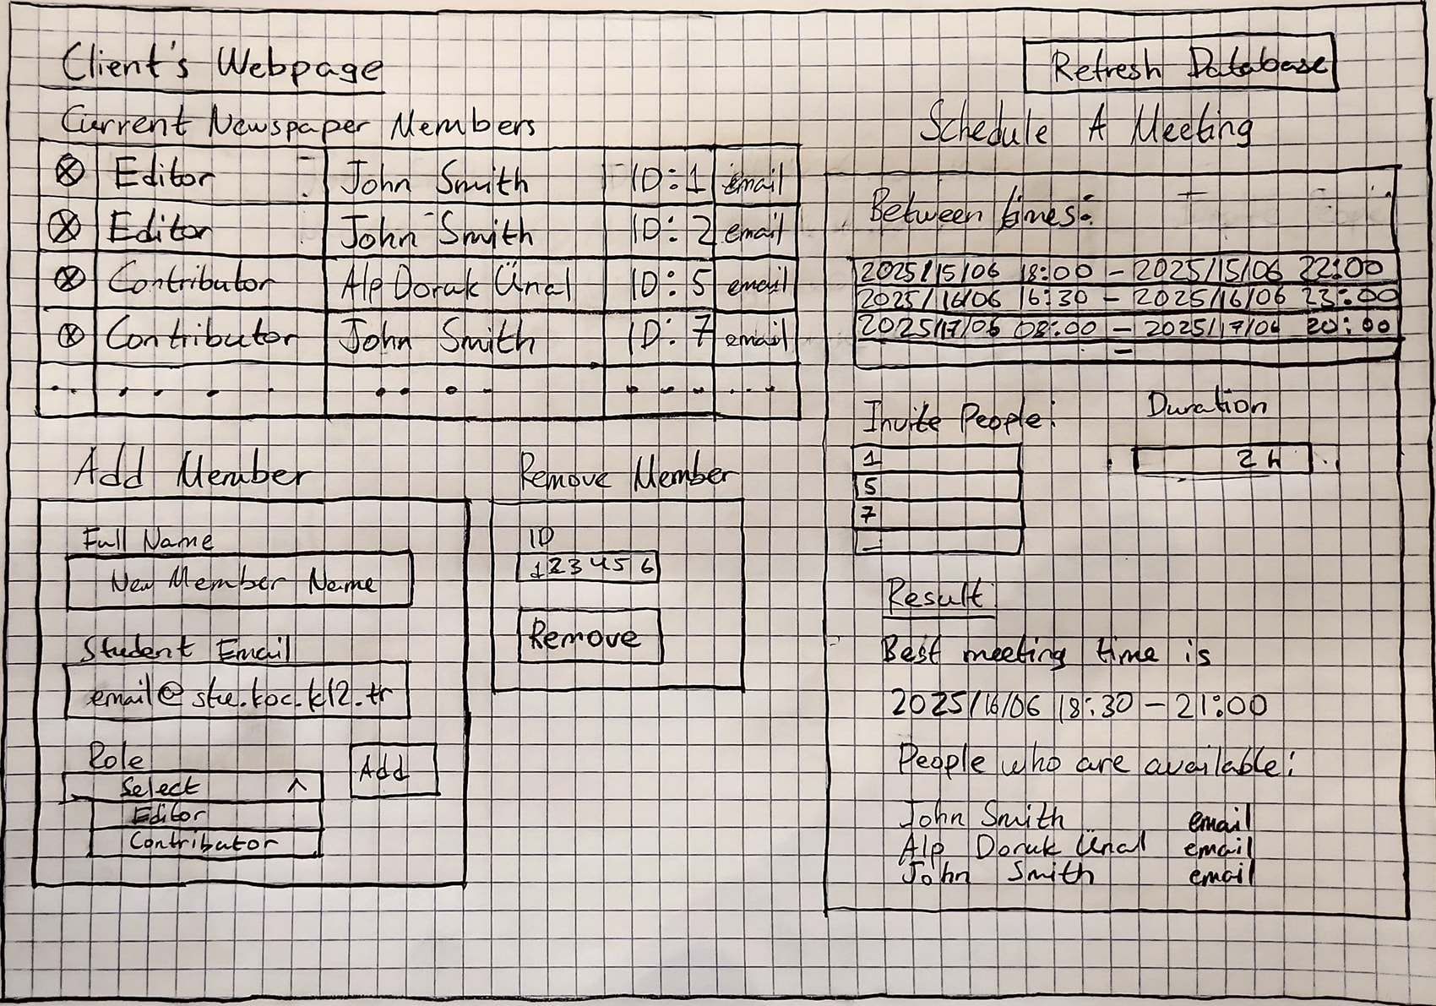
output of frmSelectMeetingTime
input for frmSelectMeetingTime
output of frmShowPeople, called automatically at launch

implementation of frmRefreshDatabase
shortcut implementation of frmRemovePerson
implementation of frmRemovePerson
implementation of frmAddPerson

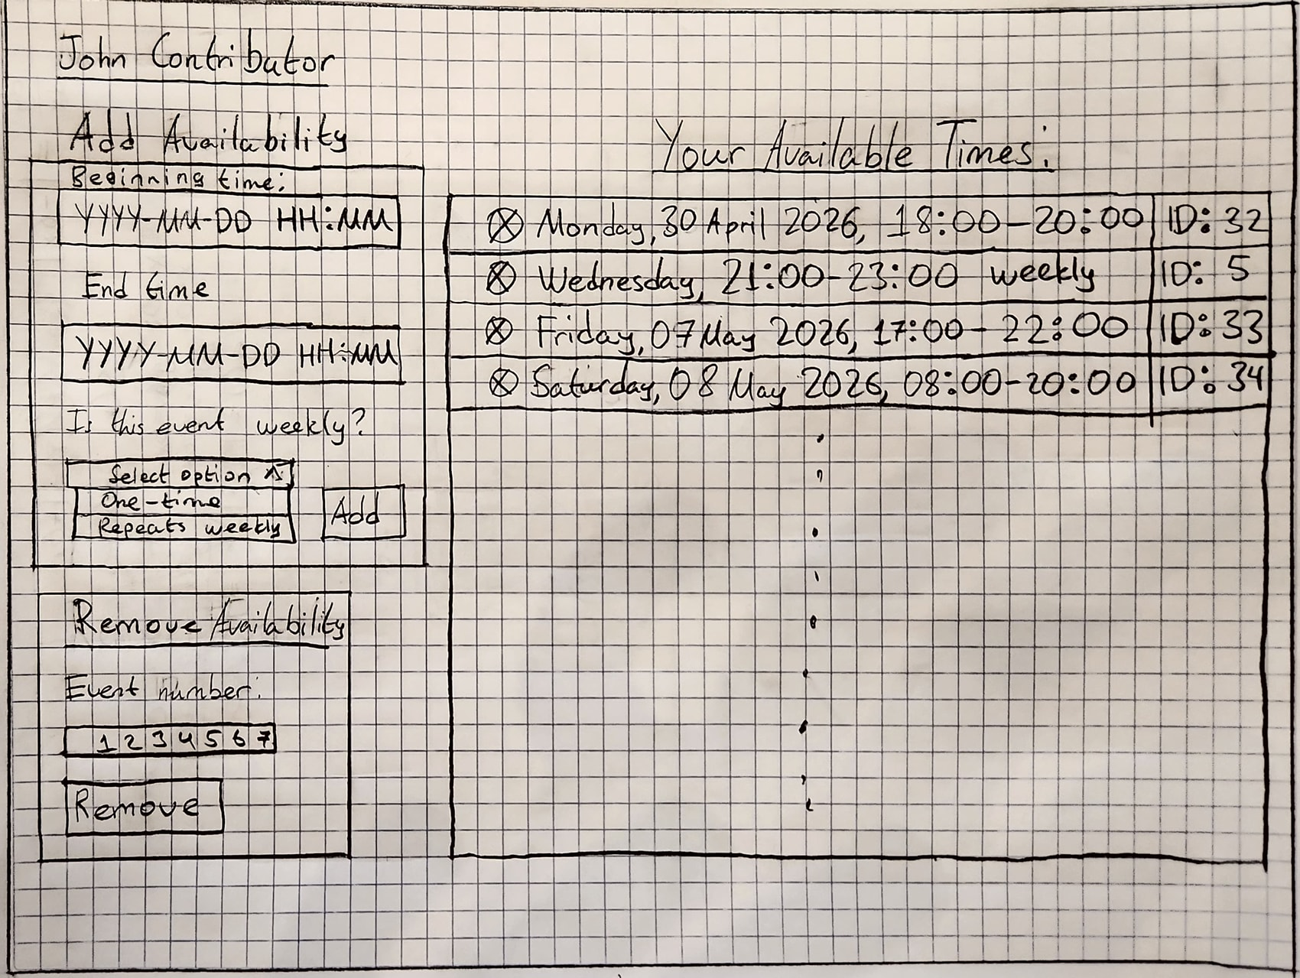
Contributor Webpage
implementation of frmRemoveEvent
implementation of frmAddEvent
shortcut implementation of frmRemoveEvent
output from frmShowEvents, called automatically at launch
displays name of contributor based on email from Google sign-in
Database

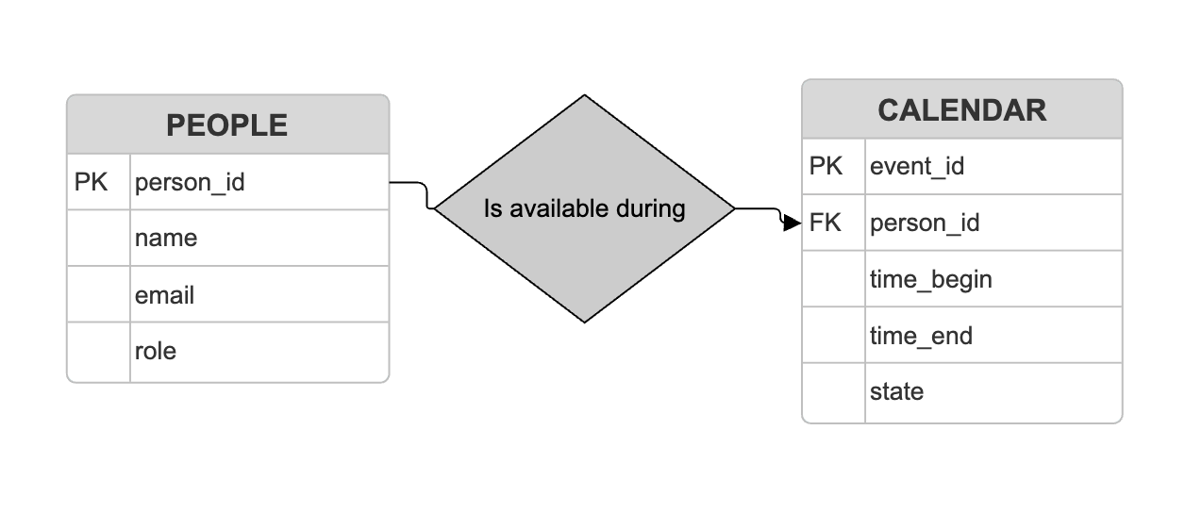
ERD

Data Dictionary

Table PEOPLE
Field Name | Data Type | Description | Format Restrictions | PK/FK?
person_id | int (auto-increment) | The ID of each editor or contributor. | Incremented by 1 automatically by the system for every new record created, starting at 1. | PK
name | string | The full name of the person. This will only be used to display, so it is not needed to distinguish between first and last name. | Maximum length = 100 to prevent malicious long strings.
email | string | The email address of the person | String must end with “@stu.koc.k12.tr” to ensure it is a valid school email address. Maximum length = 100 to prevent malicious long strings.
role | string | The role of the person. Will be used to set rules for whether this person’s attendance to an event is mandatory. | Value can only be “editor” or “contributor”.

Table CALENDAR
Stores all availability/unavailability of each person. If a timeslot is not specified here, it is assumed the person is unavailable.
Field Name | Data Type | Description | Format Restrictions | PK/FK?
event_id | int (auto-increment) | The ID of each event. Events do not represent specific events in a person's life, but rather any time they are available for any reason. | Incremented by 1 automatically by the system for every new record created, starting at 1. | PK
person_id | int | The ID of the person who's event this is. | Matches an existing value person_id in table PEOPLE. | FK (from PEOPLE)
time_begin | timestamp | The time the period of availability starts. Two periods overlapping is not an issue - both indicate availability. | YYYY-MM-DD HH:MM
time_end | timestamp | The time the period of availability ends. | YYYY-MM-DD HH:MM
state | string | Whether the event represent a time the person is available once, or repeated each week. | Value can only be "once" or "weekly".

Queries
Queries are parametrized, meaning a parameter input by the user will be used in the query, much like an argument passed to a function. Queries starting with qry read information, queries starting with ins write information.
Query Name | Parameters | Description | Tables Used
qryID | p_email | Shows field person_id in the row where email = p_email. | PEOPLE
qryRole | p_person_id | Shows field role in the row where person_id = p_person_id. | PEOPLE
qryAvailabilityByEmail | p_email | Merges tables PEOPLE and CALENDAR, then shows fields time_begin, time_end, state for every row where email_id = p_email_id. | CALENDAR, PEOPLE
qryAvailabilityByID | p_person_id | Shows fields event_id, time_begin, time_end, state for every row where person_id = p_person_id. | CALENDAR
qryAvailabilityByTime | p_time_begin, p_time_end, p_person_id | Checks if a person is available during a range of time (p_time_begin to p_time_end) by checking whether that range is contained within the ranges of the events associated with that person_id. Returns TRUE or FALSE. | CALENDAR
qryShowPeople |  | Shows all of the table PEOPLE. | PEOPLE
insAddPerson | p_name, p_email, p_role | Adds a new record to PEOPLE in the form (p_name, p_email, p_role). person_id is generated automatically. | PEOPLE
insRemovePerson | p_person_id | Removes the record of a given person_id from PEOPLE, and all associated events from CALENDAR. | CALENDAR, PEOPLE
insAddEvent | p_person_id, p_time_begin, p_time_end, p_state | Adds a record to CALENDAR in the form (p_person_id, p_time_begin, p_time_end, p_state). event_id is generated automatically. | CALENDAR
insRemoveEvent | p_event_id | Removes the record of an event associated with event_id from CALENDAR. | CALENDAR
insRefreshDatabase |  | Removes all records of events which ended in the past and are not repeated weekly. | CALENDAR

Functions
Functions will use the queries listed above to accomplish more complex tasks. These functions use lists/arrays, which may be difficult to implement in SQL, so they might be written in a different language.
Function Name | Arguments | Description | Tables Used
fGetIDs | p_email[list] | Calls qryID for a list of emails. | PEOPLE
fEvaluateTimeslot | p_time_begin, p_time_end, p_people[list] | Calls qryAvailabilityByTime and qryRole. Evaluates the validity of holding a meeting during a range of time (p_time_begin to p_time_end) where all people with person_id's in the list p_people[] need to attend. If any of the people with role = "editor" are unavailable, returns 0. Else, returns the amount of people who are available as an integer. | PEOPLE, CALENDAR
fGetBestTimeslots | (p_search_begin, p_search_end)[list of pairs], p_people[list], duration, interval | Calls fEvaluateTimeslot repeatedly, checking for valid meetings of length duration within the ranges of p_search_begin to p_search_end, incrementing by interval (e.g. if interval = 10 minutes, then every timeslot starting with XX:X0 will be checked). Returns all possible beginning times with the maximum amount of people available. | PEOPLE, CALENDAR
fGetPeople | (p_time_begin, p_time_end, p_people[list]) | Calls qryAvailabilityByID for every person in p_people[] and returns the records in PEOPLE of those who are available. | PEOPLE, CALENDAR

Forms
Form Name | Webpage | Queries/Functions implemented | Description/Data Input Method
frmShowPeople | Client | qryShowPeople | Calls qryShowPeople.
frmAddPerson | Client | insAddPerson | Calls insAddPerson. p_name and p_email are text input fields with format validation. p_role is a dropdown list.
frmRemovePerson | Client | insRemovePerson | Calls insRemovePerson. p_person_id is a text input box with format validation.
frmSelectMeetingTime | Client | fGetBestTimeslots fGetPeople | First, calls fGetBestTimeslots. After it returns the best beginning time, calls fGetPeople for the interval beginning time to beginning time + duration.  (p_search_begin, p_search_end)[list of pairs] is a 2*n table of time selection boxes. p_people[list] is a 1*n table of text input boxes with format validation. duration and increment are single text input boxes with format validation. See client webpage design.
frmRefreshDatabase | Client | insRefreshDatabase | Calls insRefreshDatabase.
frmAddEvent | Contributor | insAddEvent | Calls insAddEvent. p_person_id is based on which e-mail address logs into the webpage. p_time_begin, p_time_end are time selection boxes. p_state is a dropdown list.
frmRemoveEvent | Contributor | insRemoveEvent | Validates that the event is associated with the person logged into the webpage. If the validation succeeds, calls insRemoveEvent. Else, displays an error. p_event_id is a text input box with format validation.
frmShowEvents | Contributor | qryAvailabilityByEmail | Calls qryAvailabilityByEmail. p_email is based on which e-mail address logs into the webpage.

Test Plan
Test item number | Test item | Outcome
1 | The database must be correctly normalized and able to store timeslots for many people. | Successful - the database is normalized and implemented in PostgreSQL.
2 | The database must have a way to add or change available times for contributors. | Successful - The database interacts with the contributor website to provide this functionality.
3 | The database must have a user-defined function, usable in a query, to find the timeslot when all editors and the most contributors are available within a range of time. | Successful - This functionality is implemented via fGetBestTimeslots in the editor webpage.
4 | The database must be able to take API requests/webhooks for points 2 and 3. | Successful - This functionality is provided via Supabase's API, which interacts with the frontend to read and write to the database.
5 | The client webpage must feature a UI element that allows the client to input a range of time for a meeting to be scheduled. | Successful - This functionality is implemented via frmSelectMeetingTime in the editor webpage.
6 | The client webpage must display the best time according to the indicated availability of the editors and contributors. | Successful - There is a dynamically populated table that displays this information.
7 | The contributor webpage must feature a UI that allows users to input the times when they are available. | Successful - This functionality is implemented via frmAddEvent.

