Criterion C: Development

Introduction
The product consists of two web pages (the editor webpage and the contributor webpage) as well as a database storing the contact information and availability of users. Contributors and editors of the newspaper can go to the contributor webpage, sign in through Google OAuth with their Gmail account, and are then able to add/remove times at which they are available, which are stored in the database. An editor can use the editor webpage to add/remove editors and contributors from the database or schedule a meeting, specifying a range of times, and the webpage will output a time at which the most people possible are available.
The database and Google OAuth integration are done through Supabase (Supabase, “The Open Source Firebase Alternative”), and the web pages are hosted statically on GitHub Pages (“Quickstart for GitHub Pages”).

List of techniques:

-Relational database

-Complex (parametrized) database queries

-User defined functions with parameters and return values

-Search algorithm using recursive function calls

-Dynamic table population through HTML injection

Relational database
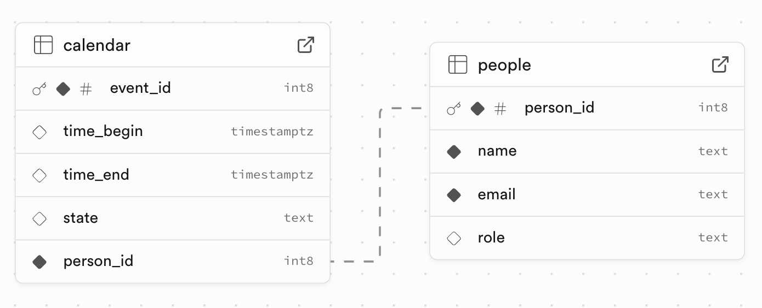
Figure 1: an ERD diagram of my database, made with Supabase Schema Visualizer (Supabase)
Supabase, a SaaS Postgres database, was chosen to serve as the only backend infratructure of the product, as its built-in features satisfy success criteria 1,4. Since the data stored is not highly sensitive, does not need to be preserved for a long time, and corruption would not lead to significant damage, I decided that Supabase provides enough security to justify not setting up a dedicated backend server.
Supabase provides its own library for authentication, which supports login via email/password or many choices of third-party services. I opted for authentication via Google OAuth as every school newspaper member has a school Gmail account.
It should be noted that due to the low need for security, authentication is used primarily for identification rather than security. It is theoretically possible to edit the JavaScript code to send queries as other people, however any attempt to do this can be easily addressed in person by the client.

Complex (parametrized) database queries
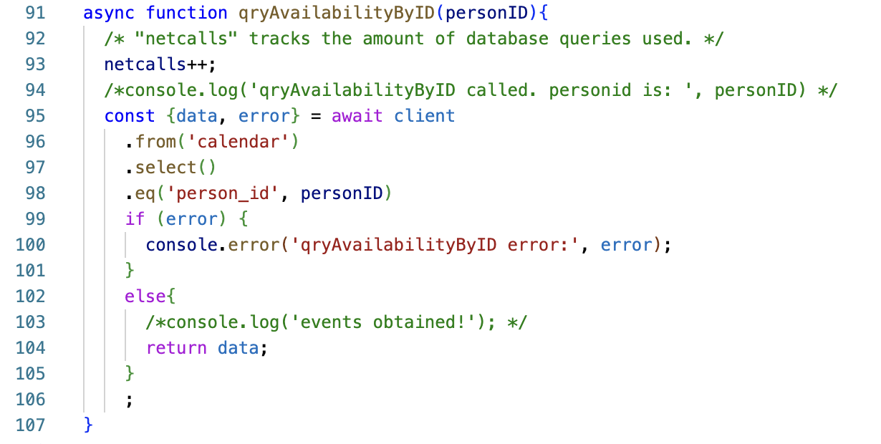
Parametrized database queries were used in both web pages to satisfy success criteria 5,6,8. Queries were sent using Supabase's JavaScript API (“JavaScript API Reference | Supabase Docs.”).
Figure 2: the function qryAvailabilityByID(), that queries the database to obtain the events associated with a specified person
As an example, this function from the editor webpage takes a value from people.person_id as an argument and returns an array of all the time ranges when they are available - that is, records in calendar having that person_id as FK. Supabase's JS API expresses queries as methods of the object "client". All queries listed in the Design document were implemented this way.

User defined functions with parameters and return values
Functions were used to manipulate data, work with arrays, and read input from forms. Three functions are shown here that demonstrate each of these use cases.
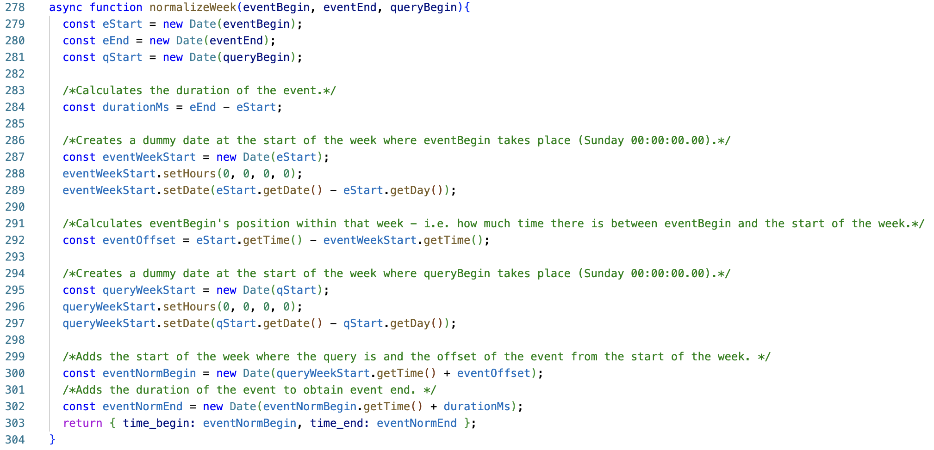
Figure 3: a function NormalizeWeek() that moves an event to the current week, while keeping the same day of the week and time
This is a function in the editor webpage. Some calendar entries represent events that repeat weekly, so they must be “normalized” to the week of the query before checking availability. The function takes an event’s start and end times, along with the start time of the availability query, and returns new event start/end timestamps that match the query’s week while matching the event’s offset within the week. The return value is an Object - Objects in JavaScript can be created dynamically with no need for classes.
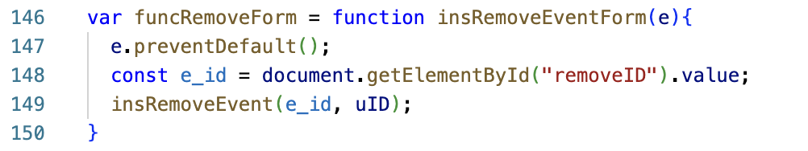
Figure 4: the function insRemoveEventForm(), a function that is responsible for reading the value from the "remove person" form and passing it to the function that removes a person
This is a helper function in the contributor webpage used to read data from the form frmRemovePerson. It reads the value in the removeID input field and passes it as a parameter to the query insRemoveEvent. Every form in the product is connected to a function that reads its inputs and passes them to the appropriate queries.

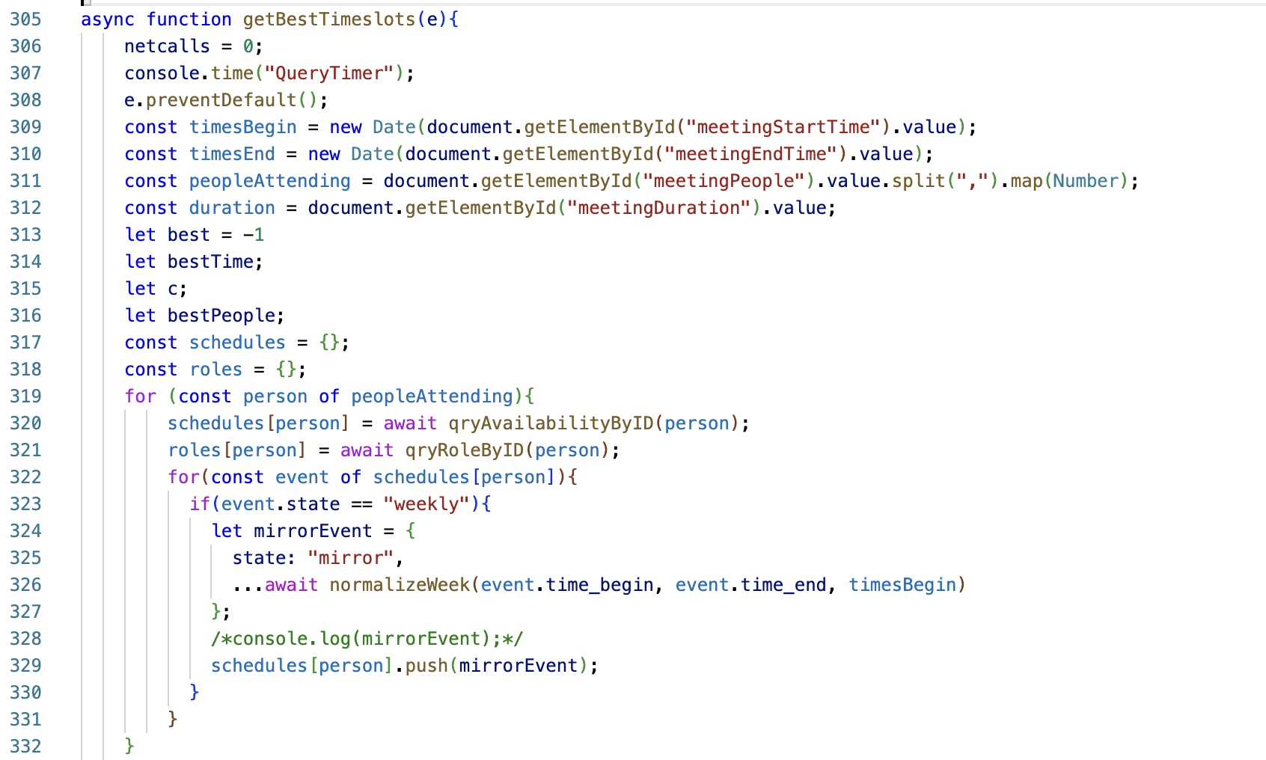
Figure 5: a part of the function getBestTimeslots(), responsible for querying the database to create a schedule (in a 2D array-like structure) of people's events
This is part of the function in the editor webpage that determines the timeslot with the most people available. This part of the function reads frmSelectMeetingTime, then calls qryAvailabilityByID for every invited participant (indicated by the user in field meetingPeople) and combines their schedules into an object (so that person_id values can be used as keys). It then loops through all events and populating the arrays with "mirror" events that are shifted to the query's week by calling normalizeWeek.

Search algorithm using recursive function calls
The core of the meeting scheduling program, satisfying success criteria 5,6, is the function evaluateTimeslotByPerson(), a search algorithm that checks whether a person is available during a given timeslot.
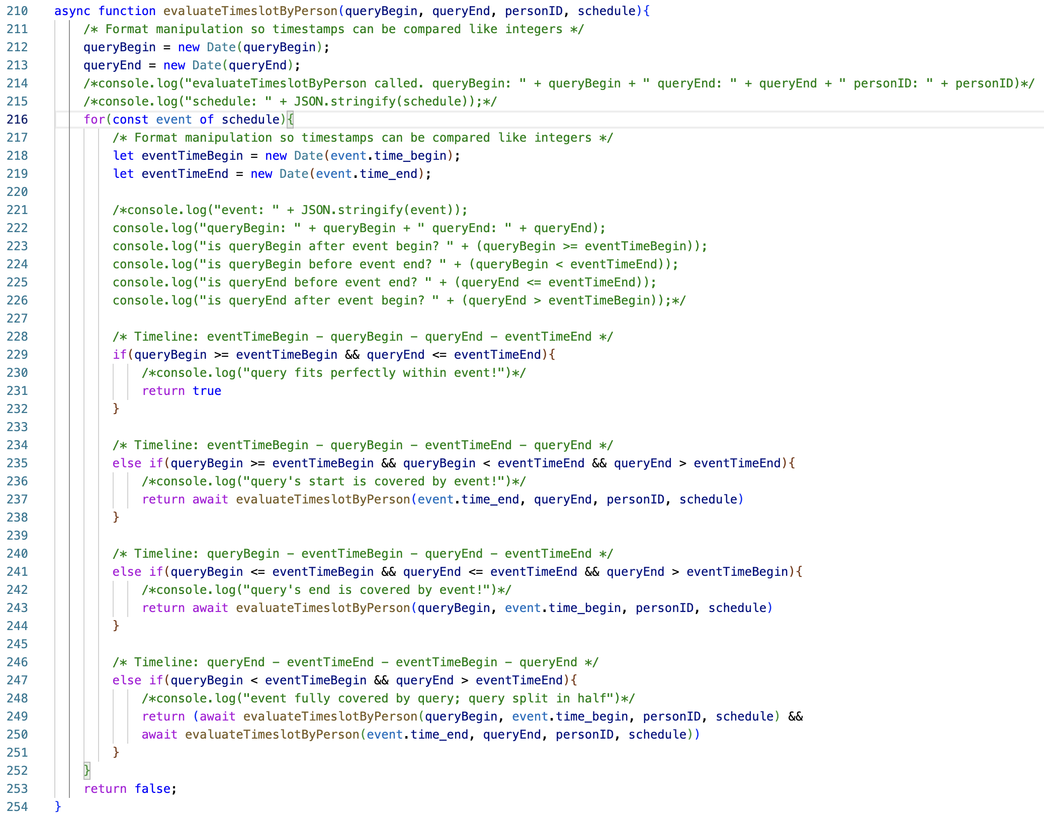
Figure 6: the function evaluateTimeslotByPerson(), which checks whether a specified person is available for all of a specified time range

The algorithm makes use of recursive functions. First, it loops through all the events in the schedule and compares them to the queried timeslot. Note that an event indicates the person is available.
If it encounters an event that completely covers the timeslot, the person is available during that time and the algorithm returns true.
If it encounters an event that overlaps the beginning or end of the query, it trims the covered part and recursively evaluates the non-covered part of the query.
If it encounters an event that is completely covered by the queried timeslot, it cuts the middle part that covers the event, then calls the function twice, to evaluate the uncovered parts at the start and at the end. It then returns true
only if both of those subroutines return true (i.e. those parts are covered by other events). 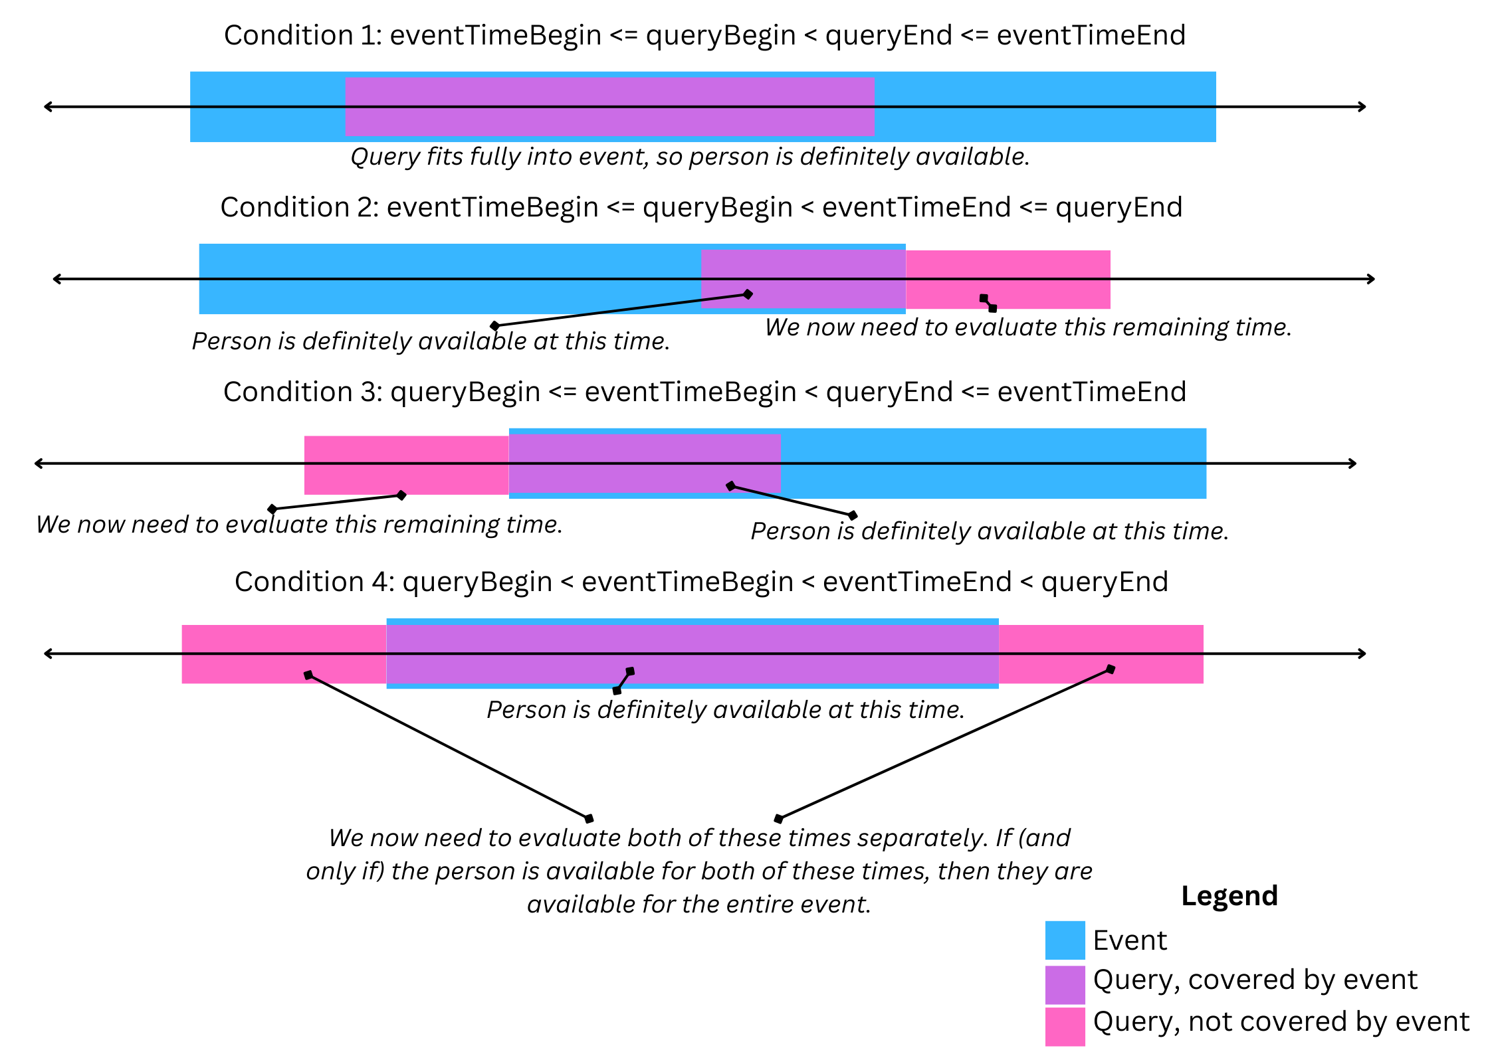
Figure 7: a diagram explaining the principle of the function evaluateTimeslotByPerson()

Dynamic table population through HTML injection
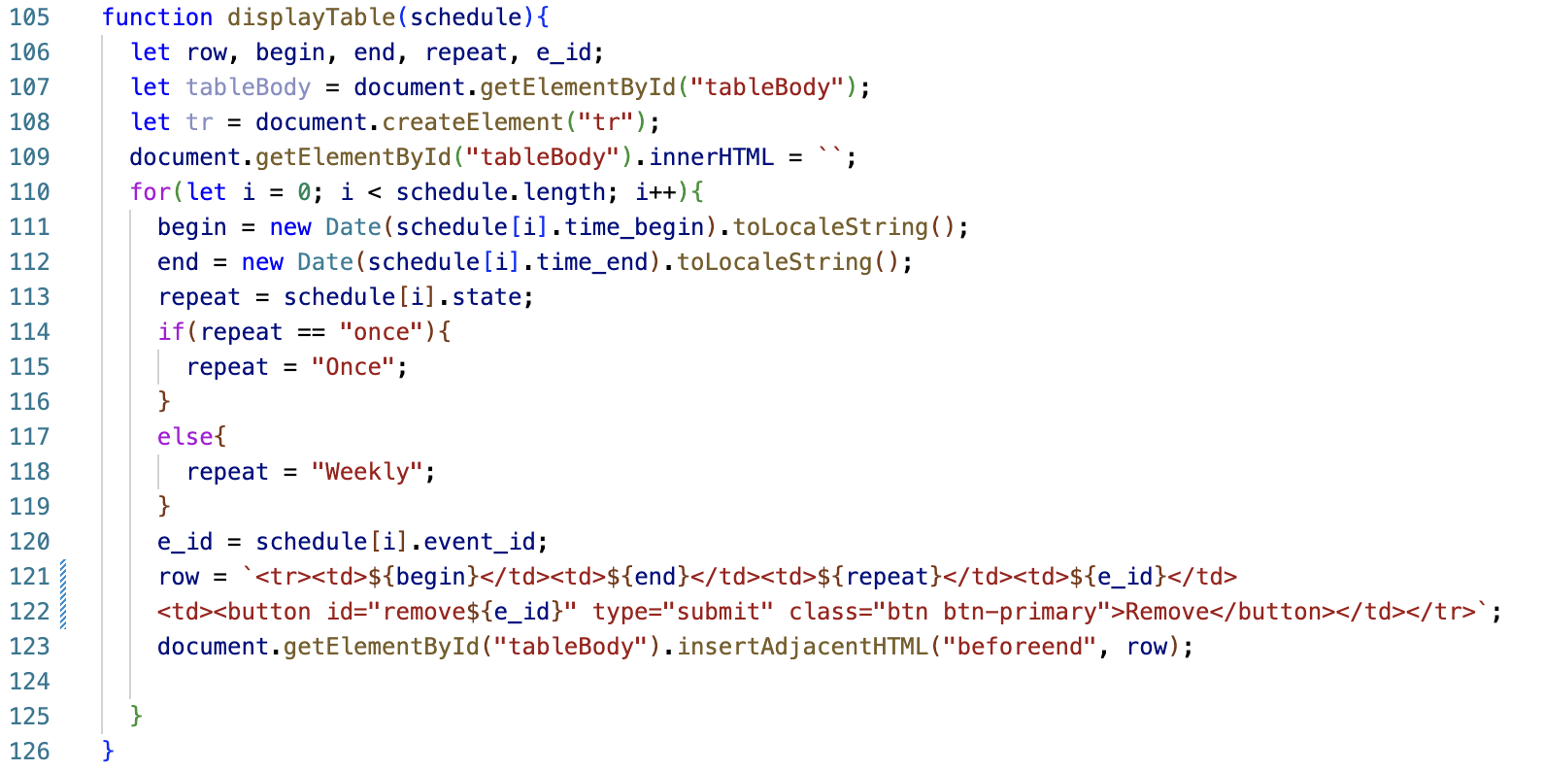
Figure 8: the function displayTable(), responsible for populating HTML/Bootstrap tables based on output from other functions
The tables used to display timeslots in the contributor webpage and newspaper members in the editor webpage need to be populated dynamically based on data fetched from the database. This function from the contributor webpage populates a Bootstrap table (Otto, Code licensed MIT, docs CC BY 3.0.) with dynamically generated HTML elements based on values fetched from qryAvailabilityByID(), displaying the times when the user is available. It also generates a "remove" button with a unique ID on each row, that can then be traced to determine which button was pressed. The display for qryShowPeople() in the editor webpage works similarly.

Extensibility
While developing the product, I followed strict and understandable naming conventions for my variables: all variables use camelCase except values fetched from the database, which use snake_case. All queries, functions and forms have names that match or extend those in the design document where it is possible.
I made sure that no function is too long so that errors in the code can be isolated to a function and quickly identifies. Where possible, tasks are accomplished in dedicated functions. The async/await structure (“Async Function - JavaScript | MDN”) was used to avoid errors due to functions running out of order.
The code features extensive comments and console logs in order to aid future development.
[Word Count: 1011]

Bibliography
“Async Function - JavaScript | MDN.” Developer.mozilla.org, developer.mozilla.org/en-US/docs/Web/JavaScript/Reference/Statements/async_function.
Google. “Using OAuth 2.0 to Access Google APIs | Google Identity Platform | Google Developers.” Google Developers, 12 Nov. 2018, developers.google.com/identity/protocols/OAuth2.
Otto, Mark. “Tables.” Getbootstrap.com, 2019, getbootstrap.com/docs/4.0/content/tables/.
“Quickstart for GitHub Pages.” GitHub Docs, docs.github.com/en/pages/quickstart.
Supabase. “JavaScript API Reference | Supabase Docs.” Supabase.com, Supabase Docs, 20 Nov. 2025, supabase.com/docs/reference/javascript. Accessed 21 Nov. 2025.
Supabase. “The Open Source Firebase Alternative.” Supabase, 2025, supabase.com/.

