UM TAGUM COLLEGE
BACHELOR OF SCIENCE IN COMPUTER SCIENCE
Department of Computing Education
Visayan Village, Tagum City, Philippines



Course Requirements
in
CST 9/L
CS Professional Track 3

NETSENTRY: A Web-Based Firewall Action Classification System

Submitted to:
IRIS MAE C. MENDOZA, MIT

Submitted by:
REMEDIOS, RENNEYX, E.
PANONG, KRISTYL P.
BAULA, ANA A.

October 18, 2025

I. Project Overview
Project Title: NetSentry: A Web-Based Firewall Action Classification System
Type of Application: Web application (Flask)
Description: NetSentry is a web application that predicts firewall action from network traffic measurements. A user enters source/destination ports, byte and packet totals, and connection duration; the system predicts Allow, Deny, Drop, or Reset with a model-confidence value. Users can also generate examples from held-out test records and review prediction history stored in their browser.
Objective: To classify historical firewall traffic into four action categories using a supervised machine learning model, while demonstrating data preprocessing, model training, evaluation, and integration with a usable web application.

II. Problem Statement
Firewall traffic records contain multiple numerical measurements that are not always easy to interpret manually. This project explores whether historical traffic patterns can help classify likely firewall actions. Machine learning can identify patterns across the measurements and return a predicted category for a new record. The system is intended for learning and demonstration; it does not inspect live traffic, enforce firewall rules, or guarantee a security decision.

III. Methodology

1. Development Tools
Component | Used in this project
Programming languages | Python, JavaScript, HTML, CSS
Frameworks and libraries | Flask; pandas, NumPy, scikit-learn, joblib
Database / storage | Original UCI CSV file; local .joblib model; JSON reports; browser localStorage for prediction history
Platform / IDE | Windows environment; Jupyter notebook compatible with Google Colab or VS Code. Visual Studio Code.

2. Machine Learning Component
The model uses 11 numerical network-traffic inputs to predict one of four historical action labels. The training code cleans the dataset, splits it into training and testing subsets, applies a scikit-learn pipeline, selects model settings using training-only validation, calibrates confidence values, and evaluates the final model on untouched test records.

3. Algorithm Used
Supervised learning: Random Forest Classifier (100 decision trees, class_weight="balanced", random_state=42). The model is wrapped in a scikit-learn Pipeline with SimpleImputer(strategy="median"). Probability scores are adjusted using sigmoid calibration fitted on training data only. The algorithm must be confirmed against the algorithm assigned to the group in the course draw; the guideline lists Decision Tree, Logistic Regression, SVM, and Neural Networks as supervised examples, but does not explicitly name Random Forest.

4. Dataset Description
Source: UCI Machine Learning Repository, Internet Firewall Data (DOI: 10.24432/C5131M). The original file data/log2.csv contains 65,532 records, 11 numeric input features, and one Action target. Sample features include Source Port, Destination Port, NAT Source Port, NAT Destination Port, Bytes, Bytes Sent, Bytes Received, Packets, Elapsed Time (sec), pkts_sent, and pkts_received. Action values are standardized to Allow, Deny, Drop, and Reset (from Reset-Both).
Cleaning/split stage | Records
Original dataset | 65,532
Exact duplicate records removed | 8,362
Contradictory-label rows removed | 18
Records kept | 57,152
Train (80%) | 45,721
Held-out test (20%) | 11,431

5. Data Preprocessing
- Import the raw CSV using pandas.read_csv(), then standardize column names and action labels.
- Convert numeric fields, check missing values and reject invalid port ranges, negative/non-finite values, non-integer counts, and inconsistent traffic totals.
- Remove identical records and records with the same features but contradictory labels. Keep genuine missing numeric measurements for later imputation.
- Separate the 11 feature columns (X) from the Action labels (y), then use a stratified 80/20 train-test split with random_state=42.
- Inside each training fold, use SimpleImputer with median strategy. Scaling is unnecessary for this tree-based classifier, and one-hot encoding is unnecessary because there are no categorical input features.
This approach avoids learning imputation statistics from the test set. The original dataset has no missing measurements, but the pipeline can handle missing values in future data. The cleaning audit is saved to data/data_quality_report.json.

6. Model Training and Testing
Representative training code (shortened for presentation):
pipeline = Pipeline([
("imputer", SimpleImputer(strategy="median")),
("model", RandomForestClassifier(
n_estimators=100, random_state=42, class_weight="balanced"))
])
X_train, X_test, y_train, y_test = train_test_split(
X, y, test_size=0.2, stratify=y, random_state=42)
scores = cross_validate(
pipeline, X_train, y_train,
cv=StratifiedKFold(5, shuffle=True, random_state=42),
scoring={"accuracy": "accuracy", "macro_f1": "f1_macro"})
In the actual train_model.py, model settings are compared using training-only validation before final fitting. The selected base Random Forest is evaluated with five-fold stratified cross-validation; a three-fold sigmoid calibration stage is then fitted on training data only. Final accuracy and class metrics are computed using the untouched 20% test set.

IV. System Output and Screenshots
The running application was verified and a genuine screenshot of its homepage is included below. A second colored screenshot showing an actual prediction must still be captured and inserted before submission.
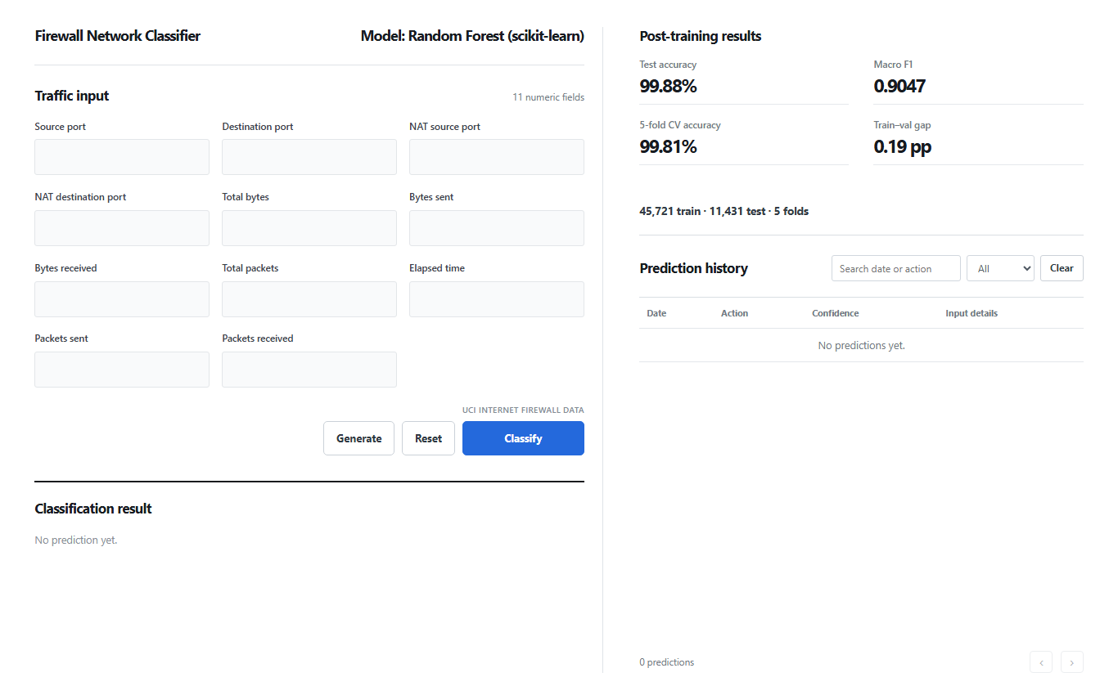
Screenshot 1. Live NetSentry homepage: input form, model evaluation summary, and prediction history.

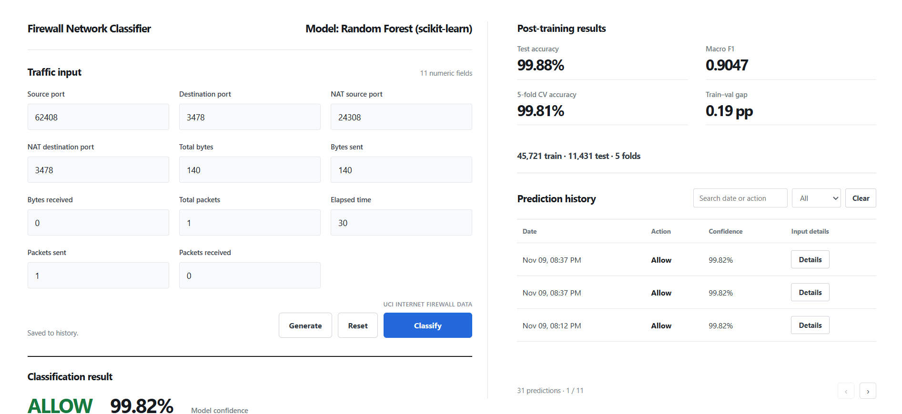

The following colored confusion-matrix figure is based on the saved evaluation_report.json from the trained model.
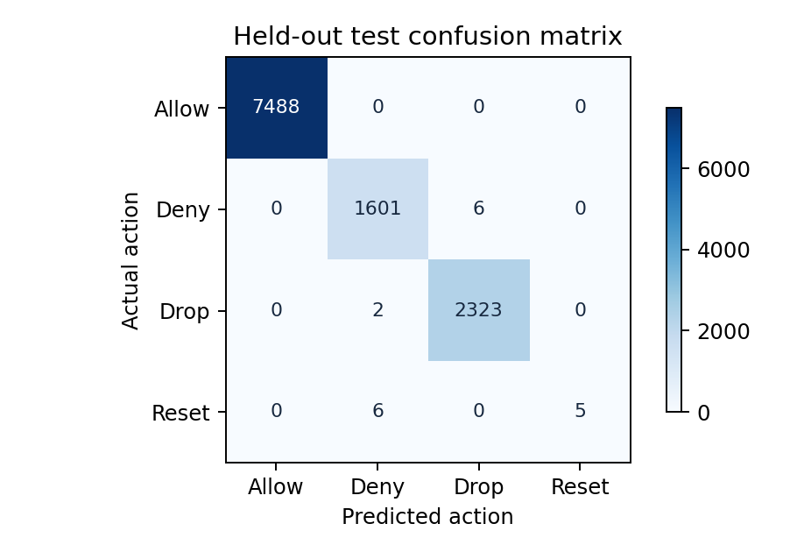
Figure 1. Confusion matrix from the saved evaluation report (11,431 test records).

V. Results and Discussion
Metric | Saved result
Held-out test accuracy | 99.8775%
Held-out macro-F1 | 0.9047
Five-fold CV mean accuracy (base model) | 99.8075%
Five-fold CV mean macro-F1 | 0.8581
Training-validation accuracy gap | 0.1914 percentage points
Reset recall on holdout | 45.45% (5 correctly classified out of 11 Reset records)
Exact 100% calibrated confidence values on test | 0

The high test accuracy shows that the model classified most records in the historical UCI test split correctly. The strong overall score must be interpreted carefully because the action classes are imbalanced. Only 54 Reset records remain after cleaning; 11 appear in the test set, and the model correctly identifies 5. This means Reset recognition is weaker than the overall accuracy suggests.
The probability calibration addresses the tendency of raw Random Forest votes to report 100% confidence, but calibration does not guarantee correctness. Results from this dataset do not establish reliable performance on current or unfamiliar network environments.

VI. Conclusion and Recommendations
NetSentry meets its technical goal of creating a web interface that takes 11 traffic measurements and predicts one of four firewall actions using a trained supervised classifier. The project demonstrates importing and cleaning a real dataset, using a scikit-learn pipeline, separating training and test records, performing cross-validation, reporting performance, and presenting results in a web application.
Recommended next steps: gather more examples of rare Reset traffic, compare additional classifiers, test on independently collected network data, improve documentation with actual application screenshots, and verify that the algorithm is acceptable under the group's assigned draw. The application should remain educational unless independently validated for operational security use.

VII. REFERENCES
[1] UCI Machine Learning Repository, "Internet Firewall Data," Dataset 542, DOI: 10.24432/C5131M. [Online]. Available: https://archive.ics.uci.edu/dataset/542/internet+firewall+data.
[2] Scikit-learn developers, "Pipeline," scikit-learn documentation. [Online]. Available: https://scikit-learn.org/stable/modules/generated/sklearn.pipeline.Pipeline.html.
[3] Scikit-learn developers, "RandomForestClassifier," scikit-learn documentation. [Online]. Available: https://scikit-learn.org/stable/modules/generated/sklearn.ensemble.RandomForestClassifier.html.
[4] Scikit-learn developers, "StratifiedKFold," scikit-learn documentation. [Online]. Available: https://scikit-learn.org/stable/modules/generated/sklearn.model_selection.StratifiedKFold.html.

