PELIKULAK DATU BASEA (taula 1) 0.BERTSIOA / BD Peliculas (1 tabla) VERSION 0

2aw3_peli DBarekin CRUD aplikazio bat egin / Con la BD 2aw3_peli haced una aplicación CRUD

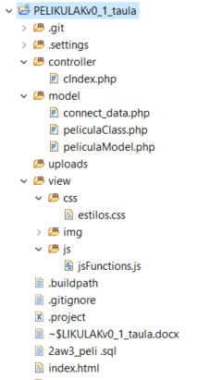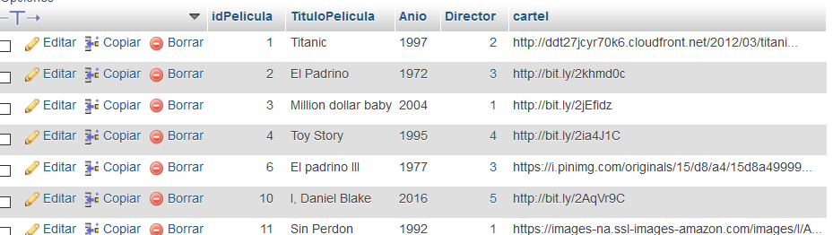

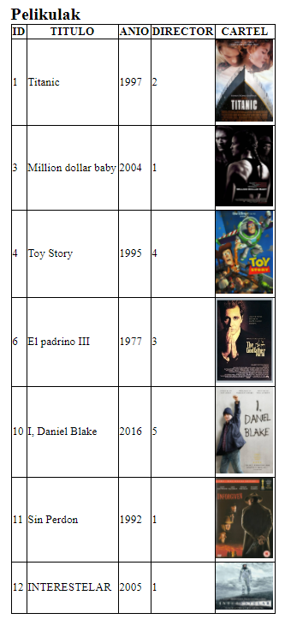

View🡪index.html

when document.ready

from ajax 🡪cIndex called

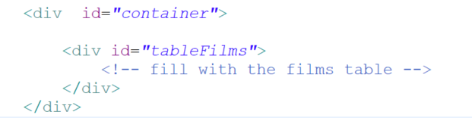

ajax fill it with all the films in TABLE format

jsFunctions

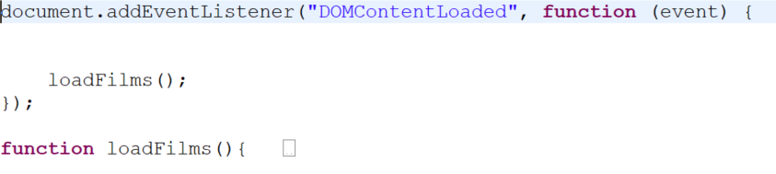

When page loading :

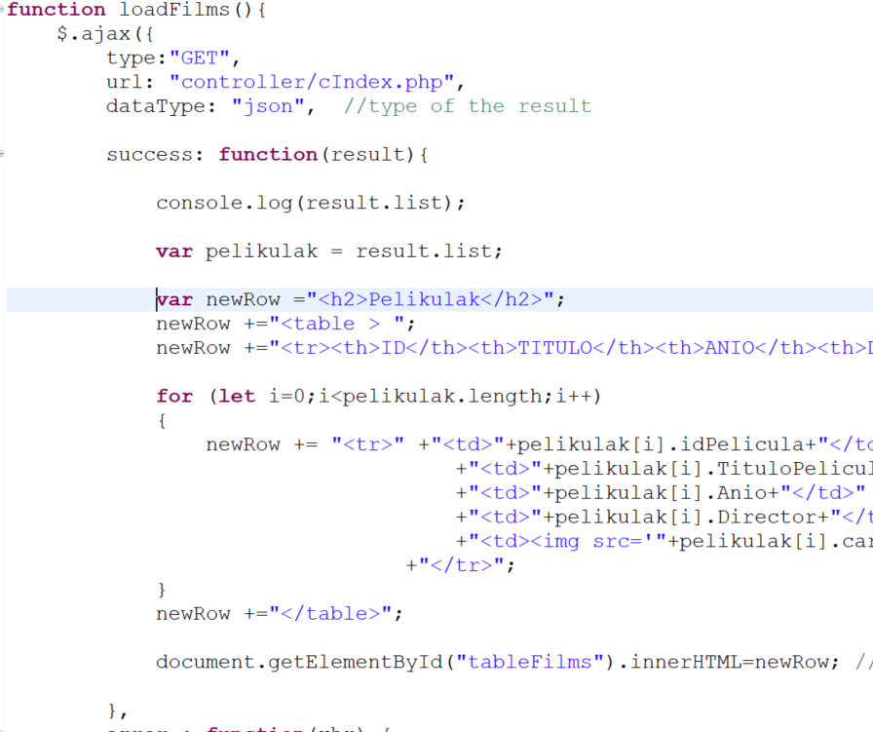

for each json element

select * from peliculas