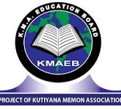
KMA GIRLS SECONDARY school
Nawab Khanji Road, Kharadar
School Leaving Certificate

The Certificate Proudly Presented To
Anabiya Abdul Qadir
Has successfully completed the recommended course of study by the school administration

DATE: July 30, 2025 SIGNATURE:────────────

