Girijananda Chowdhury University
Guwahati,Assam



Mini Project Report

GCU Notes Portal: Web-Based Question Paper and Notes Management System

Submitted in partial fulfillment of the requirements for the degree of B.Tech (CSE) 6thsemester

Submitted by

Apratim Kalita(2313018009)
Manas Basu (2313018035)
Yuvraj Talukdar (2313018062)

Under the guidance
Ms. Mala Ahmed

Department of Computer Science and Engineering
Girijananda Chowdhury University,Azara,
Guwahati-781017, Assam, India
June - 2026


GIRIJANANDA CHOWDHURY UNIVERSITY, ASSAM
DEPARTMENT OF COMPUTER SCIENCE & ENGINEERING

CERTIFICATE FROM THE HEAD OF THE DEPARTMENT

This is to certify that the Mini Project entitled “GCU Notes Portal” being submitted by___________________ with roll no ______________ has completed the mini project under 6th semester course curriculum during the academic session Jan-June 2026.

I approve the report for submission as required for the partial completion of B. Tech 6th Semester from GIRIJANANDA CHOWDHURY UNIVERSITY, ASSAM. The report submitted is genuine and no part of the report has been submitted anywhere for the award of any degree from any university

.

Prof. Minakshi Gogoi

Professor and HOD

Girijananda Chowdhury University,Assam



GIRIJANANDA CHOWDHURY UNIVERSITY,ASSAM
DEPARTMENT OF COMPUTER SCIENCE & ENGINEERING

CERTIFICATE FROM THE GUIDE

This is to certify that the Mini Project entitled “GCU Notes Portal” being submitted by___________________ with roll no ______________ has completed the mini project under my guidance for B.Tech(CSE) 6th semester course curriculum during the academic session Jan-June 2026.

I approve the report for submission as required for the partial completion of B. Tech 6th Semester from GIRIJANANDA CHOWDHURY UNIVERSITY, ASSAM. The report submitted is genuine and no part of the report has been submitted anywhere for the award of any degree from any university.

Under the Guidance
Ms. Mala Ahmed
Assitant Professor

Girjananda Chowdhury University,Assam

Acknowledgment

The success and final outcome of this project required a lot of guidance and assistant from many people and we are extremely fortunate to have their support till the completion of my report work.

Although this report has been prepared with utmost care and deep routed interest, even then we accept it respondent and imperfect.

It is a great opportunity and pleasure for me to express my profound gratitude towards all the individuals who directly and indirectly contributed towards completion of this report.

Thank you!

Apratim Kalita (2313018009)

Manas Basu (2313018035)

Yuvraj Talukdar (2313018062)

ABSTRACT

The management and accessibility of study materials as well as previous year question papers are important aspect in academic preparation for students. The conventional approach to storing and distributing question papers often results in issues related to accessibility, disorganization, and unavailability. This project work describes the design and development of a Web Based Question Paper and Notes Management System, which offers a centralized platform for storing, organizing, and efficiently accessing academic resources. The proposed system enables users to register and log in securely to access previous year question papers and study notes. An authentication mechanism is incorporated to ensure data security and restricted access. The system allows organized storage of study materials according to subject, semester, or year, making retrieval easy and efficient. The system is developed using contemporary web technologies to ensure a responsive and user-friendly interface and optimal functionality. The application is expected to minimize reliance on conventional methods of sharing and maximize accessibility to academic resources. With the incorporation of secure login functionality, organized content management, and a user-friendly interface, the system is expected to enhance the overall learning experience. The development of this project is anticipated to assist students in efficient exam preparation and facilitate organized digital resource management within academic institutions.

TABLE OF CONTENT

Acknowledgement v
Abstract vii
Chapter1 Introduction
  - Aim
  - Objectives
  - Need……………………………………………………………………………….

Chapter2 Literature Review
2.1 Summary

Chapter3 Methodology
  - Flowchart and Summary
  - Entity Relation Diagram and Explaination………………………………………..
  - Technology Stack Used……………………………………………………………………………….

Chapter4 Results and Discussions
  - Snapshot of the website
  - Summary ………………………………………………………………………….

Chapter5 Conclusion & Future work
5.1 Future Work……………………………………………………………………………….
5.2 Conclusion………………………………………………………………………………...

Chapter 1 : INTRODUCTION

1.1 Aim of the Project

The aim of the GCU Notes Portal is to provide a centralized and user-friendly platform for storing, managing, and accessing academic resources such as study notes and previous year question papers. The system enables administrators to upload and manage educational materials efficiently, while students can easily search, view, and download resources based on their subject, semester, and branch. The project aims to improve accessibility, organization, and availability of academic content, thereby supporting effective learning and exam preparation.
1.2 Objective of the Project

- To develop a centralized platform for storing and managing study notes and previous year question papers.

- To provide secure user authentication and role-based access for administrators and students.

- To enable students to search, view, and access academic resources efficiently based on subject, semester, and branch.

- To facilitate easy uploading, updating, and deletion of resources by administrators.

- To improve the accessibility, organization, and availability of academic materials for effective learning and examination preparation

1.3 Need of the project

In many educational institutions, study materials and previous year question papers are shared through multiple platforms such as messaging applications, emails, or physical copies, making them difficult to organize and access. Students often spend considerable time searching for relevant resources. The GCU Notes Portal addresses this problem by providing a centralized digital repository where academic materials can be stored, managed, and accessed efficiently. The system ensures easy availability of resources, reduces redundancy, and supports students in their academic preparation through a well-organized and user-friendly platform.

Chapter 2 : Literature Review

2.1 Summary

The management and distribution of academic resources have evolved significantly with the advancement of digital technologies. Traditionally, study notes and previous year question papers were maintained in physical form within libraries and academic departments. Students were required to visit these locations to access materials, making the process time-consuming and less efficient. As educational institutions increasingly adopt digital solutions, several systems have been developed to facilitate the sharing and management of academic resources.
Google Classroom is one of the most widely used learning management systems that enables teachers to share notes, assignments, and learning materials with students. It provides a structured environment for classroom activities and communication. However, its primary focus is on course management and assignment handling rather than maintaining a dedicated repository of notes and previous year question papers categorized by semester, branch, and subject.
Another popular platform is Moodle, an open-source learning management system used by educational institutions worldwide. Moodle offers features such as course management, assessments, discussion forums, and resource sharing. While it is highly versatile and feature-rich, its complexity can make it less suitable for students who only require quick and convenient access to study materials and examination resources.
Many educational institutions also utilize cloud-based storage platforms such as Google Drive and Dropbox for sharing academic resources. These platforms provide easy file storage and sharing capabilities but lack structured categorization, role-based management, and advanced search functionality tailored to academic requirements. As a result, students often face difficulties in locating specific resources.
In addition, several colleges and universities have developed their own resource management portals to store and distribute study materials. These systems provide centralized access to academic content; however, many of them lack efficient resource organization, search capabilities, and user-friendly interfaces. The absence of proper categorization often leads to challenges in managing large collections of notes and question papers.
Considering the limitations of existing systems, there is a need for a dedicated platform that focuses specifically on the management of academic resources. The proposed GCU Notes Portal addresses this need by providing a centralized, secure, and user-friendly web application for storing and accessing study notes and previous year question papers. The system implements role-based access control, where administrators can upload, update, and delete resources, while students can search, view, and download materials. Resources are organized according to branch, semester, and subject, ensuring efficient retrieval of information. The portal utilizes Firebase Authentication for secure login, Firebase Firestore for database management, and Firebase Storage for file handling, providing a reliable and scalable solution.
From the study of existing systems, it can be concluded that while various platforms support academic resource sharing, they often suffer from limitations such as lack of organization, complex interfaces, and inadequate resource management features. The GCU Notes Portal overcomes these challenges by offering a simple, structured, and efficient platform specifically designed to meet the academic needs of students and administrators.

Chapter 3 : Methodology

3.1 Flowchart and Summary of GCU Notes PORTAL

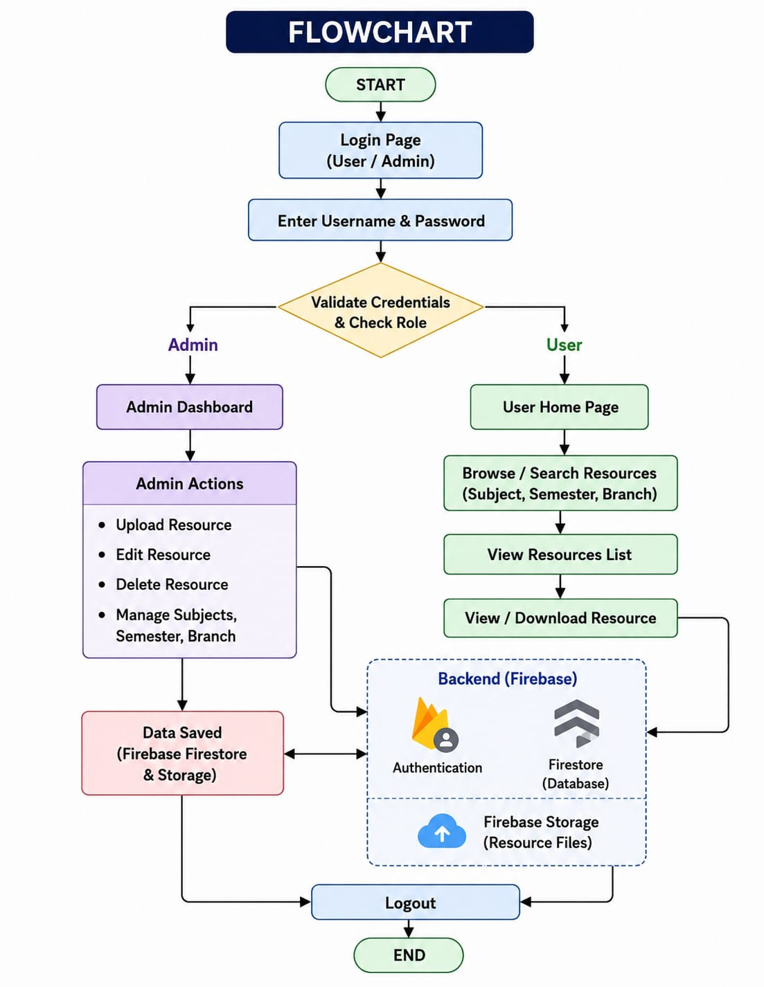

The flowchart of the GCU Notes Portal illustrates the overall working process of the system from user authentication to resource management and access. The process begins when a user opens the application and is presented with the login page. The user enters their username and password, which are then verified through Firebase Authentication.
Once the credentials are submitted, the system checks whether they are valid. If the credentials are incorrect, the user is redirected back to the login page and prompted to enter valid login details. If the authentication is successful, the system determines the role of the user.
If the logged-in user is an Administrator, the system redirects them to the Admin Dashboard. The administrator has complete control over academic resources and can perform operations such as uploading new notes and question papers, updating existing resources, and deleting outdated or incorrect files. When a resource is uploaded, the file is stored in Firebase Storage, while its details such as title, subject, semester, branch, and file URL are stored in the Firebase Firestore Database. This ensures efficient management and retrieval of resources.

If the logged-in user is a Student, the system redirects them to the User Dashboard. Students can browse available resources, search for specific notes or question papers based on subject, semester, or branch, and view or download the required files. Unlike administrators, students are not permitted to upload, modify, or delete resources, ensuring the integrity and security of the academic materials.

The system continuously interacts with the Firebase Database to retrieve and display the requested resources. All updates made by the administrator are immediately reflected in the database, allowing students to access the latest study materials. Finally, after completing their tasks, both administrators and students can securely log out of the system, which terminates the current session and returns them to the login page.
Thus, the flowchart demonstrates a secure and structured workflow that enables efficient management, storage, and retrieval of academic resources while maintaining role-based access control within the GCU Notes Portal.

3.2 Entity Relationship(ER) Diagram of GCU Notes PORTAL

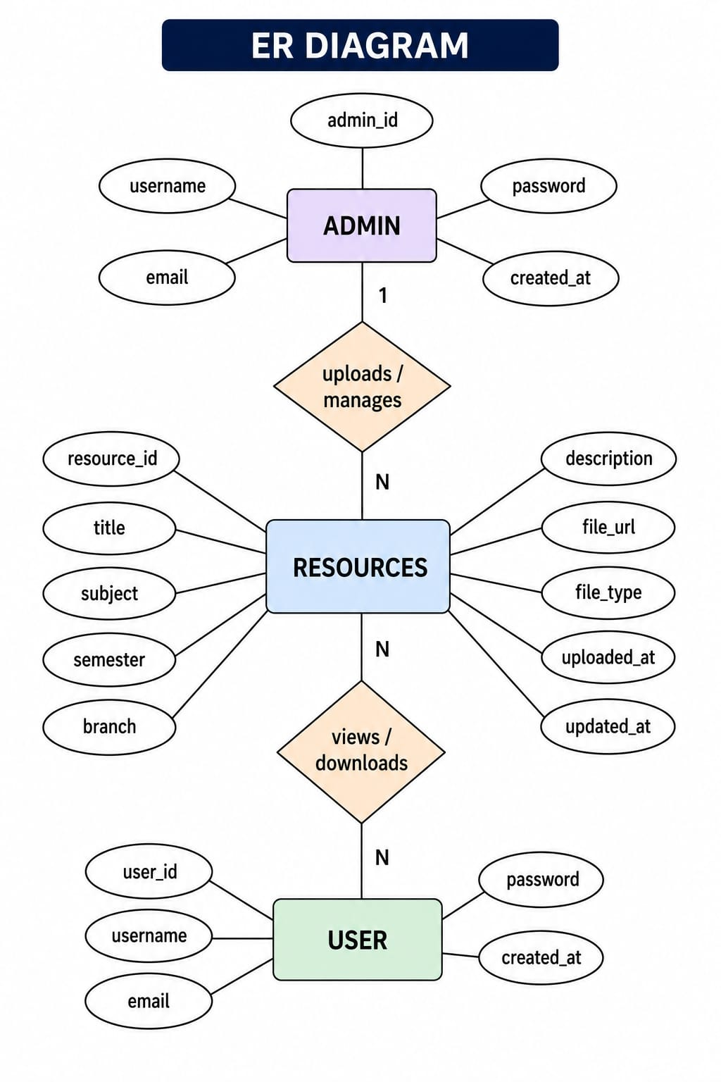

The Entity Relationship (ER) Diagram of the GCU Notes Portal represents the structure of the database and illustrates how different entities interact with each other. The system consists of three main entities: Admin, User, and Resource. These entities work together to facilitate the management and access of academic materials such as notes and previous year question papers.

Admin Entity

The Admin entity stores information related to administrators who manage the portal. The attributes of this entity include Admin ID, Username, Email, Password, and Created At. Administrators have the authority to upload, update, and delete resources within the system. They play a crucial role in maintaining the accuracy and availability of academic materials.

User Entity

The User entity contains information about students who access the portal. The attributes include User ID, Username, Email, Password, and Created At. Users can log in to the system, browse available resources, search for specific materials, and view or download notes and question papers. However, users are not permitted to modify any resources.

Resource Entity

The Resource entity stores details about academic materials available on the portal. Its attributes include Resource ID, Title, Subject, Semester, Branch, Description, File URL, File Type, Uploaded At, and Updated At. This entity acts as the central repository for all notes and question papers uploaded by administrators.

Relationship Between Entities

The relationship between the entities is designed to ensure efficient management and access of resources. An Admin can upload and manage multiple Resources, establishing a one-to-many relationship between Admin and Resource. Similarly, multiple Users can access and view multiple Resources, creating a many-to-many interaction from the usage perspective. The Resource entity serves as the bridge between administrators who manage the content and students who utilize it for academic purposes.

The ER Diagram provides a clear representation of the database structure and helps in understanding how data is stored, managed, and accessed within the GCU Notes Portal. It ensures proper organization of information and supports the efficient functioning of the system.

  - Technology Stack Used

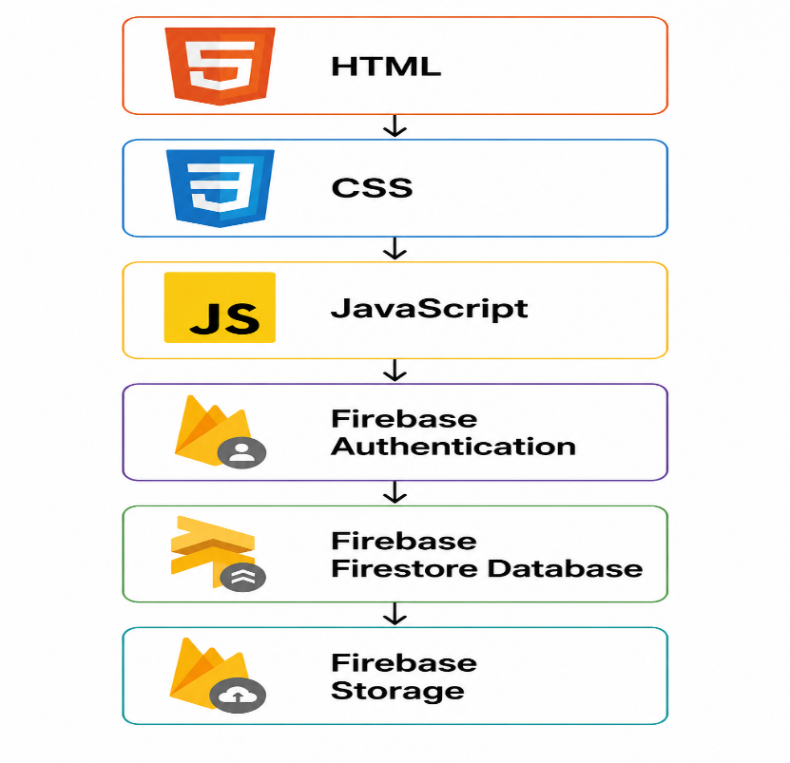

The GCU Notes Portal is developed using modern web technologies and Firebase services. The selected technologies provide an efficient, secure, and user-friendly environment for managing and accessing academic resources.
3.3.1 HTML (HyperText Markup Language)
HTML is used to create the basic structure and content of the web pages. It defines various elements such as headings, forms, buttons, tables, navigation menus, and other components that are displayed to users.
3.3.2 CSS (Cascading Style Sheets)
CSS is used to design and style the user interface of the portal. It controls the layout, colors, fonts, spacing, responsiveness, and overall visual appearance of the website, ensuring a better user experience.
3.3.3 JavaScript
JavaScript is responsible for the interactive and dynamic functionality of the portal. It handles user actions such as login validation, resource searching, data retrieval, form submission, and communication with Firebase services.

3.3.4 Firebase Authentication
Firebase Authentication is used to implement secure user login and authentication. It verifies user credentials and manages role-based access control, ensuring that administrators and students can access only the features permitted to them.
3.3.5 Firebase Firestore Database
Firebase Firestore is a cloud-based NoSQL database used to store and manage application data. It stores information such as user details, resource metadata, subject information, semester details, and file links required by the portal.
3.3.6 Firebase Storage
Firebase Storage is used to store uploaded files such as study notes and previous year question papers. It provides secure and scalable storage while generating file URLs that can be accessed by students for viewing or downloading resources.
Technology Stack Summary
The combination of HTML, CSS, JavaScript, Firebase Authentication, Firestore Database, and Firebase Storage enables the GCU Notes Portal to provide a secure, efficient, scalable, and user-friendly platform for managing academic resources.

Chapter 4: Results and Discussion
4.1 Snapshot of the Website

Chapter 5: Conclusion and Future Work
5.1 Future Work
The GCU Notes Portal can be further enhanced by incorporating additional features to improve its functionality and user experience. Some potential future enhancements include:
- Implementation of advanced search and filtering options for faster resource retrieval like search most downloaded or recent uploads or apply multiple filter at a time.
- Addition of a resource rating and feedback system to help students identify high-quality study materials.
- Integration of notifications and announcements to inform users about newly uploaded resources.
- Development of a mobile application to provide easier access across different devices.
- Integration of Artificial Intelligence (AI) features to recommend relevant notes and question papers based on user preferences and academic interests.

  - Conclusion

The GCU Notes Portal is a web-based academic resource management system designed to provide a centralized platform for storing and accessing study notes and previous year question papers. The system enables administrators to efficiently upload, manage, and organize academic resources, while students can easily search, view, and download the required materials. By implementing role-based access control and utilizing Firebase services for authentication, database management, and file storage, the portal ensures security, reliability, and ease of use. The project successfully addresses the challenges associated with resource sharing and organization, making academic materials more accessible to students. Overall, the GCU Notes Portal serves as an effective and user-friendly solution that supports learning, improves resource management, and enhances the academic experience for both students and administrators.

