**CSCE 567**: Final Progress Report

Ana Boccanfuso

1. Response to Midterm Proposal Questions/Feedback
   1. “I did not read anything that seemed like a plan B but more other things that the proposal wanted to do”: I considered my plan B my base requirements for my project. Plan A is more things I would like to achieve if time permits.
2. Draft of Initial Visualizations/Update on Data Cleaning

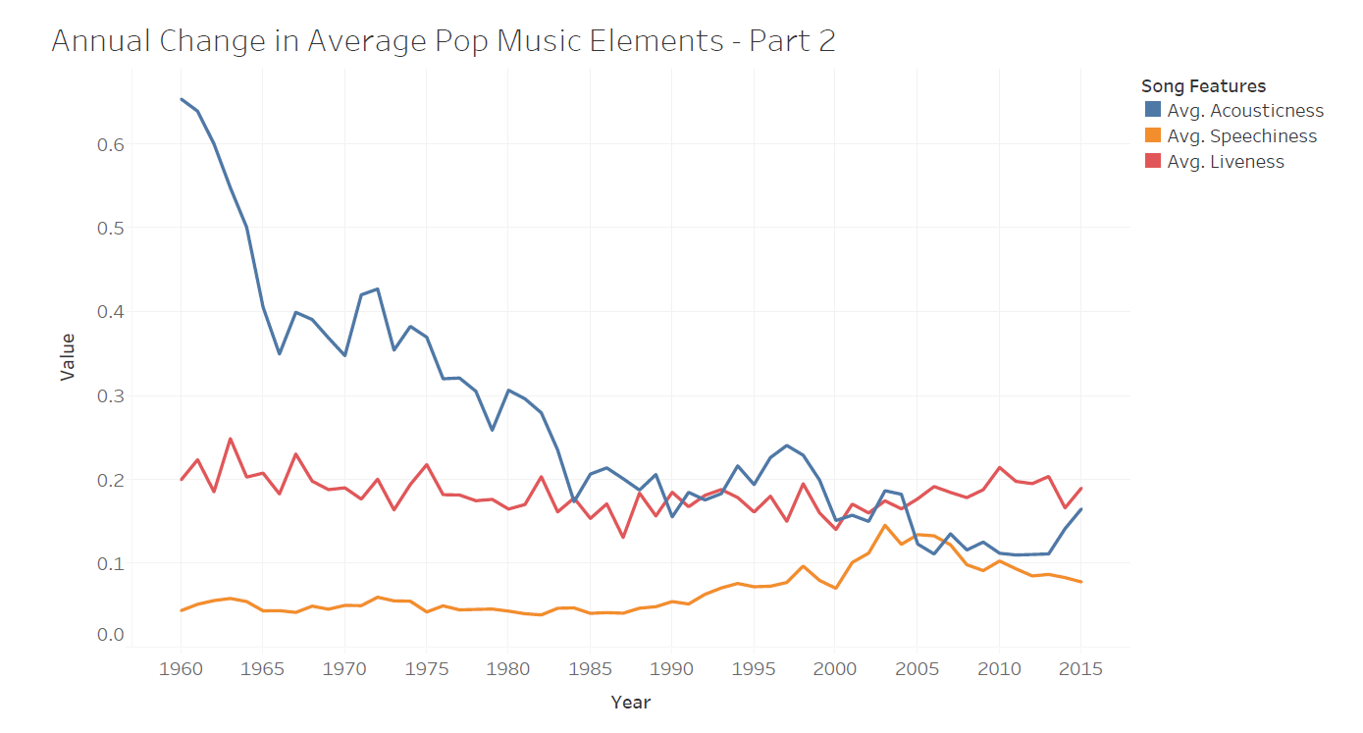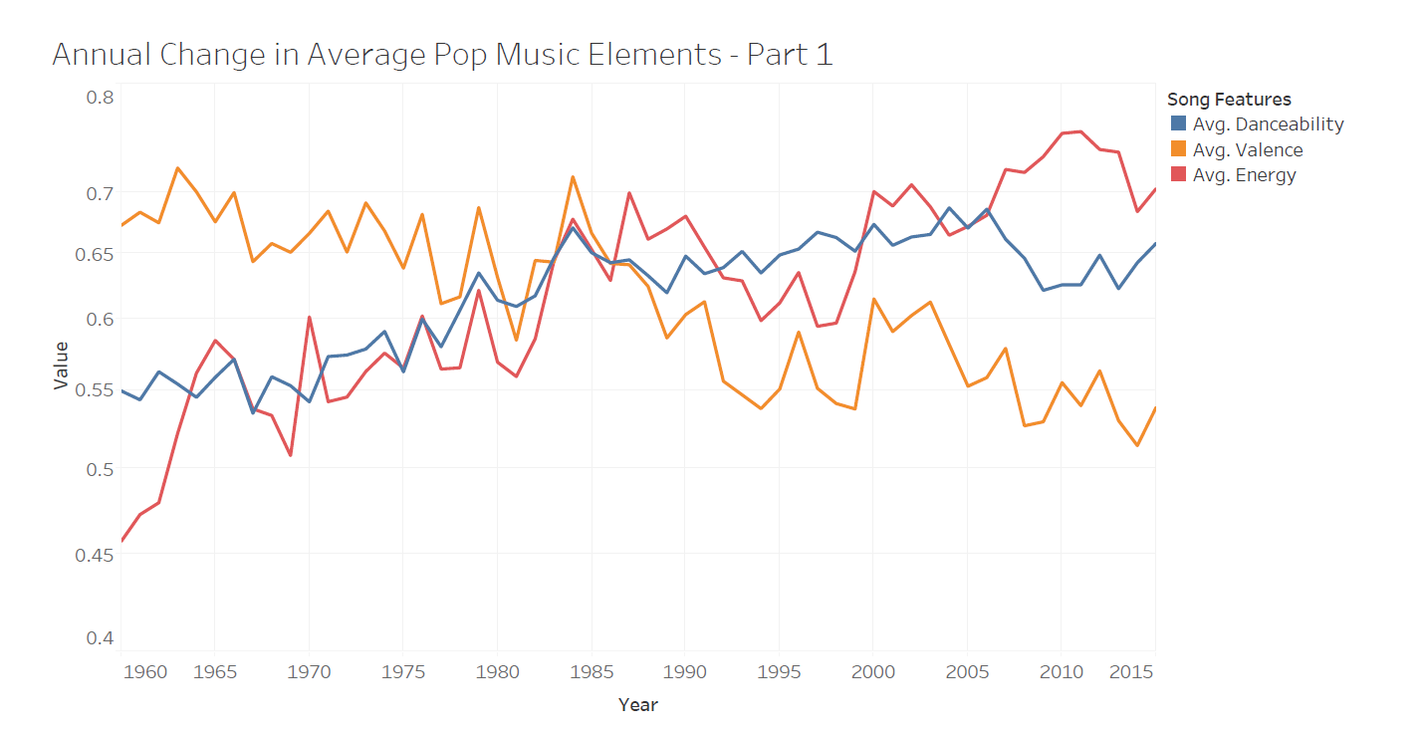

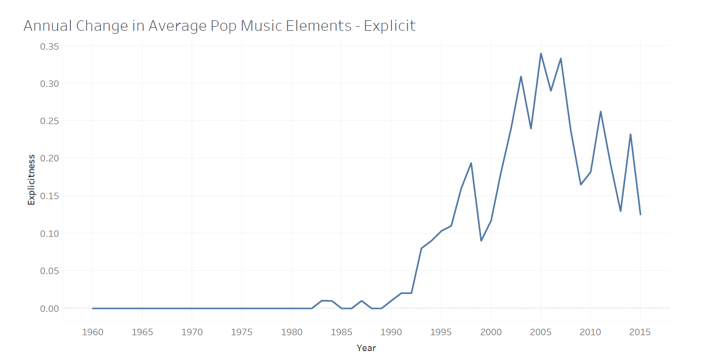

* 1. Above are my current drafts for my first three visualizations. Currently, I am researching on how to clean my lyrics data to create word clouds. The raw data is messy and is random sentences with [chorus] and [verse] comments. Additionally, I have cleaned my artist-specific data by only including the main albums and deleting repeat songs.

1. Current Plan for Providing Access to My Project

My current plan for providing access to my project is an HTML file. I have found that I can download RStudio charts as HTML files and embed them together, but I am still searching for how to download Tableau charts with interactivity. Additionally, embedding RStudio graphs has given me some trouble, so I may look into alternative options of making my project public.