**Bill Nye – Friction**

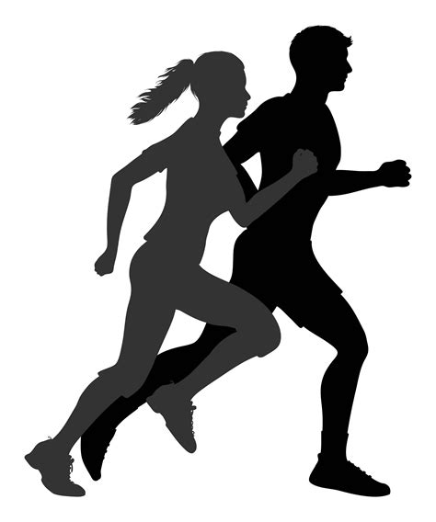

*Answer the questions as you watch the video.*

1. What is holding the triangular weight on the table?
2. Friction turned work into __________ so the ramp is warm to the touch.
3. Is there any friction in space?
4. How does a hovercraft float on the water?
5. Why do baseball players wear cleats (spikes)?
6. Why are the soles of skis made slippery?
7. Why does barefoot waterskiing make your feet “burn?”
8. List one reason why a world without friction would be dangerous.
9. What lowers the amount friction on a bike?
10. Why do trains have to have at least some friction?
11. Why do airplanes have smooth shapes?
12. How do fish overcome friction to swim through the water?
13. How do the straws help the box move?

**After the Video:**

1. Write a definition of friction in your own words:
2. List two examples of friction shown in the video:

**Bill Nye – Friction Answer Key**

*As you watch the video, answer the questions in the line below each question.*

1. What is holding the triangular weight on the table?

Friction.

1. Friction turned work into __________ so the ramp is warm to the touch.  
   Heat.
2. Is there any friction in space?  
   Very little (gas molecule and gravity)
3. How does a hovercraft float on the water?  
   It pushes air underneath it, so there is less friction.
4. Why do baseball players wear cleats (spikes)?  
   They stick to the ground better (more friction), which helps them start or stop faster.
5. Why are the soles of skis made slippery?  
   It has less friction on snow, which helps you slide/ski.
6. Why does barefoot waterskiing make your feet “burn?”  
   There is energy and friction from the water.
7. List one reason why a world without friction would be dangerous.  
   Brakes on a car would be useless.
8. What lowers the amount friction on a bike?   
   Grease on the chains.
9. Why do trains have to have at least some friction?  
   Trains need traction between its wheels and the track to get it to move.
10. Why do airplanes have smooth shapes?  
    It helps reduce the friction from air.
11. How do fish overcome friction to swim through the water?  
    Its shape helps reduce friction as it swims through water.
12. How do the straws help the box move?  
    The straws reduce friction by acting like rollers.

**After the Video:**

1. Write a definition of friction in your own words:   
   Answers will vary. Ex. “Friction is a force that opposes and resists motion.”
2. List two different examples of friction shown in the video:  
   Answers will vary. Ex. “Sliding friction while ice skating, rolling friction while biking.”