# Hair Colors

**Instructions:** Solve the two questions below and use a Punnett square to demonstrate how you arrived at your answers.

**Question 1:** Harry has dark hair like his father, but his mom had red hair. Using the genotypes of **rr** (red hair), **Rr** (dark/brown hair), **RR** (dark/brown hair), what possible genotypes does each of the Potters have?

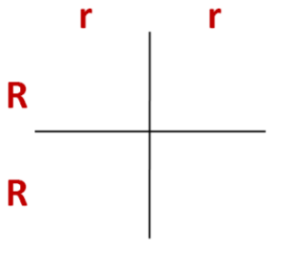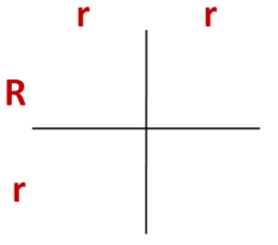

**Question 2:** Harry marries Ginny who has red hair. What are possible genotypes of their children’s hair colors?

