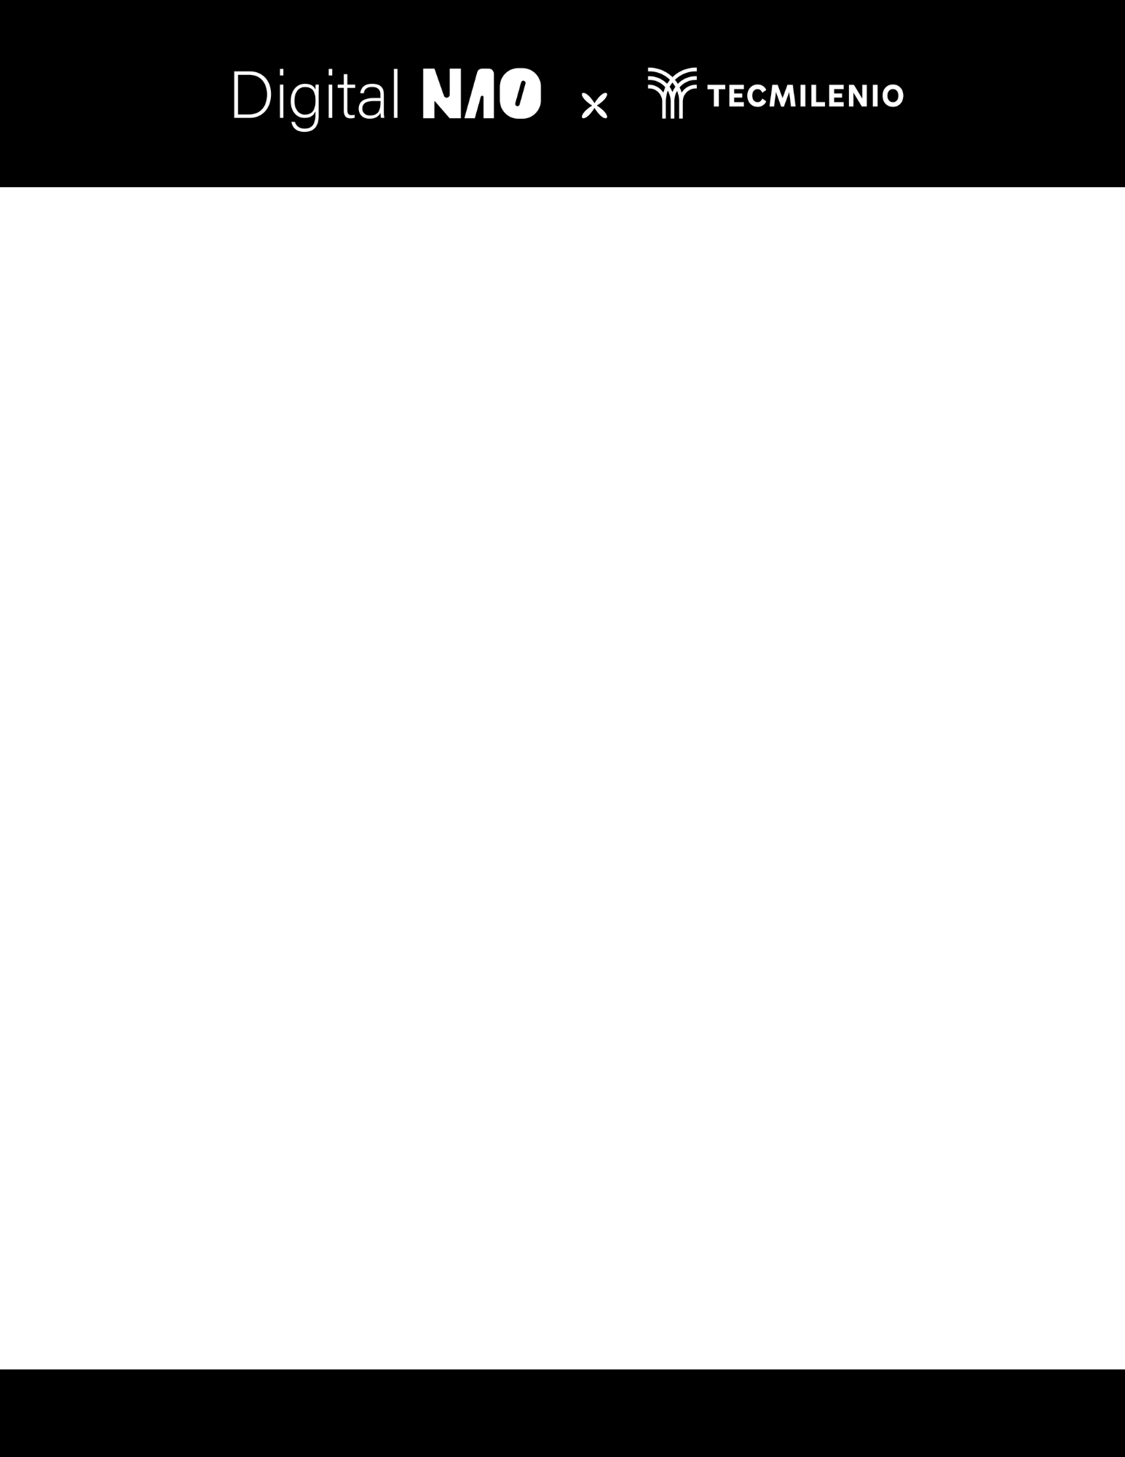

Xóchitl Analí Cabañas Mota

NAO ID: 3319

September 11th, 2025

In-Mexico Program Backend Developer Certification

GitHub and Digital Repository Management:

**Backlog**

Table 1

|  |  |
| --- | --- |
| **User Story** | **Requirements** |
| 1. As a software engineer, I want to set up my development environment with git, so that I can collaborate with the team. | The system must allow developers to configure a Git environment that supports collaboration within the company. |
| 1. As a no prior git experience developer, I want to create a GitHub account, so that I can contribute to the company’s repositories. | Developers must be able to create and access a corporate GitHub account to contribute to company repositories. |
| 1. As a new to git developer, I want to interact with files in a repository, so that I can practice. | The system must allow developers to interact with repositories using Git commands. |
| 1. As a junior software engineer, I want to work on my own branch, so that I can organize my changes before PR. | Developers must be able to work on independent branches without affecting the main branch. |
| 1. As a beginner in Git, I want to get feedback of my pull request, so that I can improve my inputs. | The system must support code review workflows via pull requests. |
| 1. As a trainee, I want to succeed on my onboarding process, so that I can integrate successfully with the team. | The onboarding process must provide access to company tools, processes, and confirmation of completion. |

Table 2

|  |  |  |  |
| --- | --- | --- | --- |
| **Requirements** | **Stages** | **Time estimation** | **Deliverables** |
| The system must allow developers to configure a Git environment that supports collaboration within the company. | 1 | 1 | * Git installed and configured on the machine (installation screenshot) * .gitconfig file with credentials * Proof of successful connection (screenshot) |
| Developers must be able to create and access a corporate GitHub account to contribute to company repositories. | 1 | 1 | * GitHub account created (profile screenshot) * Authentication setup documented (SSH key or 2FA) |
| The system must allow developers to interact with repositories using Git commands. | 1 | 1 | * Repository cloned locally * Commit history visible in git log. * Evidence of git push and git pull working (logs or screenshots) |
| Developers must be able to work on independent branches without affecting the main branch. | 2 | 1 | * New branch created * List of commits with meaningful messages * Branch pushed to remote repository (git push origin) |
| The system must support code review workflows via pull requests. | 2 | 1 | * Pull Request created on GitHub (PR screenshot) * Comments/reviews from at least one team member * Evidence of changes made after feedback (additional commits) * PR approved and merged into main |
| The onboarding process must provide access to company tools, processes, and confirmation of completion. | 3 | 5 | * Onboarding checklist completed (document/task marked on internal platform) * Evidence of practice with company tools * Written confirmation from team lead or manager (email, ticket, or signed document) |