

Xóchitl Analí Cabañas Mota

NAO ID: 3319

September 12th, 2025

In-Mexico Program Backend Developer Certification

GitHub and Digital Repository Management:

**Develop – Sprint 3**

**Table of contents**

Branch A 3

Branch B 4

Conflict 6

Revert 7

This report shows the process of branch management, conflict resolution, and change reversion in GitHub. Each section is briefly documented along a screenshot to have a graphic description.

# Branch A

This screenshot shows the creation of branch **A** from the Master branch using Git commands. This step ensures that work on branch A can proceed independently without affecting the main codebase.



Here, the docs.txt file is created in branch A, specifically for this branch.

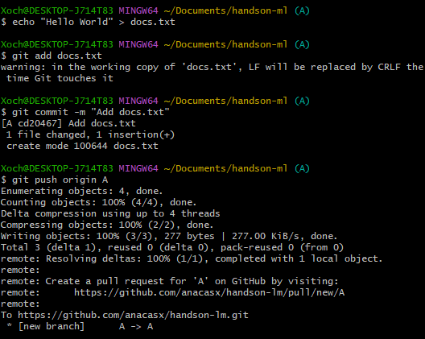

These images capture the process of opening a Pull Request (PR) from branch A to Master on GitHub.

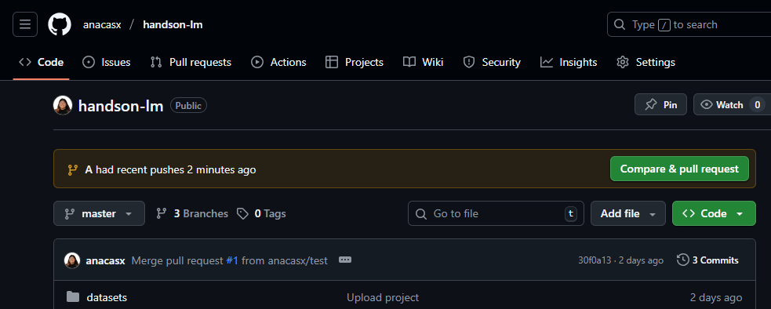

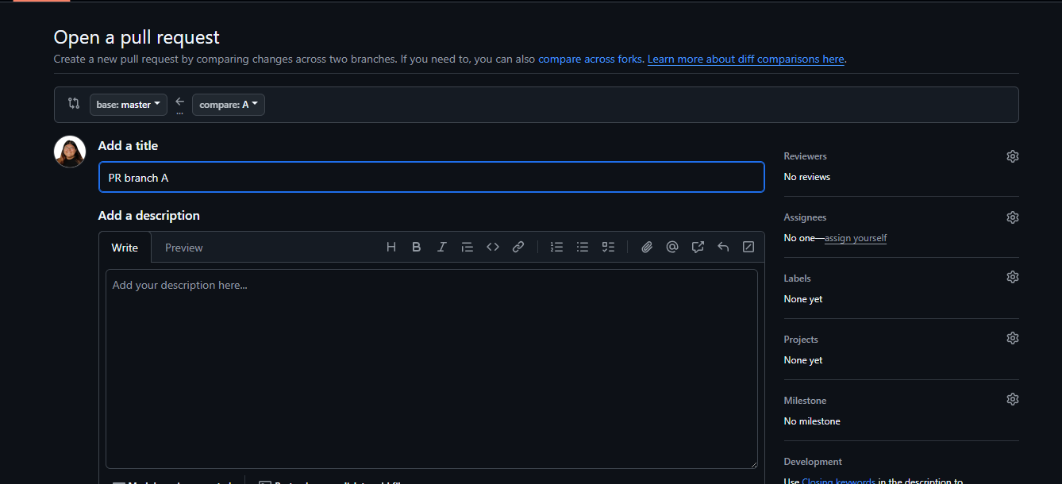

# Branch B

The screenshot shows the creation of branch **B** from Master. This ensures that development in branch B is independent and starts from the latest version of the main codebase.



A different docs.txt file is created in branch B. The screenshot confirms that both branches A and B contain distinct versions of the same file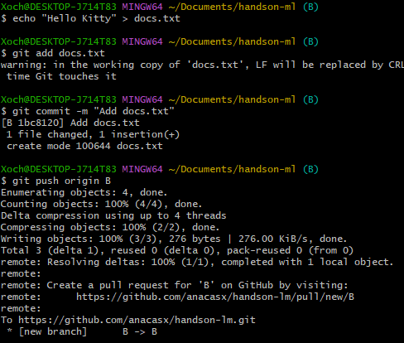

Here, a Pull Request is created from branch B to Master.

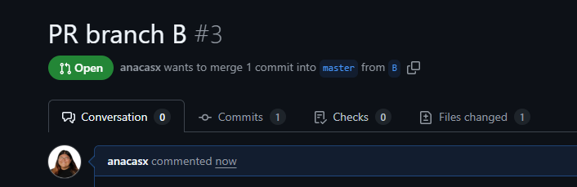

# Conflict

Trying to merge branch A.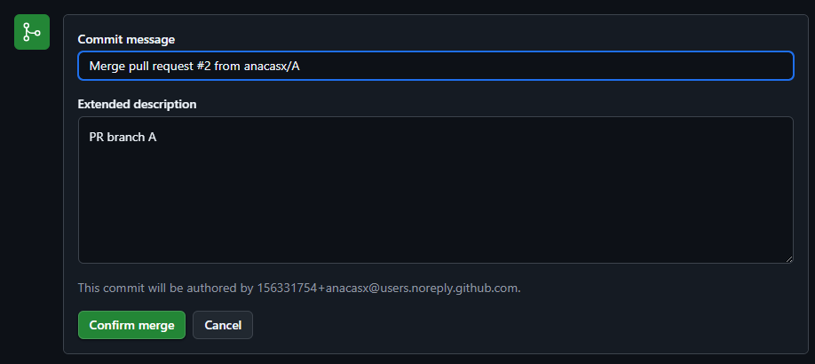

GitHub lets us know there is a conflict.

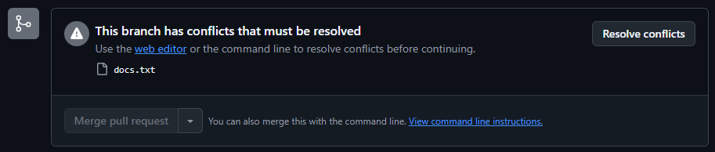

It highlights the conflict between the two versions of docs.txt. The GitHub interface displays both conflicting versions, and the resolution process involves editing and committing a unified version of the file.

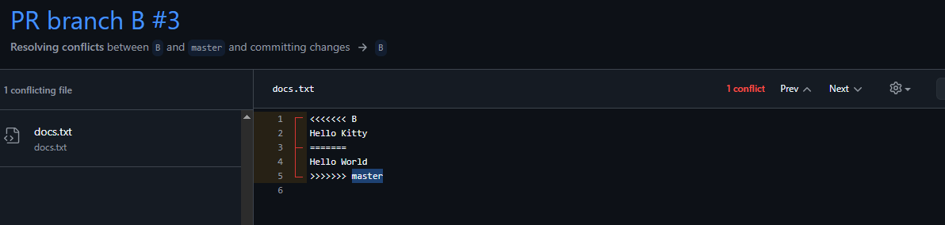

So this, a -new- version must be selected, either is the A, B or C, which would be a mix of last two.

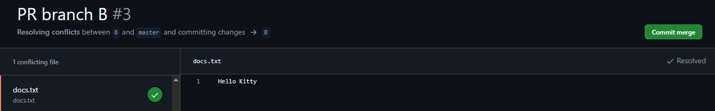

Finally, the approval and merging of both Pull Requests (A and B) into Master can be done.

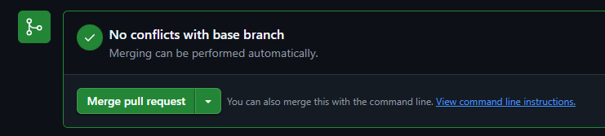

This confirms that conflicts were successfully resolved and both branches were integrated into the main project.

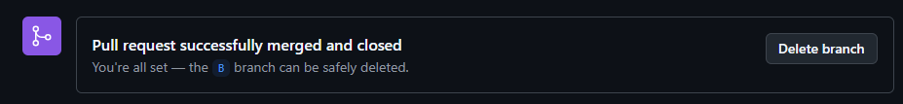

# Revert

This image demonstrates the use of the git revert command in the terminal. It shows how a specific commit can be safely undone by creating a new commit that reverses its changes.

