

Xóchitl Analí Cabañas Mota

NAO ID: 3319

September 9th, 2025

In-Mexico Program Backend Developer Certification

GitHub and Digital Repository Management:

**Develop – Sprint 1**

**Table of contents**

Executive Summary 3

Git Installation 4

Verifying Git Installation 5

SSH Key Generation 5

GitHub Configuration in Git Terminal 6

# Executive Summary

This report shows the configuration process of GitHub and Git. It includes screenshots of key steps such as account creation, installation, SSH key generation, and GitHub configuration within the Git terminal. Each section is briefly documented along a screenshot to have a graphic description.

**GitHub Account Creation**

To create a GitHub account, we go to the official page and register.  
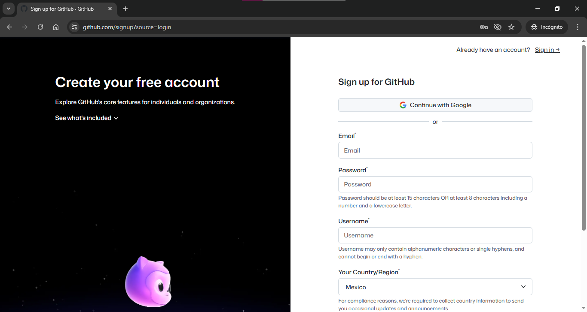

In this simple way, we can create a profile to use the cloud and organize our repositories. The profile can also be customized.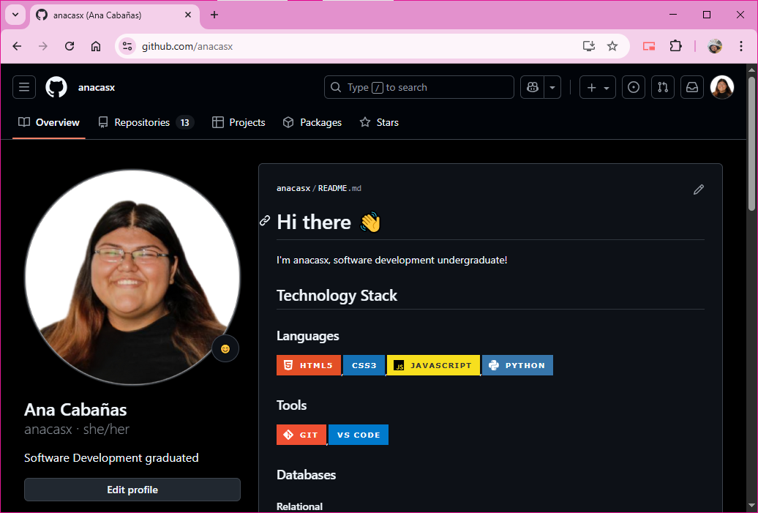

# Git Installation

To use Git in the local environment, it is necessary to install Git. In this case, for Windows, we simply access the official Git page and download the executable.  
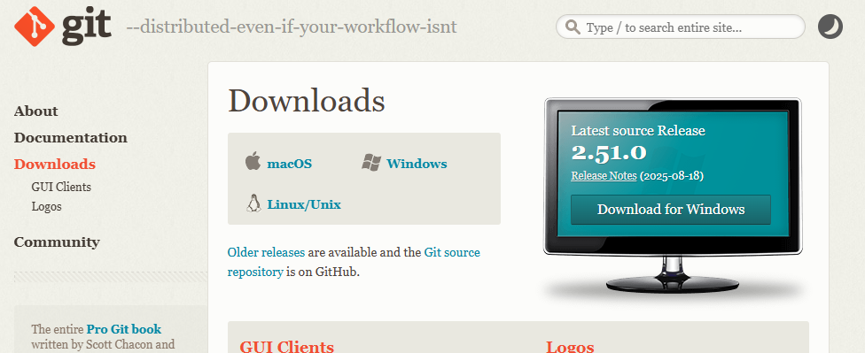

With this wizard, we can install Git in a graphical and simple manner.

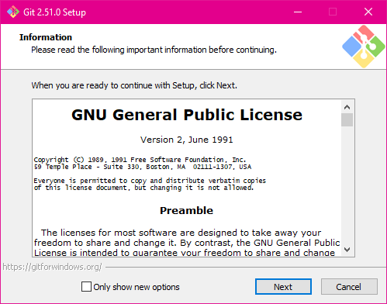

# Verifying Git Installation

To confirm that we have correctly installed Git, we can use the command git -v to display the installed version. This can be done from a CMD terminal or from Git Bash, which indirectly assumes that Git is already installed.

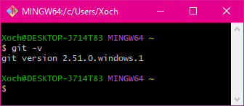

# SSH Key Generation

To create an SSH key, from Git Bash we use the command *ssh-keygen -t ed25519 -C "youremail@example.com".*

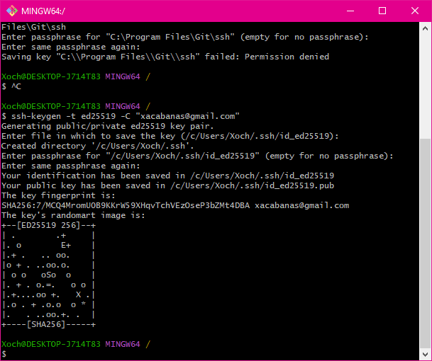

The generated key must then be added graphically to GitHub.

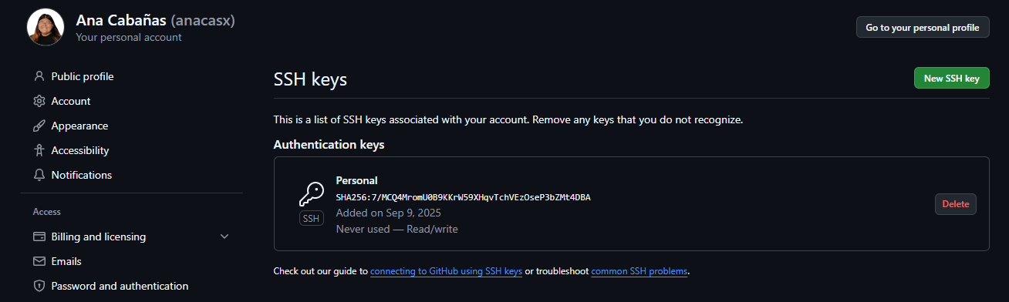

# GitHub Configuration in Git Terminal

It is also necessary to properly configure the local environment with the correct credentials.

Finally, the connection is verified with the command *ssh -T git@github.com*.