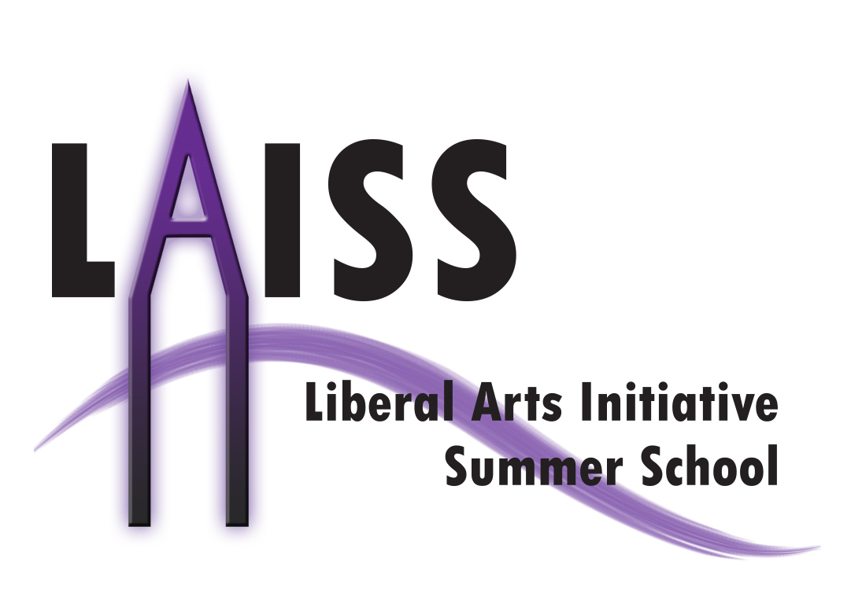

|  |  |
| --- | --- |
| Background Information (Please type your name in English and Chinese) | |
| Last Name: | First Name: |
| Current School: | |
| Dates of Attendance: | |
| Email: | Phone: |
| Skype/QQ/Social Network (*optional): | |

|  |  |  |
| --- | --- | --- |
| Standardized Test Scores (*\*if any*) including TOEFL, SAT, SAT2, AP and IB (Please attach screen shots with the form for each score): | | |
| Test | **Score** | **Date** |
|  |  |  |
|  |  |  |
|  |  |  |
|  |  |  |
|  |  |  |

|  |
| --- |
| Please list your extra-curricular activities and other achievements, including the time, position, and a brief description of each experience: |
| (Please Continue On the Next Page As Needed) |

**Liberal Arts Initiative Summer School 2014 Application Form**

|  |
| --- |
|  |

|  |
| --- |
| Please list the three most recent books you have read and write a short comment of *no more than 100 words* on *ONE* of them. |
|  |

|  |
| --- |
| Please write a personal statement of *no more than 400* words. You may write about your background, academic interests, life experiences, future plans and other things you would like us to know about you. Please also spend one paragraph stating why you are interested in our program and American higher education as a whole. *Please note that a concise but insightful response is more helpful than a long windy one.* |
| (Please Continue On the Next Page As Needed) |

|  |
| --- |
|  |

|  |
| --- |
|  |

If you think we are missing out on something that would be helpful to your application, you are welcomed to submit supplements in written or other forms.

Please do not hesitate to contact us at [laiss.common@gmail.com](mailto:laiss.common@gmail.com) for further information if you have any questions and concerns.

Thank you very much for your interest in LAISS and best wishes!

Plea