**MOTO CARE COVER INGOBOKA NA BBOXX POLICY**

**WHEREAS** the insured by a proposal and declaration stated in the schedule which shall be the basis of this contract and is deemed to be incorporated herein has applied to RADIANT YACU Ltd (called “The Company” in this Policy) for the insurance hereinafter contained and has paid or agreed to pay the premium as consideration for such insurance in respect of accident loss or damage occurring during the period of insurance.

**Now this policy witnesseth:**

That subject to the terms, exceptions and conditions contained herein or endorsed or otherwise expressed hereon, the Motor bike listed and described on the Matrix which follow the Policy Schedule are hereby insured subject to the specific Section of Cover granted by this policy and as indicated in the Policy Schedule which terms and conditions are fully detailed herein

**THE SCHEDULE**

|  |  |  |  |
| --- | --- | --- | --- |
| **The Company** | **RADIANT YACU Ltd** | | |
| **Address** | **P.O. Box 1861 Kigali-Rwanda** | | |
|  |  |  |  |
| **Policy Number** | {police} | | |
|  |  |  |  |
| **The subscriber** | {names} | | |
| **Address** | {address} | | |
| **Telephone** | {phone} | | |
| **E-mail** | {email} | | |
|  |  |  |  |
| **The Insured** | {names} | | |
| **TIN /Id Number** | {nid} | | |
|  |  |  |  |
|  |  | | |
|  |  |  |  |

**Period of Insurance** (a) From: {start_date} To: {end_date} (Both dates inclusive)

(b)Any subsequent period for which the Insured shall pay, and the Company shall agree to accept a renewal premium.

**Geographical Area** Rwanda.

**BIKE DETAILS**

|  |  |  |  |
| --- | --- | --- | --- |
| **Make** | {make} | **Type** | {bike_type} |
| **Plate Nº** | {plateno} | **Chassis Nº** | {chessis} |
| **Year of Manuf.** | {manufactured_year} | **Sum Insured** | {sum_insured} |
| **Number of Seats** | {number_seats} | **Owner** | {owner} |
| **Usage** | {usage} | | |

|  |
| --- |
|  |

|  |  |  |  |
| --- | --- | --- | --- |
| **COVERS** | **SUM INSURED** | **EXCESS /FRANCHISE** | **ANNUAL NET PREMIUM** |
| **Moto Care Cover Ingoboka** | 1,800,000 Frw | 100,000 Frw | 53,348 FRW |

|  |  |  |
| --- | --- | --- |
| Net premium | 53,348 | FRW |
| Policy fees | 5,000 | FRW |
| VAT (18%) | 10,502 | FRW |
| **Total to be paid All taxes inclusive** | **68,850** | **FRW** |

**Entered by** {utilis}

**Done at** Kigali **on** {creation_date}. **Printed by** {utilis} **on** {current_date}

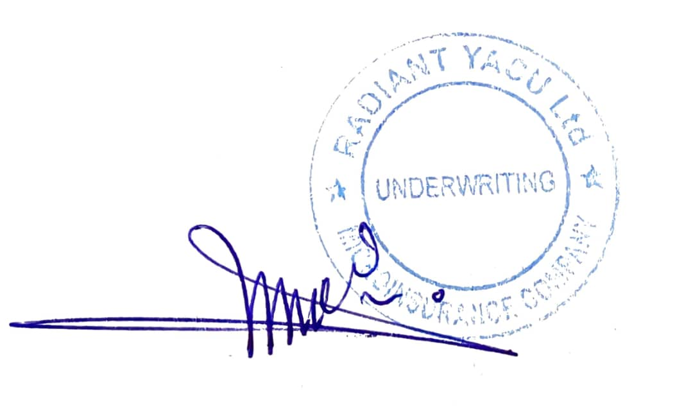

**FOR AND ON BEHALF OF THE INSURED**

**SUBSCRIBER**

**FOR AND ON BEHALF OF THE COMPANY**

**RADIANT YACU LTD**

**SECTIONS OF THE POLICY**

It's agreed and understood that the cover in front of which is written the word "Not Applicable(N/A)" in the schedule is not covered regardless its wording appears anywhere in this policy.

**1. LOSS OR DAMAGE**

The Company will indemnify the insured against loss of or damage to the Motor Bike and/or its accessories whilst thereon

(a) by accidental collision or overturning.

(b) by fire, external explosion, self-ignition or lighting

**The company shall not be liable to pay for:**

(i) consequential loss depreciation wear and tear mechanical or electrical breakdowns failures or breakages.

(ii) damage caused by overloading or strain

(iii) damage caused by explosion of any boiler forming part of attached to or on the Motor Bike

(iv)Whilst in transit (including the process of loading and unloading incidental to such transit) by road, rail, inland water way, lift or elevator.

(v) damage to tires

**Repair Authorization**

The insured may authorize the repair of the Motor Bike necessitated by damage for which the company may be liable under this policy provided that:

(a) the estimated cost of such repair does not exceed the Authorized Repair Limit

(b) the company is furnished with a detailed estimate of the cost and

(c) the insured shall give the company every assistance to see that such repair is necessary and the charge reasonable.

**2. GENERAL EXCEPTIONS**

The Company shall not be liable under this Policy in respect of

(1) any accident loss damage and/or liability caused sustained or incurred outside the Geographical Area

(2) any damage to goods transported by this bike

(3) any damage caused solely by the transported goods or by any other goods handling necessitated by transport and which do not result from the use of the bike

(4) any claim arising out of any third-party contractual liability

(5) any accident loss damage and/or liability caused sustained or incurred whilst any Motor Bike in respect of or in connection with which insurance is granted under this Policy is

(a) being used otherwise than in accordance with the Limitations as to Use or

(b) being driven by any person other than a fully licensed and authorized Driver

(6)

(a) any accident loss or damage to any property whatsoever or any loss or expense whatsoever resulting or arising therefrom or any consequential loss

(b) any liability of whatsoever nature directly or indirectly caused by or contributed to by or arising from ionizing radiations or contamination by radio activity from any nuclear fuel or from any nuclear waste from the combustion of nuclear fuel. For the purposes of this exception combustion shall include any self-sustaining process of nuclear fission.

(7) any accident loss damage or liability directly or indirectly caused by or contributed to by or arising from nuclear weapons material.

(8) The amount indicated in the Policy as the Insured's Retained Liability - Policy Excess

(9) In the event of Total Loss of the Bike; the insurer shall only be liable to the extent of the Current Market Value of the bike immediately before the loss after taking due cognizance of the Depreciated value of the bike given the age of the bike from the actual date of Manufacture

(10) The Company shall not be liable except under Section 1 (a) of this Policy in respect of any accident loss damage and/or liability directly or indirectly proximately or remotely occasioned by contributed to by or traceable to or arising out of or in connection with flood, typhoon, hurricane, volcanic eruption, earthquake or other convulsion of nature, invasion, the act of foreign, enemies, hostilities or warlike operations (whether before or after declaration of war) civil war, strike, riot, civil commotion, mutiny, rebellion, revolution, insurrection, military, terrorism, sabotage or usurped power or by any direct or indirect consequences of any of the said occurrences and in the event of any claim hereunder the Insured shall prove that the accident loss damage and/or liability arose independently of and was in no way connected thereof and in default of such proof the Company shall not be liable to make any payment in respect of such a claim.

**3.GENERAL CONDITIONS**

The Policy and the Schedule shall be read together and any word or expression to which a specific meaning has been attached in any part of this Policy or of the Schedule shall bear the same meaning wherever it may appear by

1. Notice shall be given in writing to the Company immediately upon the occurrence of any accident or loss or damage and in the event of any claim. Every letter claim writ summons and/or process shall be forwarded to the Company immediately on receipt by the Insured. Notice shall also be given in writing to the Company immediately the Insured shall have knowledge of any impending prosecution inquest or fatal inquiry in respect of any occurrence which may give rise to a claim under this Policy. In case of or other criminal act which may be the subject of a claim under this Policy the Insured shall give immediate notice to the Police and co-operate with the Company in securing the conviction of the offender.

2. No admission offer promise payment or indemnity shall be made or given by or on behalf of the Insured without the written consent of the Company which shall be entitled if it so desires to take over and conduct in the name of the Insured the defence or settlement of any claim or to prosecute in the name of the Insured for its own benefit any claim for indemnity or damages or otherwise and shall have full discretion in the conduct of any proceedings or in the settlement of any claim and the Insured shall give all such information and assistance as the Company may require.

3. At any time after the happening of any event giving rise to a claim or series of claims under sub-section 1 (b) of Section II of this Policy the Company may pay to the Insured the full amount of the Company’s liability under that sub-section and relinquish the conduct of any defence settlement or proceedings and the Company shall not be responsible for any damage alleged to have been caused to the Insured in consequence of any alleged action or omission of the relinquishing such conduct nor shall the Company be liable for any costs or expenses whatsoever incurred by the Insured or any claimant or other person after the Company shall have relinquished such conduct.

4. The Company may at its own option repair reinstate or replace the Motor Bike or part thereof and/or its accessories or may pay in cash the amount of the loss or damage and the liability of the Company shall not exceed the actual value of the parts damaged or lost plus the reasonable cost of fitting and shall in no case exceed the Insured’s estimate of the value of the Motor Bike (including accessories thereon) as specified in the Schedule or the value of the Motor Bike (including accessories thereon) at the time of the loss or damage whichever is the less.

5. The Insured shall take all reasonable steps to safeguard the Motor Bike from loss or damage and to maintain it in efficient condition and the Company shall have at all times free and full access to examine the Motor Bike or any part thereof or any driver or employee of the Insured. In the event of any accident or breakdown the Motor Bike shall not be left unattended without proper precautions being taken to prevent further damage or loss and if the Motor Bike be driven before the necessary repairs are affected any extension of the damage or any further damage to the Motor Bike shall be entirely at the Insured’s own risk.

6. The Company may cancel this Policy by sending fourteen (14) days’ notice by registered letter to the Insured at his last known address and in such event will return to the Insured the premium paid less the pro rata portion thereof for the period the Policy has been in force or the Policy may be cancelled at any time by the Insured on fourteen (14) days’ notice and (provided no claim has arisen during the then current period of Insurance) the Insured shall be entitled to a return of premium less premium at the Company’s Short Period rates for the period the Policy has been in force.

7. AVOIDANCE OF CERTAIN TERMS AND RIGHT OF RECOVERY: Nothing in this Policy or any endorsement hereon shall affect the right of any person indemnified by this Policy or any other person to recover an amount under or by virtue of the provisions of the Legislation. BUT the Insured shall repay to the Company all sums paid by the Company, which the Company would not have been liable to pay, but for the said provisions.

8. The parties agree that any dispute arising from the honoring or interpretation of this policy shall be settled amicably. Failure to amicable agreement, the matter shall be referred to the competent Courts of Law in Rwanda.

9. The due observance and fulfillment of the terms, conditions, and endorsements of this Policy in so far as they relate to anything to be done or complied with by the Insured and the truth of the statements and answers in the said proposal shall be conditions precedent to any liability of the Company to make any payment under this Policy.

**Limitations as to Use:**

Use in connection with the Policy holder’s business.

The policy does not cover:

1) Use for racing, pace-making, reliability trial or speed-testing.

2) Use whilst drawing a trailer except the towing (other than for reward) of any one disabled mechanically propelled bike.

3) Fare paying passengers

4) Use for Charter/Hire services or Liabilities arising there-from

**4. ENDORSEMENTS**

The following endorsements shall apply to this policy:

**1. INTOXICATING LIQUORS OR DRUGS CLAUSE**

Warranted that the Company shall not be liable to make any payment in respect of any accidents, loss, damage or fire, caused or arising whilst the Motor Bike in connection with which insurance or indemnity is granted hereunder is being driven by the insured (or by any person) provided he is in the Insured’s employment and/or is driving on his order (or with his permission) whilst under the influence of or whilst his efficiency as a driver is impaired by intoxicating liquors or drugs.

**2. CLAIM SETLEMENT CLAUSE**

In case of a claim, the following procedure shall be followed:

1. Notify the claim/loss to The Company at its Head office within 5 working days from the date of its occurrence. The information to be provided are policy number, Date of the claim event, Location of the claim event, causes of the claim, circumstance of the claim, damages

2. Provide required documents: Copy of bike identification certificate, Copy of Driving License, copy of the contract, pictures, police report, the estimate for reparation and any other useful documents.

3. The company shall not be liable to pay any own damage claim for which required documents are not provided within 60 days from the date of accident.

**3. TOTAL LOSS SETTLEMENT ON PRE-ACCIDENT VALUES BASIS**

The value of the bike(s) shown in this policy is not necessarily the amount payable by the Company in the event of a Total Loss since their liability is limited to the MARKET VALUE or value shown in the policy which ever the less is.

**4. REPLACEMENT PARTS (USE AND WORDING OPTIONAL)**

It is hereby understood and agreed that notwithstanding anything to the contrary in this policy that in the event of loss, damage or fire to the Motor Bike and/or its accessories necessitating the supply of a part not obtainable from stocks held in the country in which the Motor Bike is held for repair or in the event of the company exercising the option under Condition 3 to pay in cash the amount of the loss or damage the liability of the company in respect of any such part shall be limited to:

(i) The price quoted in the latest catalogue or price list issued by the Manufacturer or his Agents for the country in which the Motor Bike is held for repair or

(ii) If no such catalogue or price list existing the price last obtaining at manufacturer’s works plus the reasonable cost of transport otherwise than by air to the country in which the Motor Bike is held for repair and the amount of the relative import duty and

(iii) The reasonable cost of fitting such part.

.

**4. JURISDICTION CLAUSE**

Notwithstanding anything contained herein to the contrary, the Laws of Rwanda shall apply in the event of any dispute arising from this contract.

**6. NO PREMIUM NO COVER (NPNC)**

It is hereby agreed and understood that there is no insurance without payment of premium.

Nevertheless, for institutions and agencies permitted by the regulation, the cover accorded herein will stand NULL AND VOID if the considerate premium is not paid in FULL within forty-five (45) days from the inception date of the policy. If policy is not paid within fifteen (15) days after the above stated period, the cover will automatically be cancelled without notice and the insurer will be released from any liability in respect to this contract and the insured will pay premium for period from the inception of the policy up to cancellation date.

It is warranted that if the payment of Premium under the Policy has been made through a cheque and if the cheque is returned unpaid for whatever reasons, the policy will be null and void since inception without notice if the insured doesn’t pay the premium within seven (7) days after the cheque is returned and no liability to the insurer shall attach under the Policy.

The premium for short period insurance is paid upfront at the inception of the policy

**FOR AND ON BEHALF OF THE INSURED**

**…………………………………………**

**FOR AND ON BEHALF OF THE COMPANY**

**……………………………………..**

