Project – Linear and Logistic Regression
Name – Anadi Ranjan
Problem Statement - HarborPort experiences significant variability in ship turnaround times, affecting berth scheduling and resource allocation. Turnaround time, measured in hours from a ship’s arrival to its departure, is influenced by factors such as vessel size, cargo type, port congestion, and weather conditions. The goal is to develop a predictive model that estimates turnaround time based on these variables, enabling the port to plan operations more efficiently and minimize delays.
Objective - Requirement is to develop a multiple linear regression model that uses relevant ship and port variables to estimate turnaround time in hours. Alternatively, HarborPort consider converting turnaround time into categories like “Low TAT” and “High TAT” to classify ship visits via logistic regression, aiding quick assessment and decision-making.
Analysis –
- Ship_SizeGT: Continuous
- Cargo_Type: Categorical (Bulk, Container, General Cargo, Oil, RoRo)
- Cargo_Volume: Continuous.
- Crane_Moves: Number of crane operations (Continuous)
- Berthing_Priority: Low number means higher priority (Continuous)
- Berths_Occupied: Number of berths busy on arrival (Continuous)
- Crew_Size: Number of people aboard. (Continuous)
- Tide_m: Tide height upon arrival (Continuous).
- Port_Cong_Index: Composite congestion, 1 (low) – 10 (high) (Continuous)
- Customs Inspections: Number of required inspections (Continuous)
- Weather Severity: 1 (mild) – 5 (severe conditions during operation) (Continuous)
- Equipage: Age of handling equipment (Continuous).
- Turnaround_Time_hrs: Target variable. (Continuous)
Observation after applying the Regression Model –
Value of R square = 0.9058, Which means xi’s can explain 90.58% of the variance of y, which means model is good.
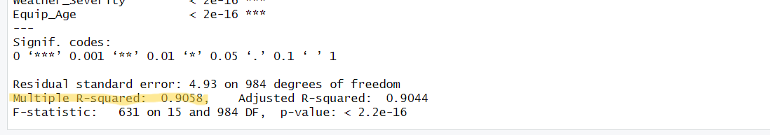
Linear Equation Y= 9.226 + 0.000108(Ship_SizeGT) + 0.9076(Cargo_typeContainer) + 0.2911(Cargo_TypeGeneral Cargo) + 0.7935(Cargo_TypeOil) - 0.4503(Cargo_TypeRORO) + 0.000343(Cargo_Volume) + 0.003288(Crane_Moves) - 2.162(Berthing_Priority) + 1.495(Berths_Occupied) - 0.01457(Crew_Size) - 0.1111(Tide_m) + 2.012(Port_Cong_Index) + 0.334(Customs_Inspections) + 3.004(Weather_Severity) + 0.5432(Equip_Age)
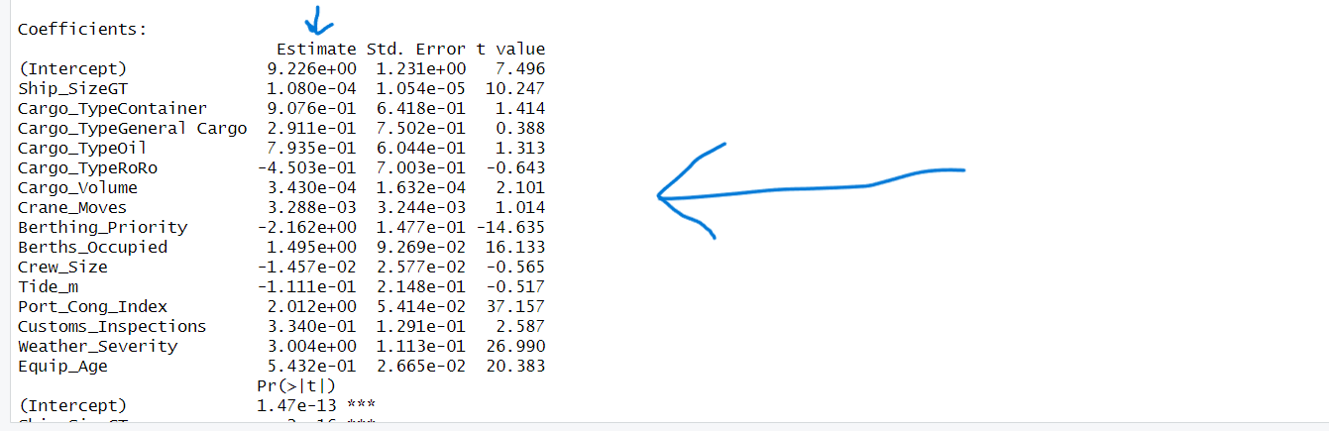
Analysis of the Linear Equation-
- CargoType Bulk was snatched by the model, so whenever need to calculate turnaround time for Bulk, we will put CargoTypeContainer = 0, CargoTypeGenral Cargo = 0, CargoTypeOil = 0 and CargoTypeRoRo = 0.
- Intercept value = 9.226, which represents the predicted value of the dependent variable (Turnaround time) when all the predictors (independent variables) are set to 0, here it includes value for Bulk
- For 1 unit increase in Ship size, turnaround time increases by 0.000108 hours.
- Turnaround time for Cargo_type, container will be 0.9076 hours more compare to Cargo_type, bulk.
- Turnaround time for Cargo_Type, General cargo will be 0.2911 hours more compare to Cargo_type, bulk.
- Turnaround time for Cargo_type, Oil tanker will be 0.7935 hours more compare to Cargo_type, bulk.
- Turnaround time for Cargo_type, RoRo will be 0.4503 hours less compare to Cargo_type, bulk.
- For every 1 unit increase in Volume, turnaround time increases by 0.000343 hours.
- For every additional crane move, turnaround time increase by 0.003288 hours
- For every 1 unit increase in berthing priority, turnaround time decreases by 2.162 hours. (Lower number means higher priority)
- For 1 unit increase in berth occupied when ship arrives, turnaround time increases by 1.495 hours.
- For each additional crew members, turnaround time decreases by 0.01457 hours
- For 1 unit increase in tide level at arrival, turnaround time decreases by 0.1111 hours.
- For 1 unit increase in congestion index, turnaround time increases by 2.012 hours.
- For each additional customs inspection, turnaround time increases by 0.3340 hours
- For each increase of severity level, turnaround time increases by 3.004 hours
- For every 1-year increase in age of equipment, turnaround time increases by 0.5432 hours.
Divided the Data into Train data and Test data, where number of rows in Train data is 700 and number of rows in Test data is 300
Now, To Evaluate the Model will check MAE (model) and MAE (base)
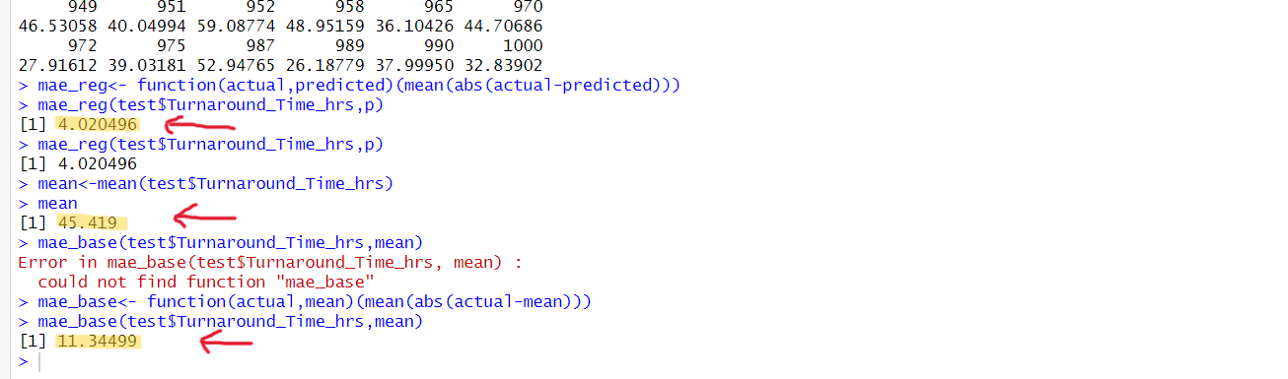
- Mean turnaround time in test data = 45.419
- MAE (model) = 4.020496
- MAE (base) = 11.34499
Analysis - Regression model reduces the average prediction error from about 11.34 hours to about 4.02 hours, a significant improvement over the base. So, it is advisable for to use the regression model to predict future turnaround time.
For population, it is observed that adjusted R square value= 0.9044 or 90.44%. which means xi’s can explain 90.44% of the variance of y, which means model is good.
Compare the LOS with p-sig value It is observed that –
- Intercept (***)
- Ship_Size (***)
- Cargo_Volume (*)
- Berthing_Priority (***)
- Berths_Occupied (***)
- Port_Cong_Index (***)
- Customs_Inspections (**)
- Weather_Serverity (***)
- Equip_Age (***)
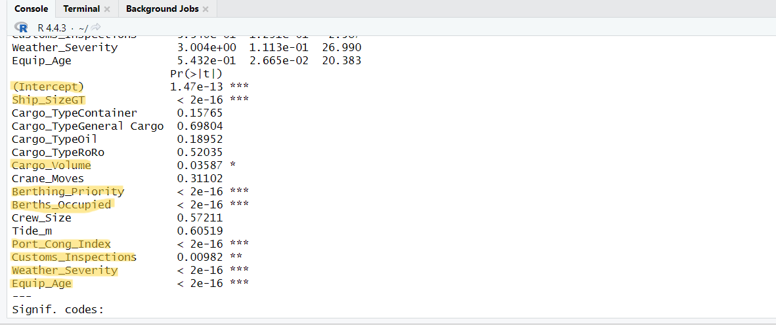
Regression line for Population will be –
Y= 9.226 + 0.000108(Ship_SizeGT) + 0.000343(Cargo_Volume) – 2.162(Berthing_Priority) + 1.495(Berth_Occupied) + 20.12(Port_Cong_index) + 0.3340(Customs_Inspection) + 3.004(Weather_Severity) + 0.5432(Equip_Age)
To Classify in Low TAT and High TAT, we need to apply the Logistic regression.
- For that we need to modify the dependent variable (turnaround time), here, we have taken the mean of all the turnaround time and for a particular entry if turnaround time is greater than mean it is classified as High TAT (1) and if turnaround time is less than mean it is classified as Low TAT (0).
- Converted the dependent variable (turnaround time) to factors.
- Applied the logistic regression.
Analysis –
Regression curve -
log(p/1-p) = −15.48 + 0.00002746(Ship_SizeGT) + 0.1836(Cargo_TypeContainer) − 0.9588(Cargo_TypeGeneralCargo) + 0.3926(Cargo_TypeOil) − 0.0826(Cargo_TypeRoRo) – 0.00009159(Cargo_Volume) + 0.006039(Crane_Moves) – 1.123(Berthing_Priority) + 0.7323(Berths_Occupied) − 0.07271(Crew_Size) + 0.1855(Tide_m) + 0.9026(Port_Cong_Index) + 0.3131(Customs_Inspections) + 1.496(Weather_Severity) + 0.2507(Equip_Age)​
- Here the regression coefficient shows the change in the logit for 1 unit change in the x (independent) variable.
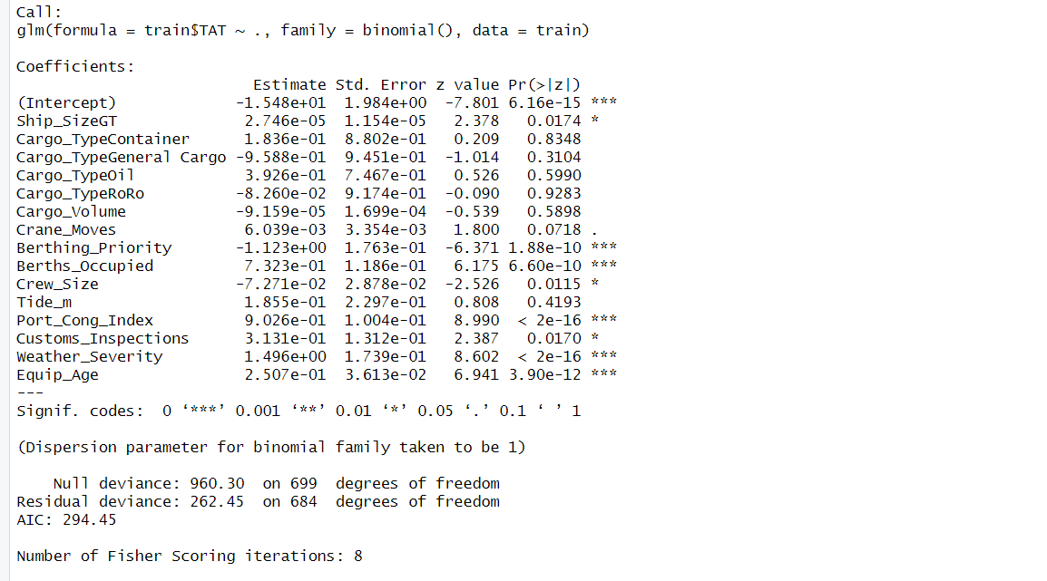
To Calculate the accuracy of the model will use confusion matrix
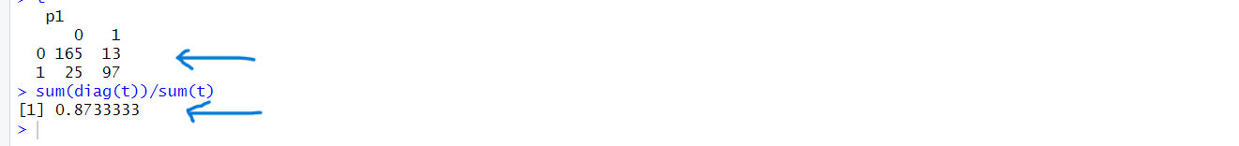
Observation –
- True negative = 165
- False Negative = 25
- False positive = 13
- True positive = 97
Accuracy = True Negative + True Positive/Total = (165+97) / (165+25+13+97) = 262/300= 0.8733
Which means that about 87.33% of the predictions made by model match the actual observed outcomes in our test dataset.
Conclusion –
The analysis demonstrates that both the Multiple Linear Regression and Logistic Regression models developed in this study are capable of accurately predicting vessel turnaround time at HarborPort. The regression model effectively estimates continuous turnaround times based on operational and environmental factors, while the logistic model reliably classifies turnaround time into categorical outcomes, aiding in quick decision-making.
Given their strong performance metrics and predictive power, it is recommended that HarborPort proceeds with deploying these models into its operational workflow. Doing so will enable data-driven berth scheduling, optimized resource allocation, and proactive management of delays, ultimately improving port efficiency and competitiveness.

