STUDENT ACADEMIC PERFORMANCE

Complete Project Documentation

Based on the UCI Student Performance Dataset Educational Data Mining & Analytics | Mathematics and Portuguese

Prepared for College Project Submission

Project Overview

Dataset source | UCI Machine Learning Repository
Dataset | Student Performance
Subjects | Mathematics and Portuguese
Total records | 1,044 (395 Mathematics + 649 Portuguese)
Attributes | 33
Main target | Final grade (G3)
Grade scale | 0–20
Main tools | Python, Pandas, NumPy, Matplotlib, Seaborn

This document consolidates the project sections from Introduction through Conclusion. Tables and graph images are inserted at the relevant points so the document can be directly used for college documentation or imported into Google Docs.

Introduction and Objective
  - Student Academic Performance analysis studies the academic outcomes of secondary school students using educational and socio-economic information.
  - The project is based on the Student Performance dataset available from the UCI Machine Learning Repository.
  - The study covers students from two Portuguese secondary schools.
  - Two subjects are represented: Mathematics and Portuguese language.
  - The Mathematics dataset contains 395 student records, while the Portuguese dataset contains 649 records.
  - The datasets contain 33 attributes describing students, their families, school support, social activities, and academic results.
  - The main academic variables are G1, G2, and G3, representing first-period, second-period, and final grades.
  - Grades are recorded on a scale from 0 to 20.
  - The project examines demographic factors such as age, sex, address, and family status.
  - It also studies behavioural factors such as study time, free time, going out, and alcohol consumption.
  - Family and educational factors such as parental education and support are also considered.
  - One objective is to understand whether G1 and G2 can act as early indicators of final performance.
  - Another objective is to identify factors associated with lower or higher final grades.
  - The analysis also compares Mathematics and Portuguese performance where appropriate.
15.The overall goal is to support data-driven understanding of student performance and possible academic interventions.

Dataset Description
  - The dataset is named Student Performance and is provided through the UCI Machine Learning Repository.
  - It contains two separate files: student-mat.csv for Mathematics and student-por.csv for Portuguese.
  - The Mathematics file contains 395 observations and the Portuguese file contains 649 observations.
  - Together, the two files represent 1,044 student-course records.
  - The students come from two Portuguese secondary schools: Gabriel Pereira (GP) and Mousinho da Silveira (MS).
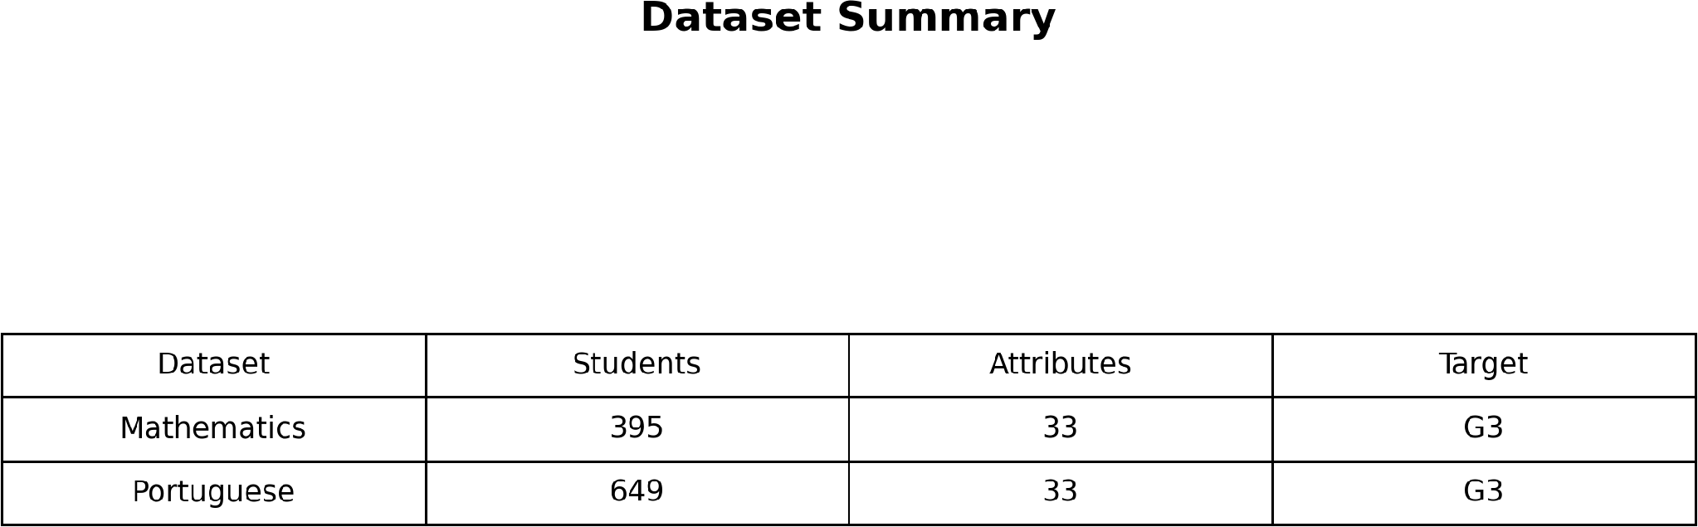

Table 1: Dataset summary
  - Some students appear in both subject datasets, allowing comparison across subjects for overlapping students.
  - Each record represents a student and includes academic, demographic, social, family, and school-related attributes.
  - The dataset contains 33 attributes in each subject file.
  - G1 represents the first-period grade, G2 represents the second-period grade, and G3 represents the final grade.
  - G3 is the principal outcome variable used in the academic performance analysis.
  - Attendance-related information is represented through the absences variable.
  - Questionnaire information includes study time, school support, family support, activities, and social behaviour.
  - Parental education is measured using ordered education levels for mother and father.
  - The dataset is suitable for descriptive, bivariate, correlation, grouping, visualization, and predictive analysis.
  - The combination of academic and contextual variables makes the dataset useful for educational data mining.

Data Types and Variables
  - The dataset contains categorical, ordinal, time-scale, and numerical variables.
  - Binary categorical variables include school, sex, address, family size, and parental status.
  - Support indicators include school support, family support, paid classes, and extracurricular activities.
  - Aspiration and domestic variables include higher education intention, nursery attendance, and romantic relationship status.
  - Nominal categorical variables include mother's job, father's job, reason for choosing school, and guardian.
  - Parental education variables Medu and Fedu are ordinal education-level measures.
  - Family relationship, free time, going out, alcohol consumption, and health are ordinal scale variables.
  - Travel time and study time represent ordered time categories.
  - Failures is a discrete numerical variable representing previous class failures.
  - Age is a discrete numerical variable, with observed ages from 15 to 22.
  - Absences is a discrete count of school absences.
  - G1, G2, and G3 are numerical academic grades measured from 0 to 20.
  - G3 is treated as the main target variable for performance analysis.
  - Categorical variables help compare academic performance between student groups.
  - Numerical variables support descriptive statistics and correlation analysis.

Tools Used for Analysis
  - Python is used as the main programming language for data analysis.
  - Pandas is used for reading, cleaning, transforming, and summarizing the datasets.
  - NumPy supports numerical operations and data processing.
  - Matplotlib is used to create standard statistical charts.
  - Seaborn is used for enhanced statistical visualization.
  - SciPy can be used for statistical analysis and correlation-related calculations.
  - Jupyter Notebook provides an interactive environment for running and documenting analysis.
  - Visual Studio Code can be used for project development and Python execution.
  - Git supports version control for the project source code.
  - GitHub can be used to store and manage the project repository.
  - CSV files provide the input data for the analysis.
  - Python's pathlib module can be used for organized file and folder management.
  - Graphs can be stored in a separate graphs folder for project documentation.
  - The analysis workflow includes loading, inspecting, validating, summarizing, grouping, and visualizing data.
  - These tools together provide a complete environment for reproducible student performance analysis.

Data Quality Assessment
  - The project report identifies zero missing or null cells in the analyzed dataset.
  - No duplicate records were identified in the data quality assessment.
  - Variable data types are consistent with their intended meanings.
  - G1, G2, and G3 values are constrained to the expected 0–20 grading scale.
  - Age values fall within the observed range of 15 to 22 years.
  - Categorical values were checked against the expected categories.
  - The Mathematics dataset has an average of 5.71 absences.
  - The maximum Mathematics absence count is 75, showing a wider spread than the average.
  - There are 38 Mathematics students with a final grade of zero.
  - Absence counts should therefore be considered when interpreting academic outcomes.
  - Ordinal variables use structured category levels suitable for grouped analysis.
  - Binary variables use consistent yes/no or categorical representations.
  - The data quality assessment supports using the dataset for descriptive and correlation analysis.
  - Although the dataset has no missing cells, zero grades require careful interpretation because they may represent very low performance.
  - Overall, the reported quality checks indicate that the dataset is ready for analytical processing.

Descriptive Statistics
  - The Mathematics final grade G3 has a mean of 10.42.
  - The Mathematics G3 standard deviation is 4.58, showing substantial variation among students.
  - The Mathematics G3 median is 11.
  - The Portuguese G3 mean is 11.91, higher than the Mathematics mean.
  - The Portuguese G3 standard deviation is 3.23.
  - The Portuguese G3 median is 12.
  - The average age is 16.70 years in Mathematics and 16.74 years in Portuguese.
  - Average study time is 2.04 in Mathematics and 1.93 in Portuguese on the dataset's ordered scale.
  - Average previous failures are 0.33 in Mathematics and 0.22 in Portuguese.
  - Average absences are 5.71 in Mathematics and 3.66 in Portuguese.
  - Mathematics G1 has a mean of 10.91.
  - Mathematics G2 has a mean of 10.71.
  - Portuguese G1 has a mean of 11.40.
  - Portuguese G2 has a mean of 11.57.
  - These statistics provide a numerical baseline for comparing student performance and related characteristics.
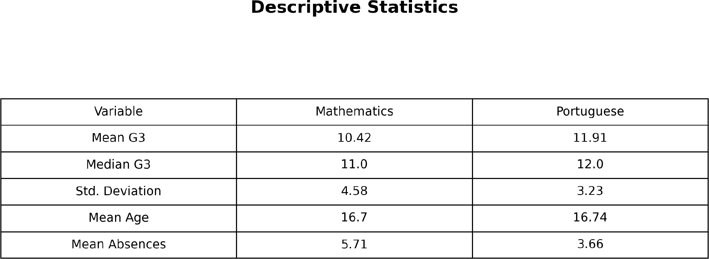

Table 2: Descriptive statistics

Univariate Analysis
  - The distribution of Mathematics G3 is concentrated around the middle of the 0–20 grade scale.
  - The final-grade distribution shows many students around grades 10–12.
  - A visible group of Mathematics students has a final grade of zero.
  - Female students represent 52.6% of the Mathematics sample, while male students represent 47.4%.
  - Most Mathematics students are from the GP school, representing 88.3% of the sample.
  - MS students represent 11.7% of the Mathematics sample.
  - Urban students account for 77.7%, while rural students account for 22.3%.
  - Most students, 94.9%, report an intention to pursue higher education.
  - Only 5.1% report no higher-education intention.
  - More than 69% of students have daily alcohol consumption at level 1.
  - Weekend alcohol consumption shows a wider distribution across the ordered levels.
  - Most students, 89.6%, have parents living together according to the Pstatus variable.
  - About 82.8% of Mathematics students have internet access at home.
  - These single-variable distributions describe the overall composition of the student population.
  - Univariate analysis is useful for understanding the structure of the dataset before studying relationships between variables.

Bivariate Analysis
  - G2 has a very strong positive relationship with G3, with a reported correlation of approximately +0.90.
  - G1 also has a strong positive relationship with G3, with a reported correlation of approximately +0.80.
  - Students with fewer previous failures generally show higher final-grade averages.
  - Students with zero failures have an average G3 of 11.25.
  - Students with three previous failures have an average G3 of 5.69.
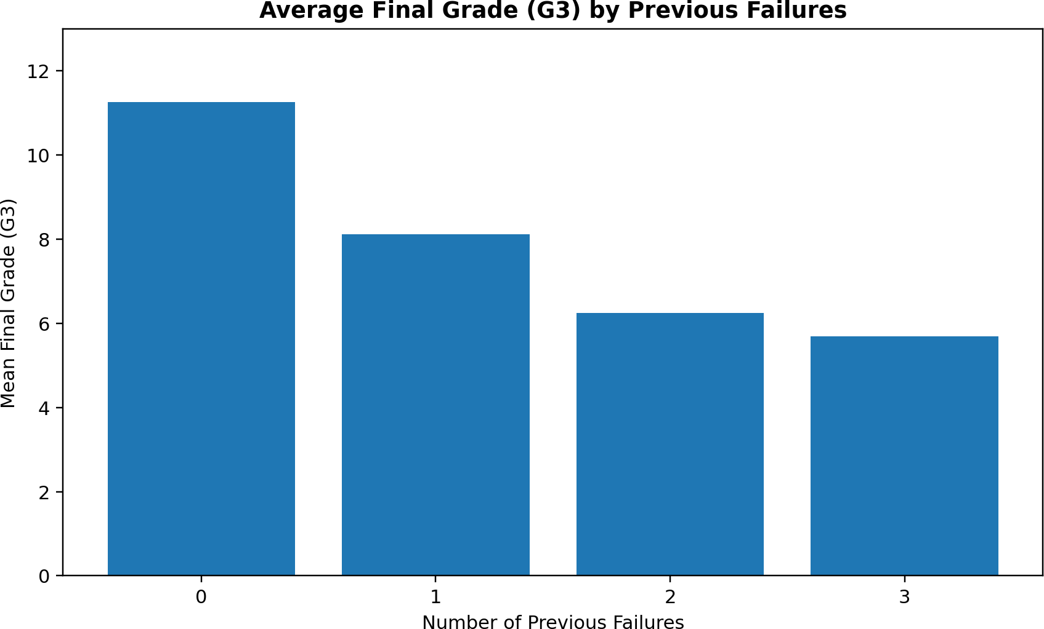
Graph 1: Previous failures vs final grade
  - Mother's education has a positive relationship with G3, with correlation about +0.22.
  - Father's education has a weaker positive relationship with G3, about +0.15.
  - Weekend alcohol consumption has a very weak negative relationship with G3.
  - Students receiving school support have a lower observed mean G3 than students not receiving it.
  - This difference should not be interpreted as a causal effect because support may be targeted at students already facing difficulties.
  - Male Mathematics students have a reported mean G3 of 10.91, compared with 9.97 for female students.
  - Study time shows a modest positive pattern, but the relationship is not strong.
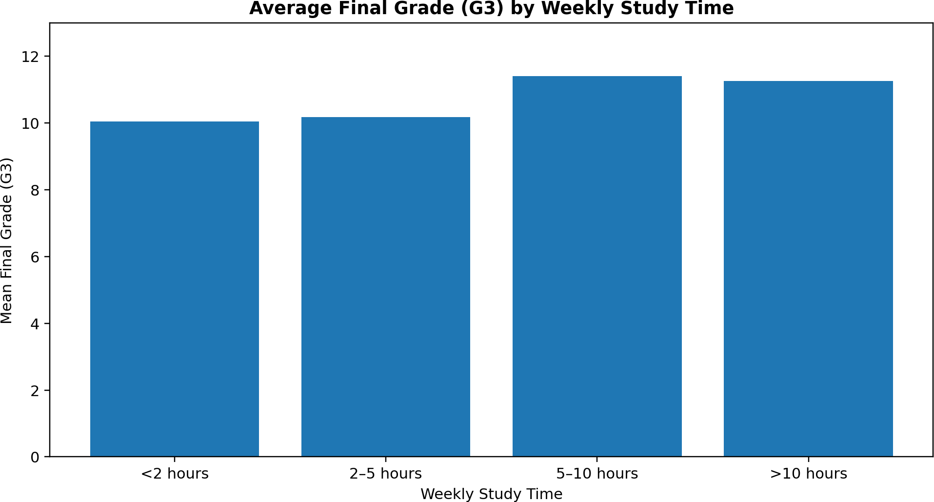
Graph 2: Study time vs final grade
  - Internet access at home is associated with a higher observed mean in the grouped results.
  - Going-out frequency shows a negative pattern at the highest level.
  - Bivariate analysis helps identify relationships and group differences, but it does not by itself prove causation.

Grouping and Aggregation
  - Grouping students by study time shows differences in average final grades.
  - Students studying less than 2 hours have a mean G3 of 10.05.
  - Students studying 2–5 hours have a mean G3 of 10.17.
  - Students studying 5–10 hours have a mean G3 of 11.40.
  - Students studying more than 10 hours have a mean G3 of 11.26.
  - The grouped results suggest improvement up to the 5–10 hour category, followed by a slight plateau.
  - Grouping by previous failures shows a strong performance difference.
  - Students with zero failures have the highest grouped mean G3 of 11.25.
  - Students with one, two, and three failures have progressively lower mean grades.
  - Students intending higher education have a mean G3 of 10.61 compared with 6.80 for students without that intention.
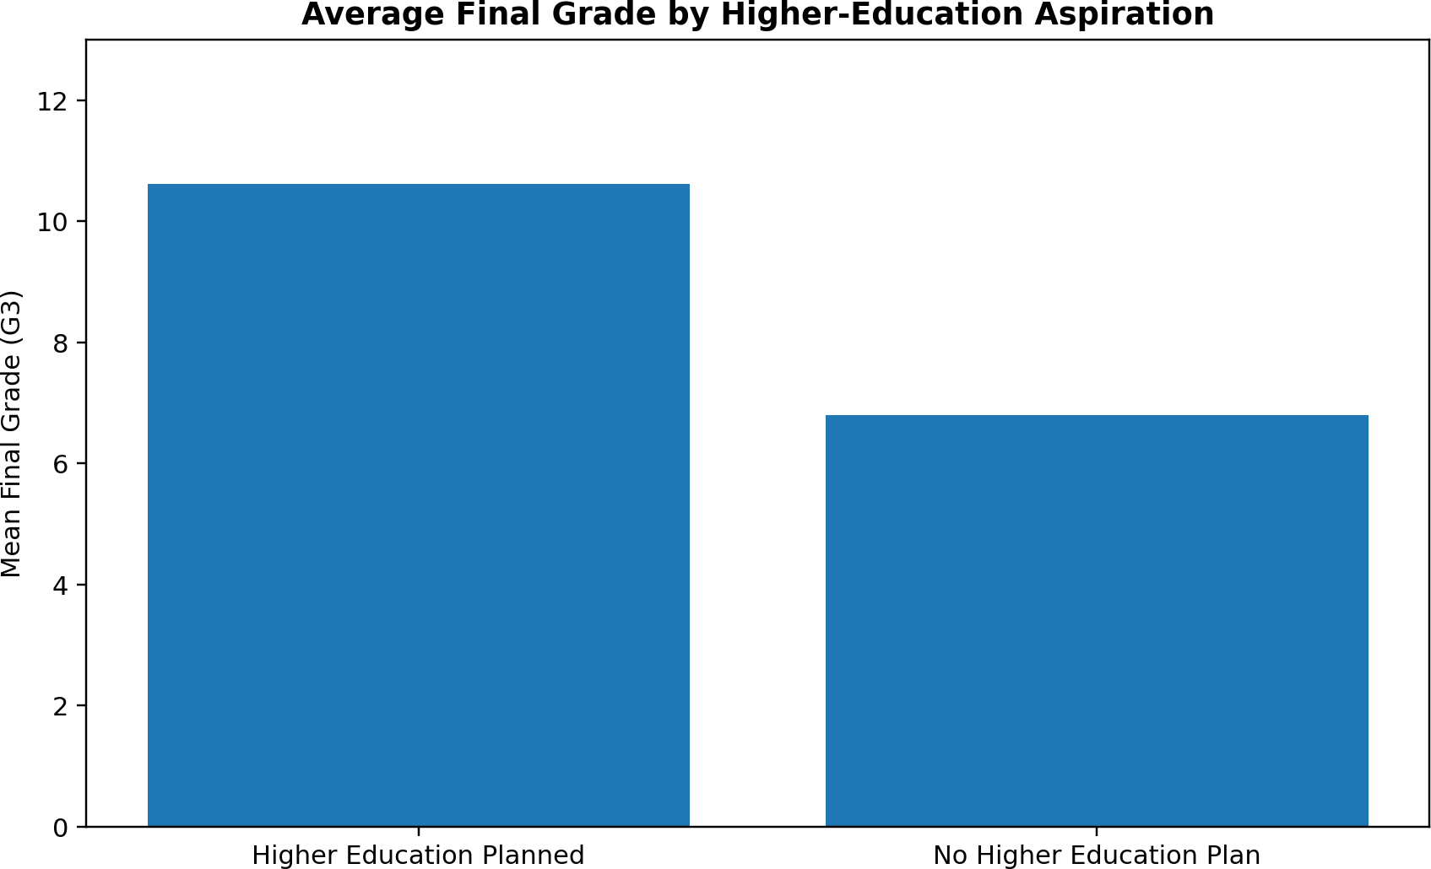
Graph 3: Higher-education intention vs final grade
  - Students with school support have a mean G3 of 9.43 compared with 10.56 for students without school support.
  - Students with home internet have a mean G3 of 10.62 compared with 9.44 without home internet.
  - Students from urban areas have a mean G3 of 10.67 compared with 9.51 for rural students.
  - Maternal education shows increasing average G3 across education categories, from 8.68 at primary level to
11.76 at higher education.
  - Grouping and aggregation convert individual records into interpretable summaries for comparison.

Correlation Analysis
  - Correlation analysis measures the strength and direction of linear relationships between numerical variables.
  - G2 has the strongest reported positive correlation with G3 at approximately +0.905.
  - G1 has the second strongest reported positive correlation with G3 at approximately +0.801.
  - Failures has a moderate negative correlation with G3 of approximately -0.360.
  - Mother's education has a weak positive correlation with G3 of approximately +0.217.
  - Father's education has a weaker positive correlation of approximately +0.152.
  - Age has a weak negative correlation with G3 of approximately -0.162.
  - Going-out frequency has a weak negative correlation of approximately -0.133.
  - Study time has a weak positive correlation of approximately +0.098.
  - Absences have a very weak negative correlation with G3 of approximately -0.04.
  - Weekend alcohol consumption has a very weak negative correlation of approximately -0.05.
  - Daily alcohol consumption also has a very weak negative correlation of approximately -0.05.
  - The strongest numerical relationships are therefore associated with prior academic grades.
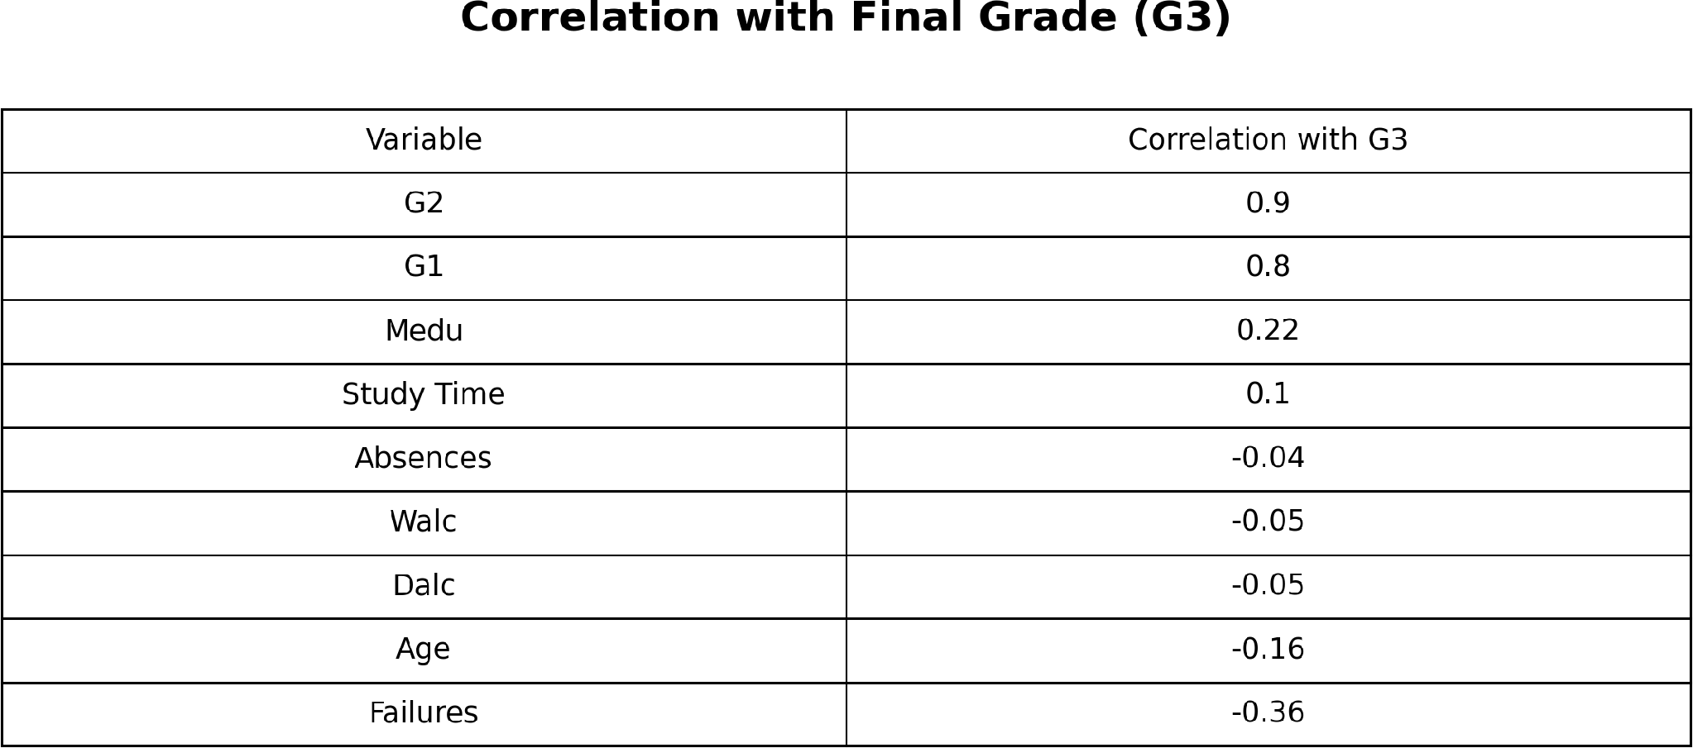

Table 3: Correlations with final grade G3
  - Correlation indicates association and should not be interpreted as proof of cause and effect.
  - The correlation results help prioritize variables for further predictive or statistical analysis.

Visualization
  - Visualization converts numerical findings into charts that are easier to interpret.
  - A histogram of G3 shows the distribution of final Mathematics grades.
  - A correlation heatmap summarizes relationships among numerical variables.
  - A boxplot can compare study-time categories and their grade distributions.
  - A bar chart can show average G3 for different previous-failure groups.
  - A grouped bar chart can compare performance by higher-education intention.
  - A scatter plot of G2 against G3 can visually show the strong positive relationship.
  - A step or grouped chart can show the relationship between maternal education and average G3.
  - A comparative boxplot can compare Mathematics and Portuguese final-grade distributions.
  - Final grades can also be grouped into low, medium, and high performance bands.
  - In the report, 130 students fall in the 0–9 low band.
  - 192 students fall in the 10–14 medium band.
  - 73 students fall in the 15–20 high band.
  - These bands provide a simple overview of how students are distributed across performance levels.
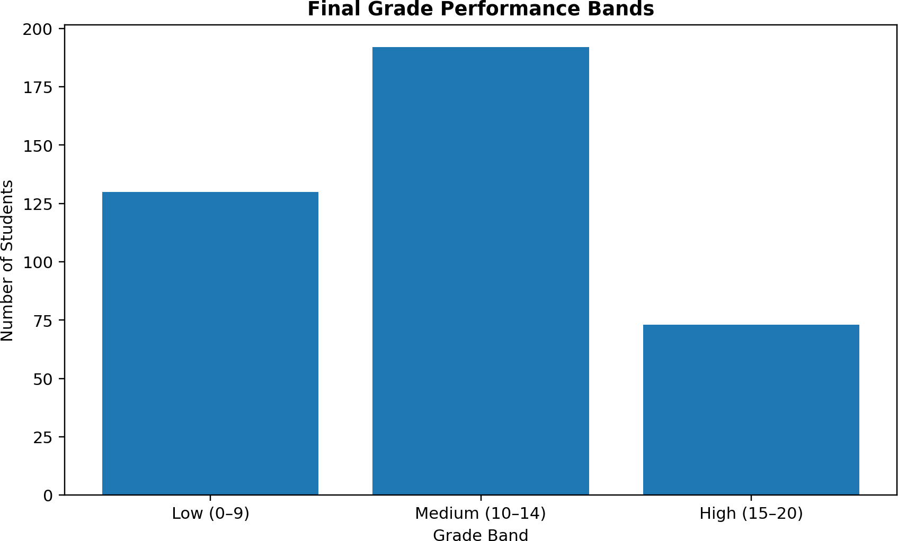
Graph 4: Final-grade performance bands
  - Visualizations complement numerical statistics and make project findings easier to communicate.
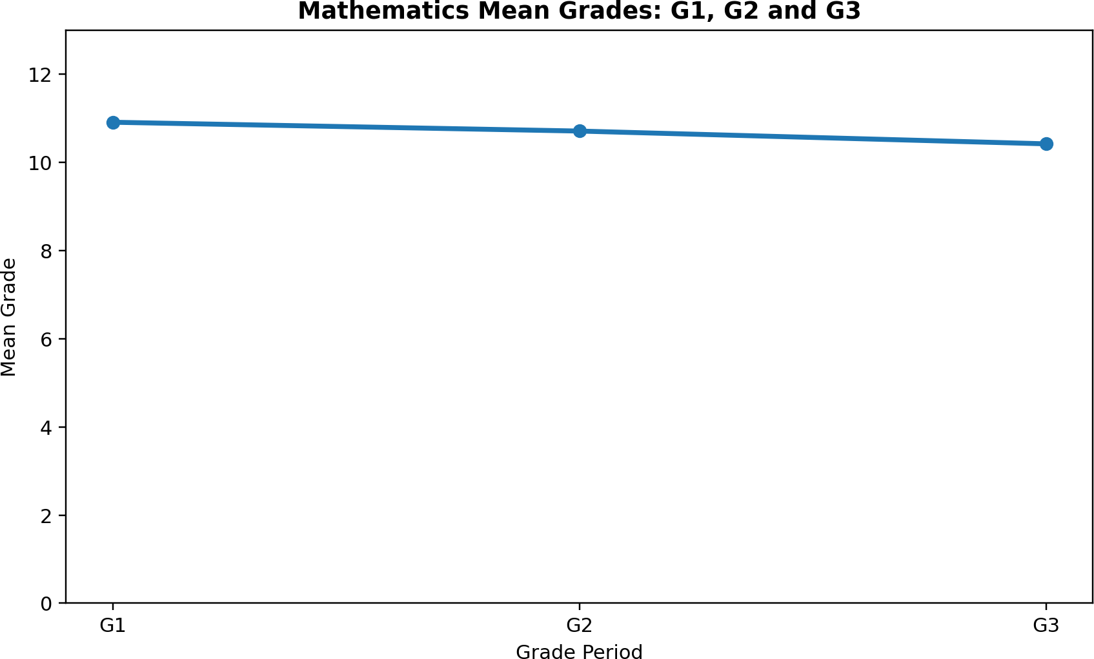

Graph 5: Mean G1, G2 and G3

Key Findings
  - G1 and G2 are the clearest numerical indicators of final academic performance.
  - G2 has the strongest reported relationship with G3.
  - G1 also has a strong positive relationship with G3.
  - Previous failures are associated with substantially lower final grades.
  - Students with zero failures have a much higher mean G3 than students with multiple failures.
  - Students with higher-education aspirations have a notably higher observed mean G3.
  - Maternal education shows a positive relationship with student performance.
  - Study time is beneficial up to the 5–10 hour category, after which the grouped mean shows little additional improvement.
  - School support is associated with a lower observed mean G3, which may reflect targeted support for struggling students rather than a harmful effect.
  - Internet access at home is associated with a higher observed mean G3.
  - High levels of going out are associated with lower average performance.
  - Portuguese students have a higher average final grade than Mathematics students in the reported descriptive statistics.
  - Most Mathematics students are in the medium performance band of 10–14.
  - The dataset contains 395 Mathematics records and 33 attributes with no reported missing values.
  - Overall, the analysis suggests that early academic monitoring and targeted support can be informed by student performance data.

Conclusion
  - The Student Academic Performance project demonstrates how educational data can be analyzed using Python.
  - The UCI Student Performance dataset provides a combination of academic, demographic, family, and behavioural information.
  - G1 and G2 emerge as the strongest numerical indicators of G3.
  - Previous failures are an important negative indicator of final performance.
  - Early identification of students with weak prior grades or repeated failures can support timely academic intervention.
  - Parental education shows a positive but weaker association with academic performance.
  - Study time shows a modest relationship and appears to have a practical plateau in the grouped results.
  - Social behaviour variables generally show weaker relationships than prior academic grades.
  - School support should be interpreted carefully because it may be targeted toward students who already need assistance.
  - Visualizations make the major patterns easier to understand and present.
  - The comparison between Mathematics and Portuguese shows differences in average final performance.
  - The project demonstrates the value of descriptive, bivariate, grouped, and correlation-based analysis.
  - The findings can support data-driven student monitoring and academic planning.
  - Correlation and descriptive results identify associations, but they do not establish causal relationships.
  - Overall, the project provides a useful foundation for future predictive modelling and educational data mining.

References
- UCI Machine Learning Repository — Student Performance dataset (Dataset ID 320).
- Student Academic Performance project report supplied for the project documentation.
- Python documentation and standard data-analysis libraries used in the project workflow.

