Studying the Effects of Web Based Portals on Perceived Quality of Undergraduate Teaching and Learning

Learning environment quality is closely associated with academic achievements, and more importantly the level of satisfaction of students and instructors of educational environments. Therefore, studying factors that significantly affect a student or a teacher’s performance is of great importance. Having spent many years in various educational environments, we were already familiar with a set of obstacles that normally interrupt a class, reduces students’ perceived quality of teaching, their satisfaction and a teacher’s perceived quality of learning. We conducted extensive empirical (research using) domain observations and user interviews to analyze factors causing interruptions and disturbances. Our study results indicate that the majority of these problems are caused by issues related to classroom equipment and environment. Other issues negatively affecting the perceived quality of teaching were reported to be related to issues with the universities’ current procedures of identifying, tracking and solving aforementioned problems. Instances of such problems include the class projector being broken, lack of markers or erasers for whiteboards, air conditioning not working properly, having messy and grubby classrooms, problems with reserving the class for a certain time, lack of knowledge about class schedule and most importantly, lack of awareness about these sort of issues. If staff and management team were notified of these issues properly, and took steps to resolve them in time and efficiently, both students’ and professors’ perceived quality of learning would significantly increase.

We hypothesized that:

* Addressing and solving these issues would lead to a higher perceived quality of teaching and teachers.
* If there existed a web based system providing these functionalities:
  + Enabling users to record and track issues that need to be solved.
  + Creating awareness of these problems among the staff and management team.

Then using such a system would lead to a higher perceived quality of learning and teaching and a higher level of satisfaction in students and professors.

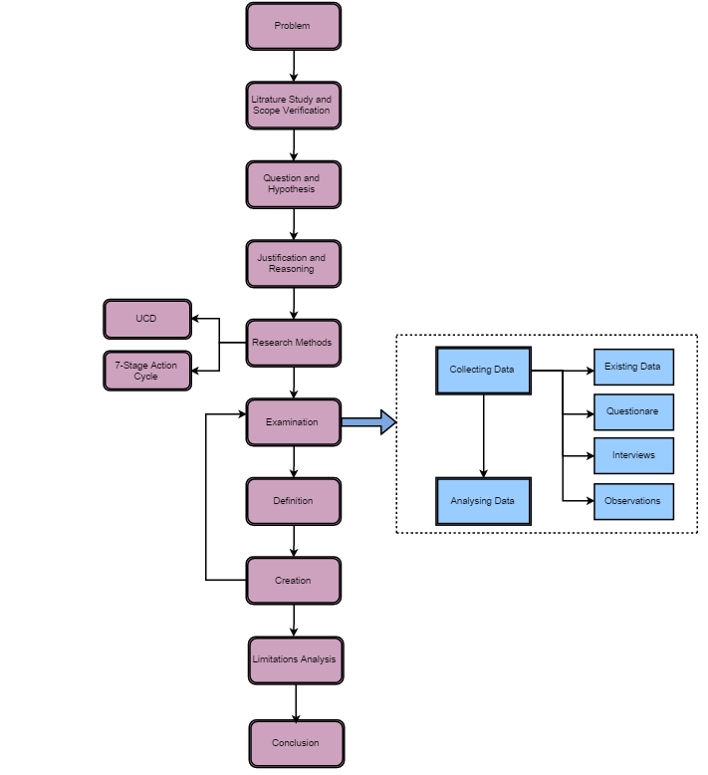

Figure 1. The Research Plan

In this paper we report an empirical study of the problem as well as the design, implementation, and evaluation of a web-based system designed to overcome the problem under study.

The reminder of this paper is as follows. Section 2 provides an analysis of existing literature smart classroom design and tools. Section 3 presents our overall research design. Our overall research consists of 5 sub steps. Firstly, we began by identifying the users, tasks they would engage in and the context in which a user interacts with the classroom. Secondly extensive user research was done, consisting of a 9 month lasting domain analysis, a questionnaire based survey of 9 students and 2 professors, following user-centric design and development of a web-based instrument created to address problems identified in the previous steps and used to collect data for studying hypothesized concepts in this work. Section 4 shows study results. Section 5 discusses findings and analysis of data. Section 6 concludes the work by presenting recommendations for future research directions as well as guidelines for practitioners advising how to improve current practices to cope with identified challenges and to improve student and professors satisfaction.