**PART I: Accounts (Basic)**

1. **Accounts: Manage your accounts.**

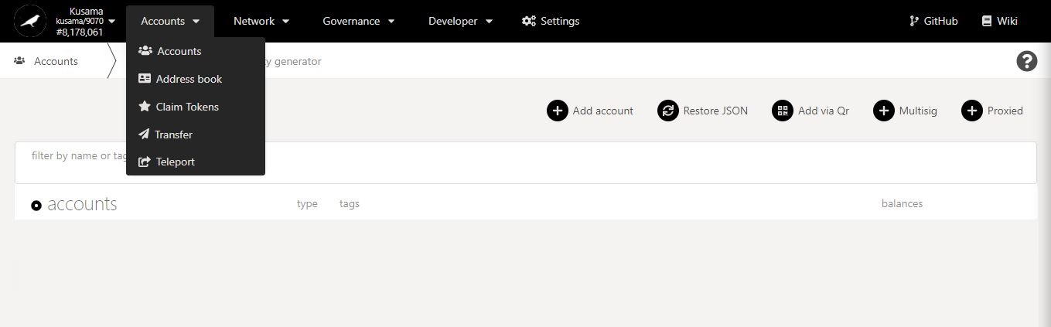

**Basic information on technical words** used in the ACCOUNTS section.

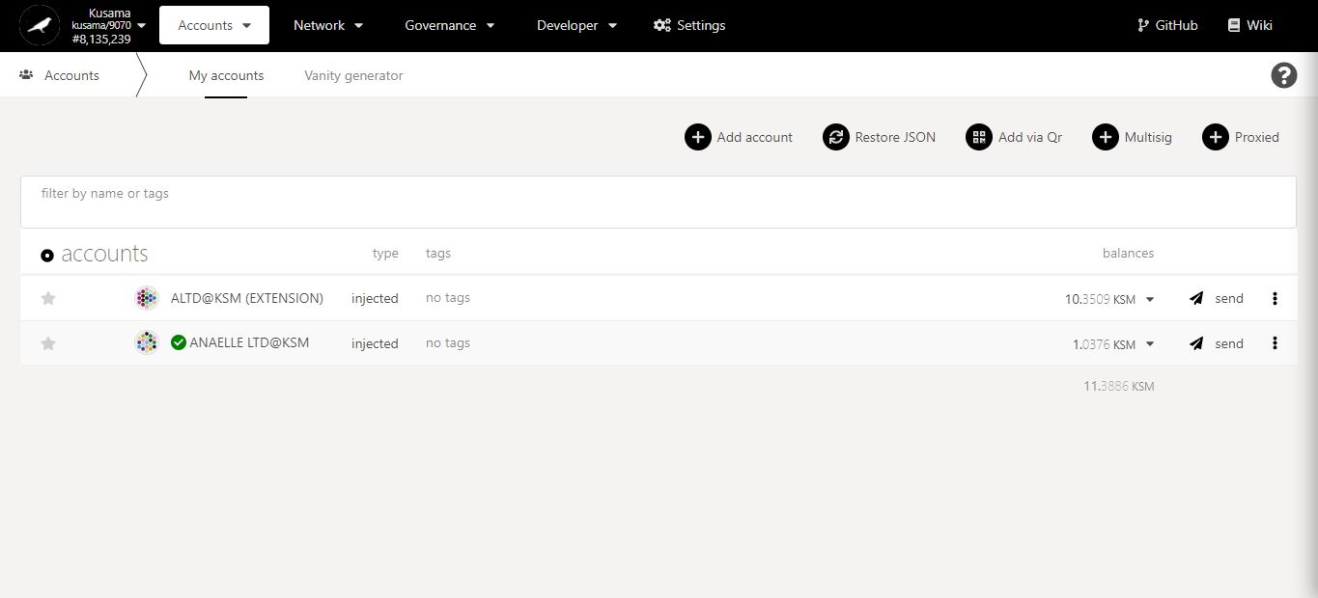

Accounts can be **injected** from Polkadot-JS extension, **created** from Polkadot-JS Apps, or derived from **Ledger** hardware.

Any **custom information/note** about the account.

Options for **creating/importing** account(s).

Overview of account’s **KSM balances**.

Existing **account(s) enabled on the Kusama network**.

* 1. ***Create a Polkadot-JS account from a new Seed and save it in a JSON file.***

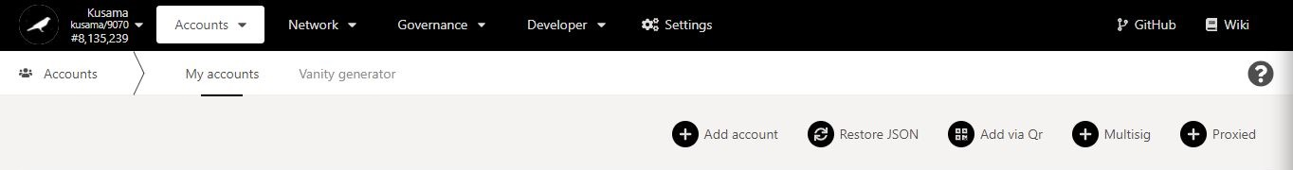

1. Click **Add account**.

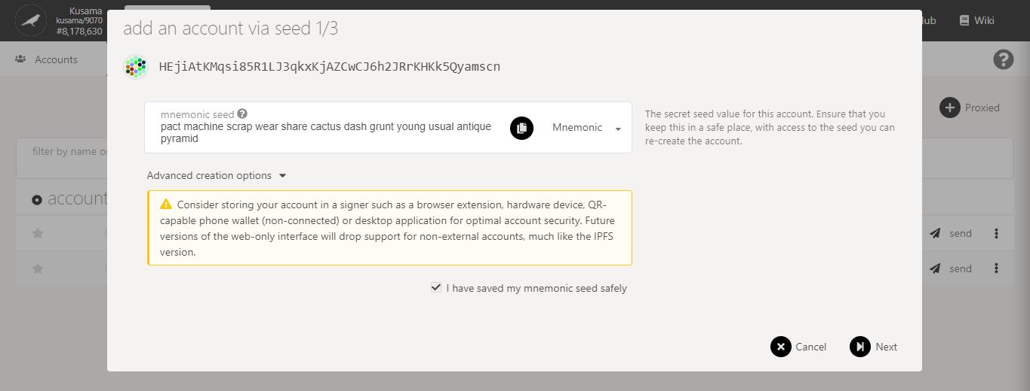

4. Click on **Next** to continue the procedure.

**NEVER store your seed in a phone/PC!** Write it in a notebook/ sketchbook or diary and keep it private.

2. Follow **on-screen instructions** carefully.

3. Make sure you **note down your seed phrase neatly** and tick the box.

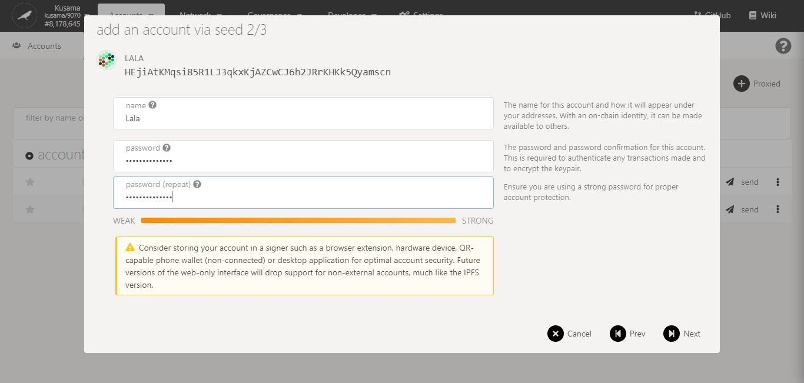

**Avoid using the same password** for all your accounts.

5. Follow the **new instructions** carefully.

6. Click on **Next** to continue the procedure.

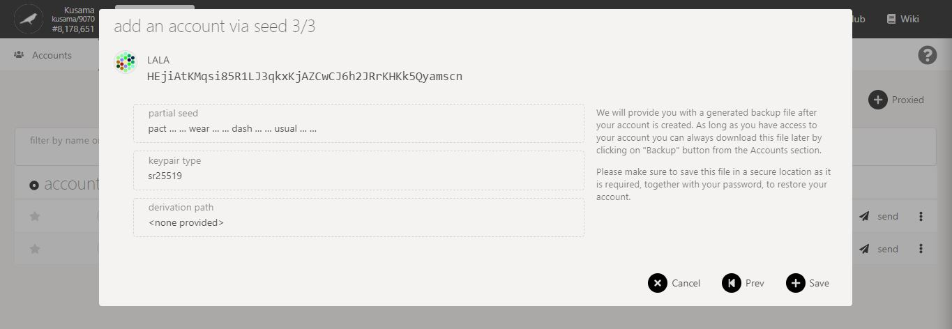

8. Click on **Save** to complete the procedure.

7. Follow the **final instructions** carefully.

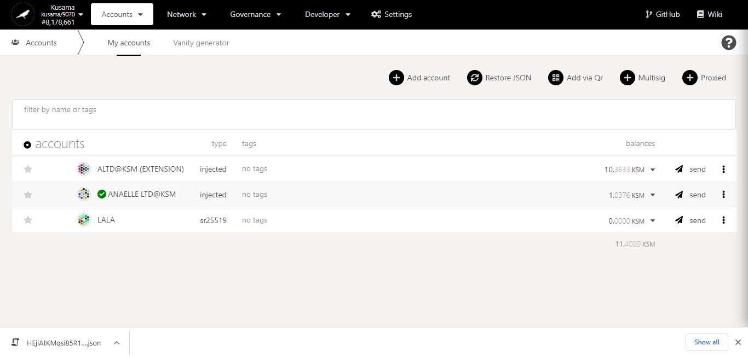

**Star** your most important accounts.

**A JSON (backup) file has also been created for your account!** It should be stored in a device that is not connected to the internet.

10. Click on the 3 vertical dots to view **Account settings**.

9. **Your account has been added to the *My accounts* list!**

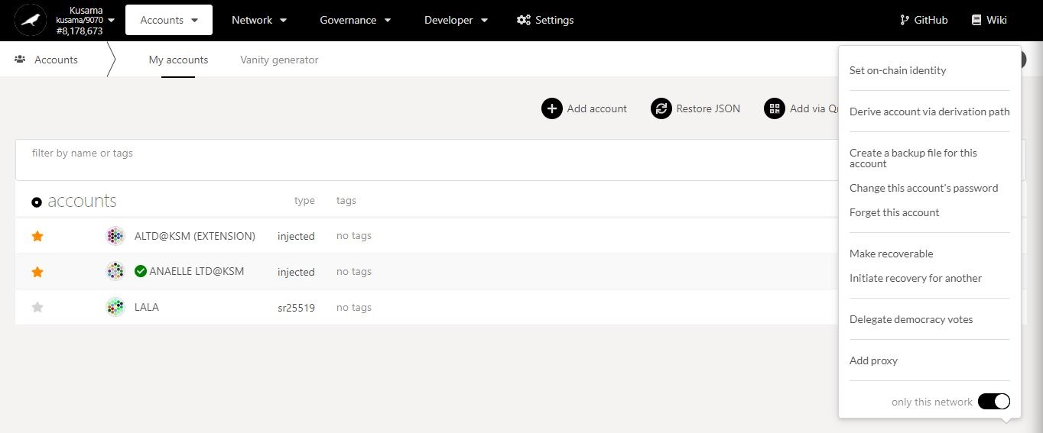

11. Click on **Create a backup file […]** to download your account’s JSON file.

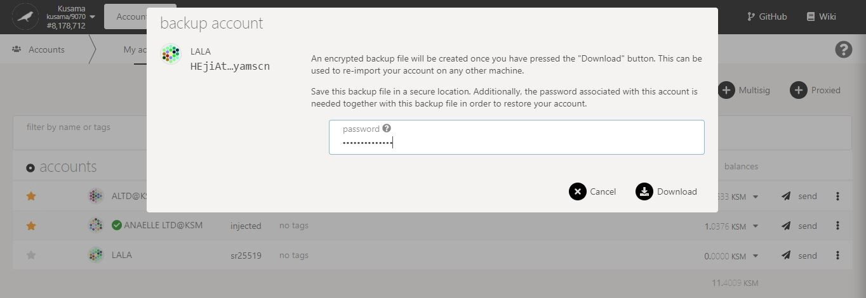

13. Click on **Download** to complete the procedure.

12. Follow **on-screen instructions** carefully.

* 1. ***Import a Polkadot-JS account from a JSON file.***



1. Click **Restore JSON**.

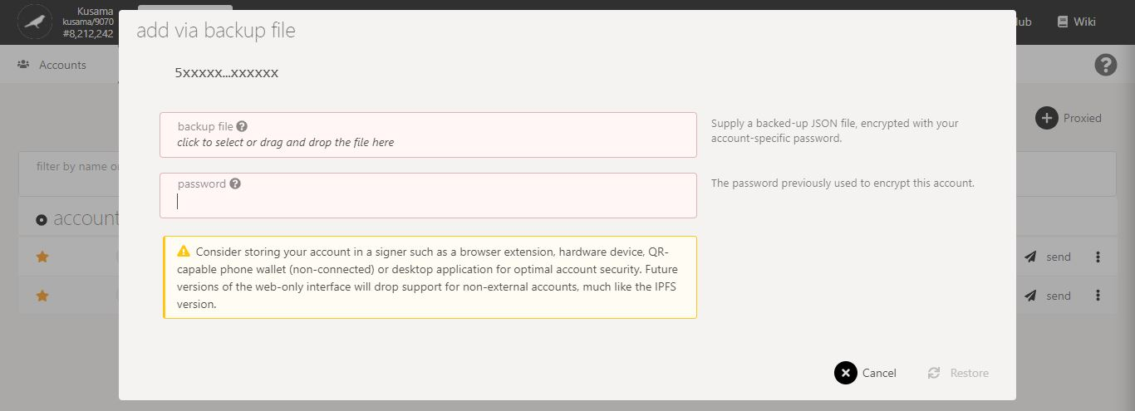

2. Follow **on-screen instructions** carefully.

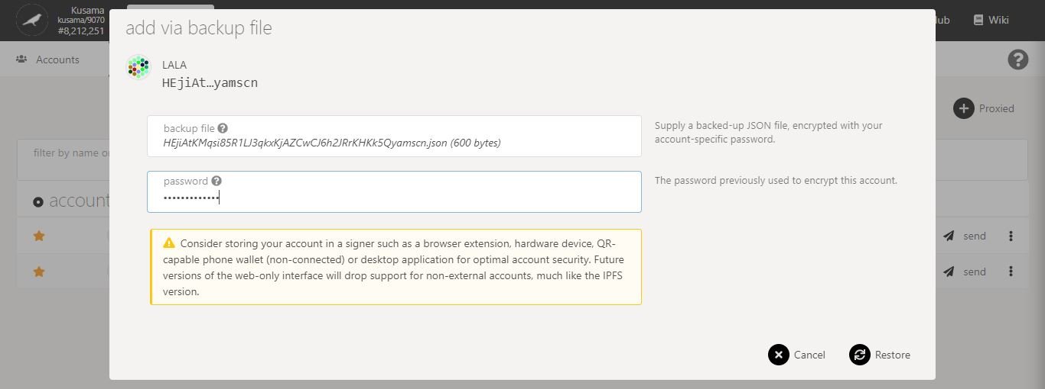

4. Click on **Restore** to complete the procedure.

3. Double-check **warning messages.**

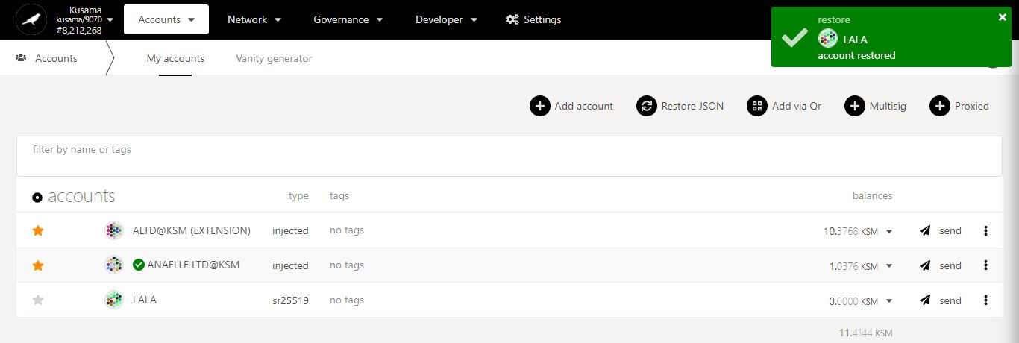

5. **Your account has been restored in the *My accounts* list!**

* 1. ***Add a Polkadot-JS account from a QR Code.***



1. Click **Add via QR**.

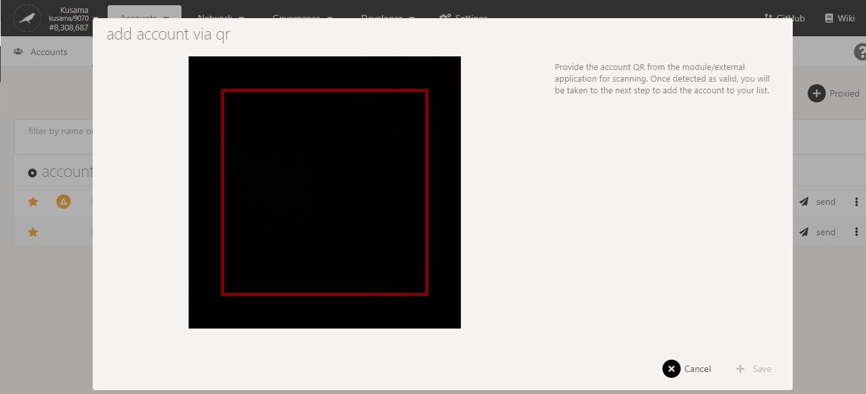

3. Click on **Save** to complete the procedure.

2. Follow **on-screen instructions** carefully.

**[Troubleshooting 1/3]**

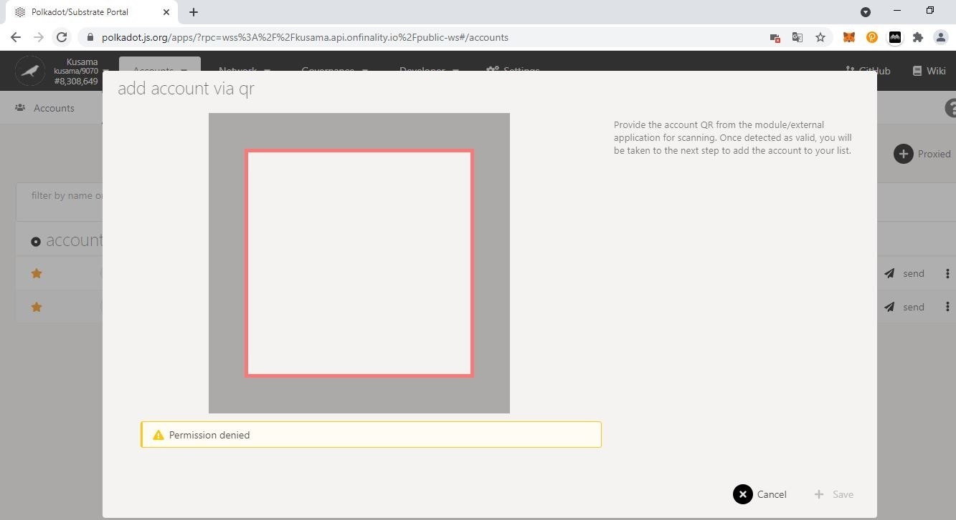

Issue:

Permission is denied is because ***Polkadot-JS Apps* does not have access to your Camera**.

Double-check **error messages.**

**[Troubleshooting 2/3]**

1. Click the **Polkadot-JS extension icon**.

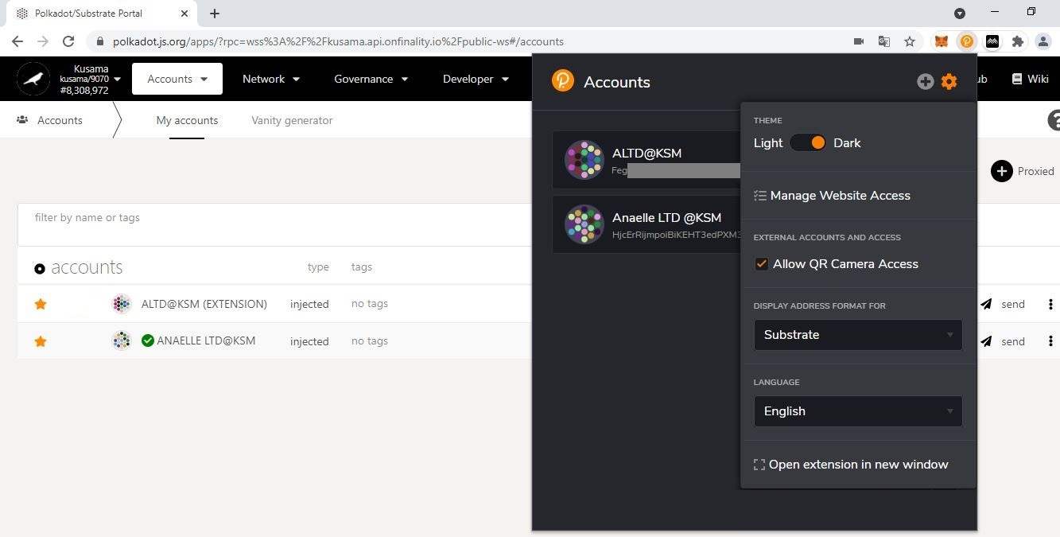

4. Click on **My accounts** to refresh your browser, then restart the procedure.

Possible solution:

1. Make sure that your Polkadot-JS extension settings allow **QR Camera Access**.

3. Tick the **QR Camera Access box** and return to Polkadot-JS Apps.

2. Click the Polkadot-JS extension **settings icon**.

**[Troubleshooting 3/3]**

1. Click the **Chrome browser Camera icon**.

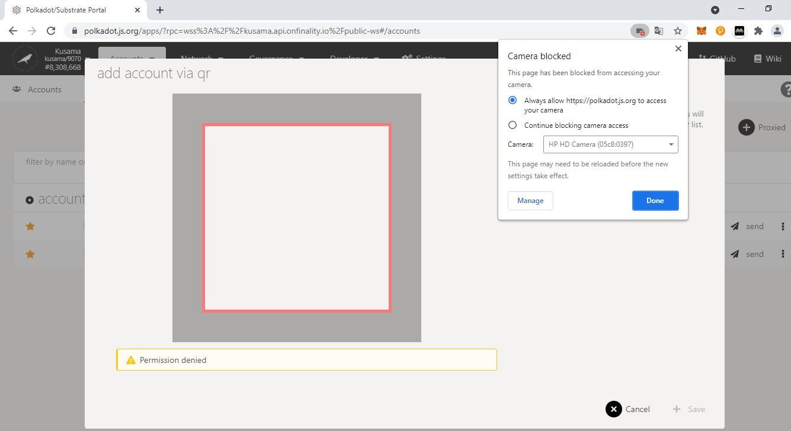

Possible solution:

2. Make sure that your Chrome browser settings allow ***Polkadot-JS Apps* to access your camera**.

4. Click on **Cancel** to refresh your browser, then restart the procedure.

3. Click on **Done** to continue the procedure.

2. Select the **Always allow […] button**.

* 1. ***Set up a Polkadot-JS Multisig account.***



1. Click **Multisig.**

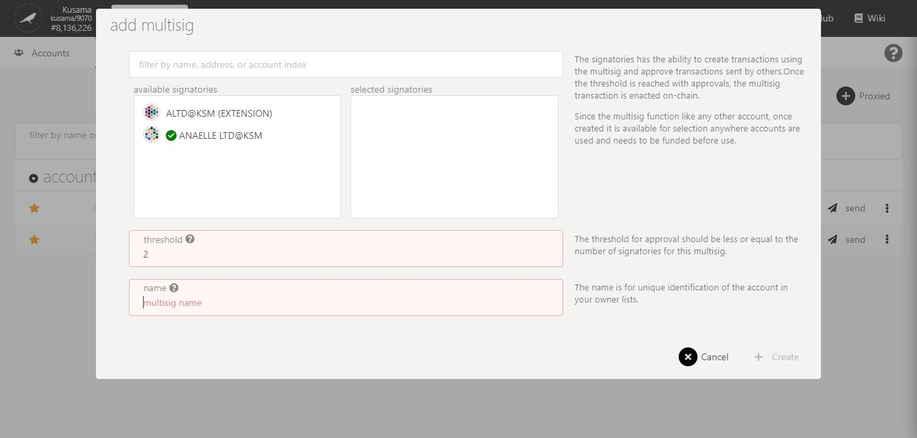

Multisig in detail:

**Multisig** = “Multisignature”.

Multisig accounts allow collectives, associations, organisations, and institutions to **manage transactions for a single account** without relying on one person.

Any account that is added as a signatory can submit/sign transactions; but the transactions will not be submitted on-chain until the **threshold** of signatories is reached.

3. Click on **Create** to complete the procedure.

2. Follow **on-screen instructions** carefully.

* 1. ***Set up a Polkadot-JS Proxied account.***



1. Click **Proxied.**

2. Follow **on-screen instructions** carefully. 0

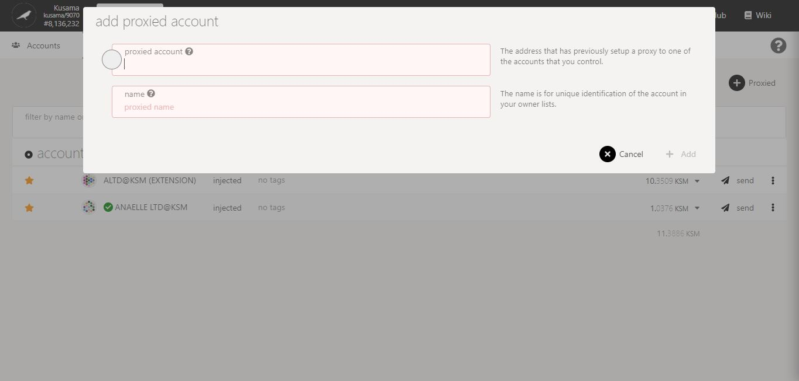

Proxy & Proxied accounts in detail:

**Proxied** = “Cared for”.

**Proxy** = “Caretaker”.

Proxy & Proxied accounts allow individuals to **manage transactions for a family member or a peer** if the person becomes unavailable or incapacitated.

The family member/peer must first **set up your account as their proxy account** before you can **add their account as your proxied account**.

To learn how to set up a proxy account for your account, refer to **Part VI: Accounts (Advanced setups).**

3. Click on **Add** to complete the procedure.

* 1. ***Check*** ***your account information, receive funds at your KSM address and view your KSM balances.***

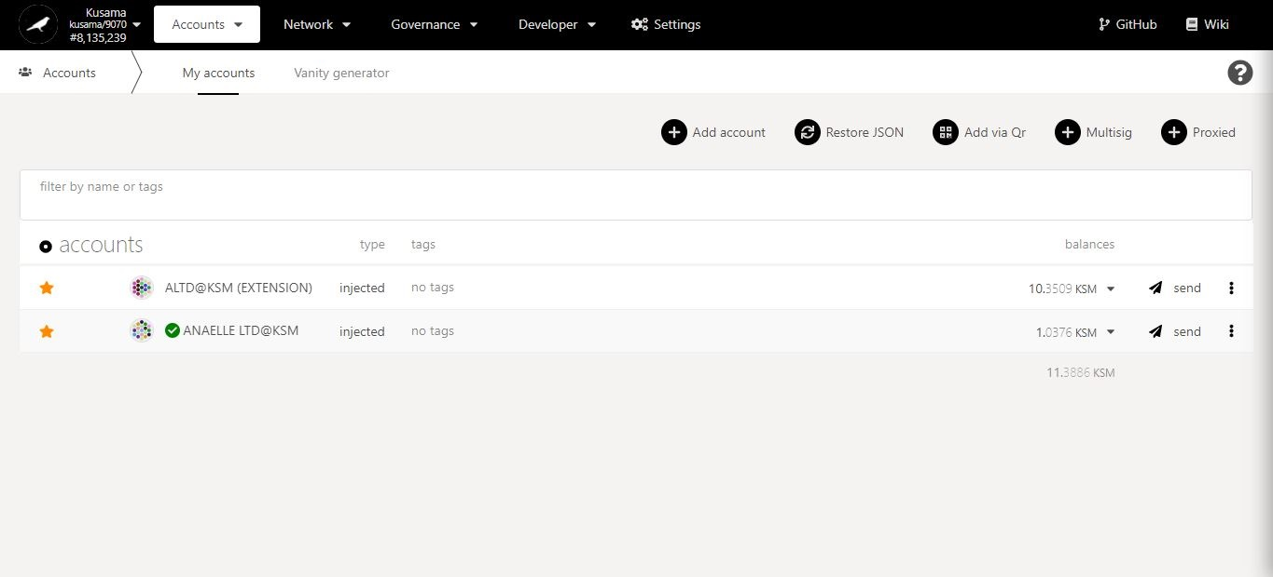

2. Click on the **identicon** to copy your KSM address.

1. Click on the **account name** to view its information.

3. Click on the **dropdown arrow** to view your detailed KSM balances.

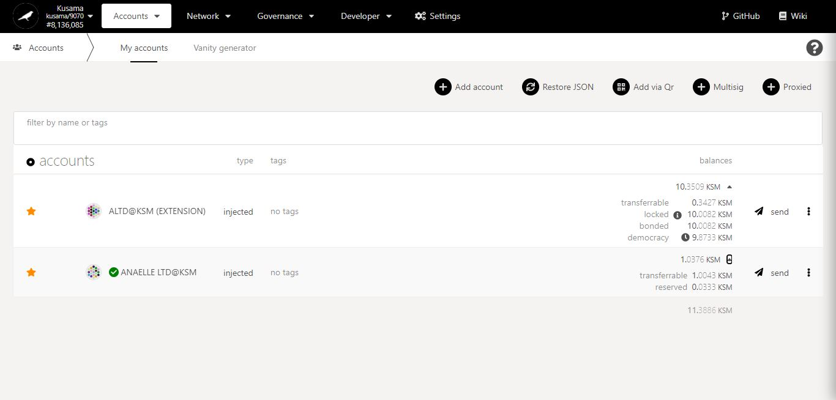

KSM balance in detail:

**Transferrable** = KSM existential deposit (0.000034 KSM) + available KSM.

**Locked** = KSM not currently transferrable because it is bonded or vested.

**Bonded** = KSM locked for staking nominations. Must be unbonded over 7 days to become transferrable.

**Democracy** = KSM locked for voting. Must be unlocked at the end of the voting period to become transferrable. Note: If a voluntary locking period of 8 days has been set during the last vote, the voting balance will be unlocked after 8 days.

**Reserved** = KSM locked for submitting council candidatures, treasury proposals, tips, on-chain identities, etc. Must be cleared to become transferrable.

* 1. ***Generate a vanity address.***

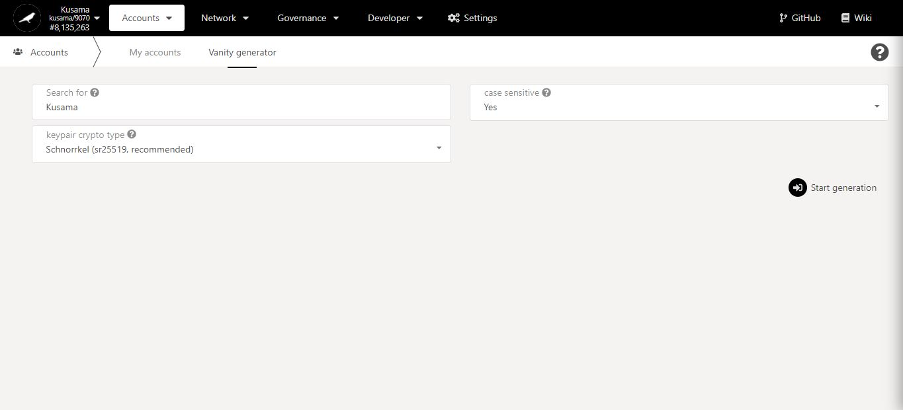

2. Fill-in or select the **information required**.

3. Click on **Start generation** to complete the procedure.

1. Click **Vanity generator**.

1. **Address book: Bookmark your favourite KSM addresses as contacts.**



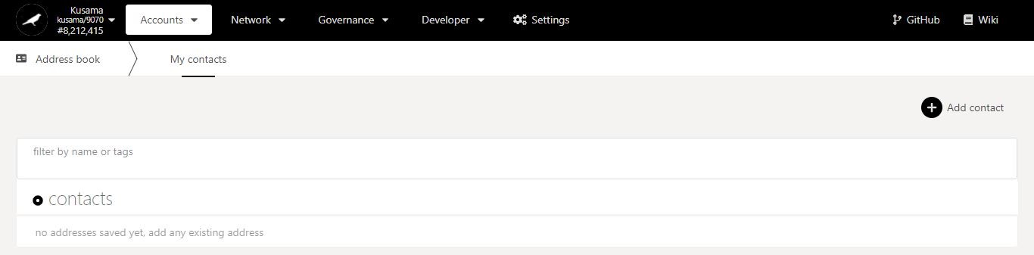

1. Click **Add contact**.

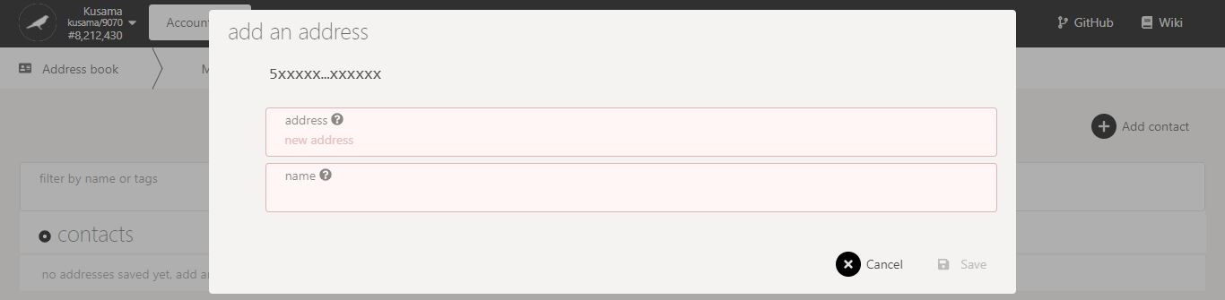

2. Enter **the information required**.

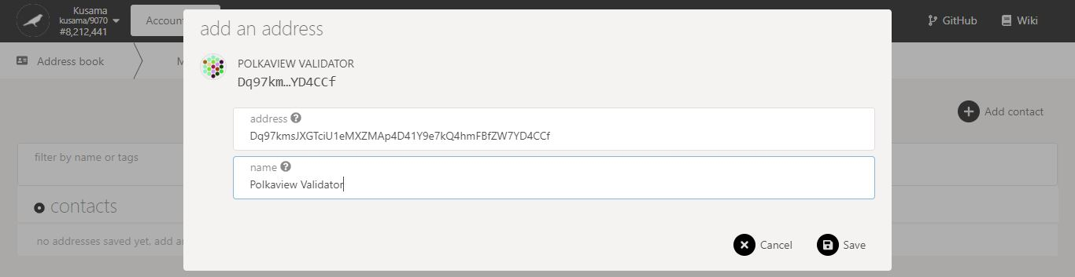

3. Click on **Save** to complete the procedure.

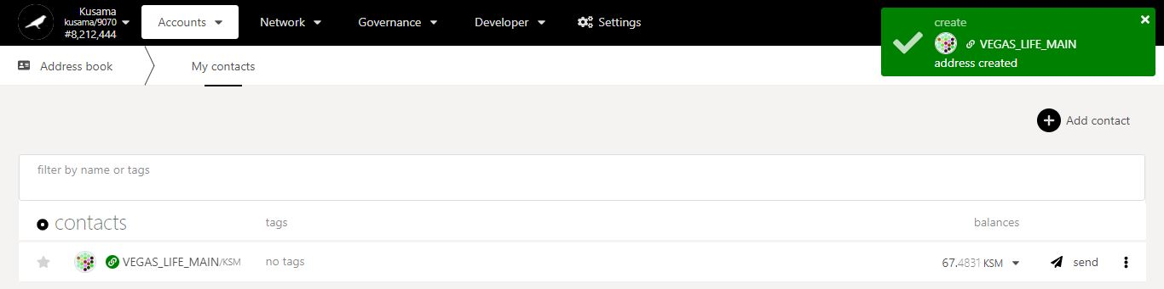

4. **Your contact has been added in the *My contacts* list!**

Note: If your contact has an identity, it will automatically replace the name you provided.

1. **Claim tokens: Claim your KSM from your ETH address.**



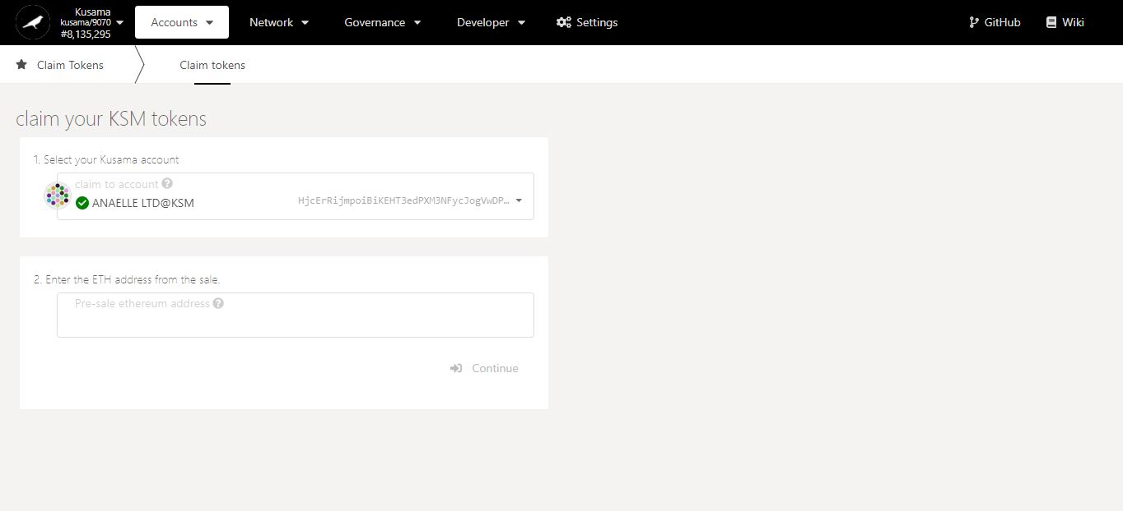

1. Enter **the information required**.

2. Click on **Continue** to view and complete subsequent steps in the procedure.

1. **Transfer: Send KSM to another KSM address.**



The receiving account must be an account from **your *My Accounts* or *My contacts* list**.

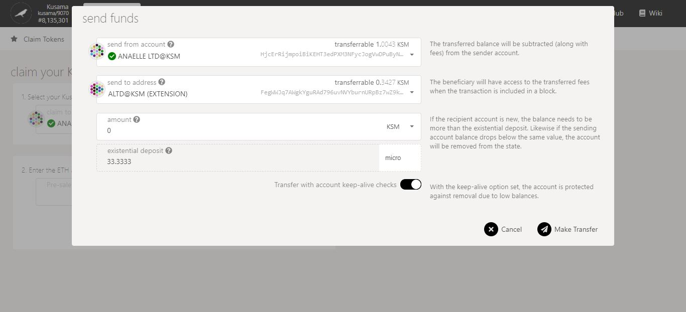

If you want to **empty the account completely**, switch the keep-alive checks **OFF**. The existential deposit will be transferred, and the account will be deactivated.

1. Follow **on-screen instructions** carefully.

2. Click on **Make Transfer** to complete the procedure.

1. **Teleport:** Send your KSM to a parachain address.



Always double-check the **parachain** information.

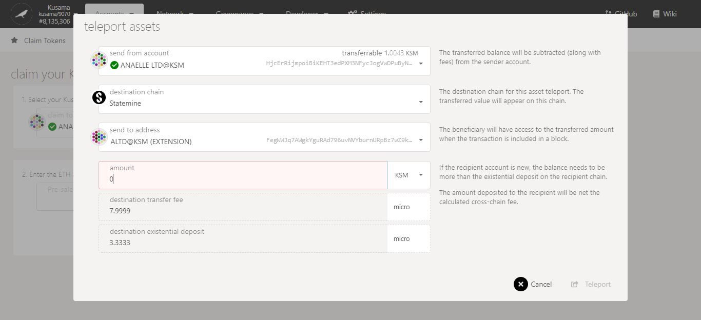

Always double-check the **existential deposit** information.

1. Follow **on-screen instructions** carefully.

2. Click on **Teleport** to complete the procedure.