**PART 0: Wallet setups**

1. **Extension:** Download and install the browser extension.
   1. **Download the extension.**

1. Go to [**https://polkadot.js.org/extension/**](https://polkadot.js.org/extension/).

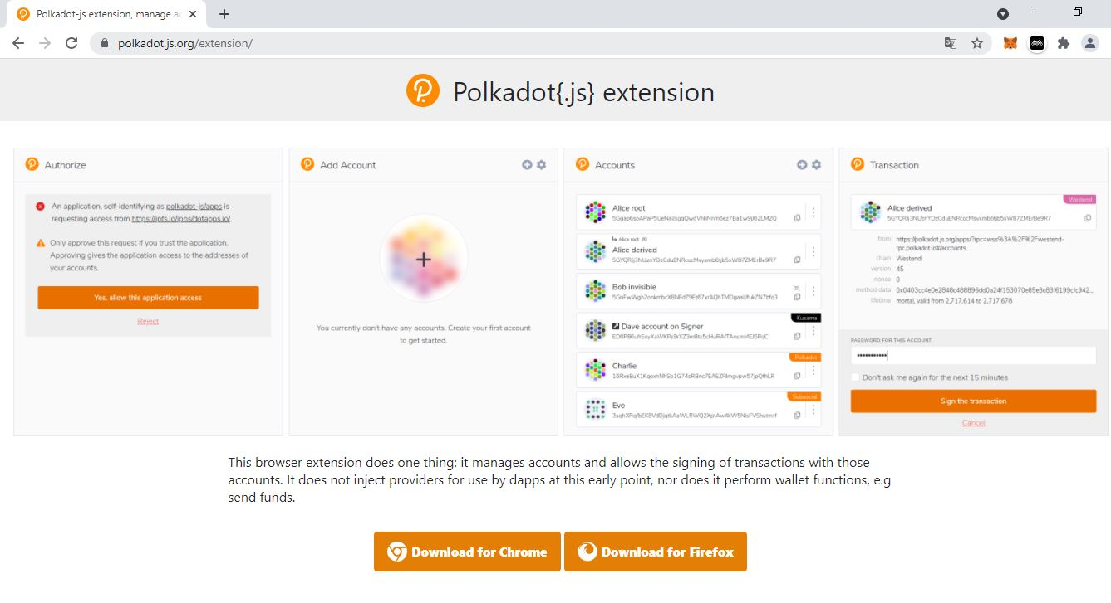

2. Click **Download for Chrome**.

* 1. **Install the extension.**

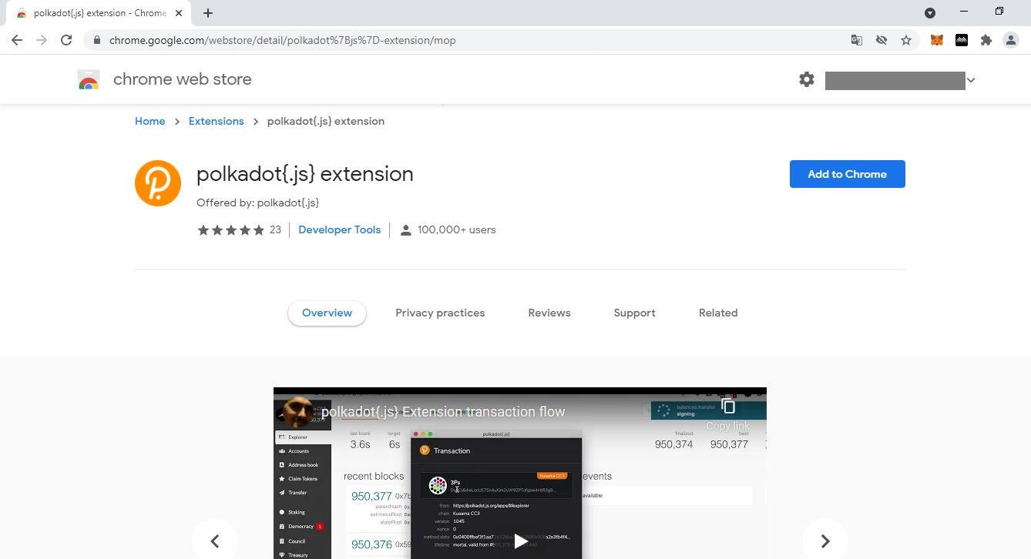

1. Click **Add to Chrome** to install the browser extension.

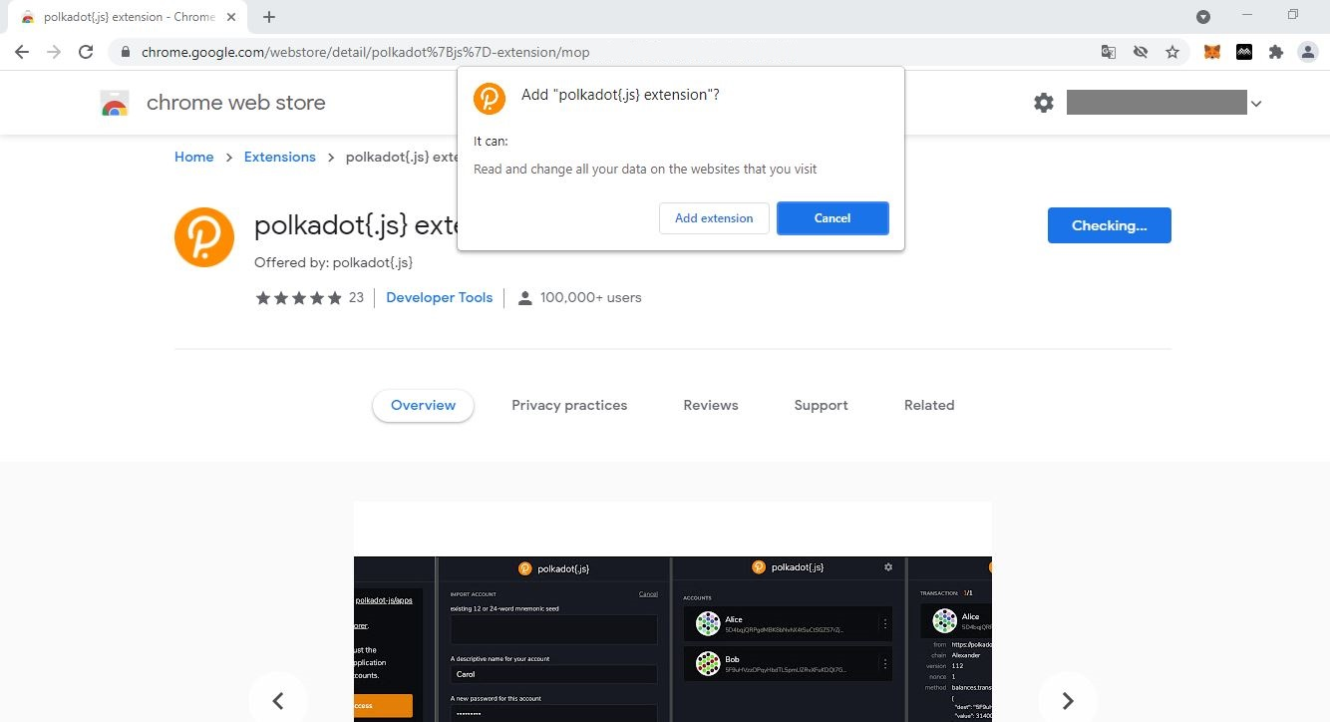

2. Click on **Add extension** to complete the procedure.

3. Click the **icon** to view the list of all installed browser extensions.

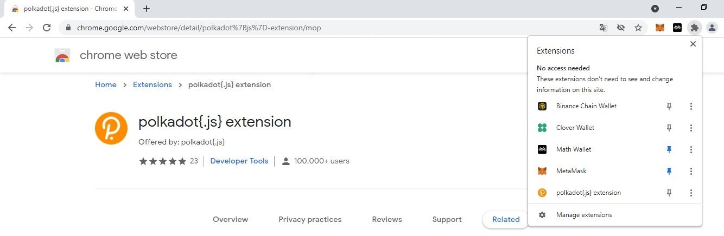

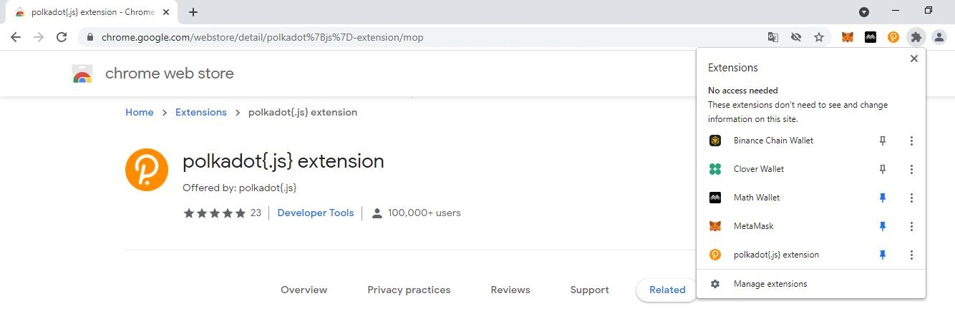

4. Click the **pin** to make the Polkadot-JS extension visible on your navigation bar.

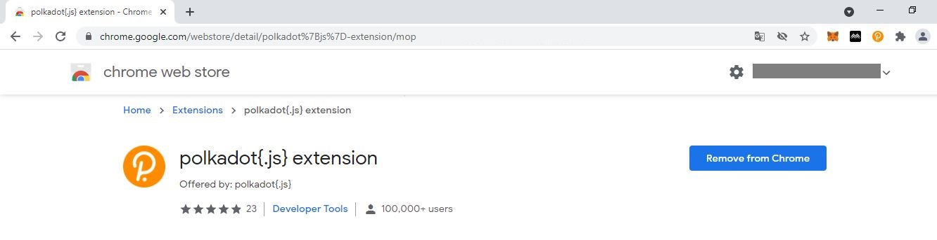

5. **The Polkadot-JS extension icon is now pinned onto your navigation bar!**

1. **Wallet:** Create a wallet from the browser extension.
   1. **Accept Polkadot-JS Terms and Conditions.**

1. Click on the **Polkadot-JS extension icon** to reveal the Accounts window.



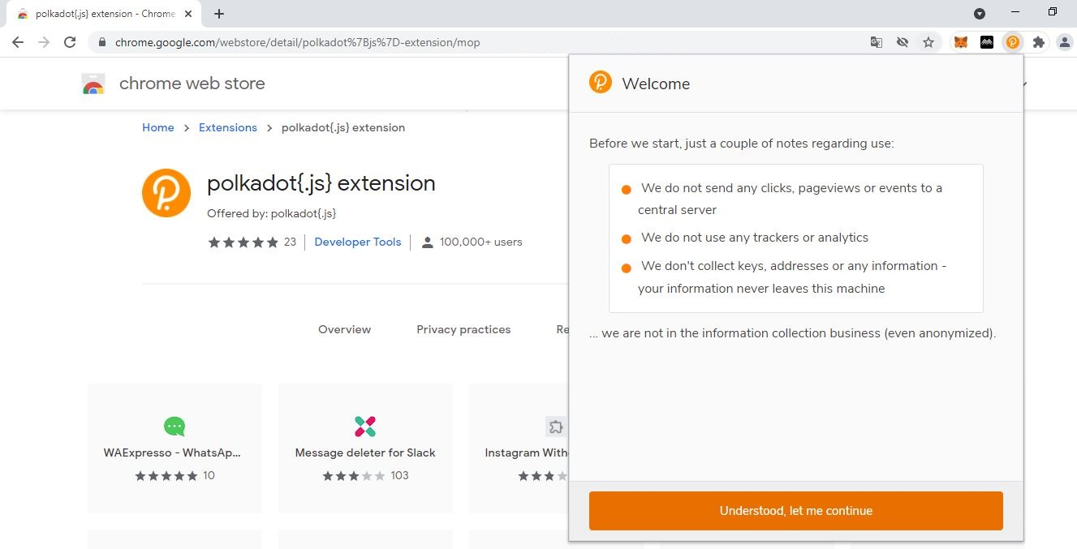

3. Click **Understood […]** to proceed.

2. Read the **notes** carefully.

* 1. **Create a wallet.**

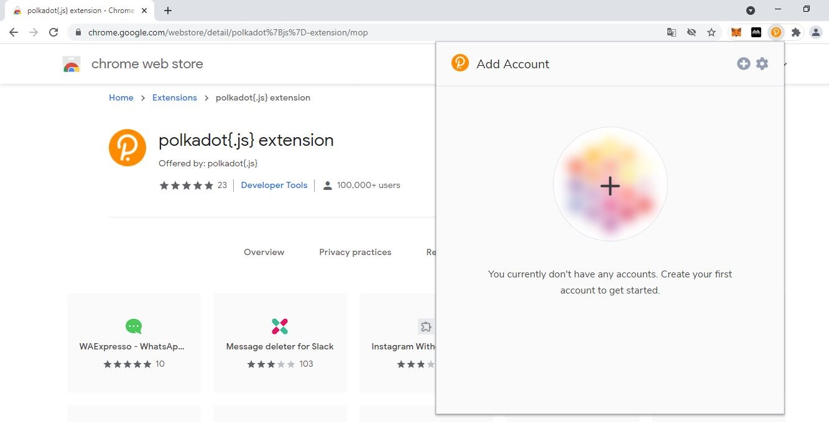

1. Click **+** to create your first account.

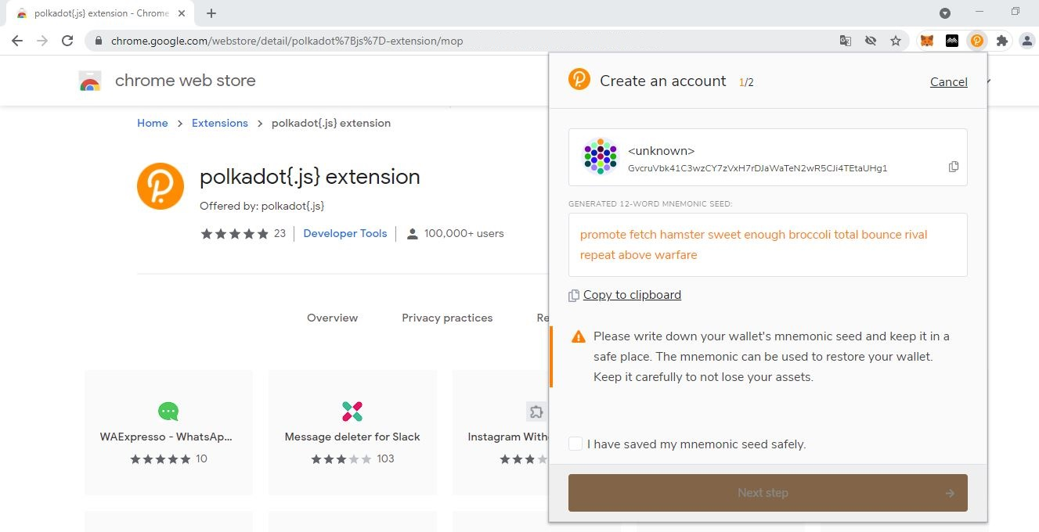

2. Make sure you **note down your seed phrase neatly** and tick the box.

**NEVER store your seed in a phone/tablet/laptop/PC!**

Write your seed in a notebook/ sketchbook or diary and keep it private.

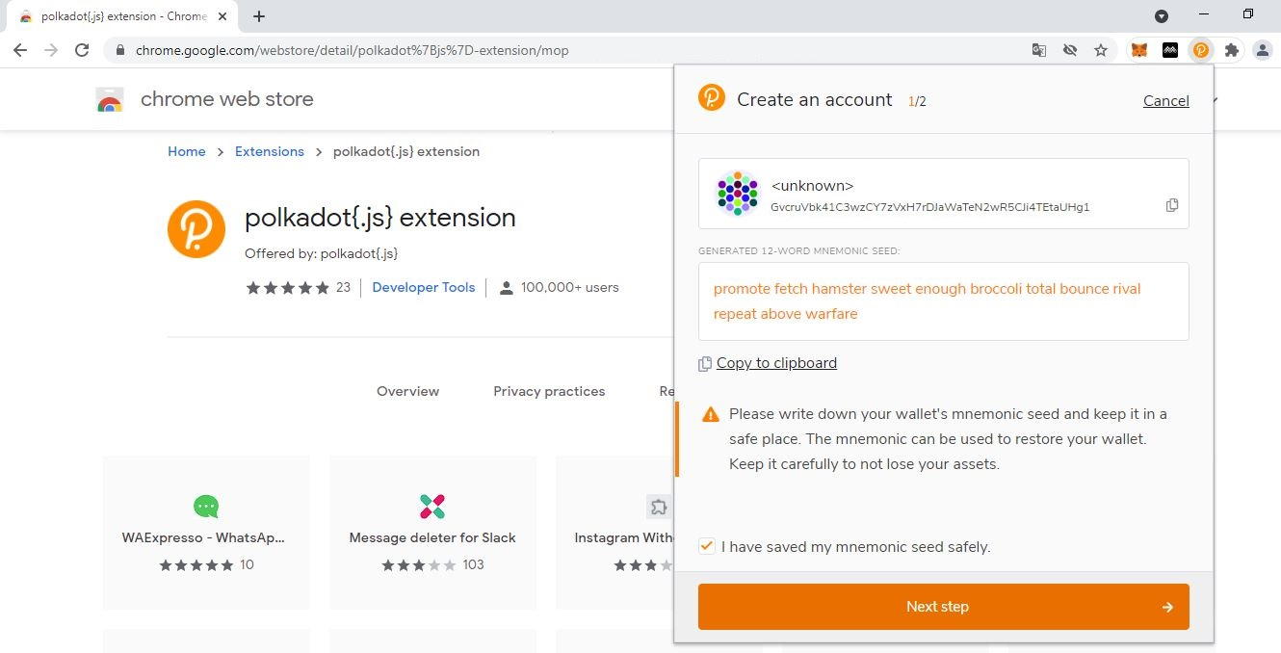

3. Click on **Next step** to continue the procedure.

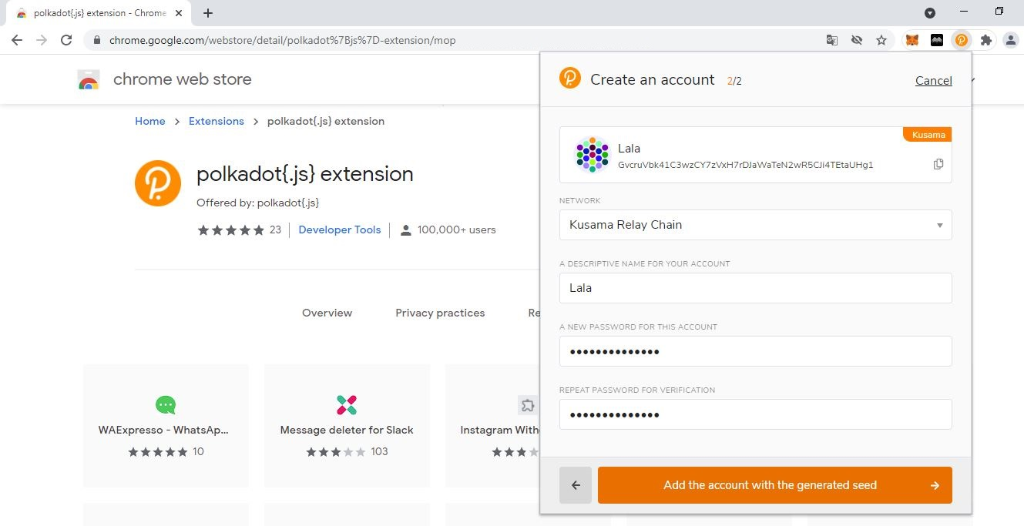

5. Click on **Add the account […]** to complete the procedure.

4. Provide the **required information.**

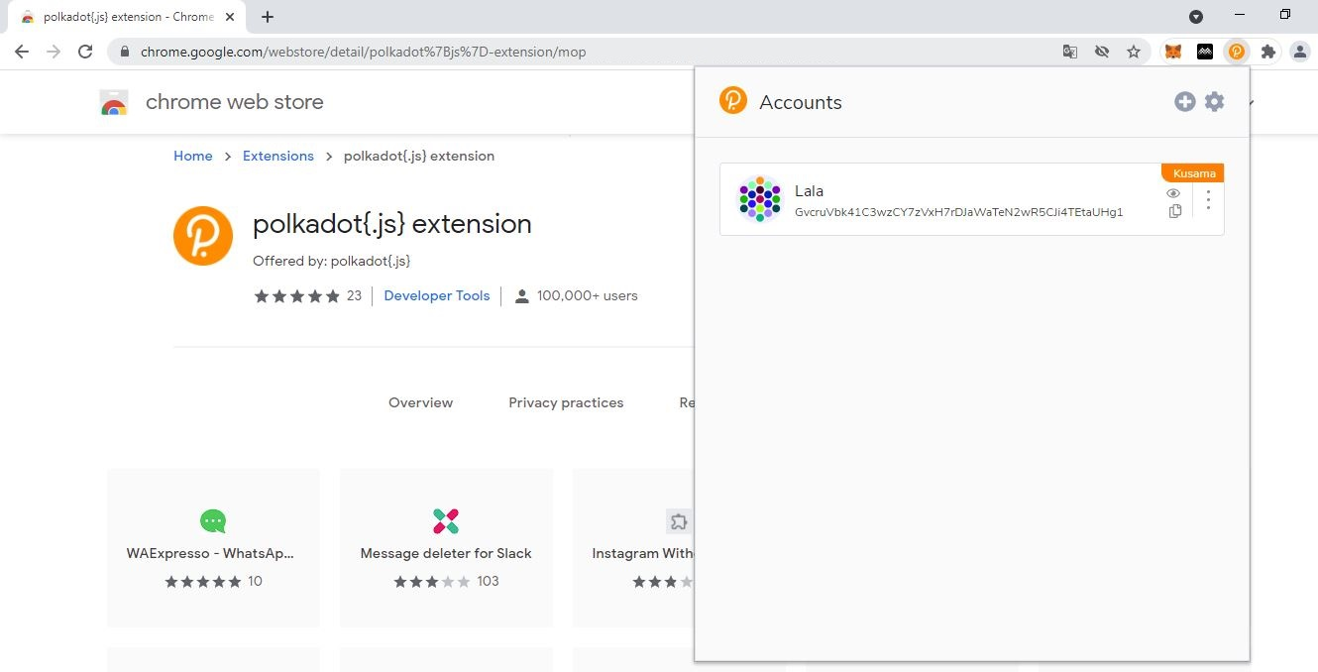

6. **Your first Polkadot-JS wallet account has been created!** procedure.

* 1. **View account information.**



Account **address** for *Polkadot-JS Apps* operations.

Note: This cannot be changed.

Account **network** on which *Polkadot-JS Apps* operations are enabled.

Note: This can be changed later.

Account **name** for *Polkadot-JS Apps* operations.

Note: This can be changed later.

1. **Settings:** Customise browser extension settings.
   1. **Manage themes and website access.**

1. Click the **icon** to open the Polkadot-JS extension settings.

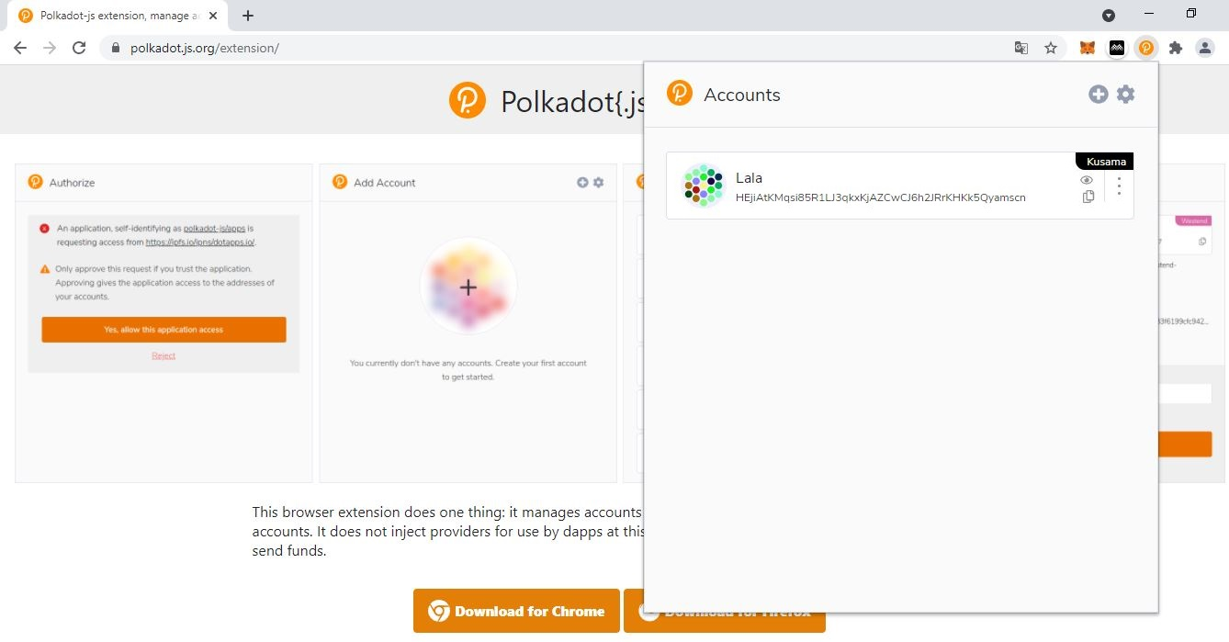

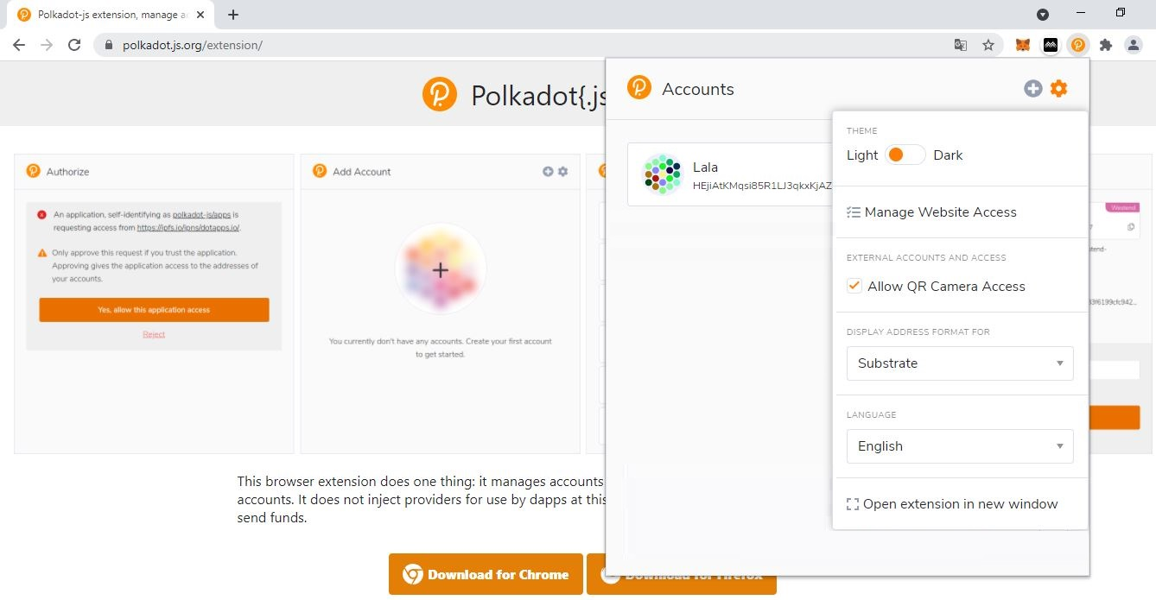

2. Toggle the **theme button** to use Light/Dark mode.

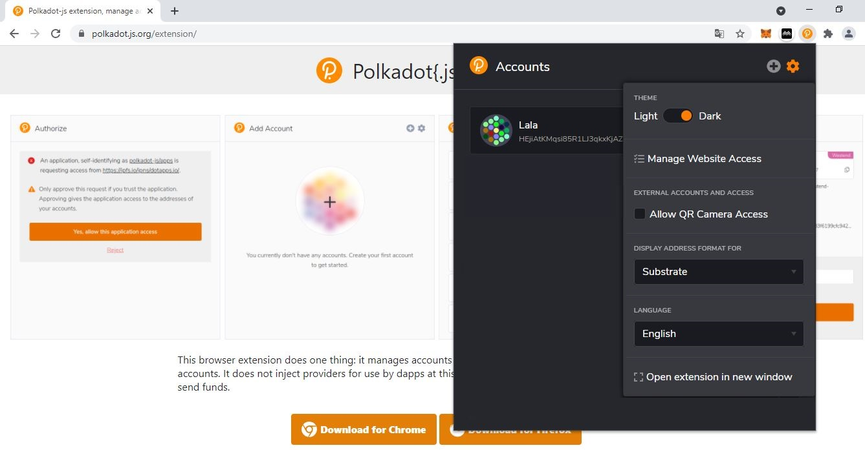

4. Click **Manage Website Access** to view third-party connections.

3. **Your Polkadot-JS extension is now using Dark mode!**

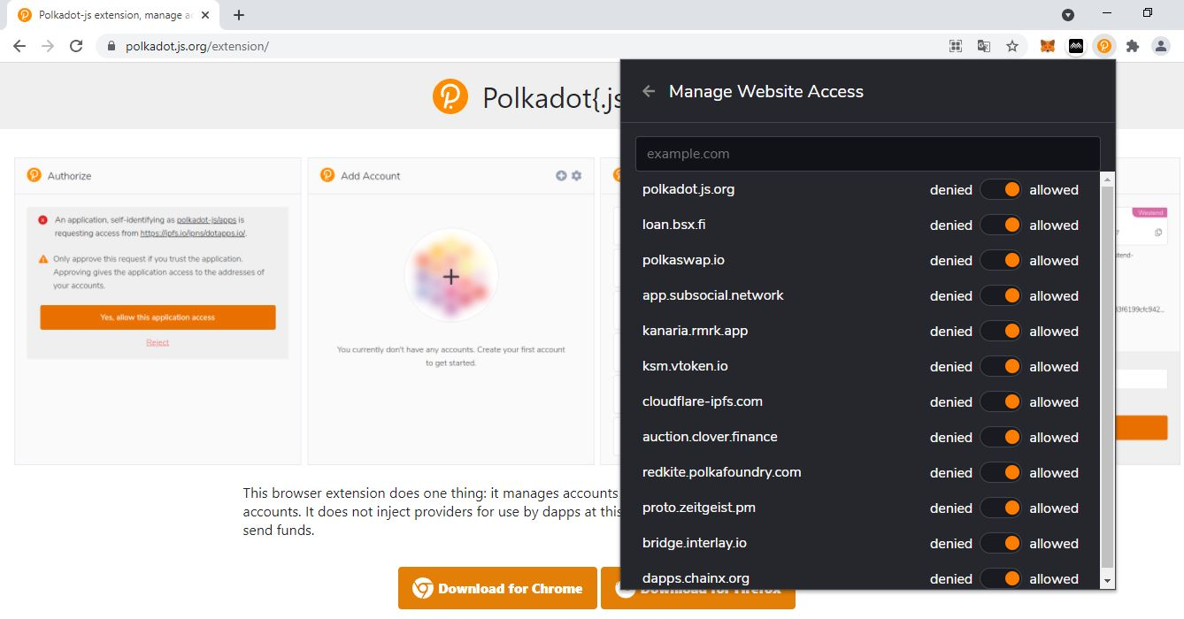

5. Toggle the **access button** to allow/deny website connections.

* 1. **Manage QR Camera, address formats, and languages.**

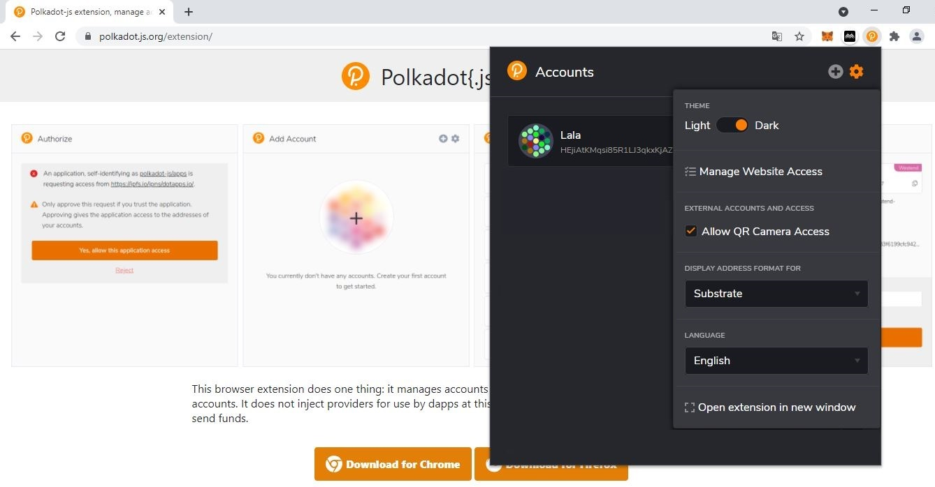

1. Tick the **Allow QR Camera Access** to enable QR operations.

2. Click the **dropdown menu** to change the default address format.

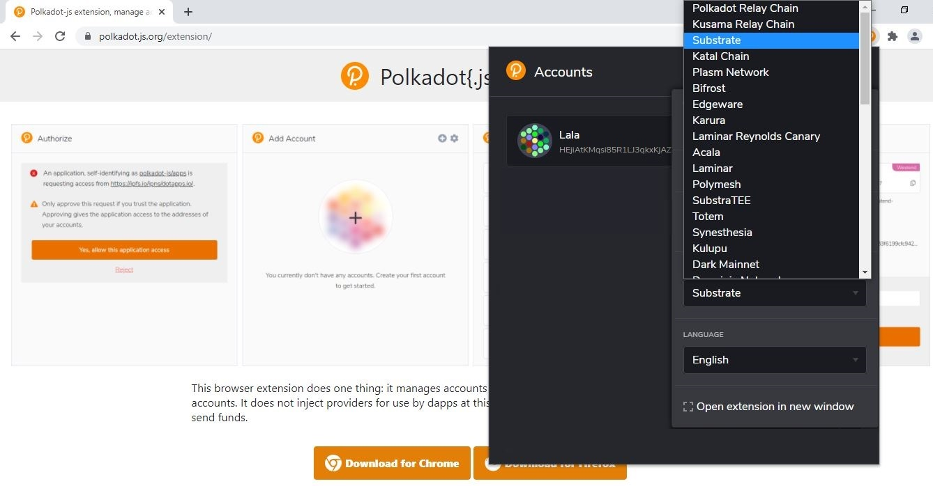

4. Click the **dropdown menu** to change the default language.

3. Select **one** address format to be applied on **all accounts that do not have an assigned network**.

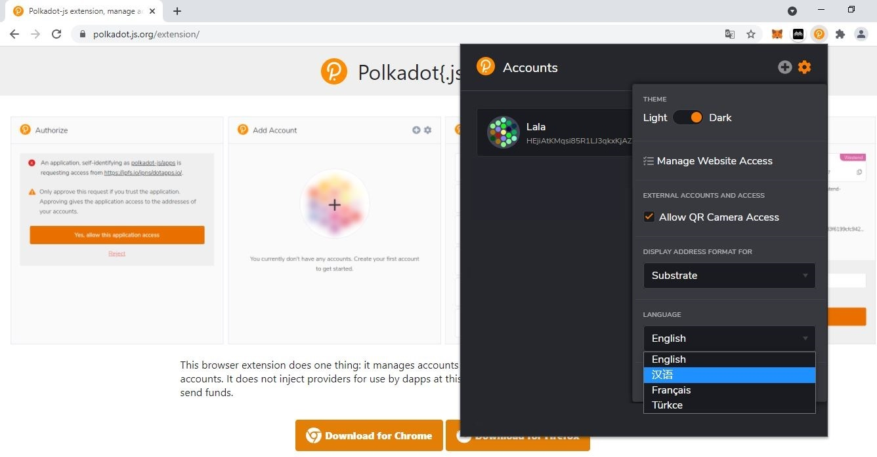

5. Select **one** language.

* 1. **Manage account visibility and incoming transfers.**

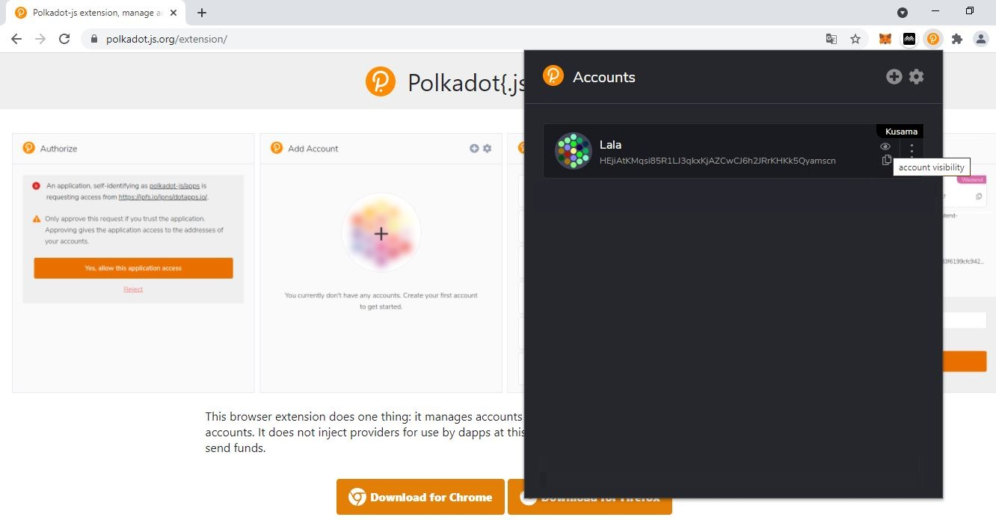

1. Click the **eye icon** to change your account’s visibility.

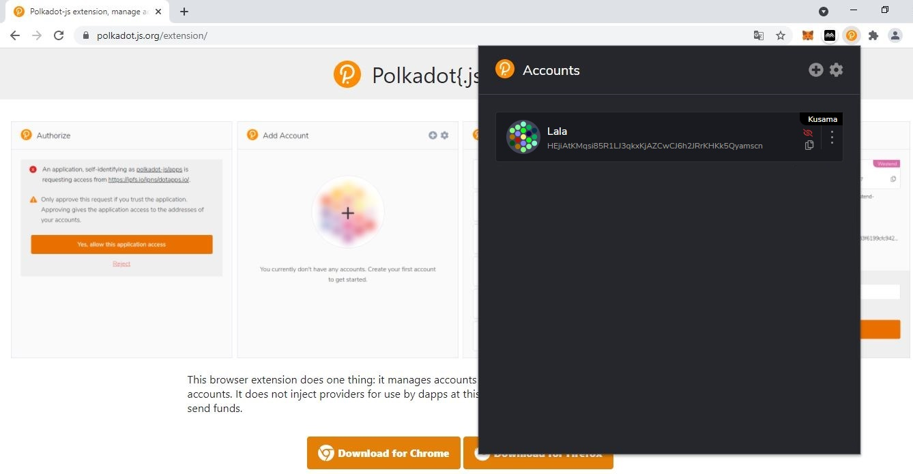

2. **Your account is now invisible and will not appear on *Polkadot-JS Apps*!**

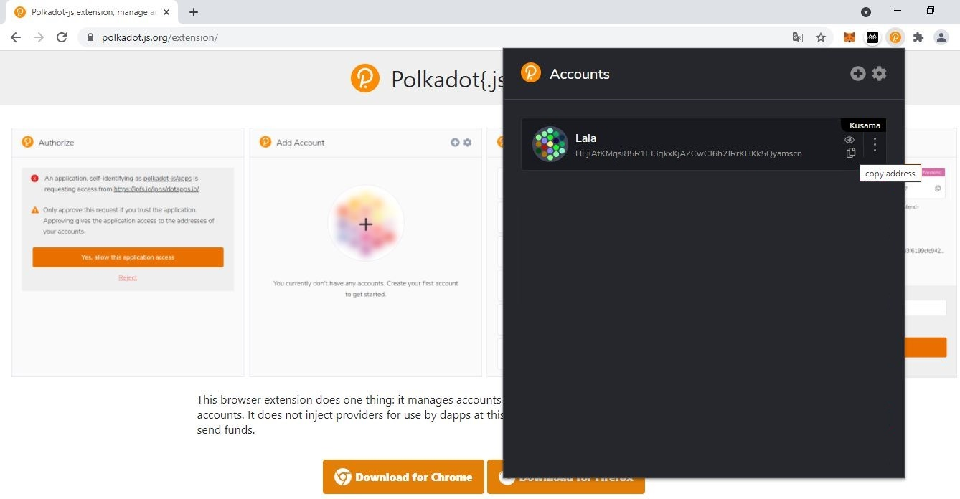

3. Click the **document icon** to copy your account address and submit it to receive KSM.