**PART III: Accounts (Intermediate)**

1. **Substrate identities: Check and manage on-chain identities.**

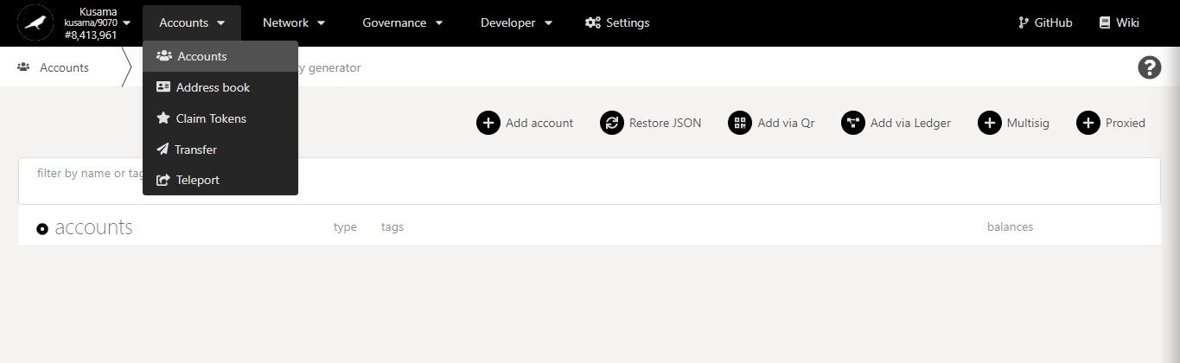

* 1. **Set account names.**

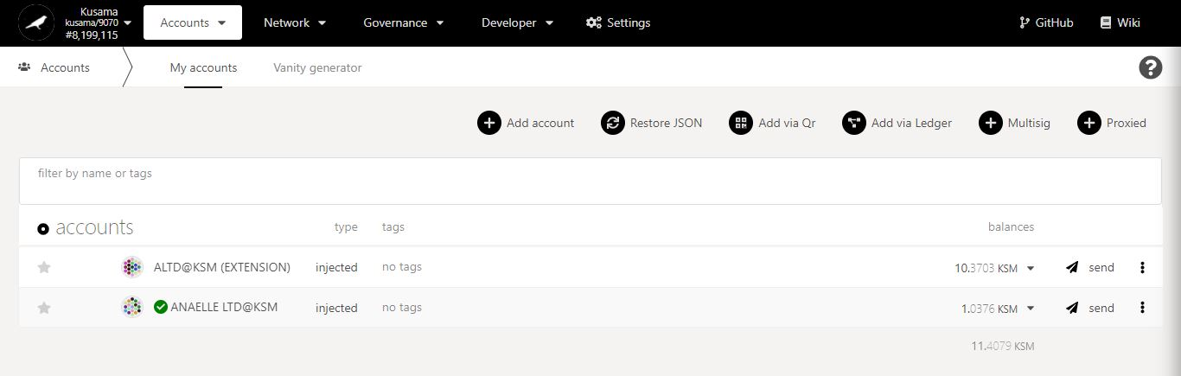

1. Click on the name of the account **to view its summary.**

The **send button** sets this account as the recipient for a transfer.

2. Click on the **pencil icon** to set the account name.

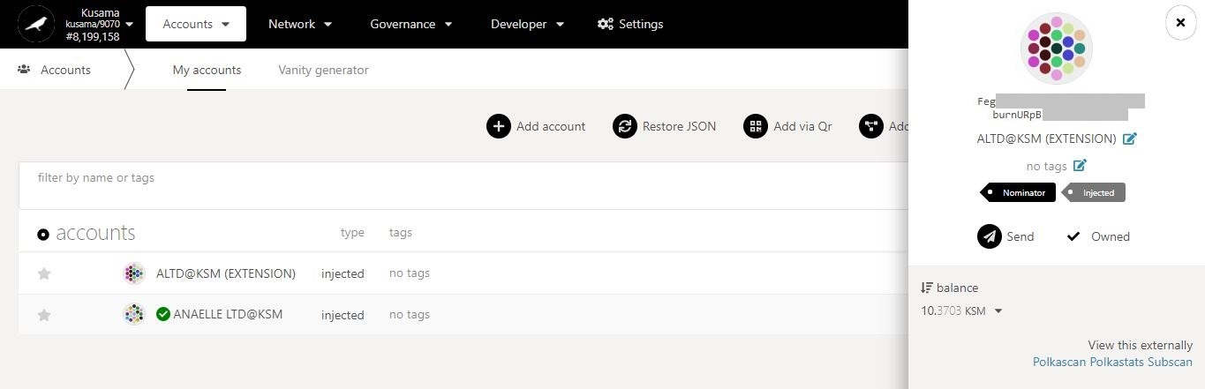

Account summary (1/2):

**Identicon:** A unique icon generated from this account address.

**Account address:** The address associated to this account on the Kusama network.

**Name of the account:** The name you have given to this account on *Polkadot-JS Extension*.

**Tag(s):** The tag(s) you have assigned to this account.

**Role:** The role this account plays within the Kusama network (i.e nominator, validator, councillor, etc).

**Type:** The type for this account on *Polkadot-JS Apps* (i.e injected, sr25519, ledger, etc).

**Balance:** The total amount of units stored at this account address on the Kusama network.

**“View this externally”:** The list of blockchain explorers than can be used to view this account’s information externally.

The **dropdown arrow** reveals the account balance details.

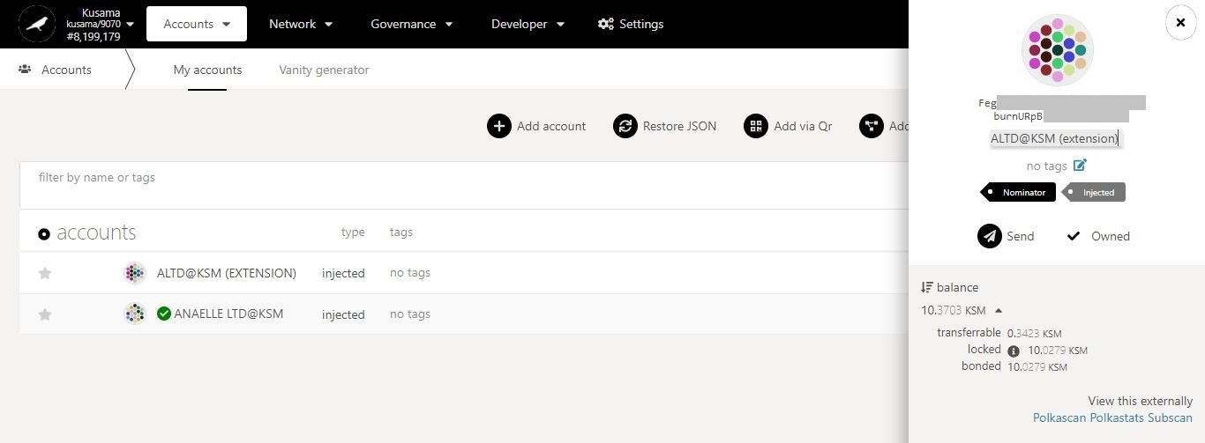

4. Click on the **pencil icon** to add/change tags for the account.

Balances in detail.

3. Enter a **(new) name** for the account.

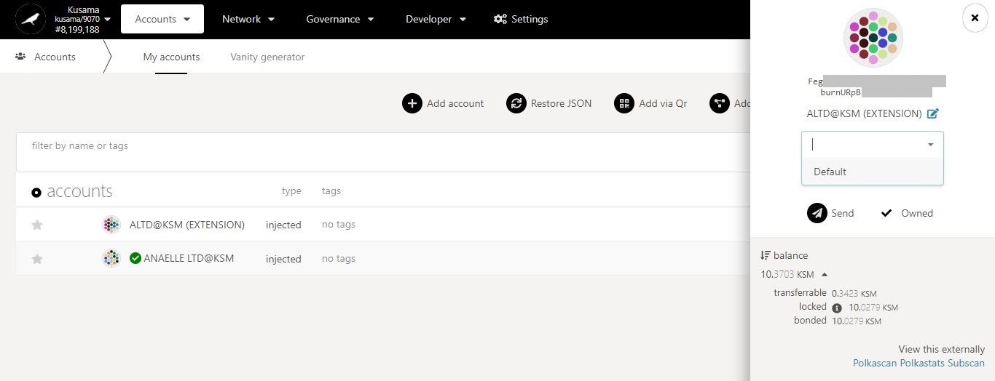

5. Enter **(new) tags** for the account.

* 1. **Set unverified on-chain identities.**

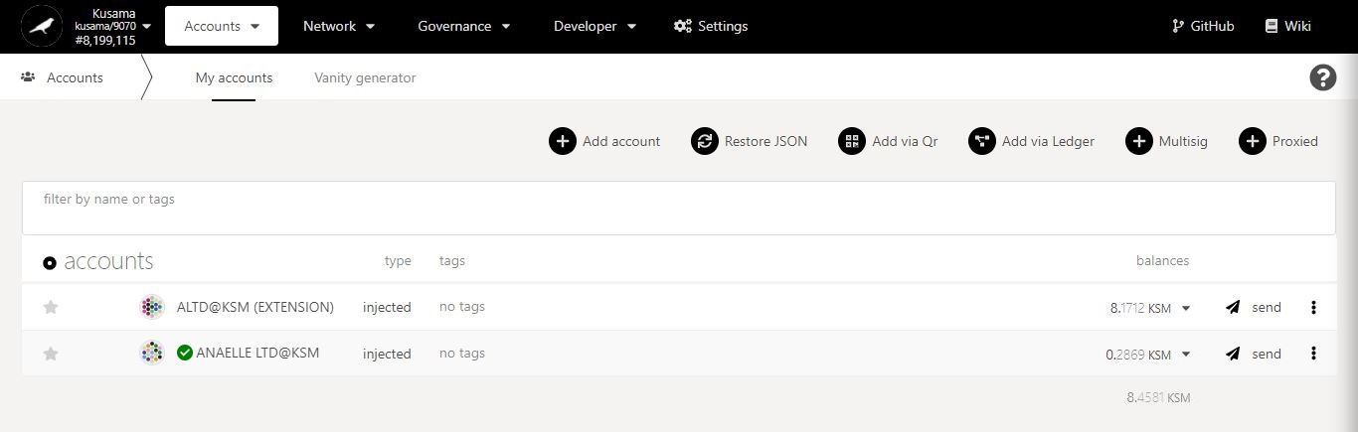

1. Click on the 3 vertical dots to view **Account settings**.

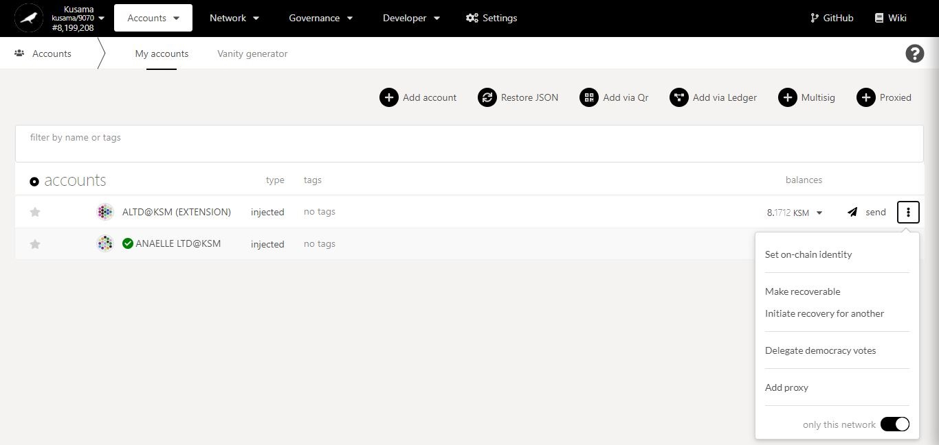

2. Click on **Set on-chain identity** to submit identity details.

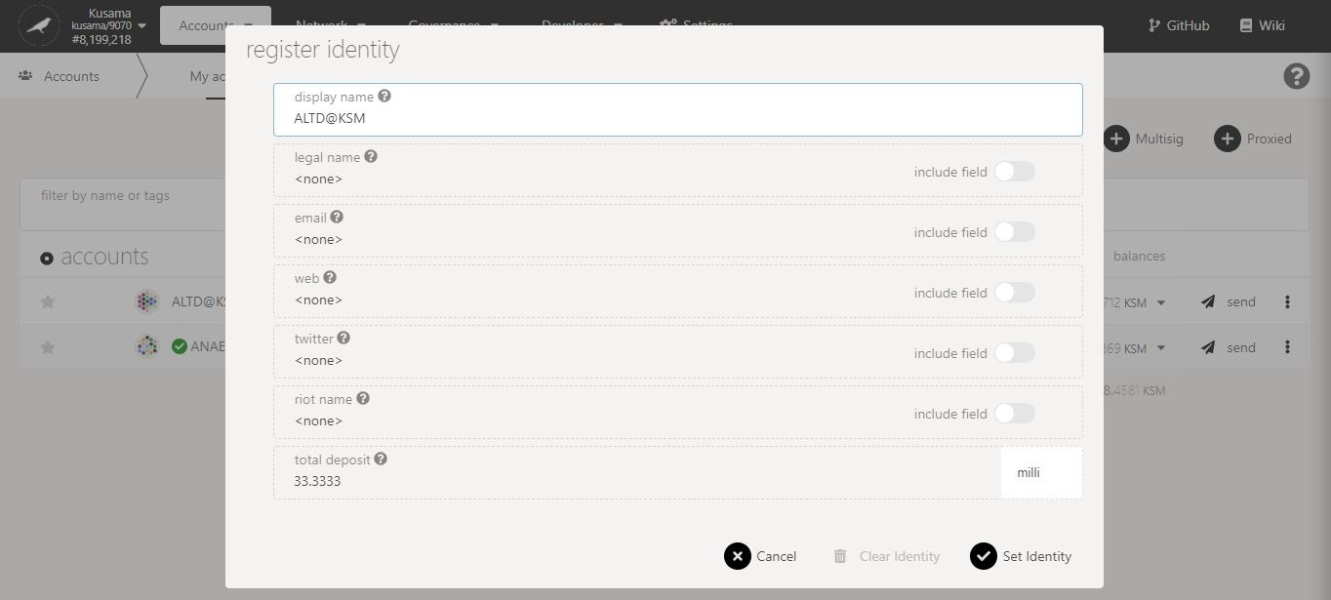

3. Fill-in a **display name**. Note: This name will be displayed on-chain, even if you don’t formally verify your identity.

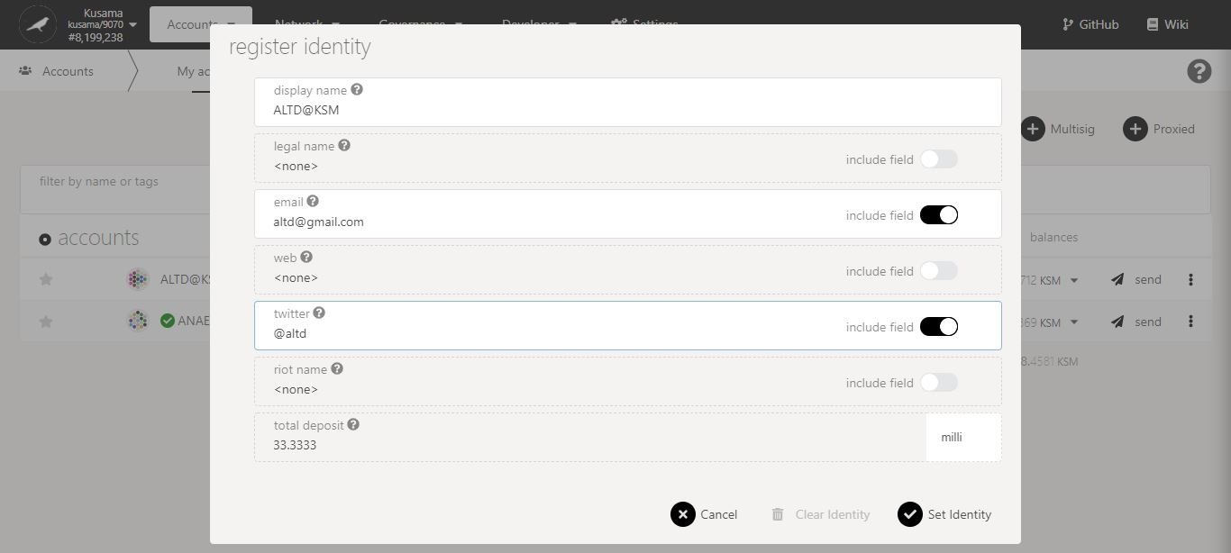

A **deposit** is required to maintain on-chain identity information. Note: This deposit will be refunded when your on-chain identity information is cleared.

4. Switch the **include field(s) ON** to enter extra information.

5. Click on **Set identity** to continue the procedure.

**Nature** of the transaction.

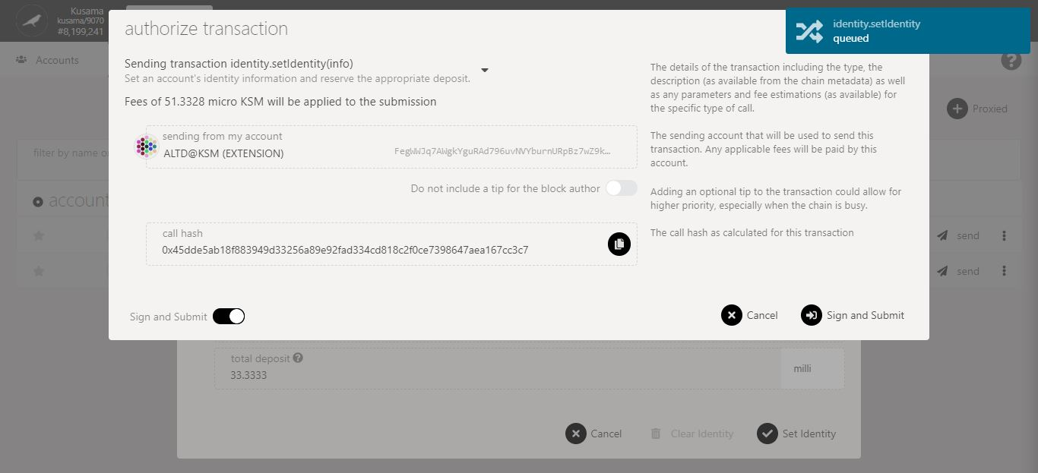

6. Check the **transaction fees**.

7. Click on **Sign & submit** to continue the procedure.

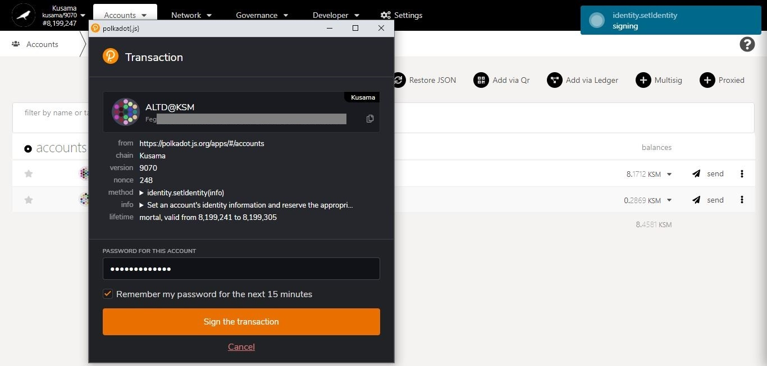

**Progress** of the transaction.

9. Click on **Sign the transaction** to complete the procedure.

8. Enter **your account’s password** and tick the box to **remember your password, if necessary**.

**Summary** of the transaction sent via the Polkadot-JS extension.

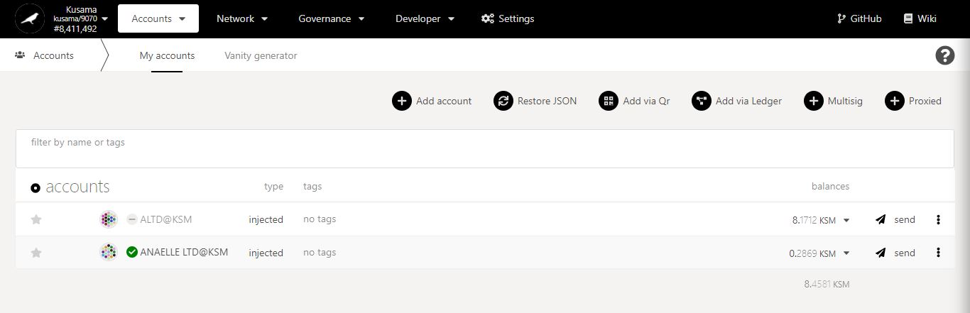

11. Click on the name of the account **to view its summary.**

10. **Your unverified identity has been set!**

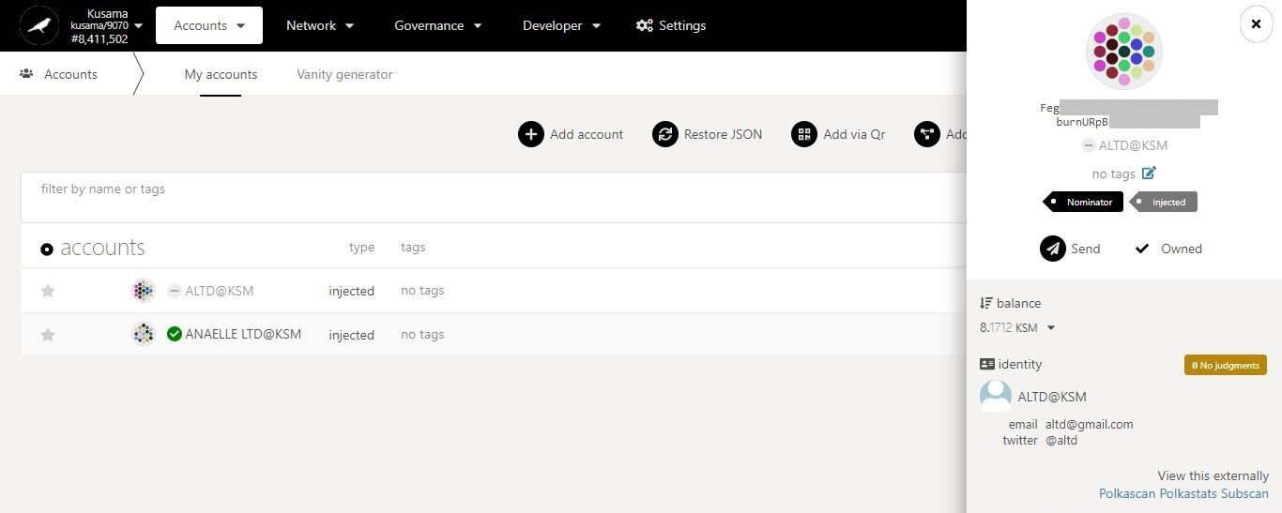

Account summary (2/2):

**Identity:** The on-chain identity information submitted for this account (i.e email, twitter handle, etc) and the judgement received from a registrar (i.e 0 = No judgement, 1 = Reasonable, 2 = Known Good, etc.).

* 1. **Set verified on-chain identities.**

1. Mouse-over **Developer.**

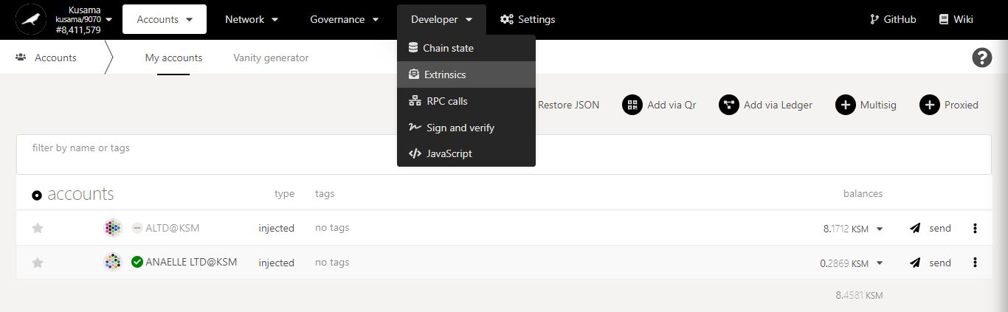

2. Select **Extrinsics** from the dropdown menu.

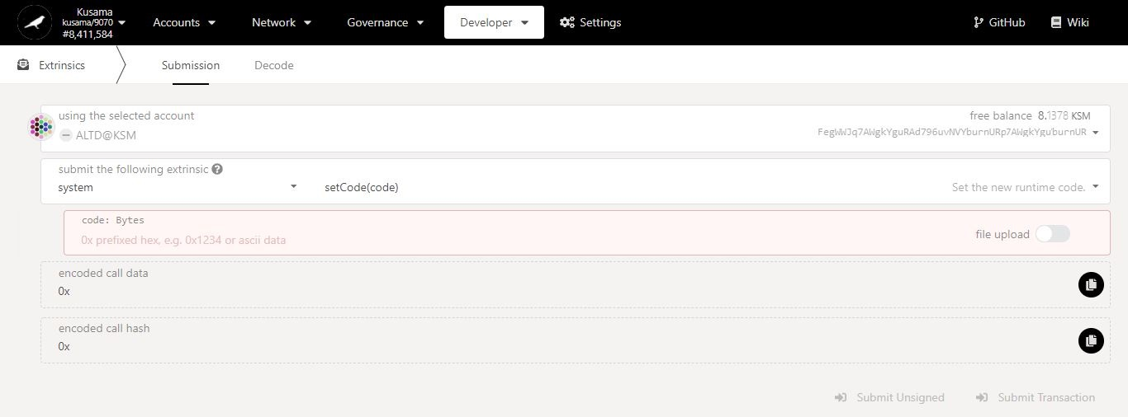

4. Click on the **dropdown arrow** to view all the available extrinsics.

3. Select the **account** to be verified.

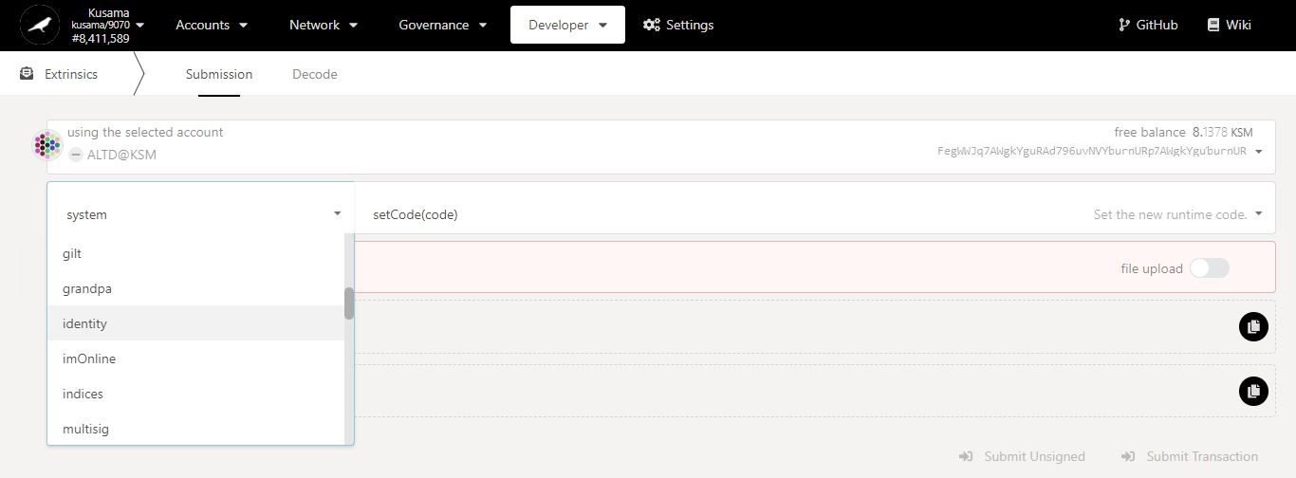

5. Select **identity** from the dropdown menu.

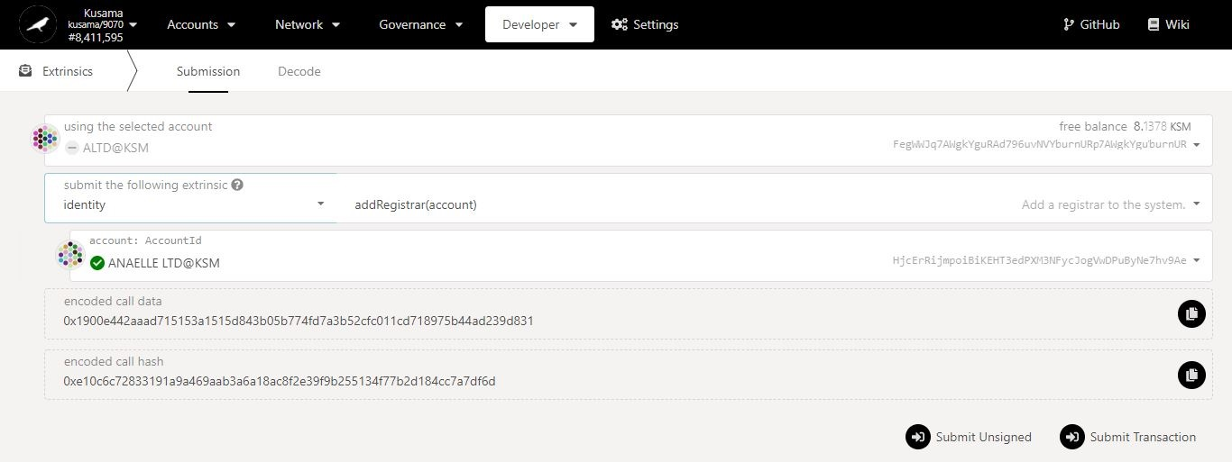

6. Click on the **dropdown arrow** to view all the available methods.

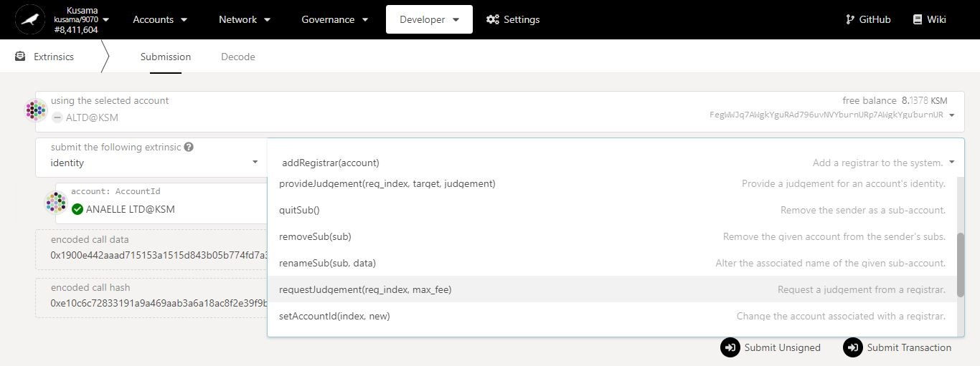

7. Select **requestJudgement()** from the dropdown menu.

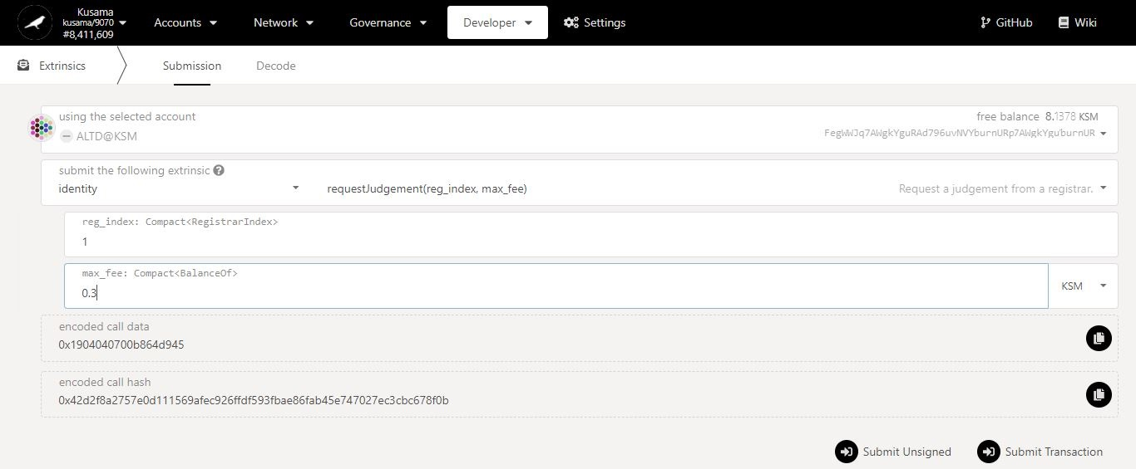

8. Enter **the information required**.

Note: Make sure that you have the correct registrar information at hand!

9. Click on **Submit Transaction** to continue the procedure.

Issue:

No information on the accounts page about registrars’ **reg_index and fee**.

Possible solutions:

1. Wait for registrar(s) to contact you and give you the information directly.

2. Query registrars information stored on-chain with *Polkadot-JS Apps*.

**[Troubleshooting 1/2]**

1. Mouse-over **Developer.**

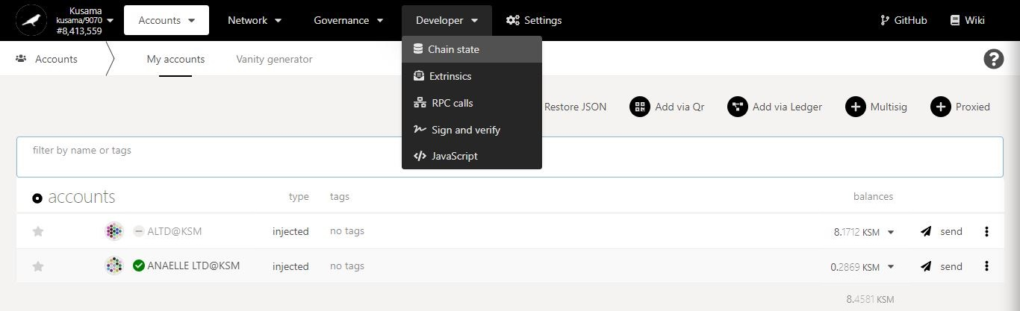

2. Select **Chain state** from the dropdown menu.

**[Troubleshooting 2/2]**

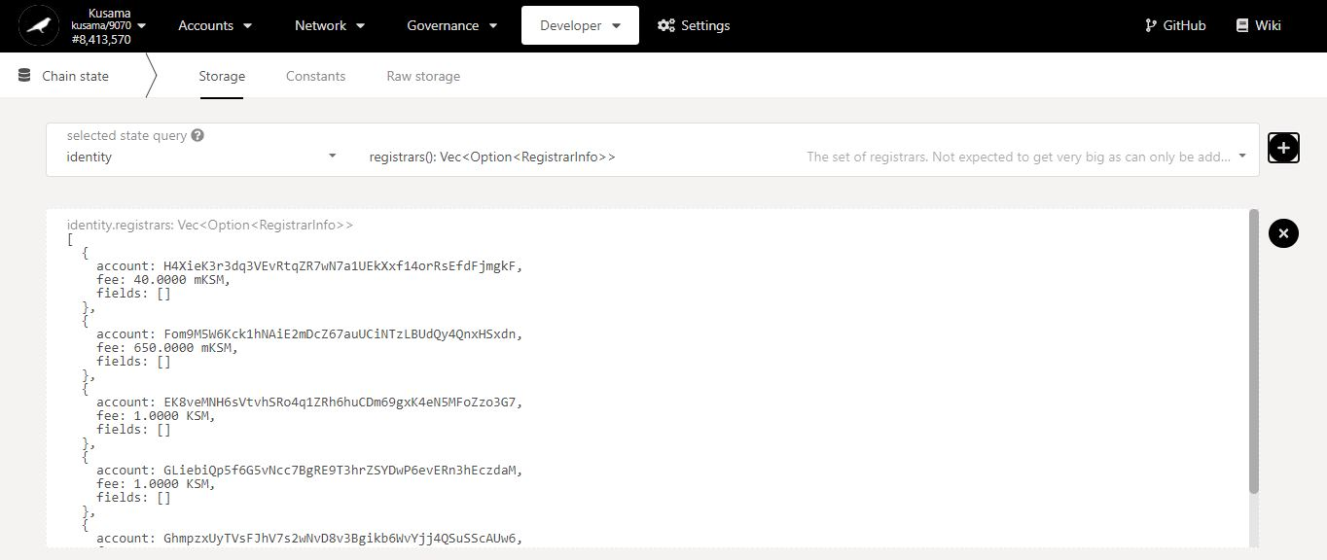

4. Select **registrars()** from the second dropdown menu.

3. Select **identity** from the first dropdown menu.

5. Click **+** to display the results.

6. **Registrars’ account address and fee are now displayed!**

**NEVER SEND YOUR KSM TO A REGISTRAR’S ADDRESS!**

**Nature** of the transaction.

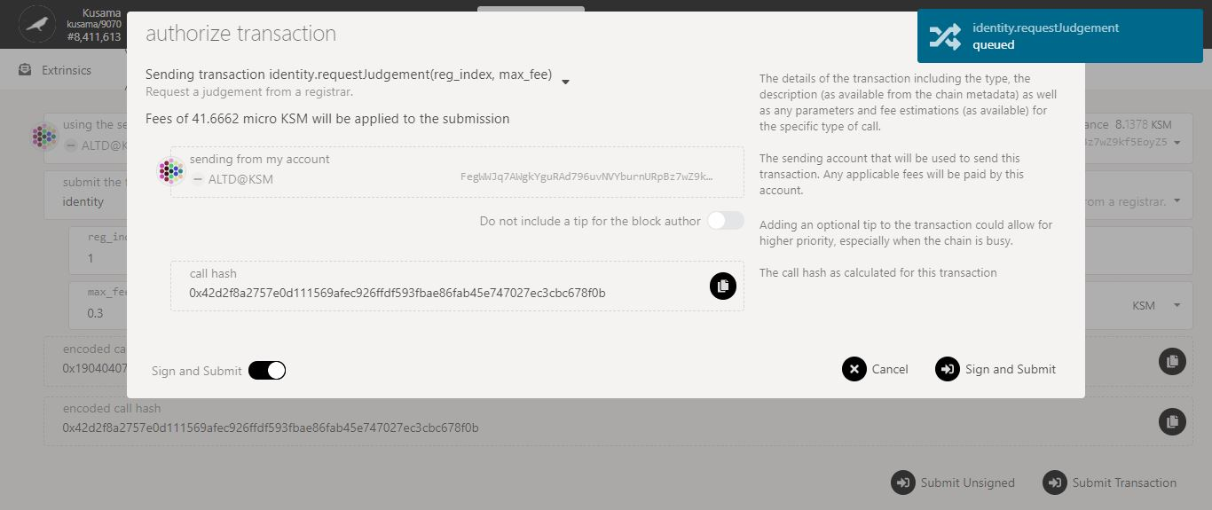

11. Click on **Sign & submit** to continue the procedure.

10. Check the **transaction fees**.

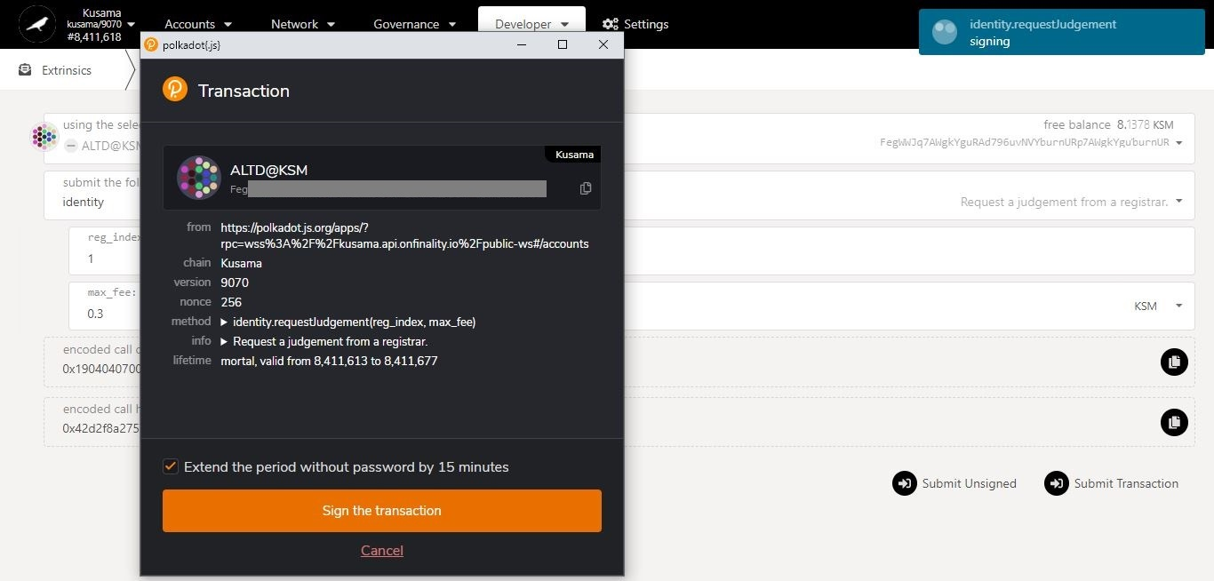

12. Tick the box to **remember your password, if necessary**.

**Progress** of the transaction.

13. Click on **Sign the transaction** to complete the procedure.

**Summary** of the transaction sent via the Polkadot-JS extension.

* 1. **Clear on-chain identities.**



1. Click on the 3 vertical dots to view **Account settings**.

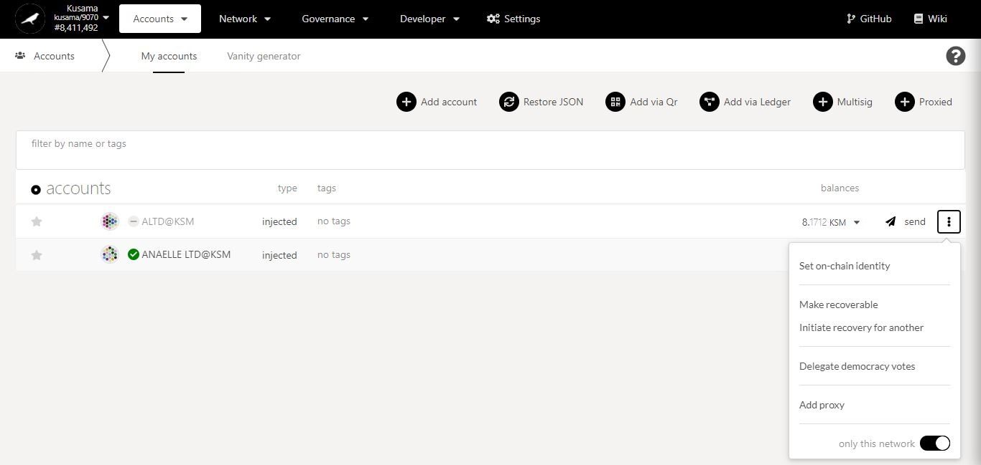

2. Click on **Set on-chain identity** to clear identity details.

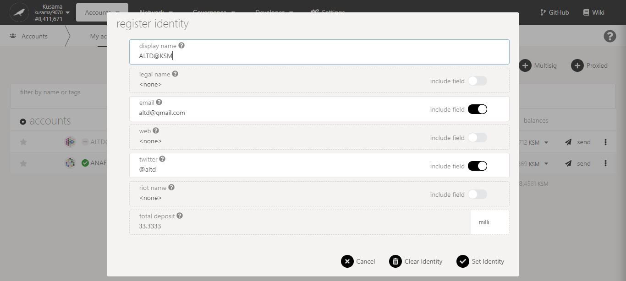

3. Click on **Clear identity** to continue the procedure.

**Nature** of the transaction.

5. Click on **Sign & submit** to continue the procedure.

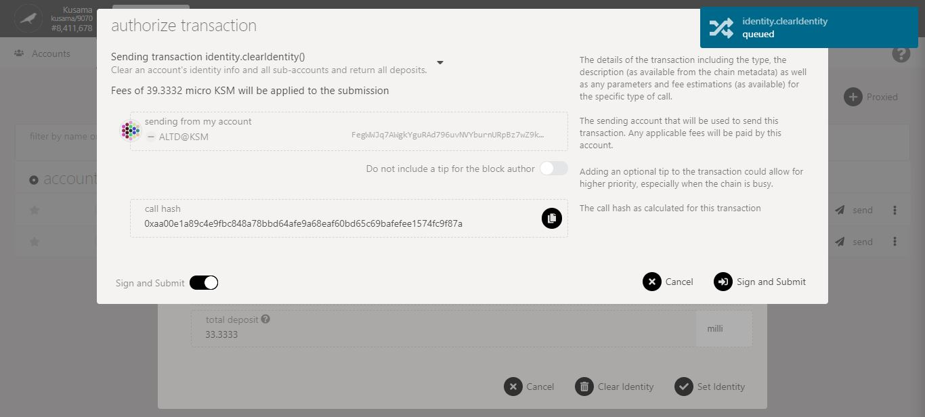

4. Check the **transaction fees**.

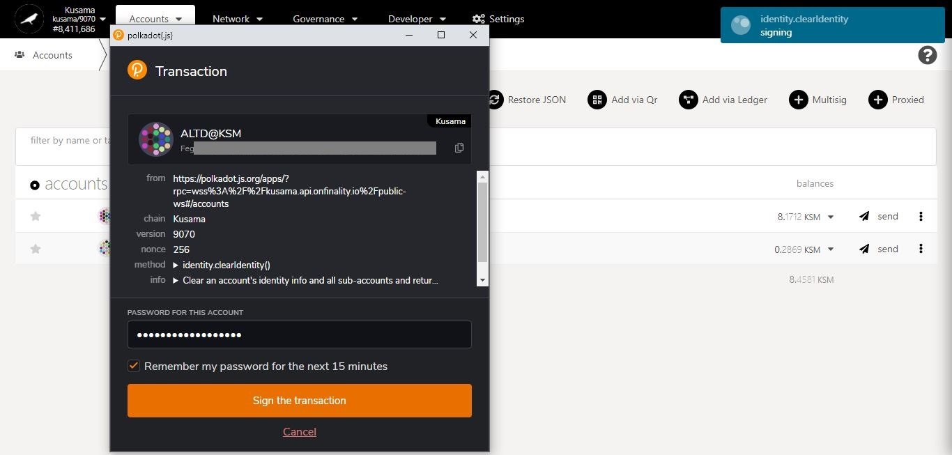

**Progress** of the transaction.

7. Click on **Sign the transaction** to complete the procedure.

6. Enter **your account’s password** and tick the box to **remember your password, if necessary**.

**Summary** of the transaction sent via the Polkadot-JS extension.

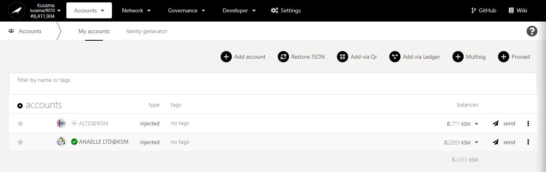

8. Click on the name of the account **to view its summary.**

9. **Your on-chain identity details have been cleared!**

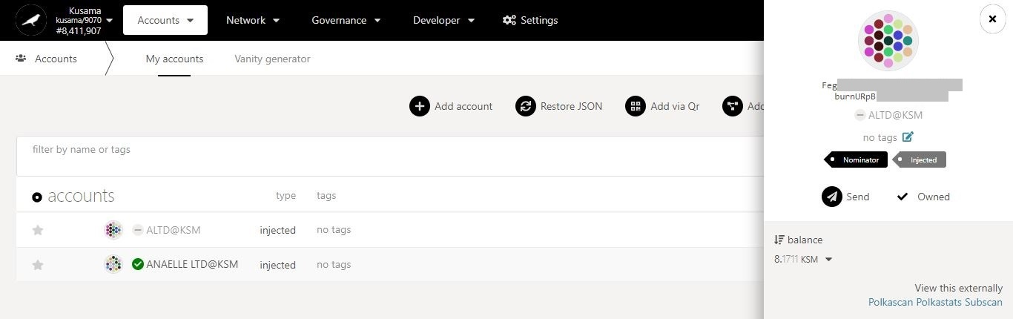

10. Click on **My accounts** to refresh the page and display the latest changes.

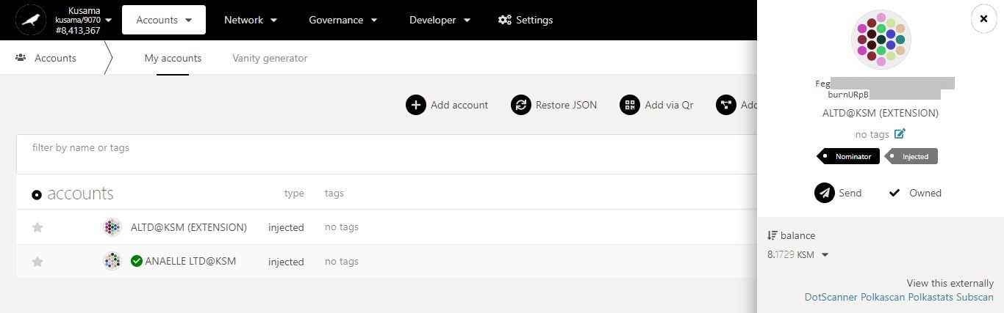

11. **The latest changes are now visible on the *My accounts* page and the account summary.**

1. **Substrate explorers: Check on-chain transactions details.**

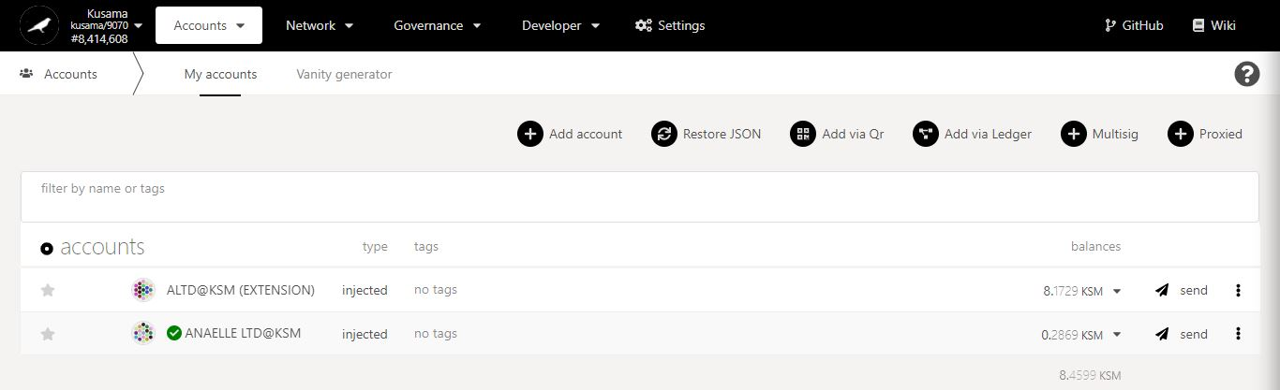

1. Click on the name of the account **to view its summary.**

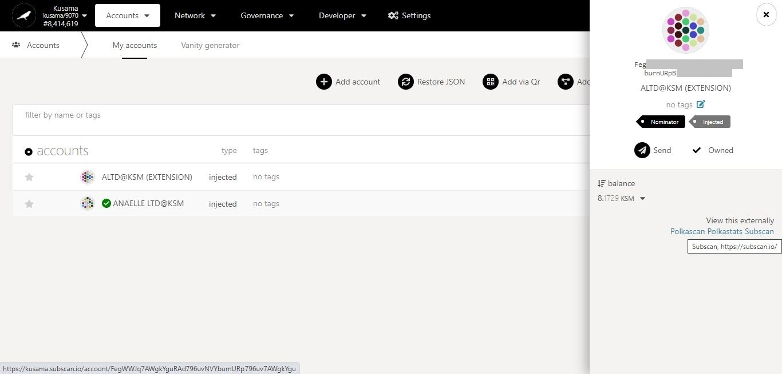

2. Click on **Subscan** to view the account’s information in the blockchain explorer.

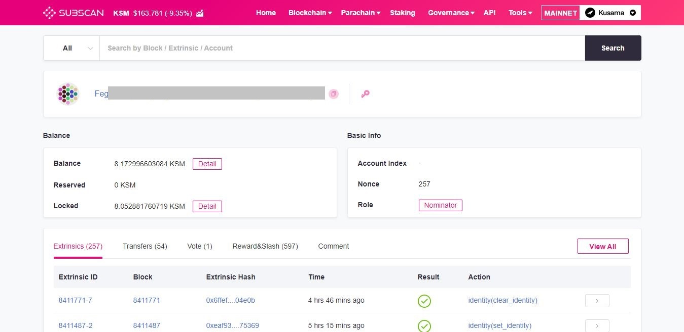

Transaction summary:

**Extrinsics:** Off-chain data submitted by this account (i.e transactions related to staking, democracy, treasury, identity, crowdloan, remark, etc).

**Transfers:** Amounts sent from/received by this account.

**Vote:** Current reward-issuing validator for this account’s stash.

**Reward&Slash:** Rewards received by this account.

Key Account information: **account identity/public Key (URI), account ID/public key (hex-encoded), balances and role.**

3. Click on **one** **Extrinsic ID** to view its transaction details.

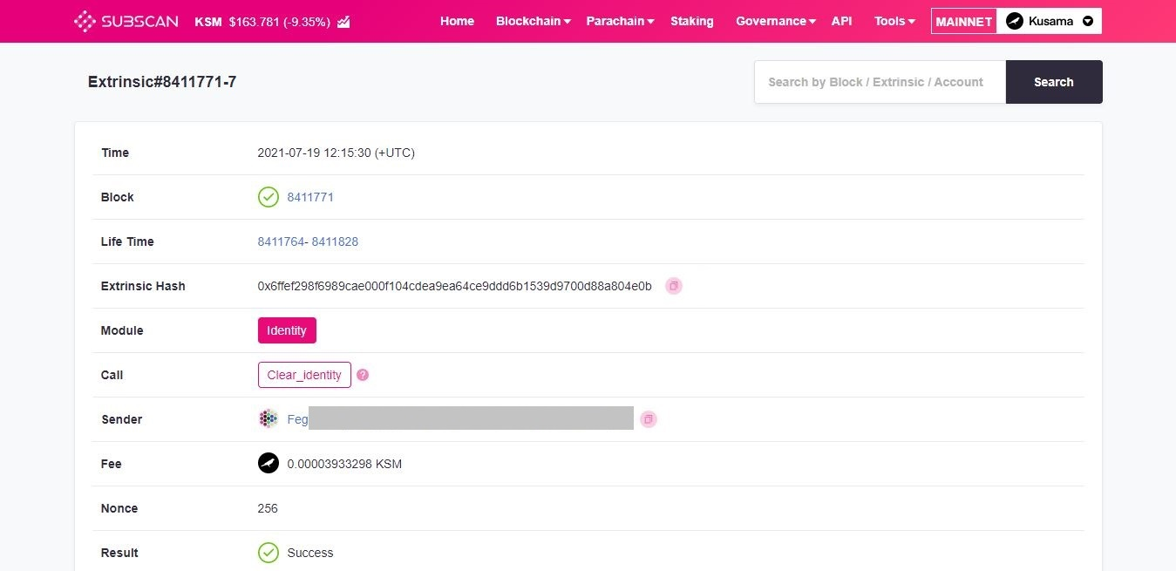

Transaction in detail:

**Time:** Time at which this transaction was signed and submitted.

**Block:** Block number at which this transaction was included.

**Life Time:** Validity period of this transaction expressed as a range between two block numbers. Note: The life time of a transaction is also called Transaction *Mortality*.

**Extrinsic Hash: “**Fingerprint” of the data submitted in this transaction. This is not a unique identifier.

**Module:** Pallet used as part of this transaction.

**Call:** Function/Method called as part of this transaction.

**Sender:** Account address that submitted this transaction.

**Fee:** Amounts paid by the sender for this transaction.

**Nonce:** Index number of this transaction.

**Result:** Outcome of this transaction (i.e Success or Failed).

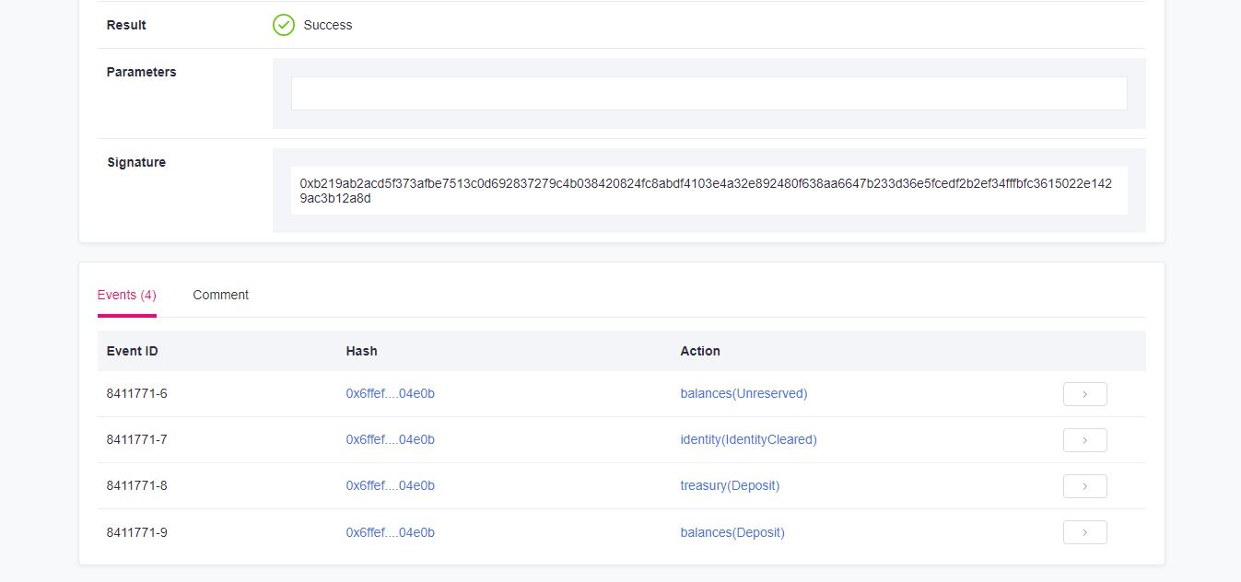

Transaction in detail:

**Parameters:** Parameters to add to this transaction as required by the function called (i.e index, destination, value, etc).

**Signature:** Signature of the sender of this transaction.

**Events:** On-chain actions triggered by this transaction (i.e withdraw a fee for the transaction, remove balance locks, etc).