**PART V: Substrate setups**

1. **Substrate accounts: Set Substrate networks for your Polkadot-JS accounts.**

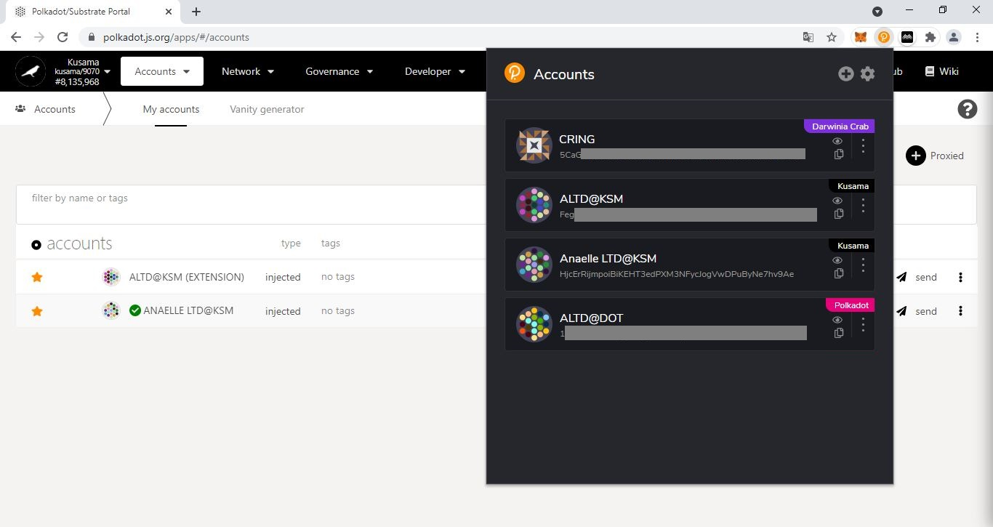

2. Click on the **3 vertical dots** to reveal the Account settings window.

1. Click on the **Polkadot-JS extension icon** to reveal the Accounts window.

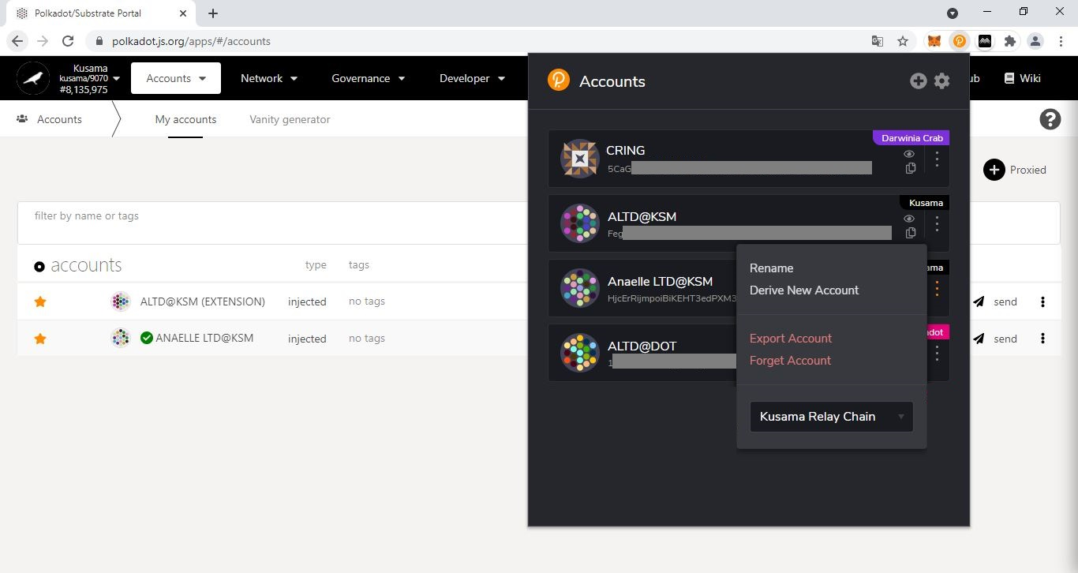

3. Click on the **dropdown arrow** to show the list of Substrate networks.

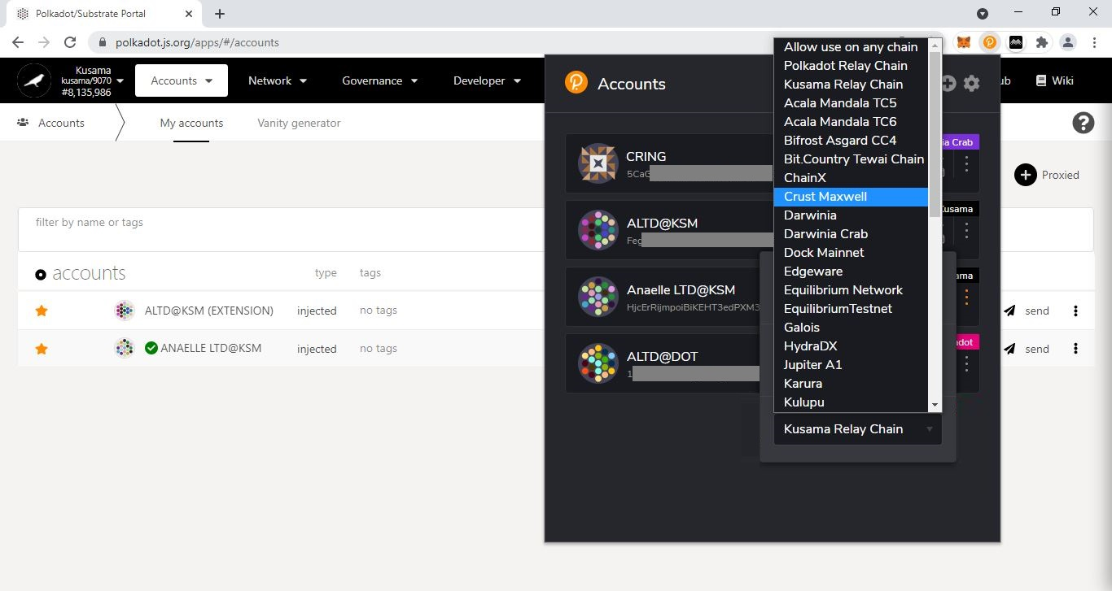

4. Select **one** Substrate network from the list or choose **Allow use on any chain** to access all Substrate networks.

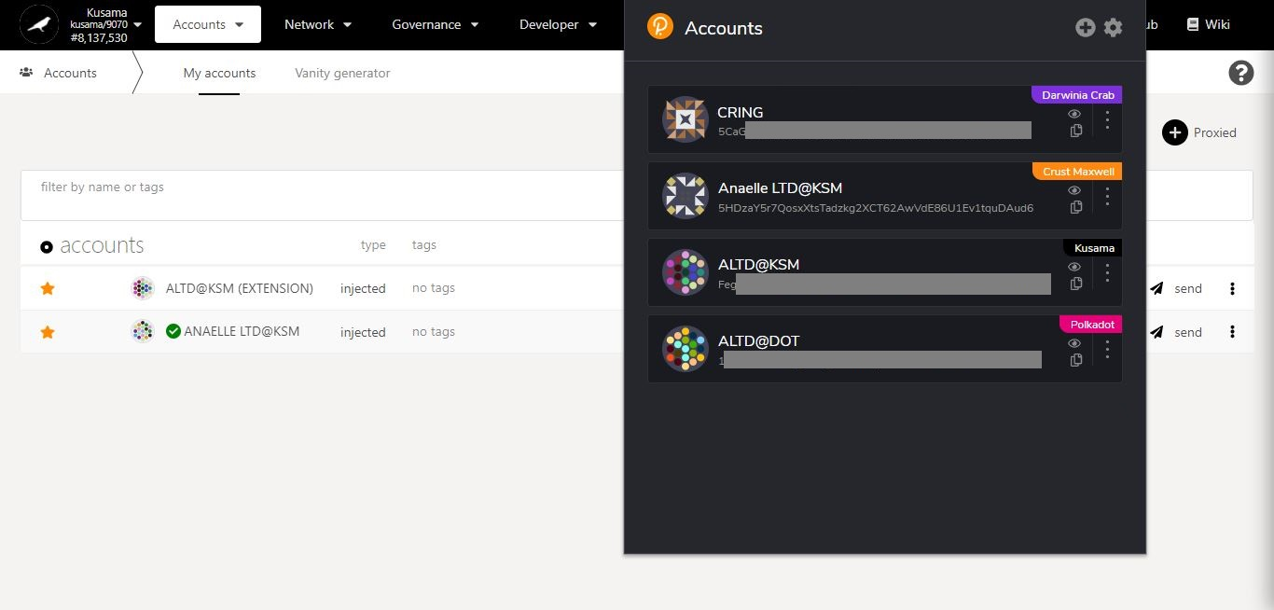

5. **Your account is now set up to access your chosen Substrate network**.

1. **Substrate chains: Switch between Relay chain/Parachain/Testnets’ interfaces.**

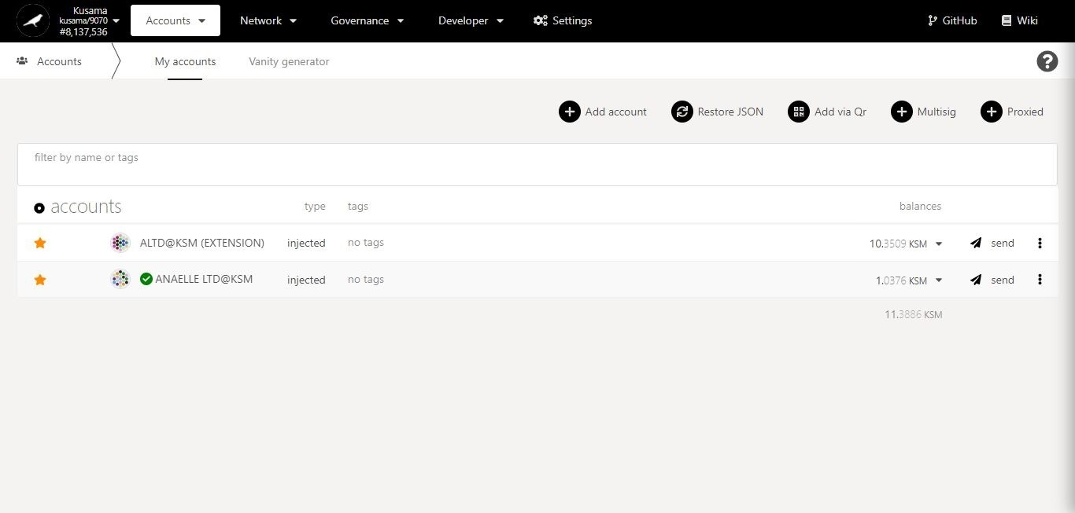

1. Click on the **dropdown arrow** to show the Substrate networks sidebar.

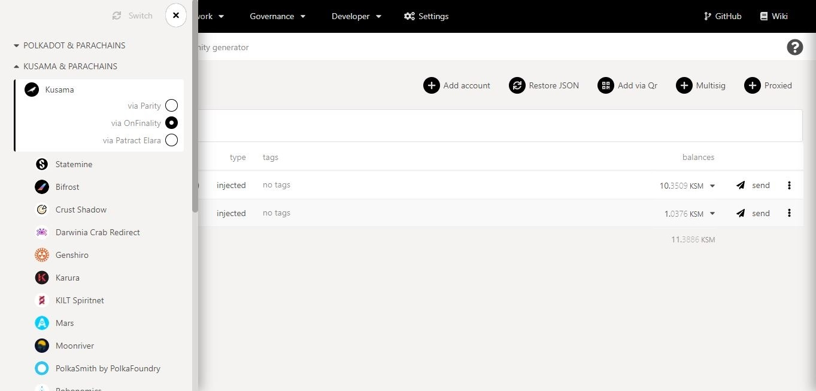

3. Navigate the sidebar dropdown menus to **find your chosen Substrate network.**

2. The sidebar displays your **current Substrate network and node**.

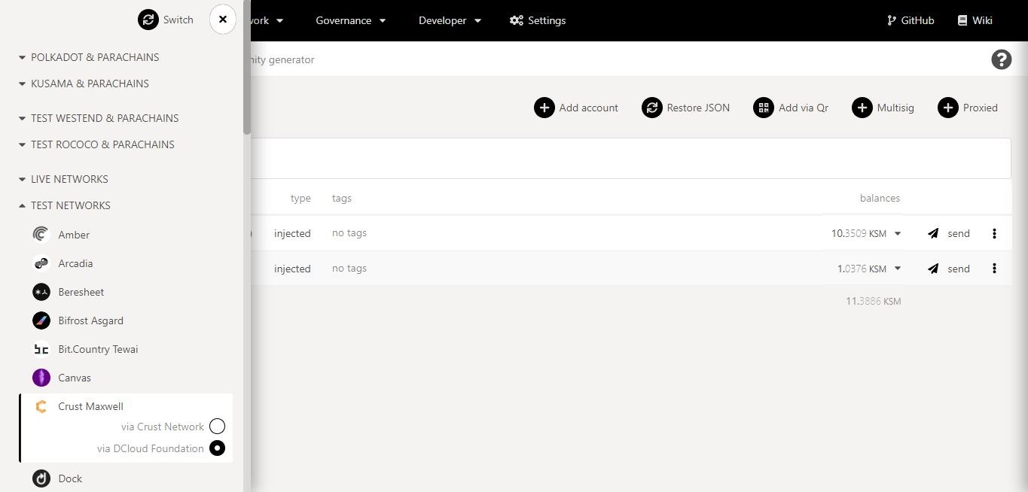

4. Select a **node for your chosen Substrate network**, then click on **Switch**.

5. **You have successfully switched Substrate networks**!

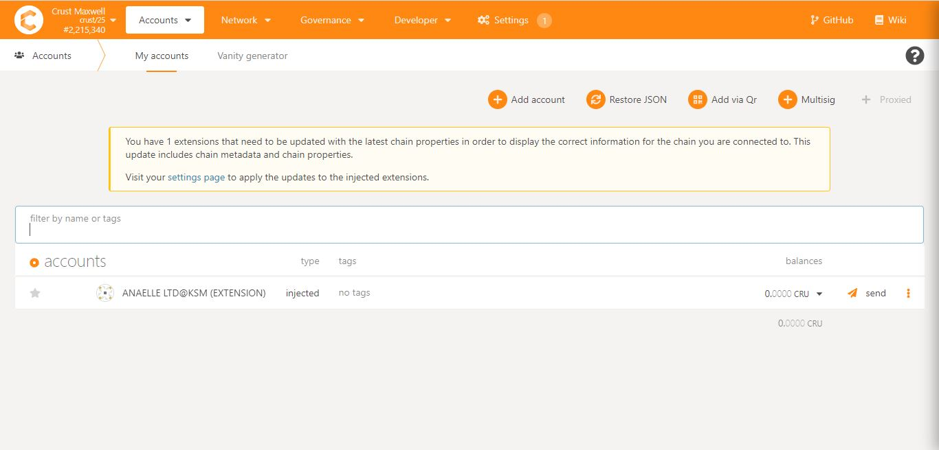

6. If prompted, update your **settings.**