**PART VI: Accounts (Advanced)**

1. **Account recovery: Set up recoverable and recovery accounts.**

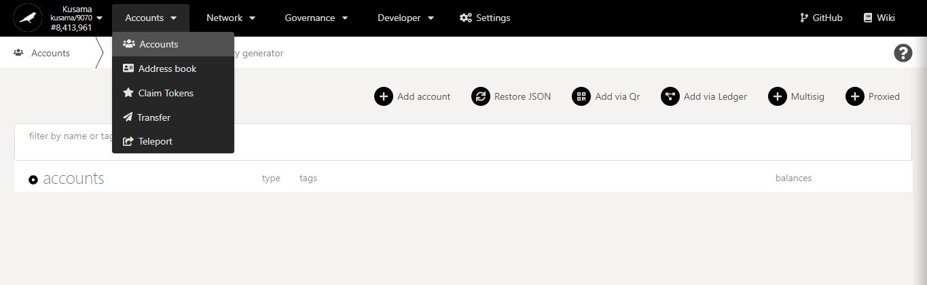

* 1. **Make an account recoverable.**

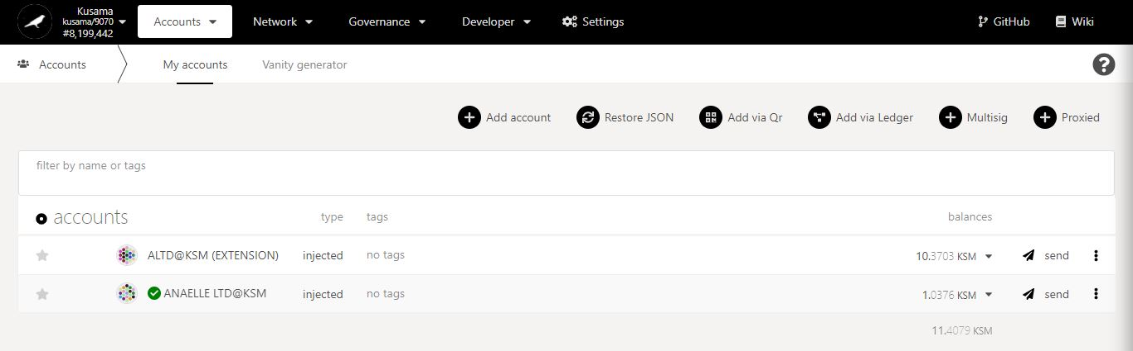

1. Click on the 3 vertical dots to view **Account settings**.

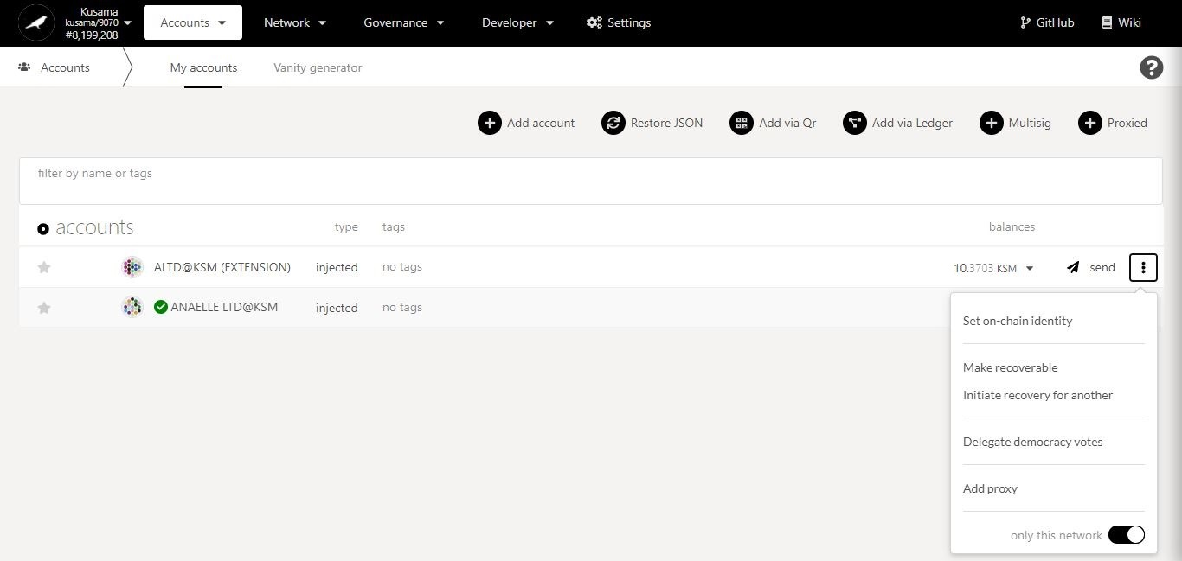

Recoverable & Recovery accounts in detail:

**Recoverable** = “Protected by a social recovery process”.

**Recovery** = “Protects by performing social recovery”.

Recoverable & Recovery accounts allow individuals to **act as third-party backups for a family member’s or a peer’s account and regain access to this account** in case the seed phrase/JSON file are lost.

The family member/peer must first **set up his/her account as recoverable** before you can **perform recovery for the account**.

2. Click on **Make recoverable** to submit social recovery details.

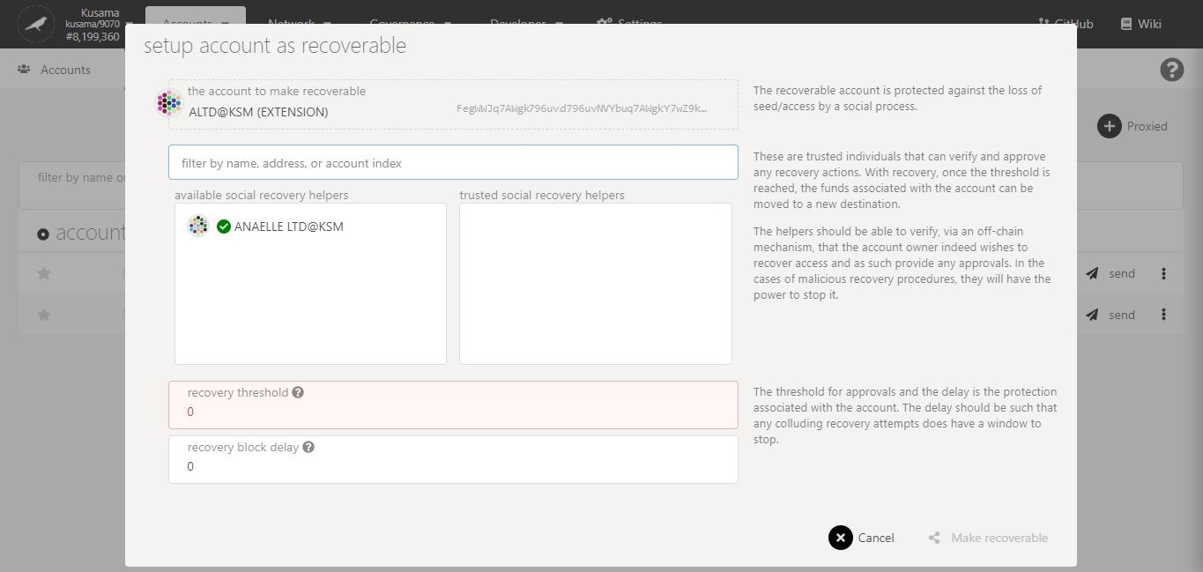

4. Click on **1-3** **contacts’ names or addresses** to set them as **recovery accounts**.

3. Follow **on-screen instructions** carefully.

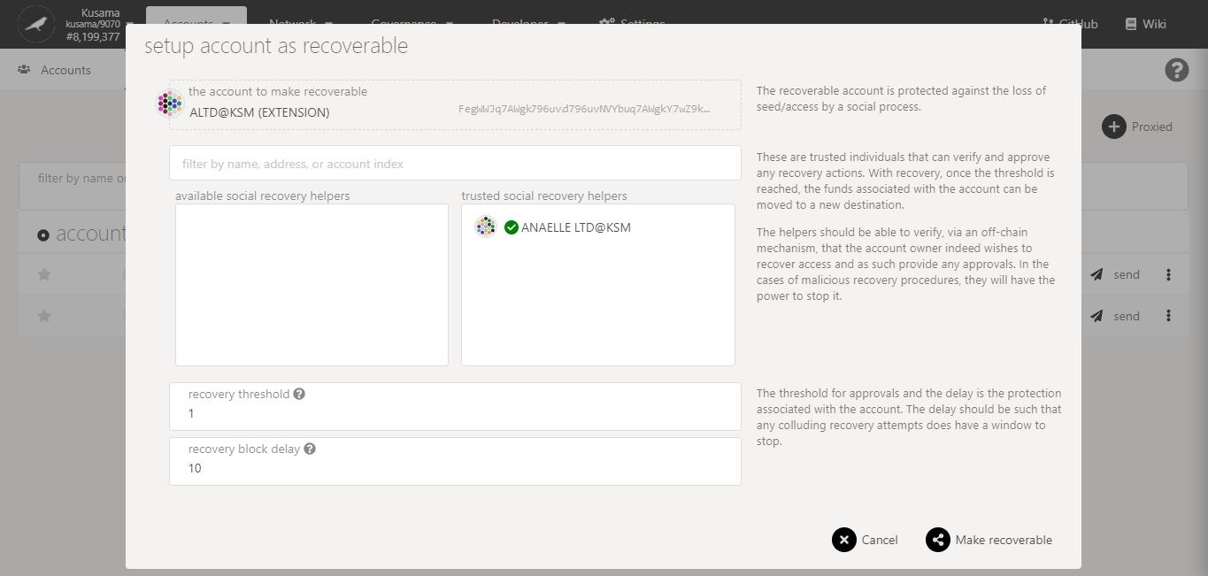

7. Click on **Make recoverable** to continue the procedure.

The recovery threshold must be **1 or more**.

Note: 1 block = 6 seconds.

6. Enter the **required information**.

5. Double-check your **selection.**

**Nature** of the transaction.

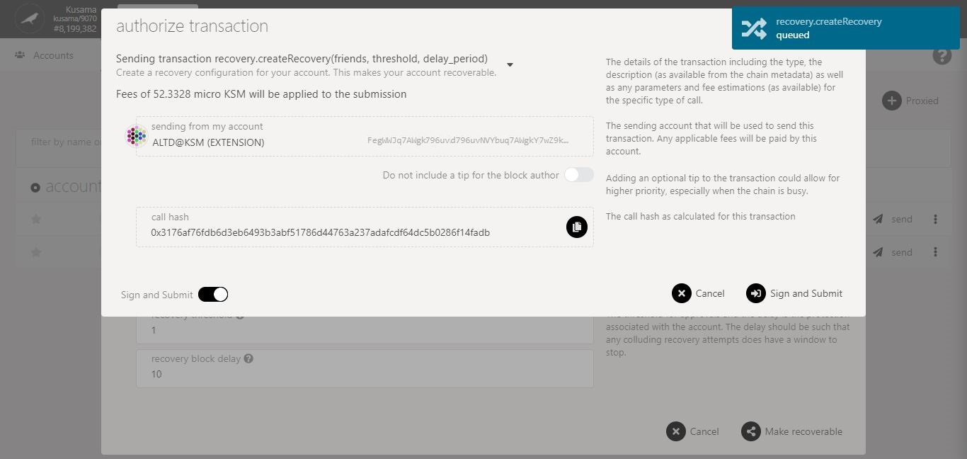

8. Check the **transaction fees**.

9. Click on **Sign & submit** to continue the procedure.

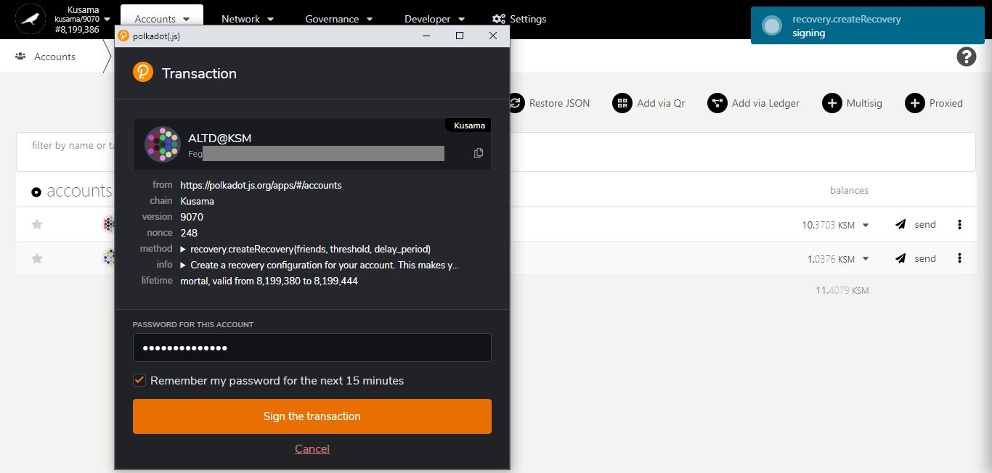

**Progress** of the transaction.

**Summary** of the transaction sent via the Polkadot-JS extension.

10. Enter **your account’s password** and tick the box to **remember your password, if necessary**.

11. Click on **Sign the transaction** to complete the procedure.

* 1. **Initiate account recovery.**



1. Click on the 3 vertical dots to view **Account settings**.

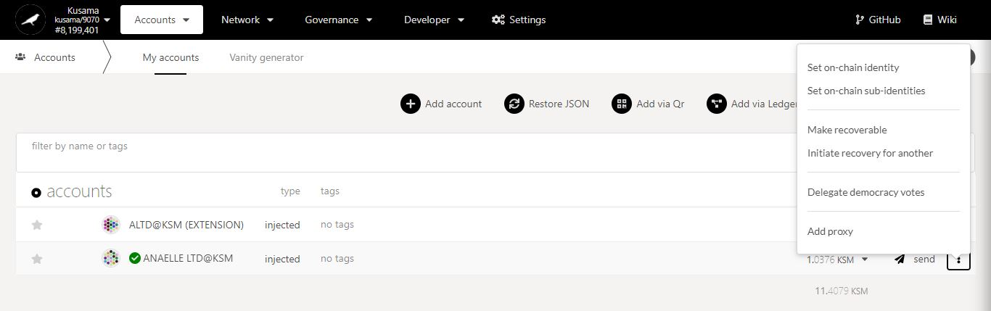

REMINDER:

**Recoverable account** = An account protected by a social recovery process in case the backups (i.e Seed phrase/JSON file) are lost.

**Account recovery** = Performing social recovery so that a third party can regain access to his/her account without backups.

2. Click on **Initiate recovery […]** to perform social recovery.

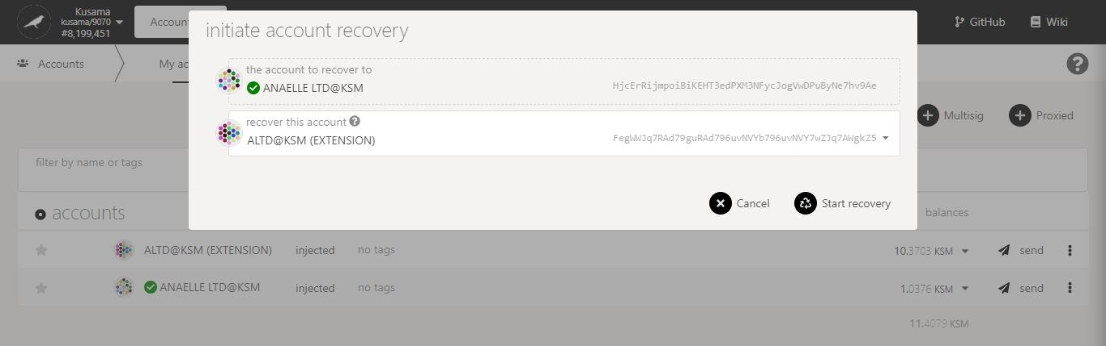

3. Select **the recoverable account** from your contacts.

4. Click on **Start recovery** to continue the procedure.

**Nature** of the transaction.

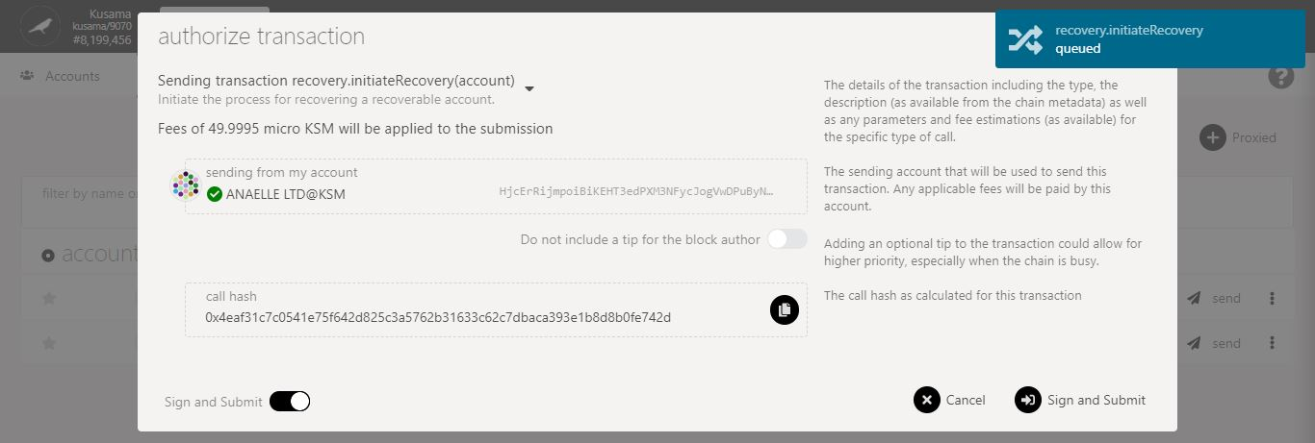

6. Click on **Sign & submit** to continue the procedure.

5. Check the **transaction fees**.

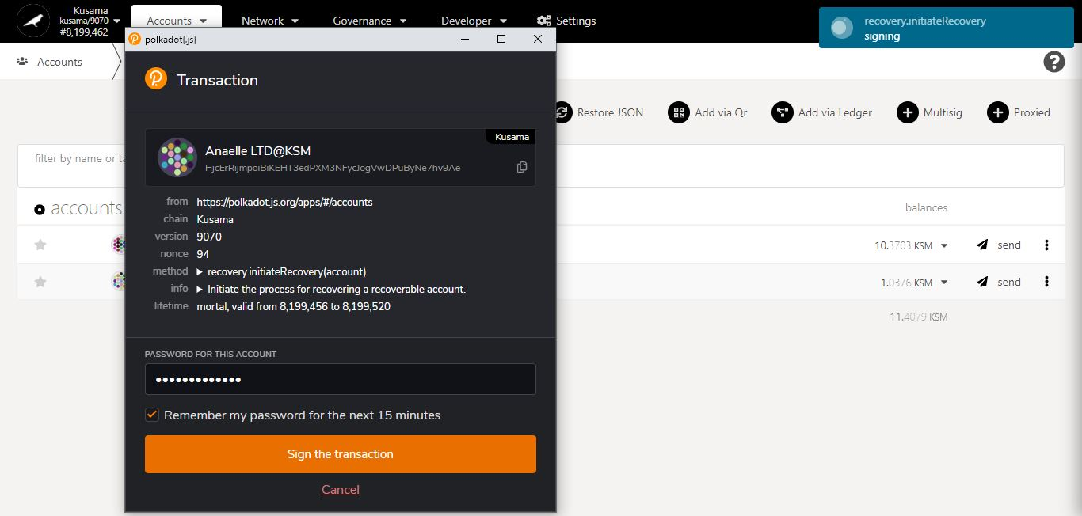

**Progress** of the transaction.

**Summary** of the transaction sent via the Polkadot-JS extension.

7. Enter **your account’s password** and tick the box to **remember your password, if necessary**.

8. Click on **Sign the transaction** to complete the procedure.

1. **Democracy delegation: Set up votes delegation.**



* 1. **Delegate democracy votes.**



1. Click on the 3 vertical dots to view **Account settings**.



Democracy votes delegation in detail:

**Democracy votes delegation** allows individuals to **transfer/pool their voting power** under a single account for all governance elections (i.e referenda and council).

The **vote value and conviction** defined by the delegating account will be applied in all elections, and the **corresponding lock period will need to be cleared after undelegation**.

The delegating account must first **set up the delegation** before you can **perform delegated voting**.

2. Click on **Delegate democracy votes** to transfer voting rights.

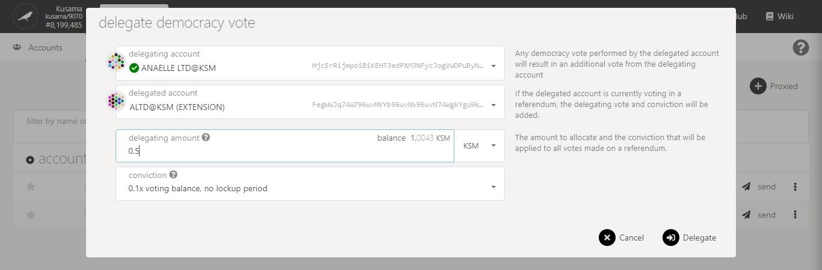

5. Click on the **dropdown arrow** to view more conviction setups.

4. Enter a KSM amount **for your vote delegation.**

3. Follow **on-screen instructions** carefully.

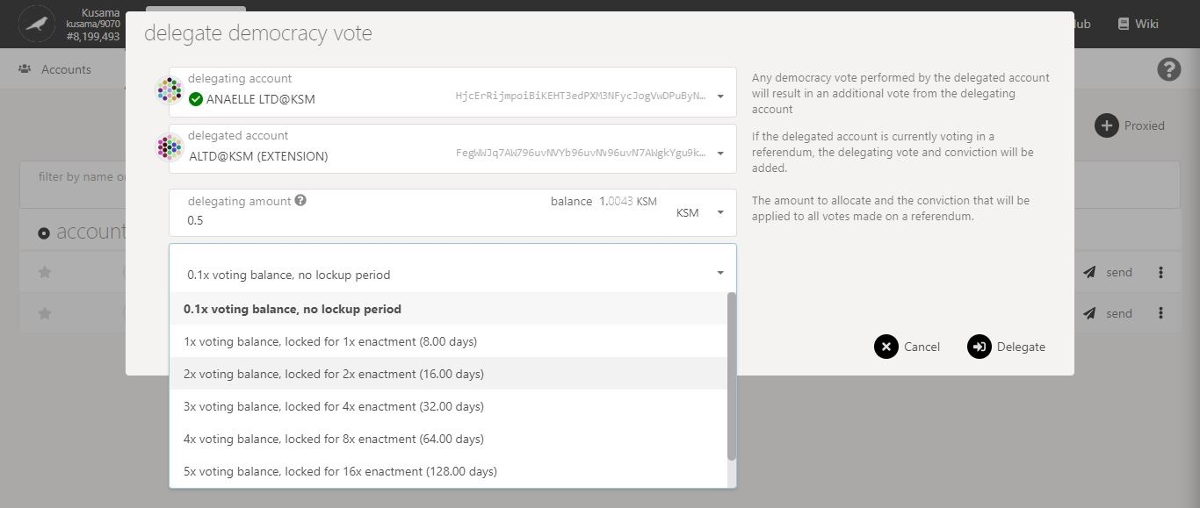

6. Select **one conviction setup** for your votes.

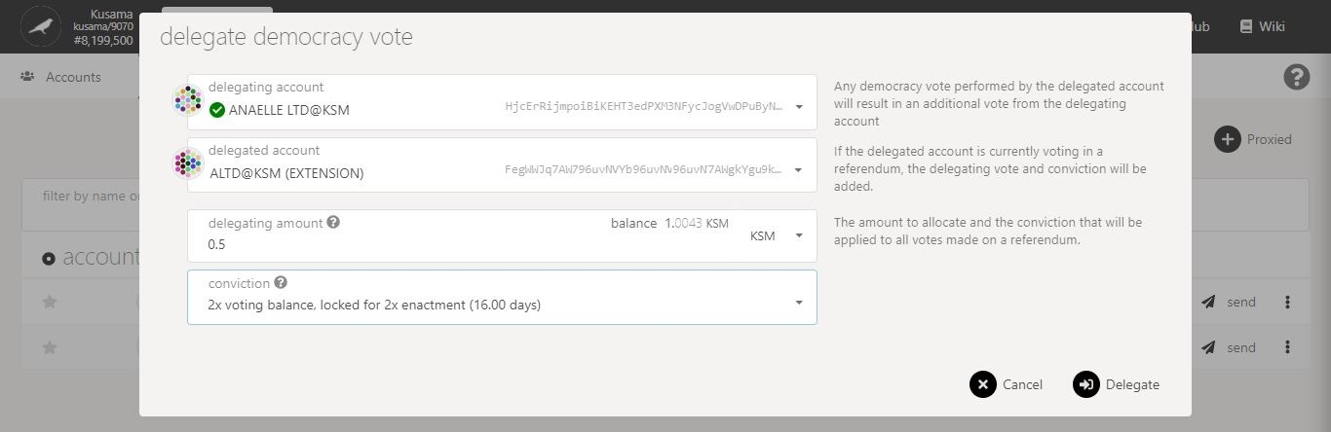

7. Click on **Delegate** to continue the procedure.

**Nature** of the transaction.

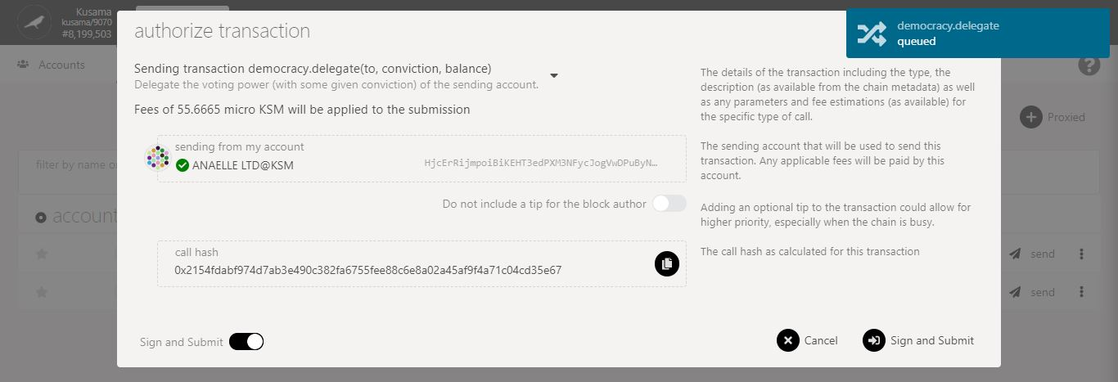

9. Click on **Sign & submit** to continue the procedure.

8. Check the **transaction fees**.

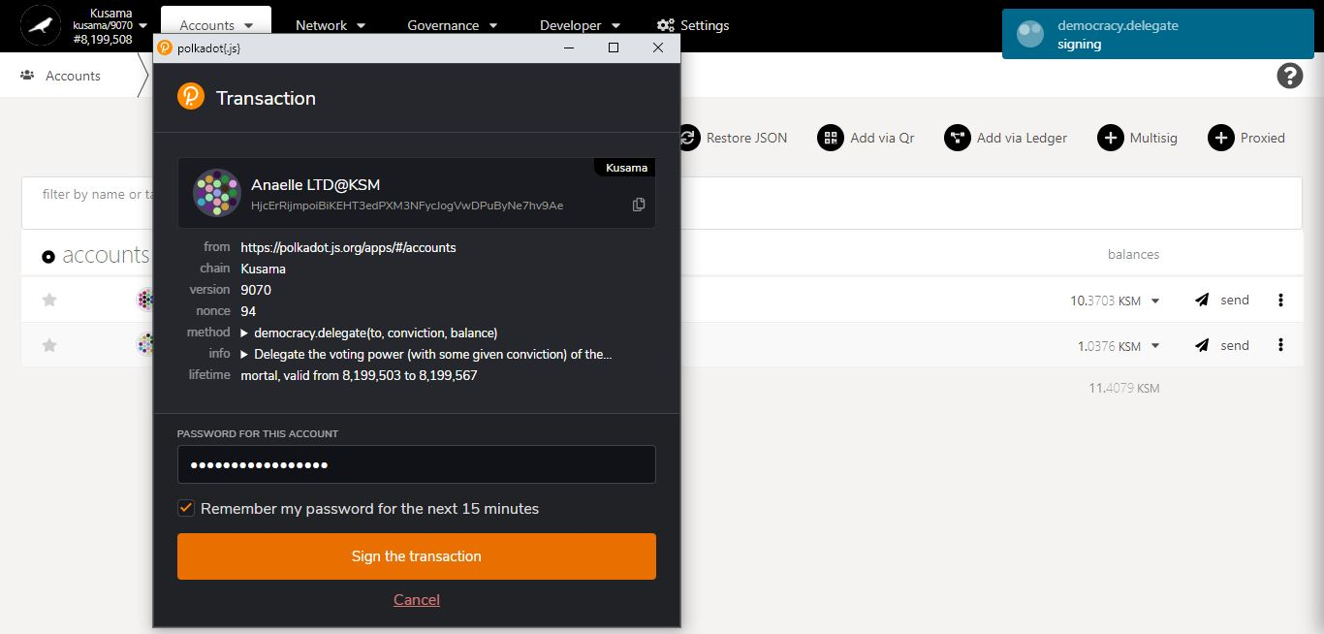

**Progress** of the transaction.

**Summary** of the transaction sent via the Polkadot-JS extension.

11. Click on **Sign the transaction** to complete the procedure.

10. Enter **your account’s password** and tick the box to **remember your password, if necessary**.

* 1. **Undelegate democracy votes.**

1. Mouse-over **Developer.**

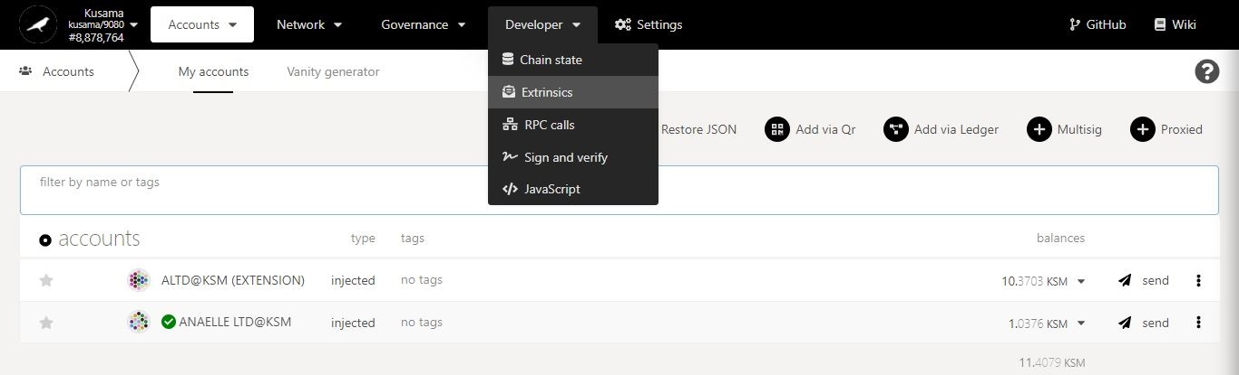

2. Select **Extrinsics** from the dropdown menu.

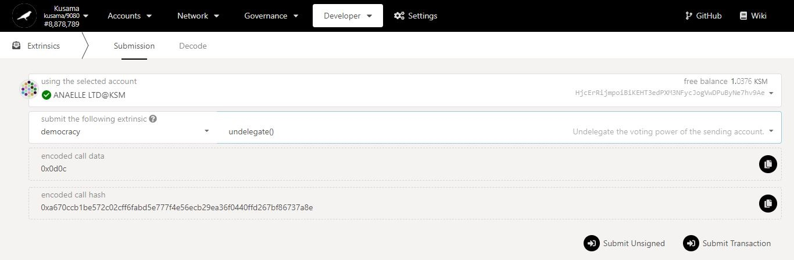

Democracy votes undelegation in detail:

**Democracy votes undelegation** must be submitted by the delegating account. The voting balance can only be unlocked once the conviction lock period has expired.

5. Click on **Submit Transaction** to continue the procedure.

4. Select **undelegate()** from the second dropdown menu.

3. Select **democracy** from the first dropdown menu.

**Nature** of the transaction.

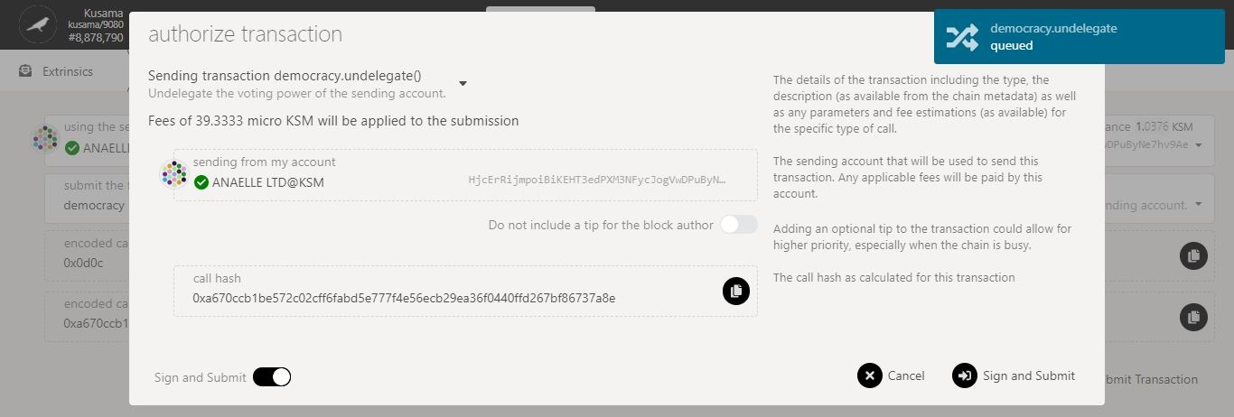

7. Click on **Sign & submit** to continue the procedure.

6. Check the **transaction fees**.

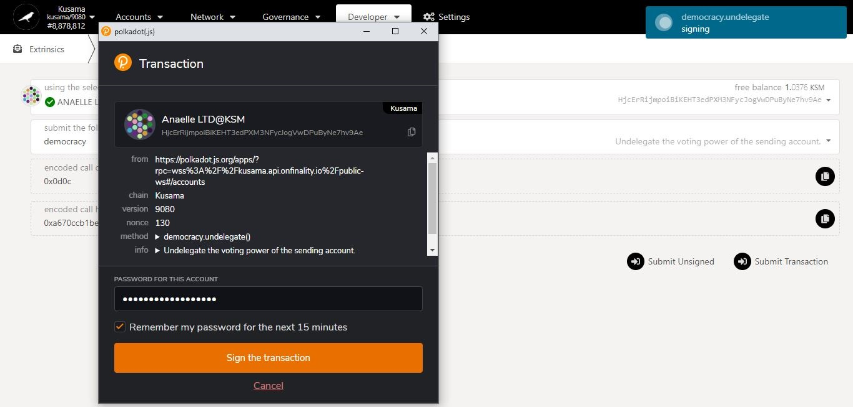

**Progress** of the transaction.

**Summary** of the transaction sent via the Polkadot-JS extension.

9. Click on **Sign the transaction** to complete the procedure.

8. Enter **your account’s password** and tick the box to **remember your password, if necessary**.

1. **Proxy setup: Set up proxy accounts and types.**



* 1. **Add a proxy account.**



1. Click on the 3 vertical dots to view **Account settings**.



2. Click on **Add proxy** to set up proxy authorisations.

Proxy & Proxied accounts in detail:

**Proxy** = “Caretaker”.

**Proxied** = “Cared for”.

Proxy & Proxied accounts allow individuals to **manage transactions for a family member or a peer** if the person becomes unavailable or incapacitated.

You must first **set up the family member’s or peer’s account as proxy** before they can **add your account as a proxied account**. To learn how to add a proxied account to your list of accounts, refer to **Part I: Accounts (Basic setups).**

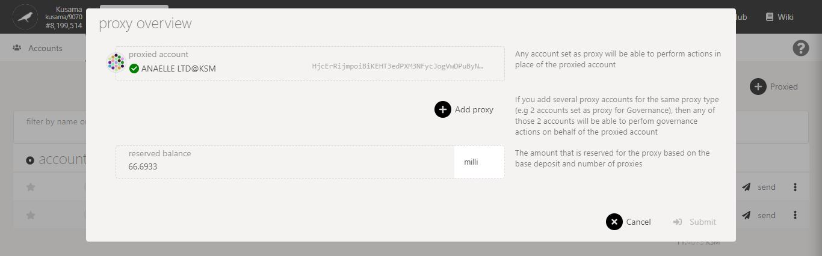

4. Click **Add proxy**.

3. Follow **on-screen instructions** carefully.

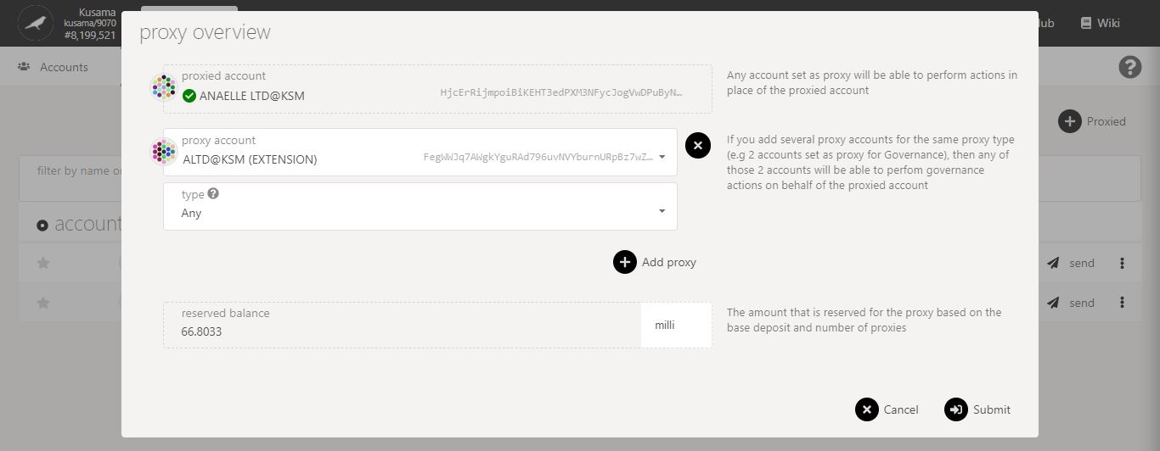

5. Choose **one** accountfrom your contacts.

* 1. **Manage proxy types.**



1. Click on the **dropdown arrow** to view all the available proxy types.

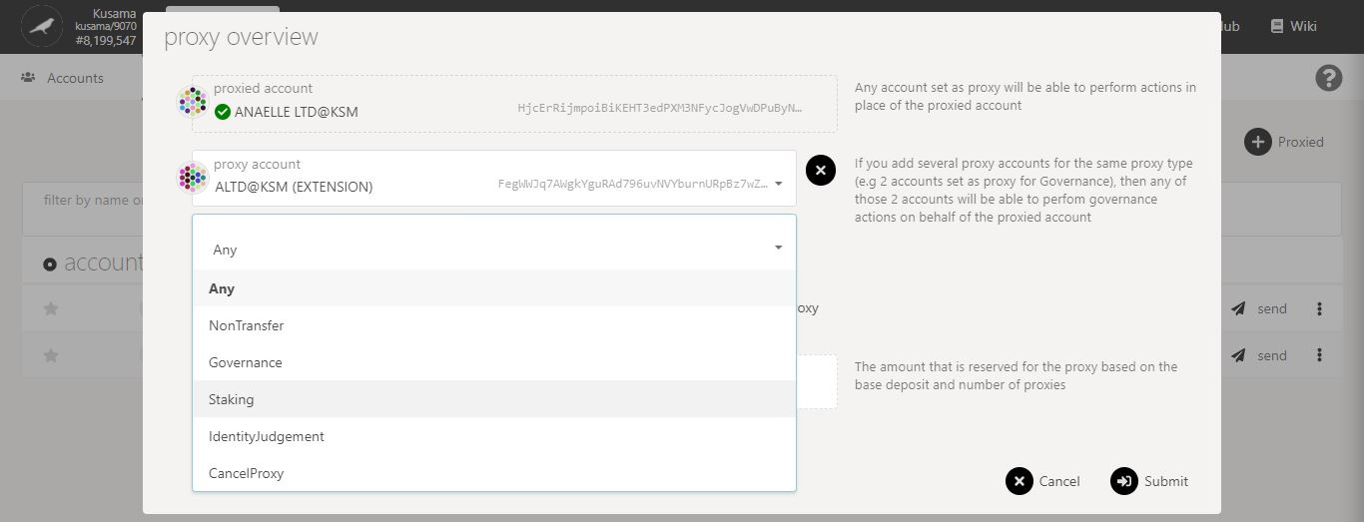

Proxy types in detail:

**Any**: Authorised to perform any on-chain transaction.

**NonTransfer**: Authorised to perform any on-chain transaction, except balance transfers.

**Governance**: Authorised to perform any governance transaction (i.e vote, submit proposals, etc).

**Staking**: Authorised to perform staking-related transactions but does not override stash-controller setups.

**IdentityJudgement**: Authorised to perform any identity-related transaction requested by registrars.

*Proxies’s actions can be time-delayed by a certain number of blocks, therefore proxies must announce their actions ahead of time.*

**CancelProxy**: Authorised to reject the announcements made by other proxy types.

2. Select **one** option from the dropdown menu.

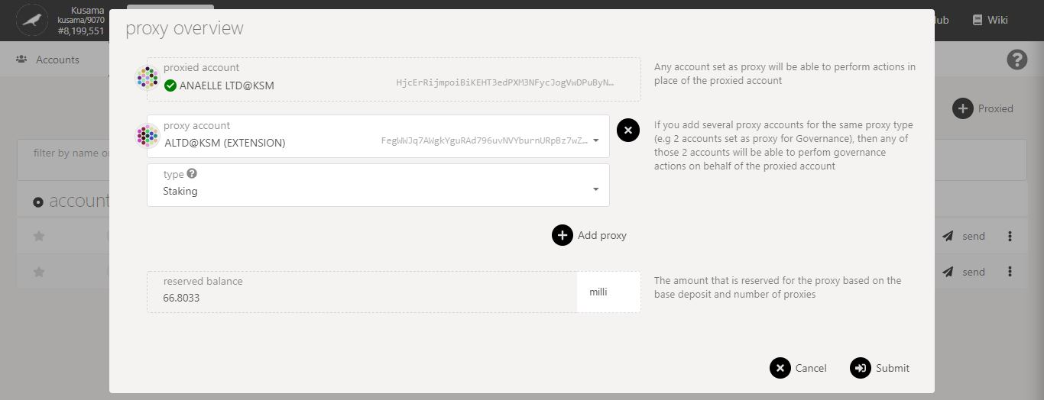

3. Click on **x** or **+** toremove or add proxy accounts.

A **deposit** is required to maintain on-chain proxy information. Note: This deposit will be refunded when your authorisations are cleared.

4. Click on **Submit** to continue the procedure.

**Nature** of the transaction.

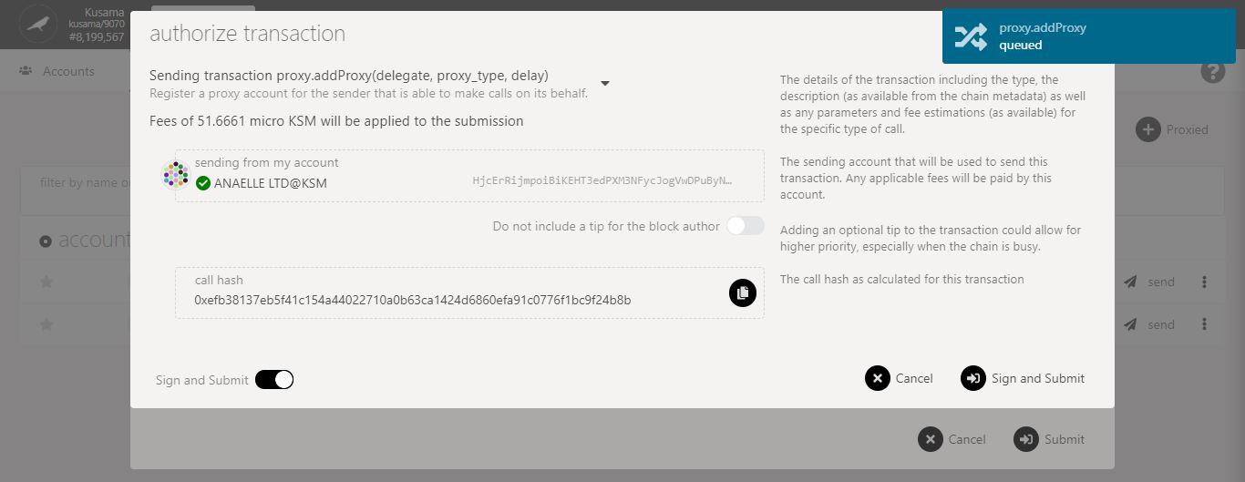

6. Click on **Sign & submit** to continue the procedure.

5. Check the **transaction fees**.

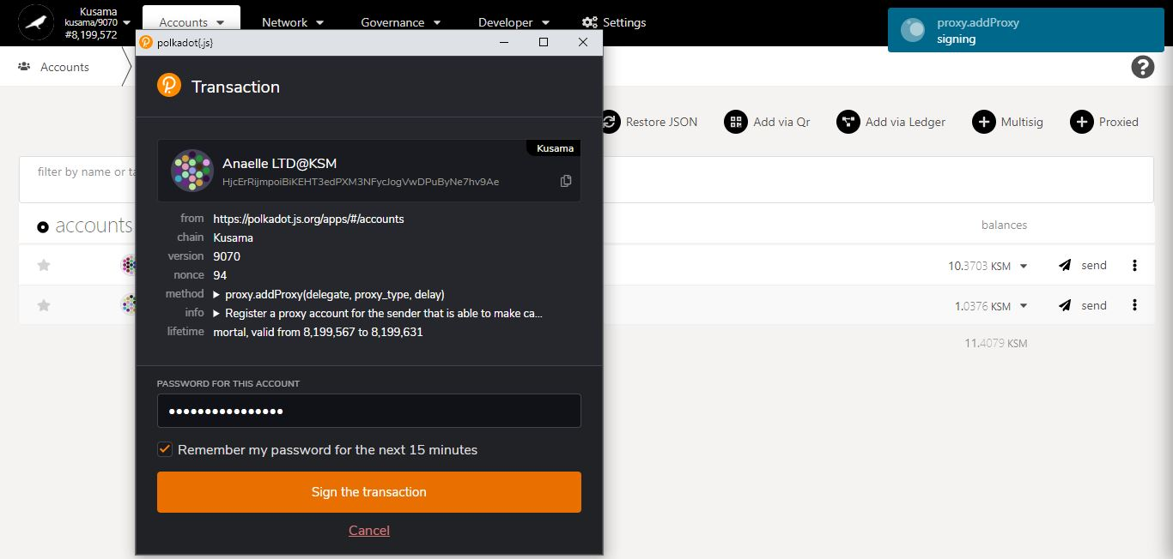

**Progress** of the transaction.

8. Click on **Sign the transaction** to complete the procedure.

7. Enter **your account’s password** and tick the box to **remember your password, if necessary**.

**Summary** of the transaction sent via the Polkadot-JS extension.