**PART VII: Settings**

1. **General: Personalise the Portal’s interface.**



* 1. **Personalise the default address prefix.**

**Basic information on technical words** used in the SETTINGS section.

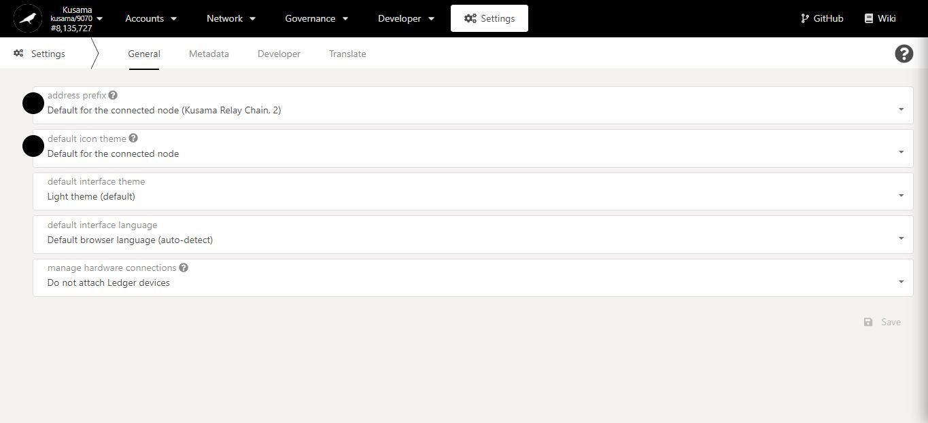

Adress prefixes in detail:

Substrate chains’ addresses follow a standardised format that allows different representations for the same public key in a private-public key pair.

This format uses an address prefix to ascribe an address to a specific network (i.e *Capital letter* for Kusama, *“1”* for Polkadot, *“5”* for the generic Substrate network).

**All Substrate chains’ addresses are compatible from one Substrate chain to another.**

* Switching from one Substrate chain to the other will change the address prefix.
* Allowing your account on any Substrate chain will set the default address prefix as 5.

1. Click on the **address prefix** dropdown menu.

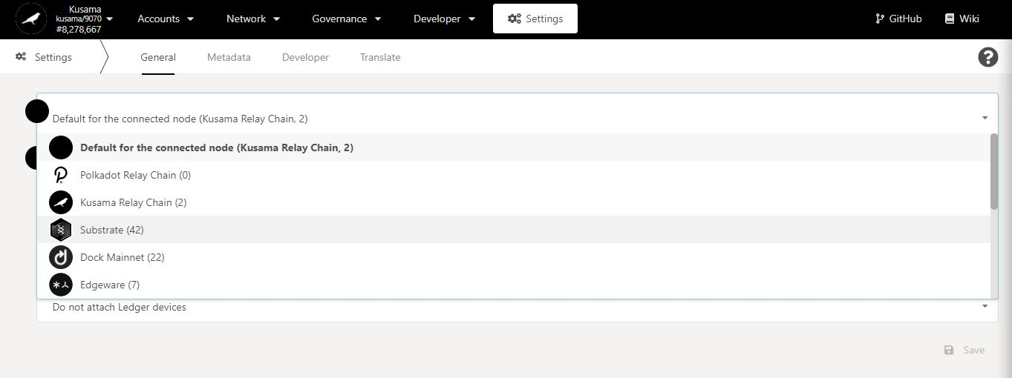

2. Select **one** option from the dropdown menu.

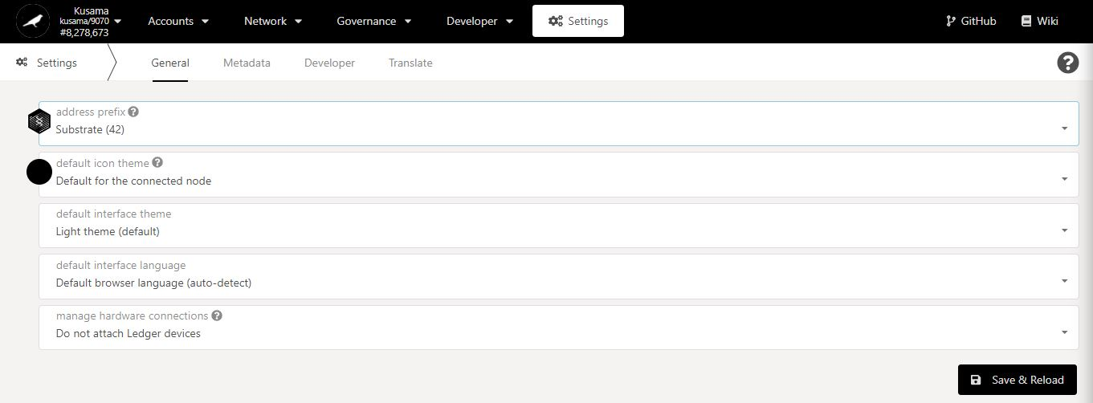

3. Click on **Save & Reload** to complete the procedure.

* 1. **Personalise the default identicon.**



Identicons in detail:

An identicon is a user interface component used to display a Substrate address as a unique icon.

Themes can be assigned to customise the look of the identicon.

1. Click the **icon theme** dropdown menu.

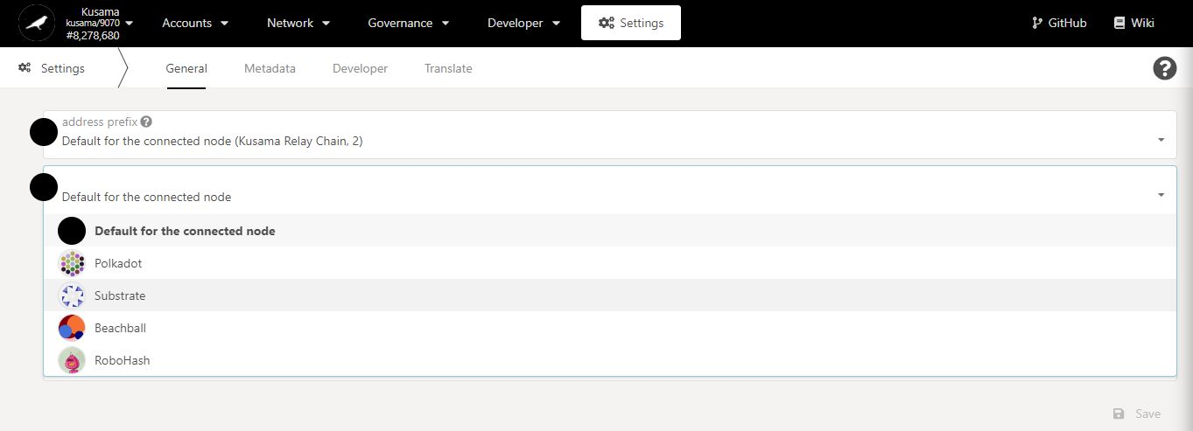

2. Select **one** option from the dropdown menu.

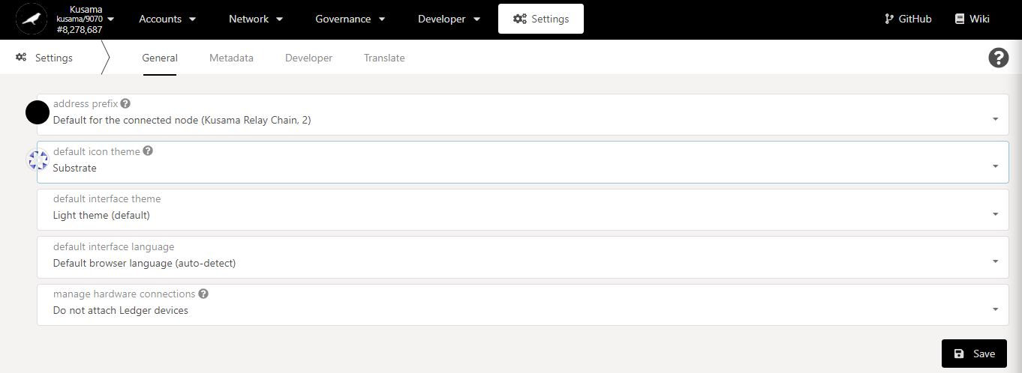

3. Click on **Save** to complete the procedure.

* 1. **Personalise the default theme.**



1. Click on the **interface theme** dropdown menu.

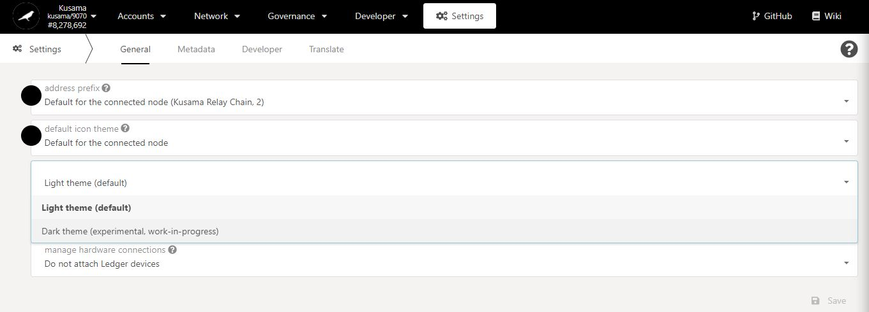

2. Select **one** option from the dropdown menu.

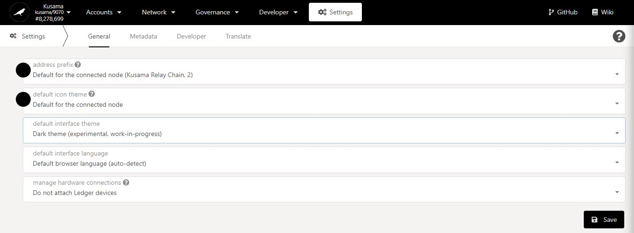

3. Click on **Save** to complete the procedure.

4. **Your default theme has been changed!**

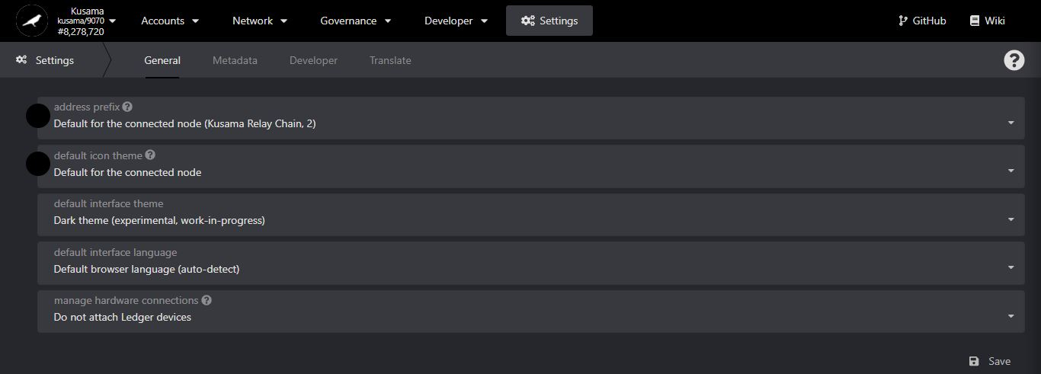

* 1. **Personalise the default language.**



1. Click on the **interface language** dropdown menu.

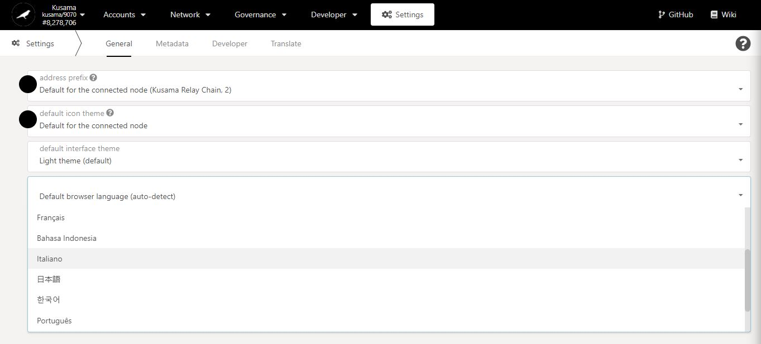

2. Select **one** option from the dropdown menu.

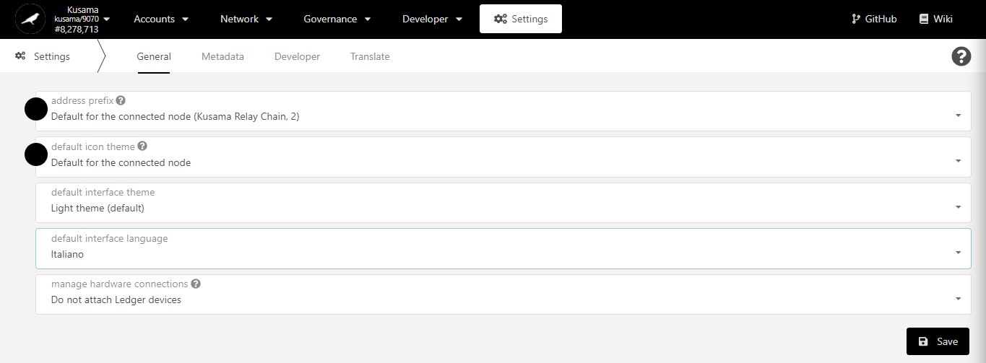

3. Click on **Save** to complete the procedure.

4. **Your default language has been changed!**

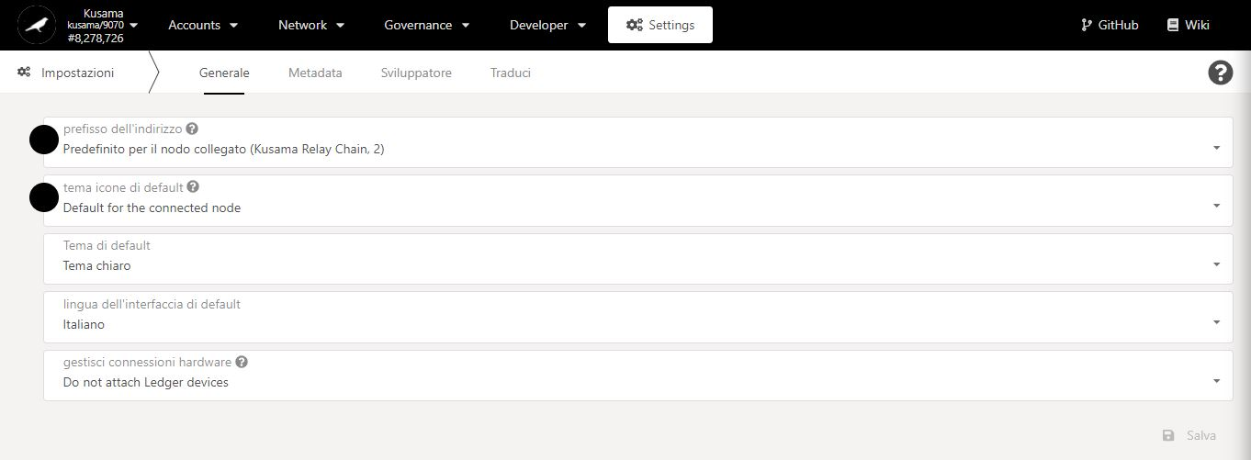

* 1. **Personalise hardware wallet connections and create a Polkadot-JS account from Ledger hardware.**



1. Click on the **hardware connections** dropdown menu.

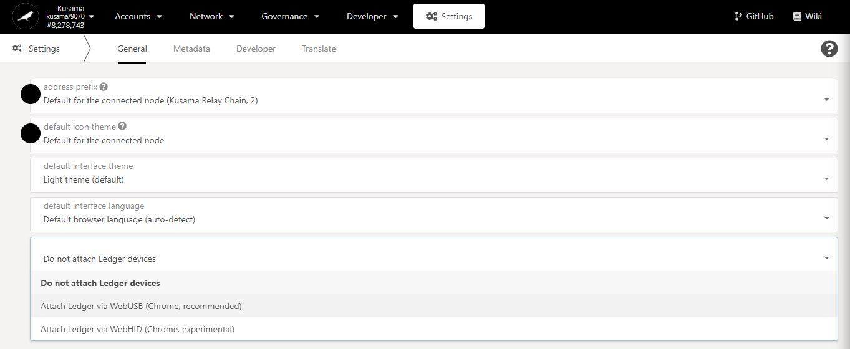

2. Select **one** option from the dropdown menu.

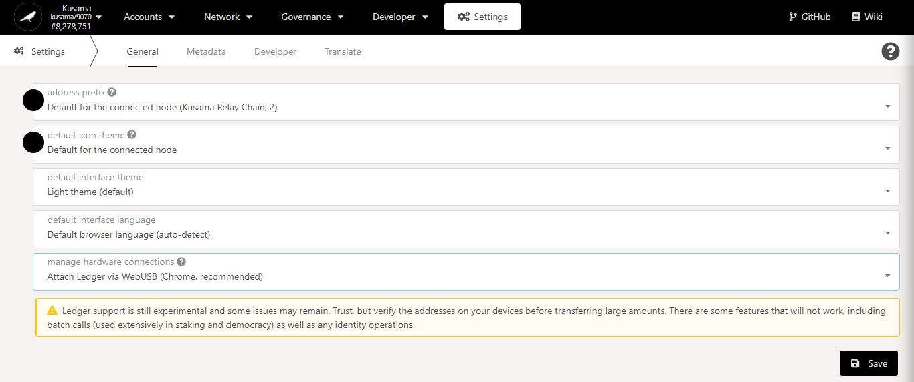

3. Click on **Save** to complete the procedure.

4. Click **Accounts**.

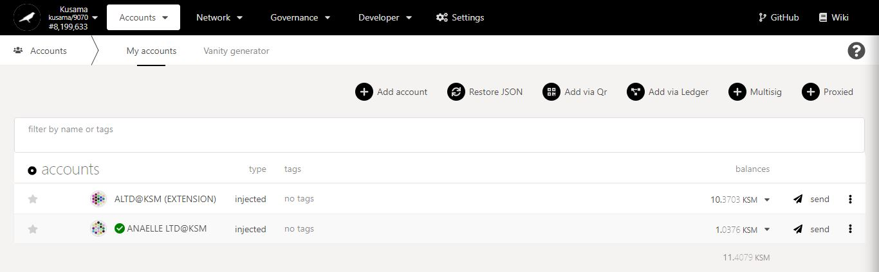

5. Click **Add via Ledger**.

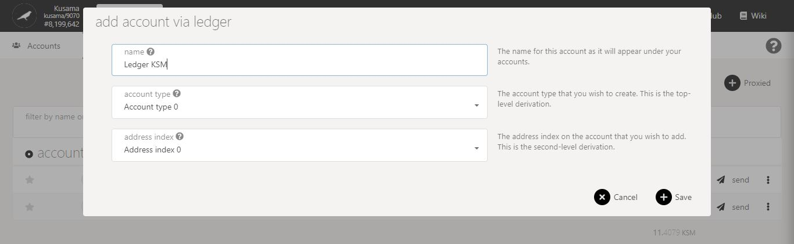

7. Click on **Save** to continue the procedure.

6. Follow **on-screen instructions** carefully.

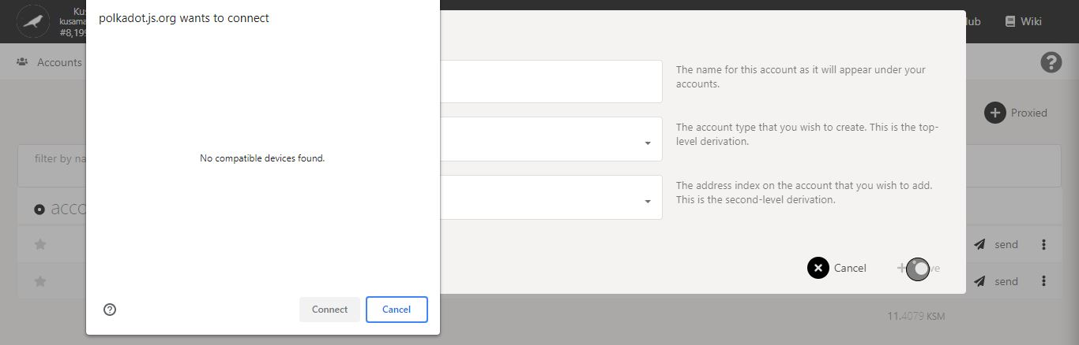

Status of your Polkadot-JS Apps **connection to your Ledger hardware**.

8. Click **Cancel** to pause the Polkadot-JS Apps procedure.

9. Connect your Ledger hardware to your computer and **open Ledger Live app.**

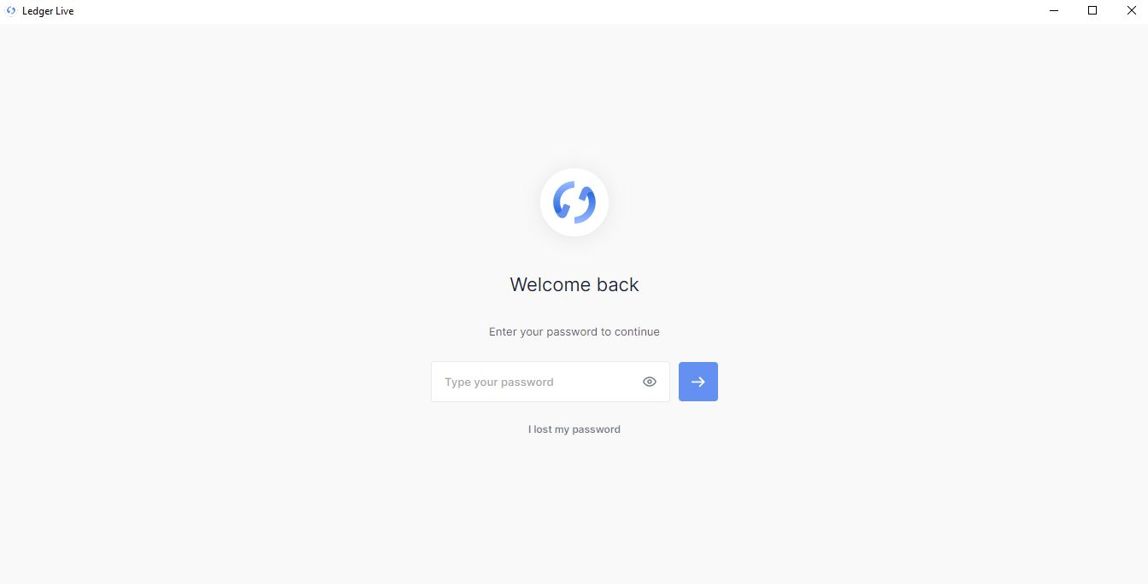

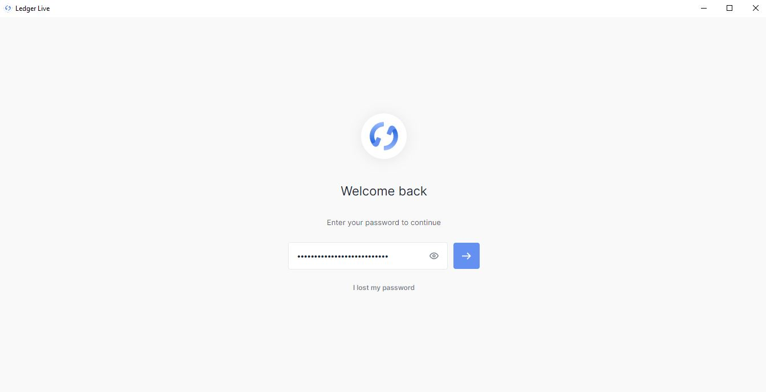

10. Enter your password and click on the arrow to continue the procedure on **Ledger Live app.**

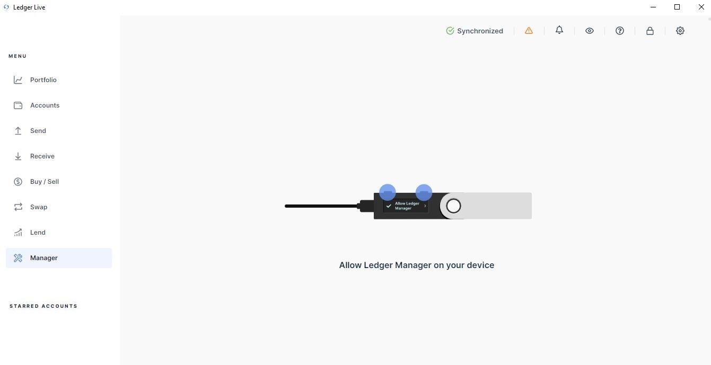

12. Follow **on-screen instructions** carefully.

11. Click on **Manager** to setup your account via **Ledger Manager.**

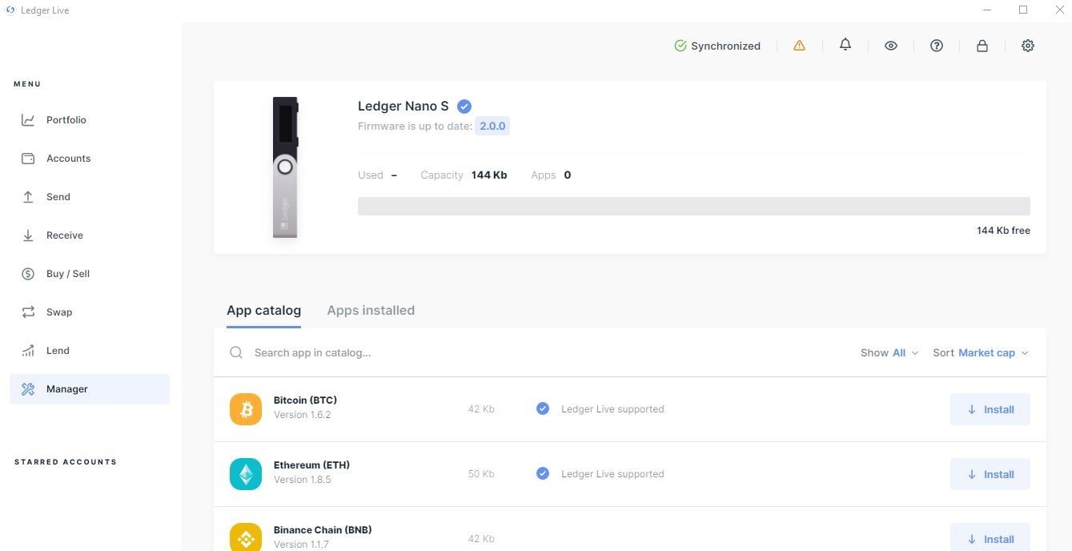

13. Click on the icon to access **Ledger Manager’s settings.**

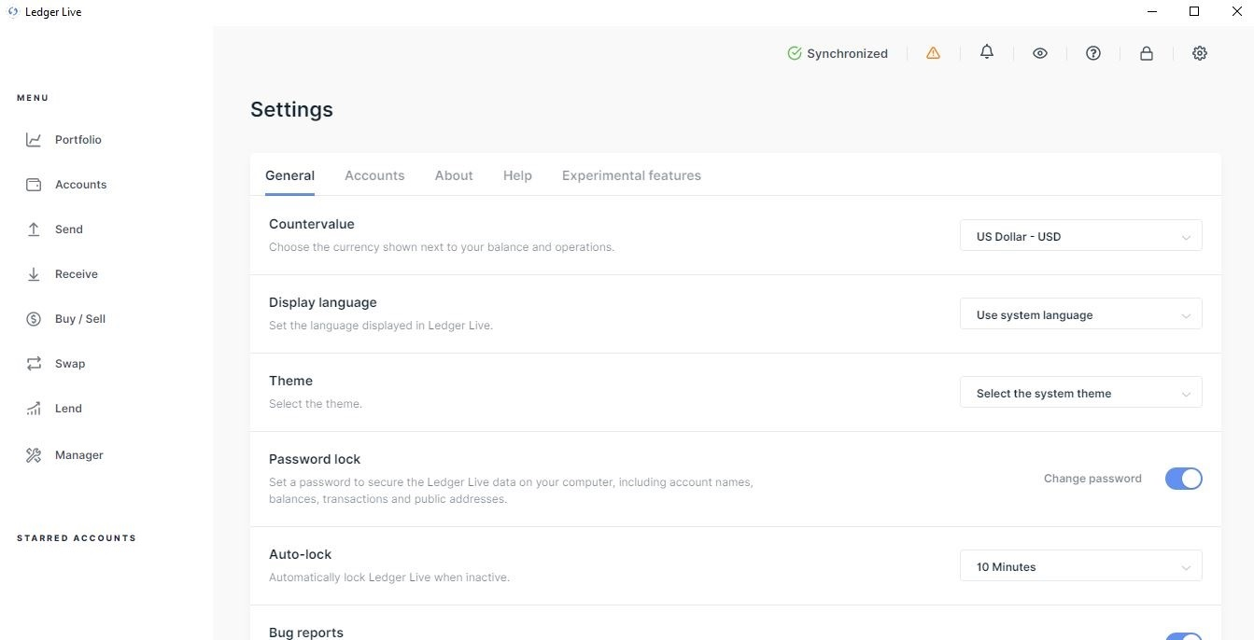

14. Click on **Experimental features** to access Developer’s setups in Ledger Manager.

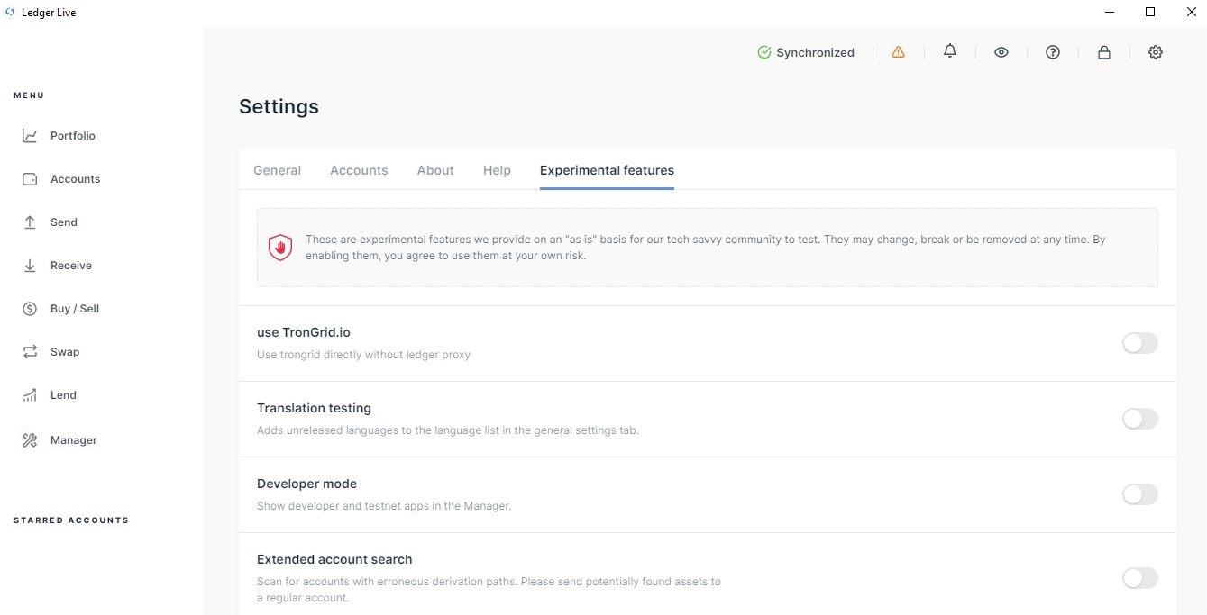

15. Switch **Developer mode****ON** to enable experimental apps in Ledger Manager.

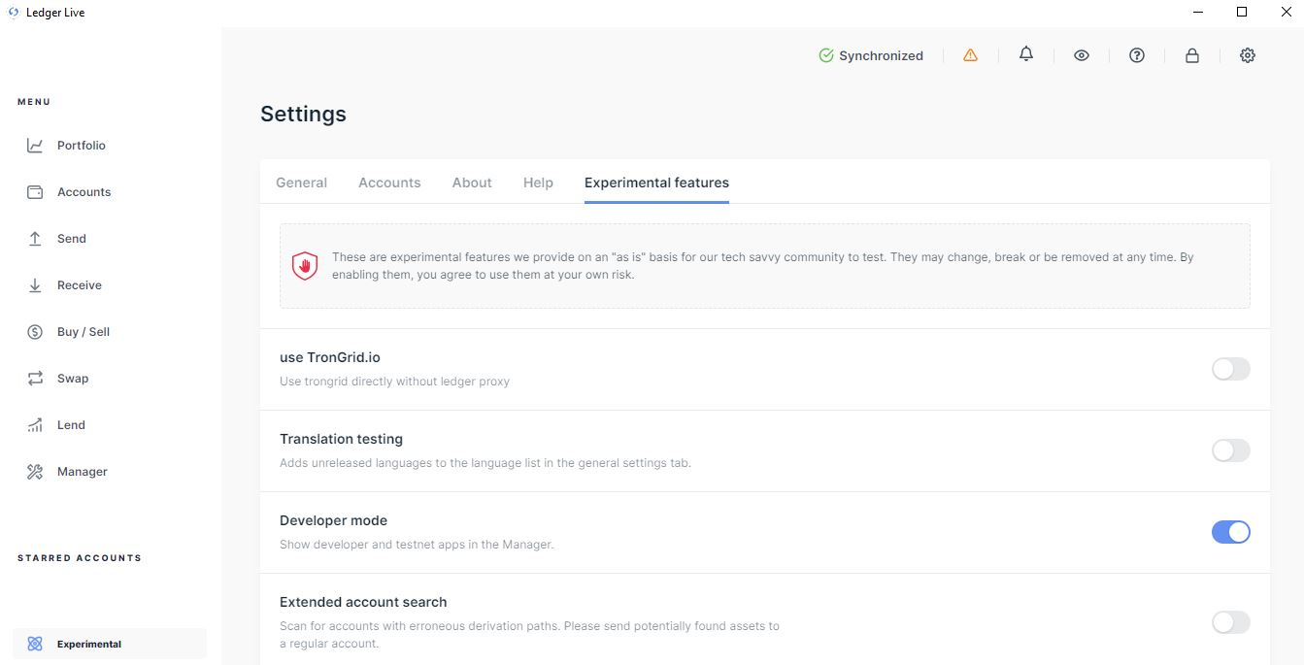

17. Click on **Manager** to return to the Ledger Manager App catalog.

16. **Experimental apps** are now enabled in Ledger Manager.

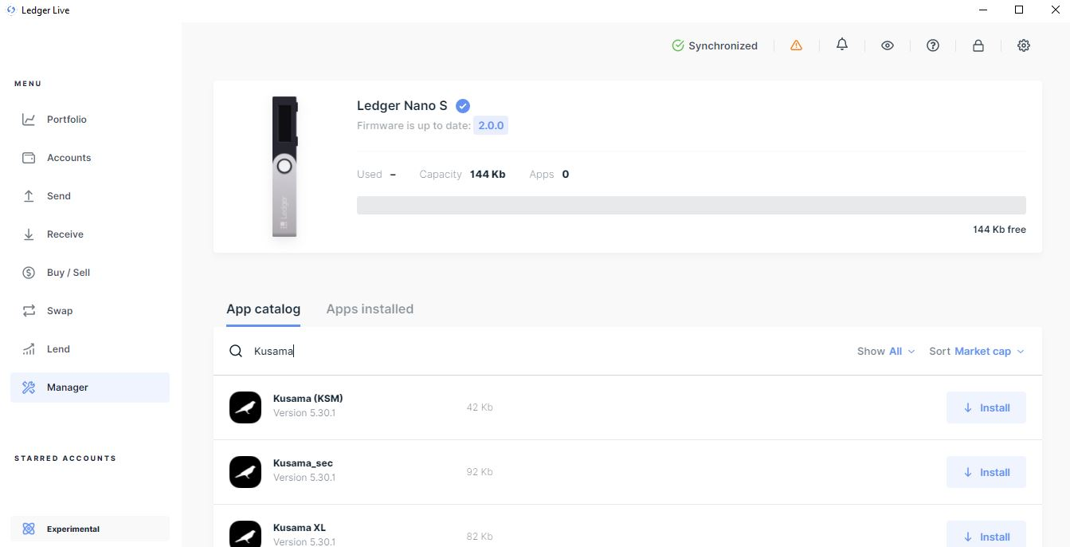

18. **Search for all available Kusama apps** in Ledger Manager.

19.Click **install** to set up the **Kusama XL app** in Ledger Manager.

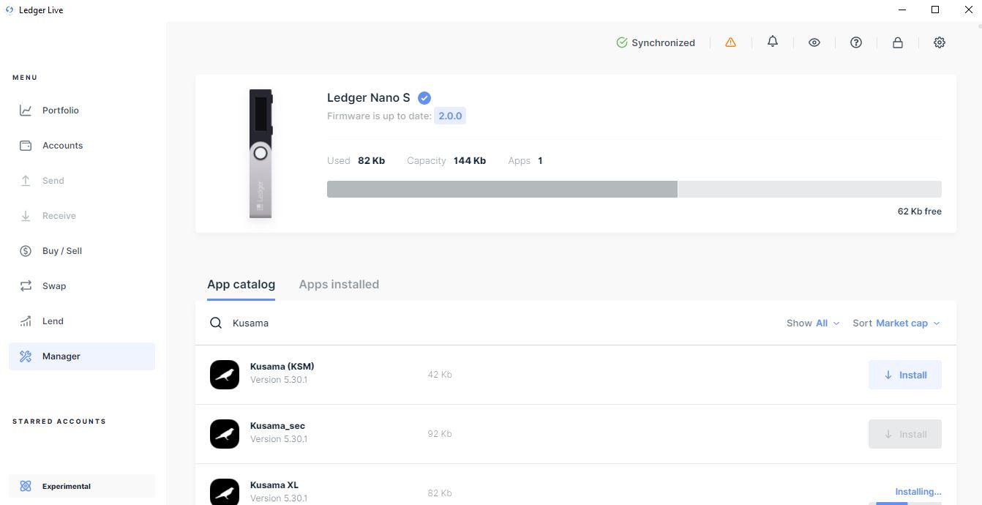

20.The installation of **Kusama XL app** takes about a minute.

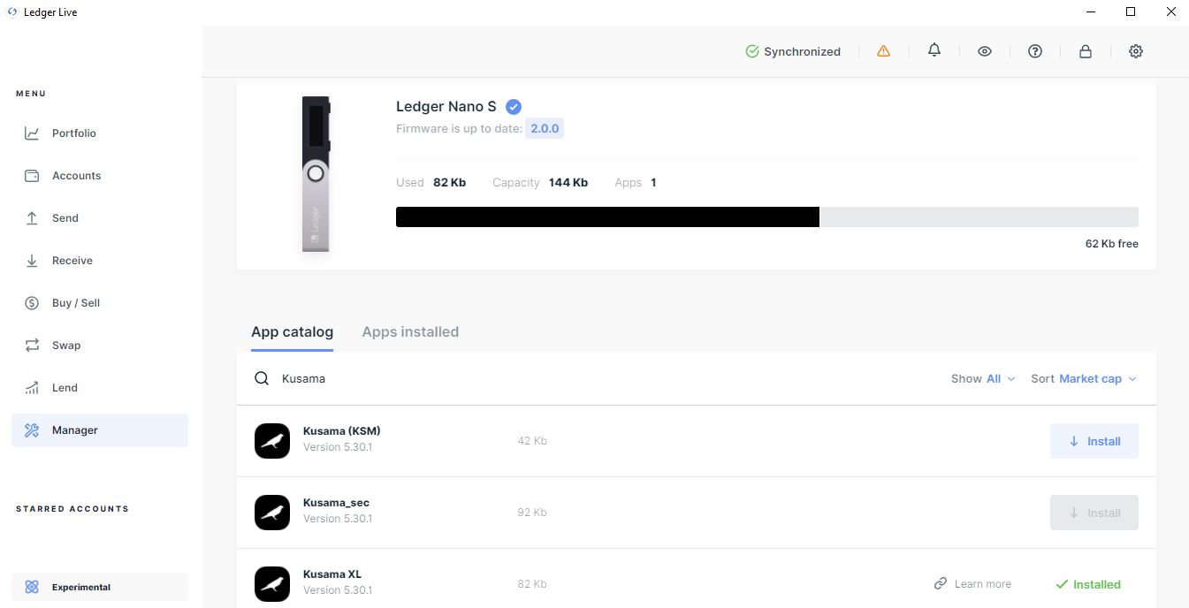

21.The **Kusama XL app** has been installed on Ledger Manager. You can now **close Ledger Live**.

22.Open the **Kusama XL app in your Ledger hardware** to resume the Polkadot-JS Apps procedure.



23. Click on **Save** to continue the procedure.

24. Follow **the final instructions on the Ledger hardware** to complete the procedure.

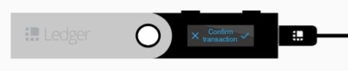

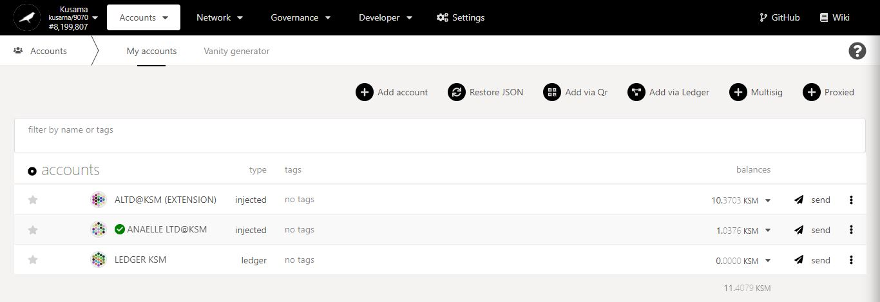

25. **Your Ledger account has been added to the *My accounts* list!**

1. **Metadata: Explore the Portal’s network settings.**



* 1. **Upgrade extensions.**

**Extension upgrades notifications** will appear on *My accounts* and next to *Settings*.

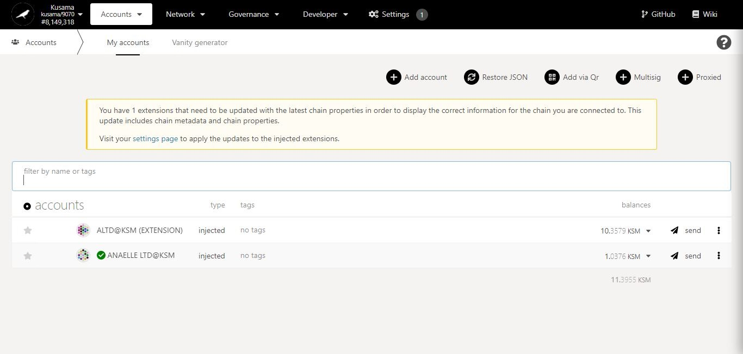

1. Click on the **link to Settings.**

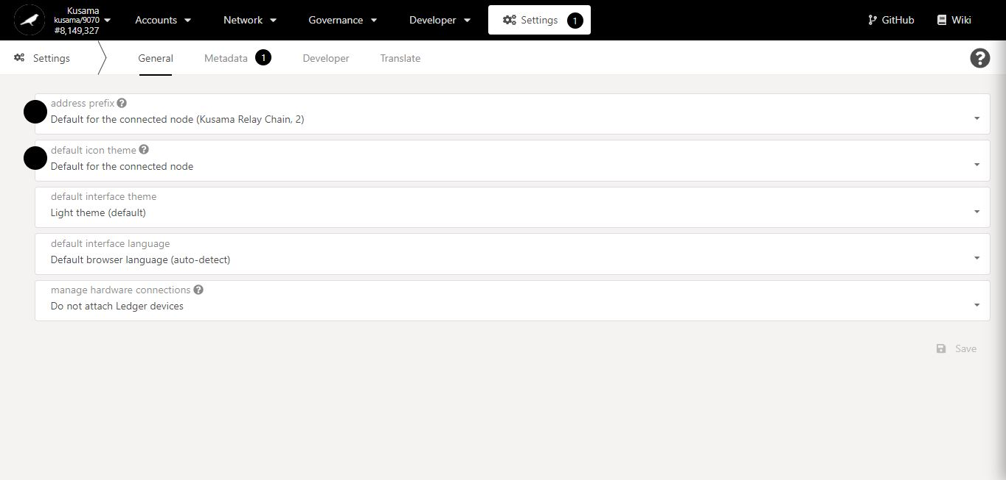

2. Click **Metadata.**

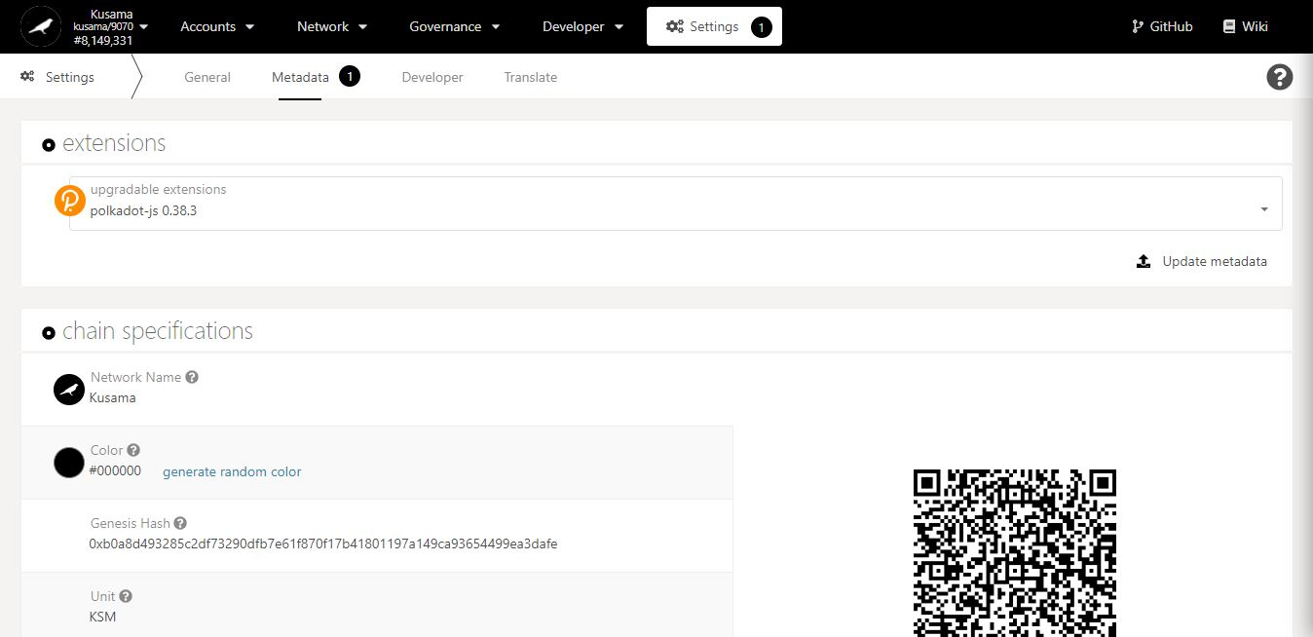

3. Click **Update Metadata.**

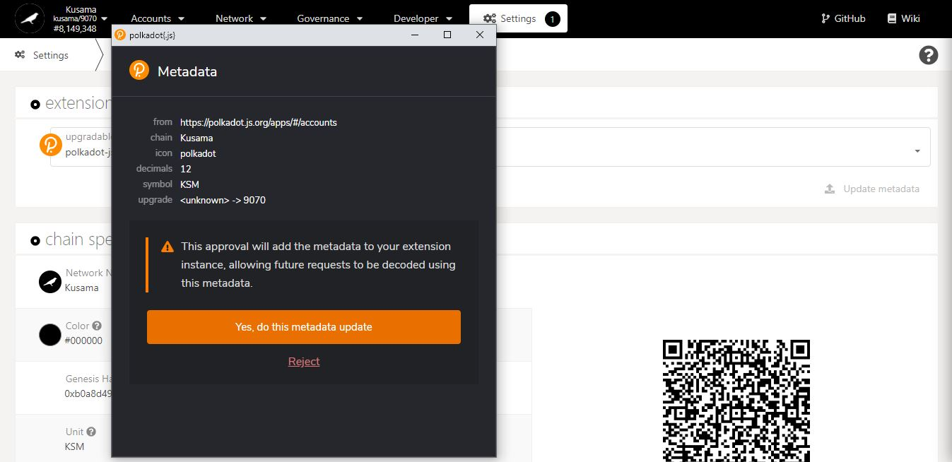

4. Click on **Yes […]** to complete the procedure.

**Summary** of the metadata upgrade made on Polkadot-JS extension.

* 1. **View chain specifications.**

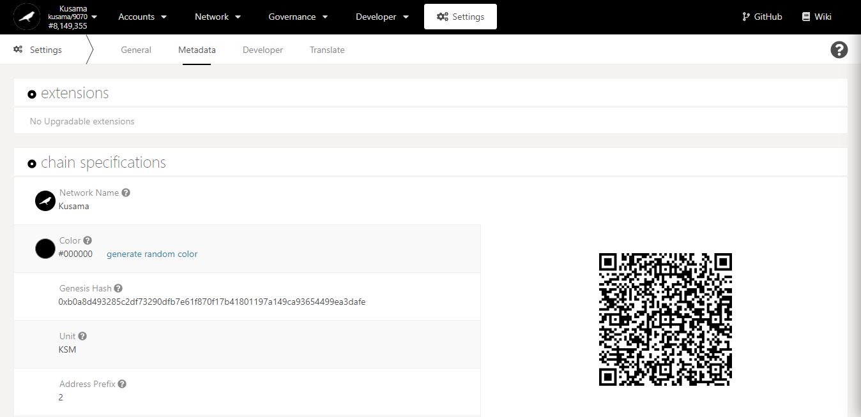

Key information on the chain: **name, genesis hash, currency, and address prefix.**

Note: These parameters are immutable.

1. **Developer: Define custom types for the Portal’s API.**



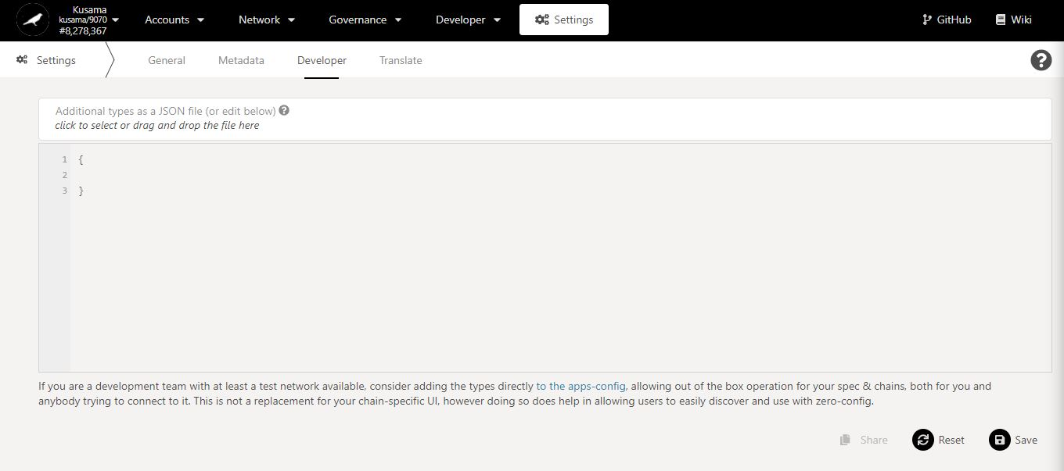

1. Click **Additional types […]** to load the JSON file.

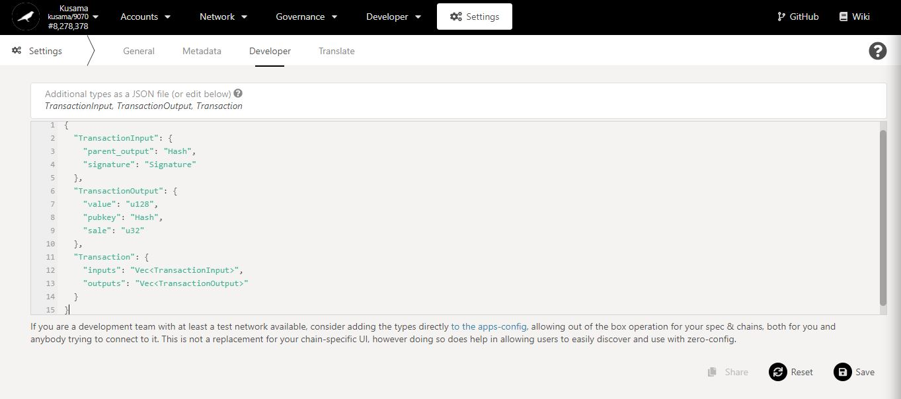

3. Click on **Save** to complete the procedure.

2. Your JSON types will **appear** here.

1. **Translate: Define custom translations for the Portal’s UI.**



* 1. **Customise translations for each language.**

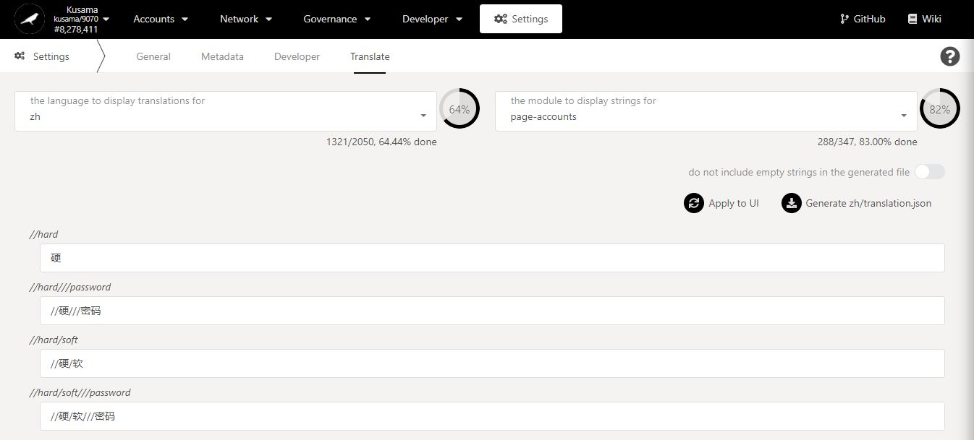

1. Click on the **languages to display** dropdown menu.

**Word-for-word** translations.

Key information on translations: **available languages, modules, completion status.**

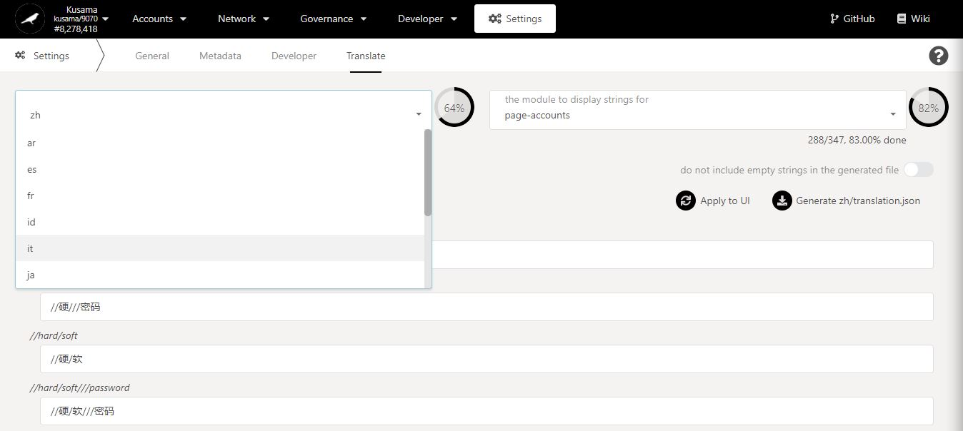

2. Select **one** option from the dropdown menu.

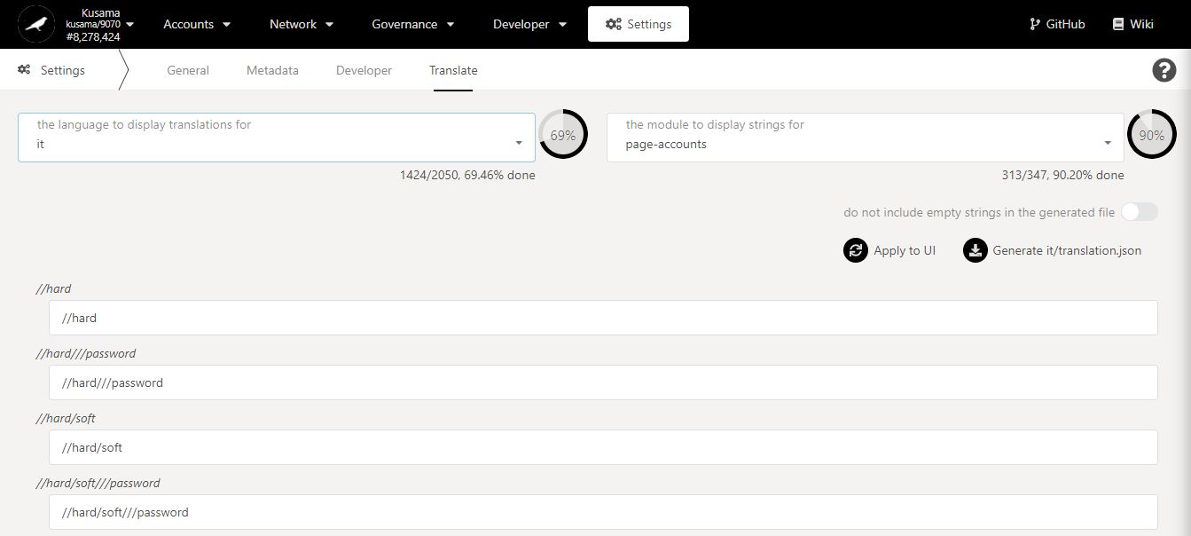

Word-for-word translations **currently active** for your selected language and for the selected module.

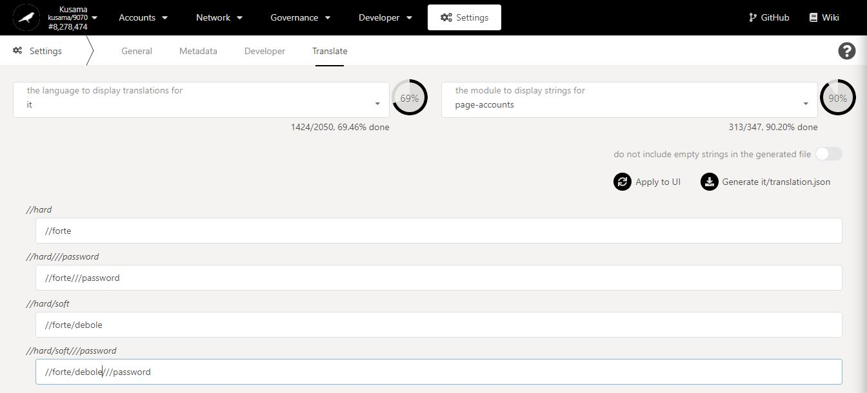

3. **Replace** the word-for-word translation(s).

* 1. **Customise translations for each module.**



1. Click on the **modules to display** dropdown menu.

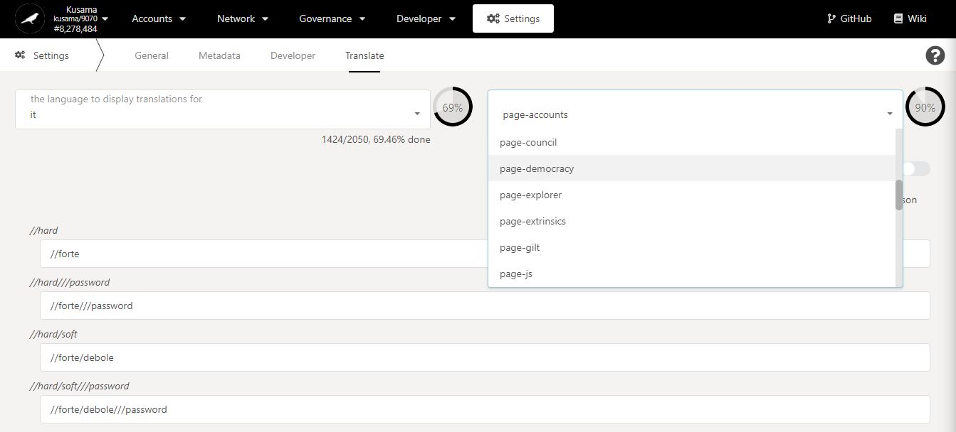

2. Select **one** option from the dropdown menu.

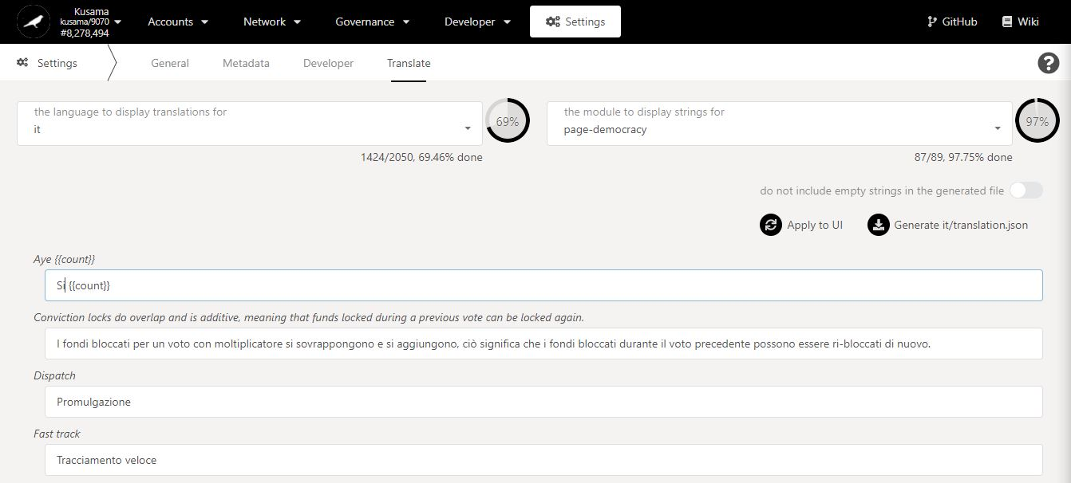

3. **Replace** the word-for-word translation(s).

* 1. **Manage translations’ backups.**

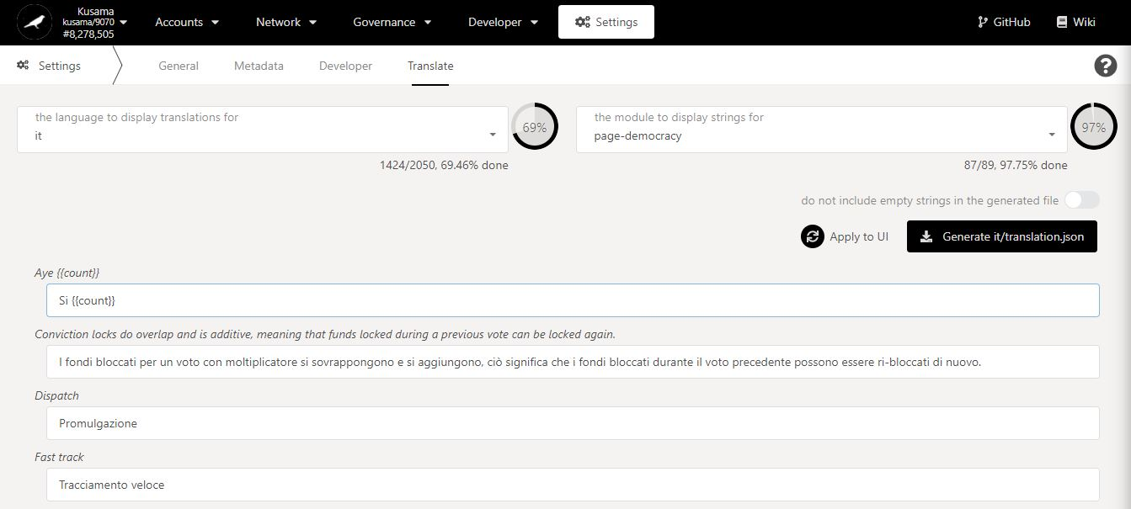

1. Click on **Generate translation** to save your custom translations in a JSON file.

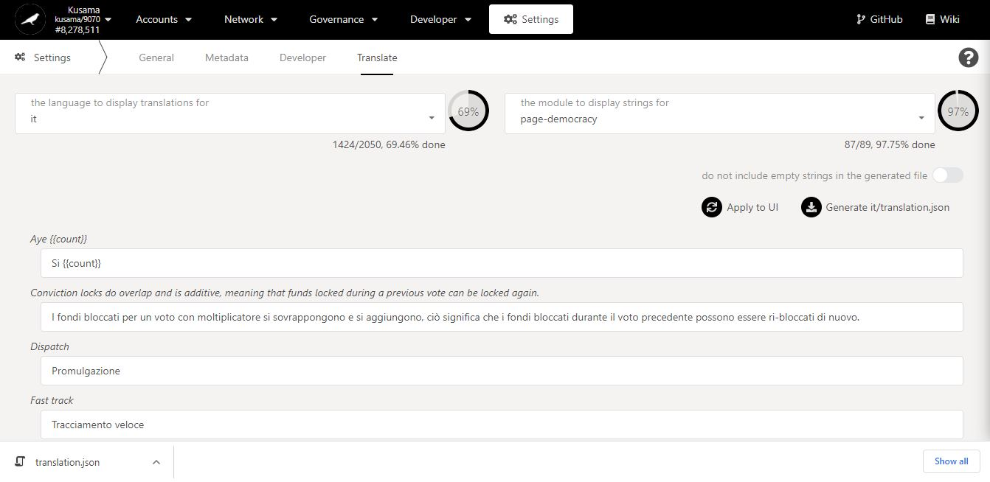

2. **A JSON file has been created and saved for your custom translations!**

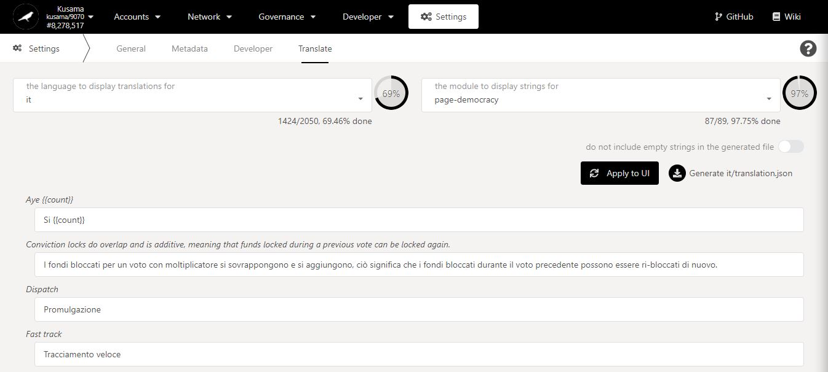

3. Click on **Apply to UI** to set the custom translations for your Polkadot-JS Apps interface.