**Proposal: Improvements and maintenance costs for** [***Guide to Polkadot-JS***](https://anaelleltd.github.io/polkadotjs-guide/)***.***

**3. Maintenance**

1. Deliver the pending sections of **Part II**.

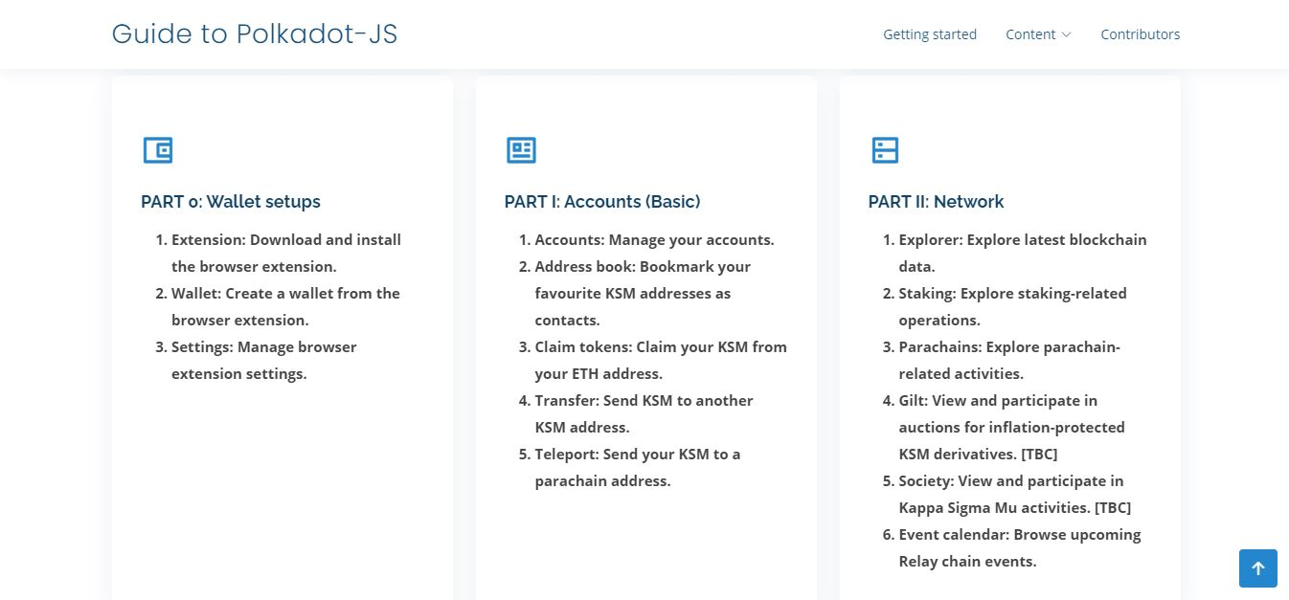

1. Include ad hoc explainers on different types of Substrate chains in **Part V**.

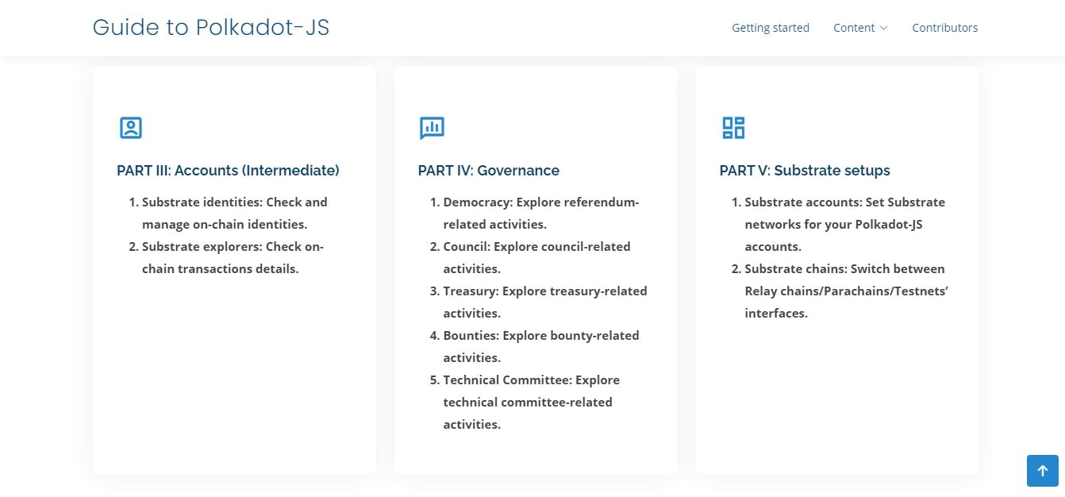

1. Deliver all sections of **Part VIII** with relevant information and in-depth explainers.

