**Proposal: Improvements and maintenance costs for** [***Guide to Polkadot-JS***](https://anaelleltd.github.io/polkadotjs-guide/)***.***

**3. Maintenance**

# Operational costs of the search widget.

Costs have been reviewed to match the content of the website (less than 2000 pages) and reflect the actual use of the search widget (less than 200 queries).

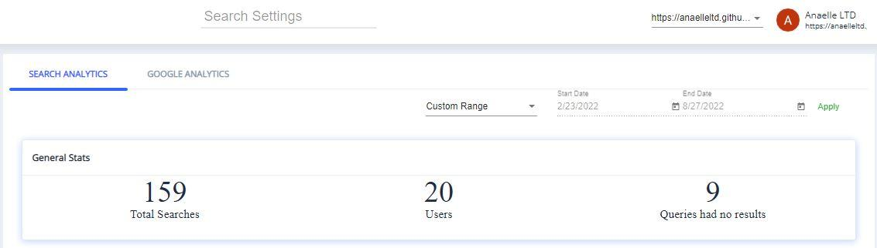

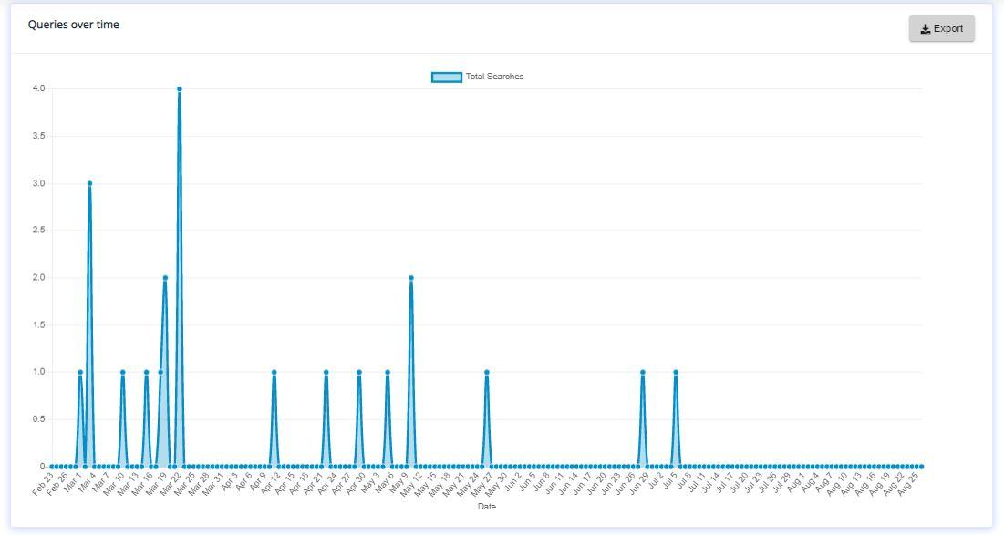

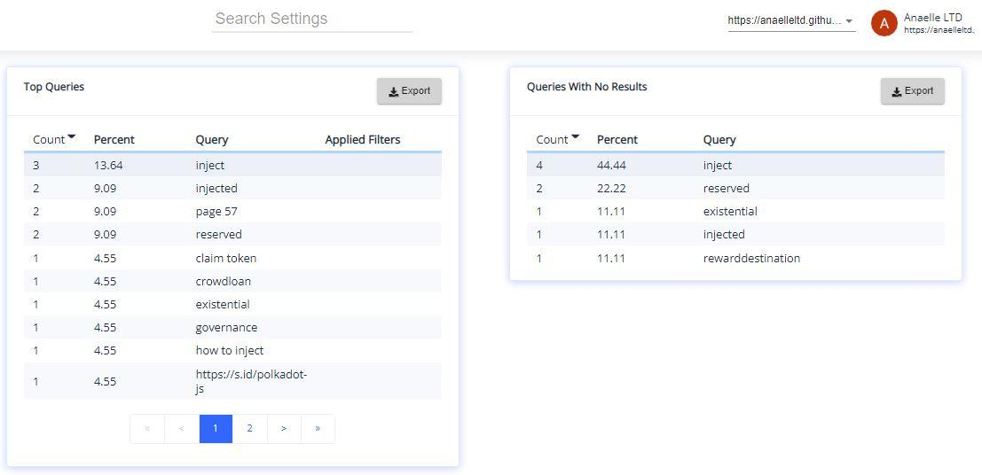

The subscription plan will therefore be downgraded from the original Skywalker plan ($25/month) to the R2D2 plan ($9/month) at the next renewal date.

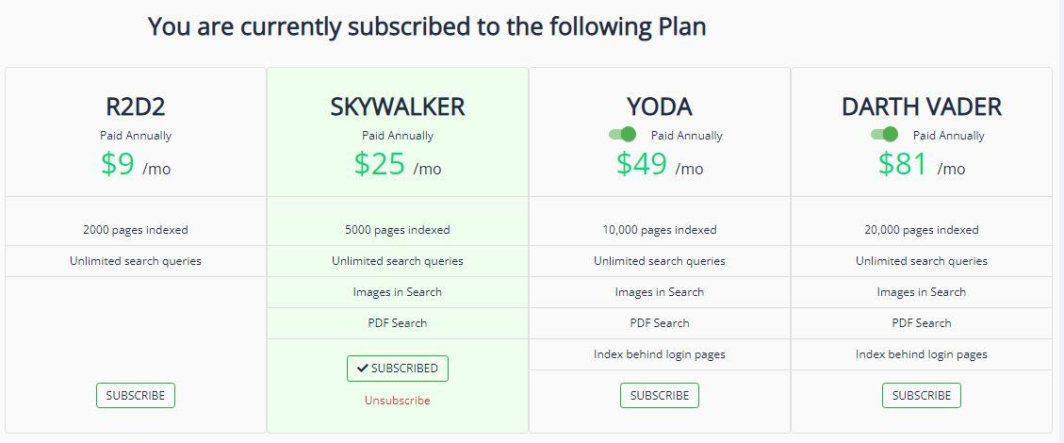

The renewal is due on 18th October 2022 at a cost of $108/year.

# Reference content on social channels.

1. Reddit:

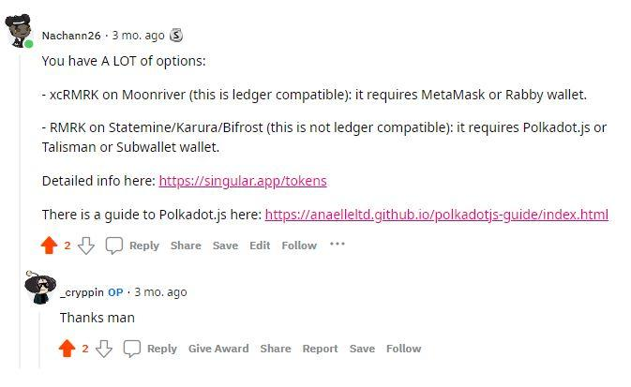

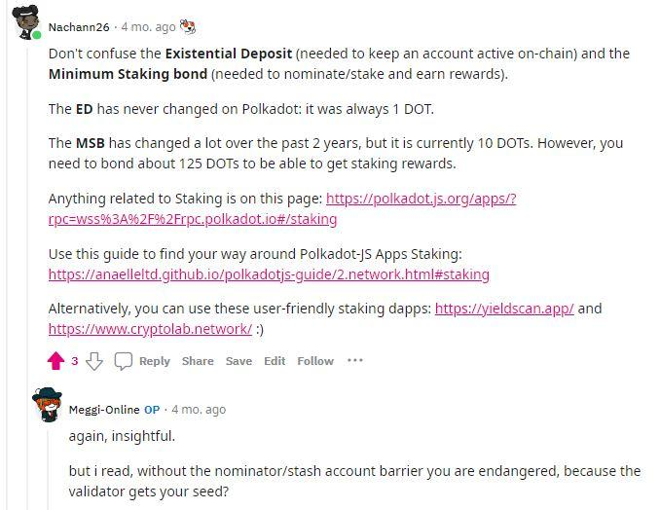

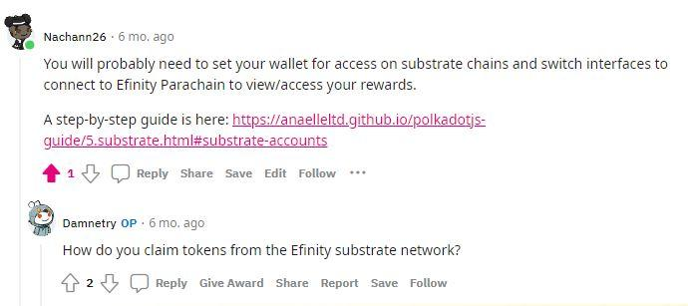

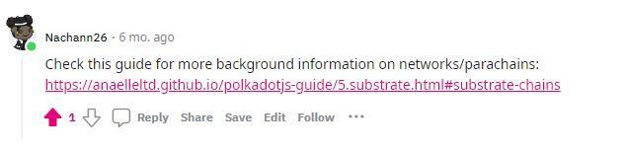

1. Twitter:

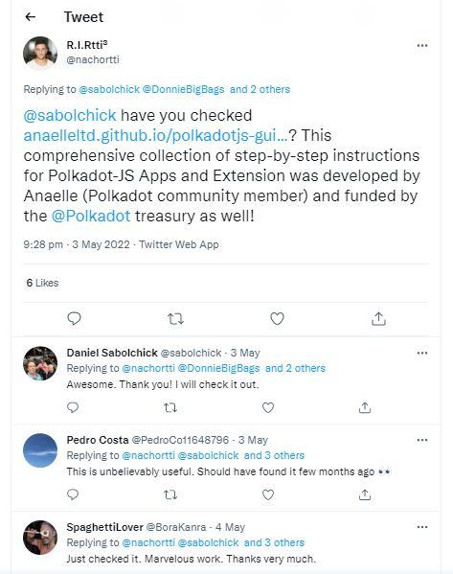

# Monitor traffic on individual pages with Google Analytics.

1. Number & origin of views:

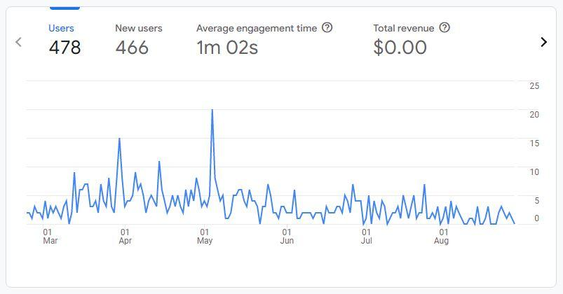

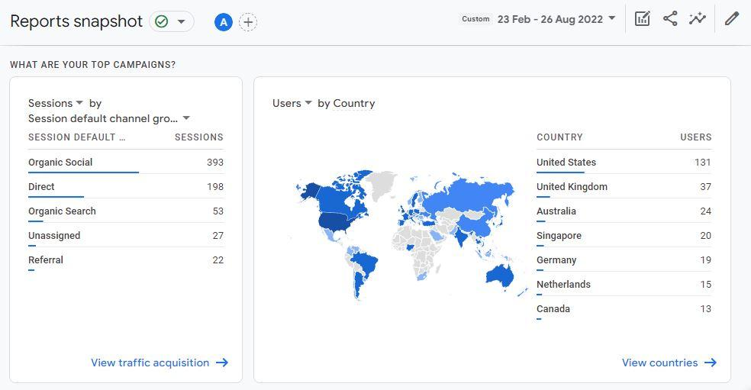

1. Number & origin of new users:

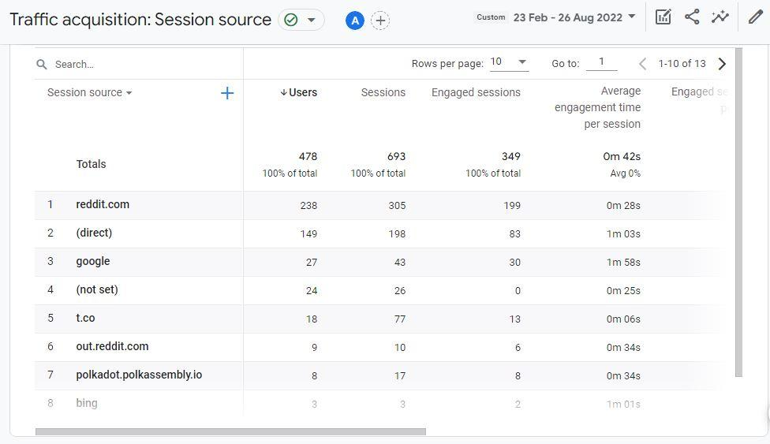

1. Most common user language(s):

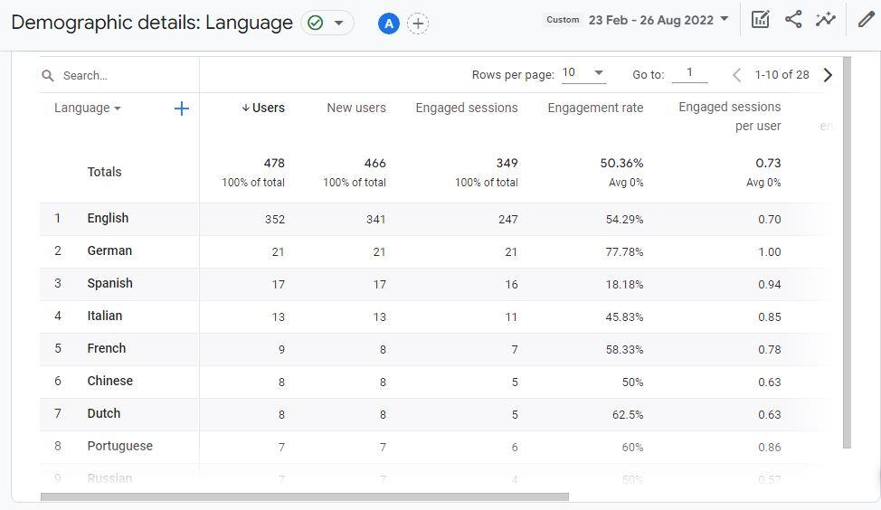

1. Most common user device(s):

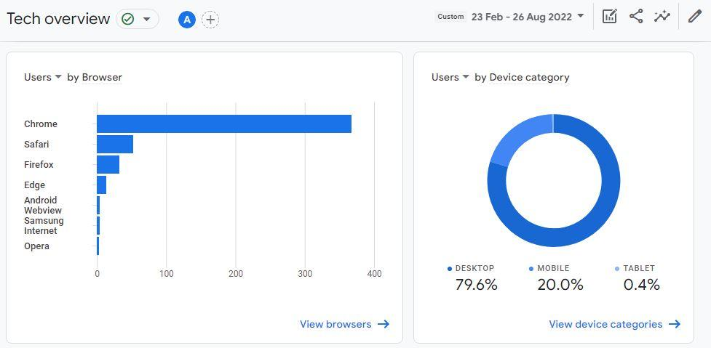

1. Most viewed content(s):

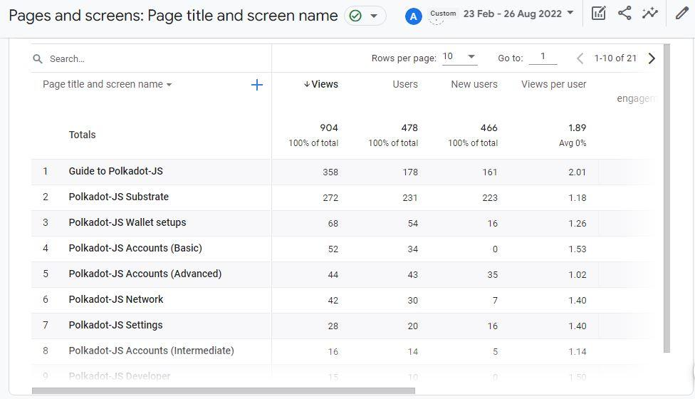

# Deliver new content in line with new/additional Polkadot-JS functionalities.

N/A for this period.