**Proposal: Improvements and maintenance costs for** [***Guide to Polkadot-JS***](https://anaelleltd.github.io/polkadotjs-guide/)***.***

**3. Maintenance**

# Operational costs of the search widget.

The subscription plan has been downgraded on 18th October 2022 to a new rate.

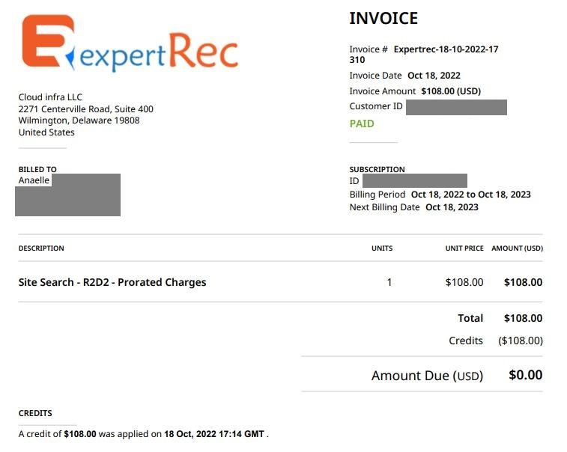

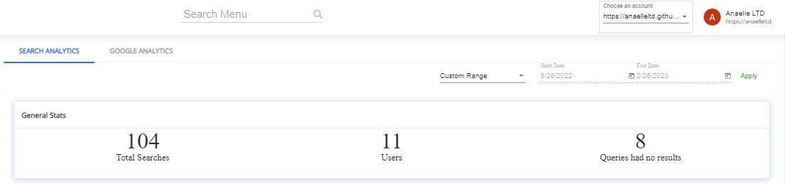

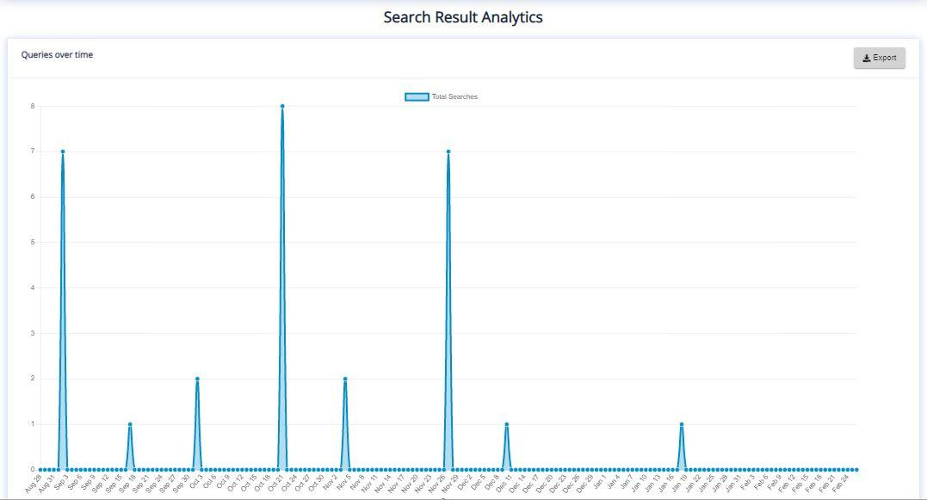

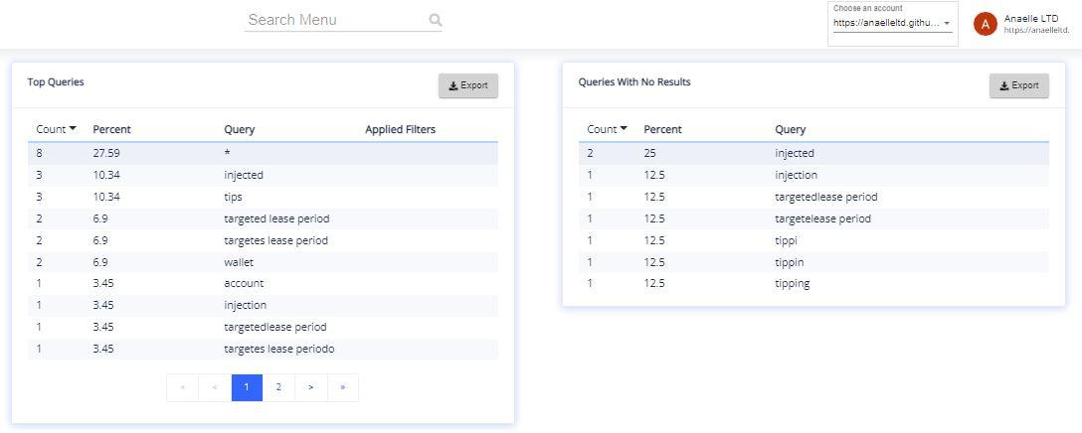

# Reference content on social channels.

1. Indexing status:

The website Guide to Polkadot-JS was launched in July 2021 and is now close to 2 years old. During this time, referencing done on social channels along with UX updates have dramatically improved the website’s ranking in Google search results.

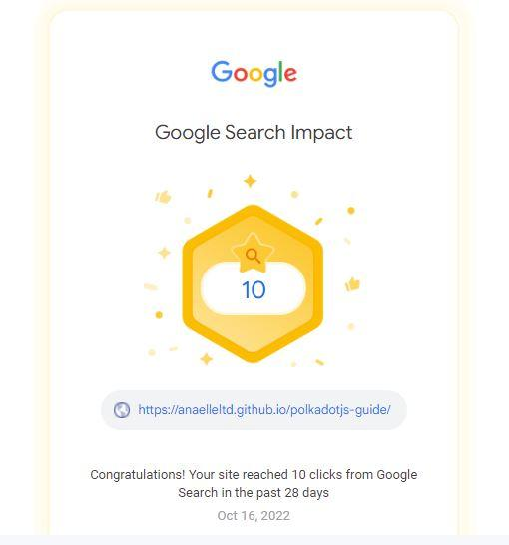

This means that general referencing is no longer needed, and that the focus should be on referencing the website on high-traffic crypto-related platforms.

b) Targeted referencing:

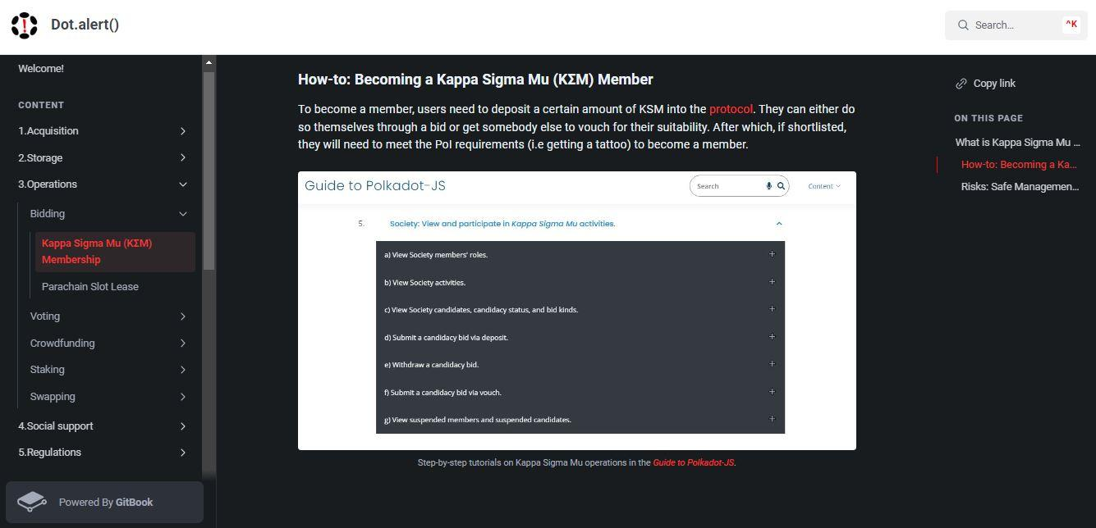

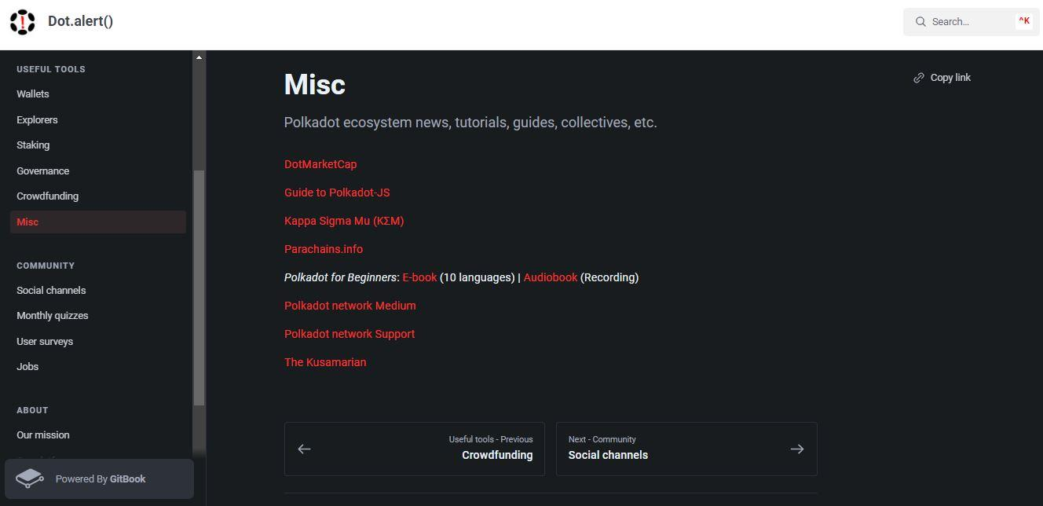

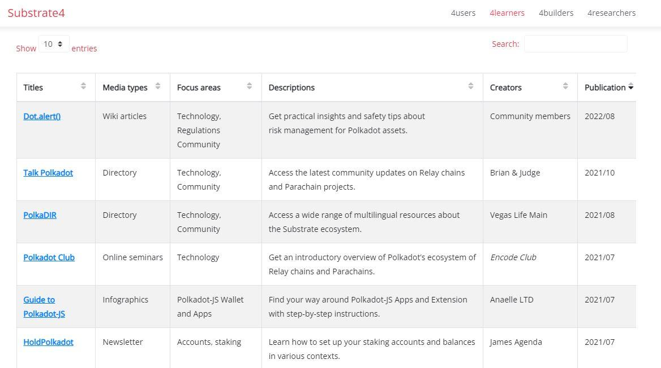

# Monitor traffic on individual pages with Google Analytics.

1. Number & origin of views:

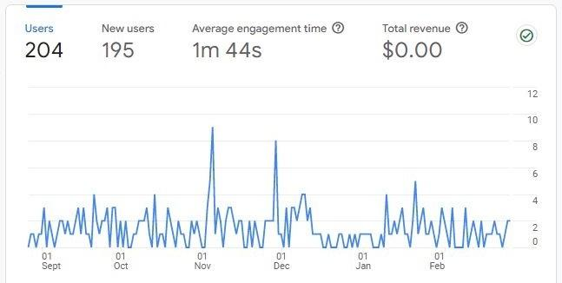

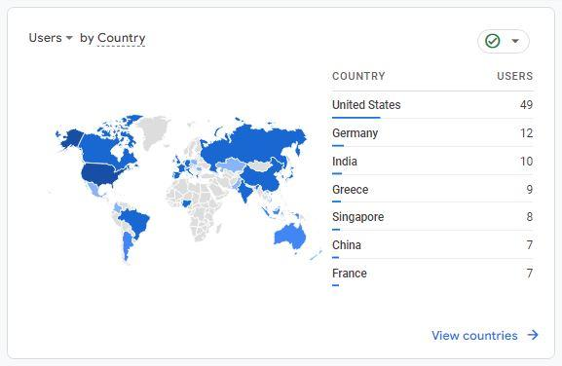

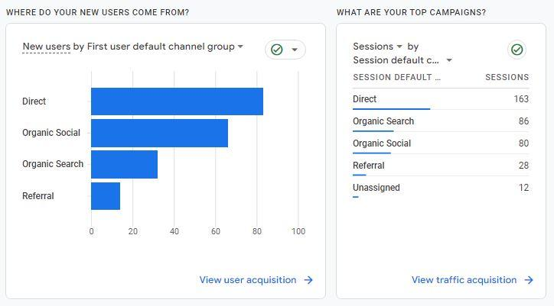

1. Number & origin of new users:

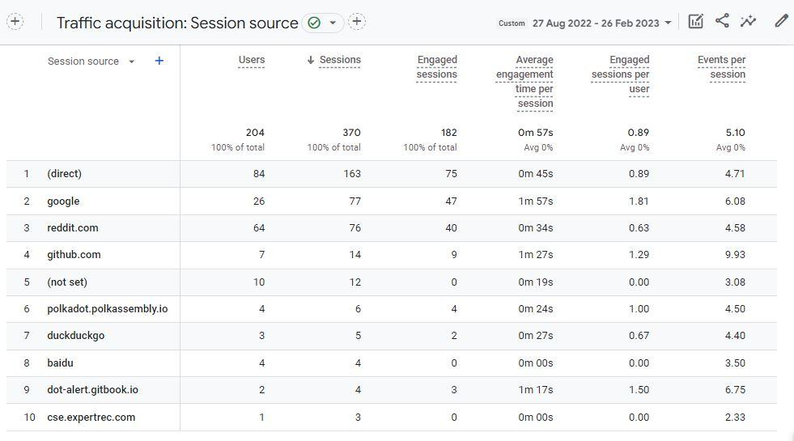

1. Most common user language(s):

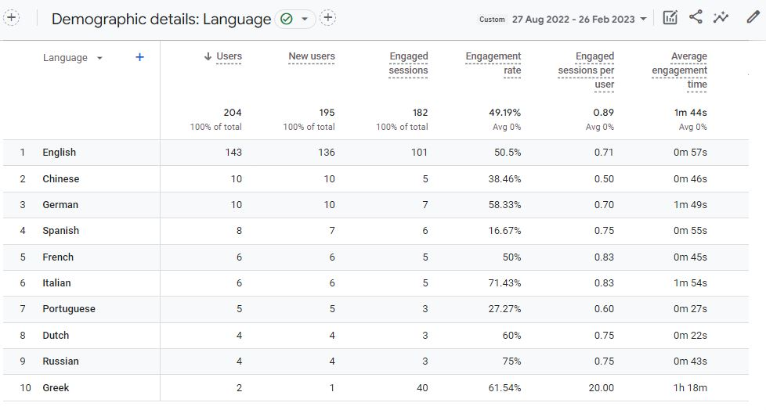

1. Most common user device(s):

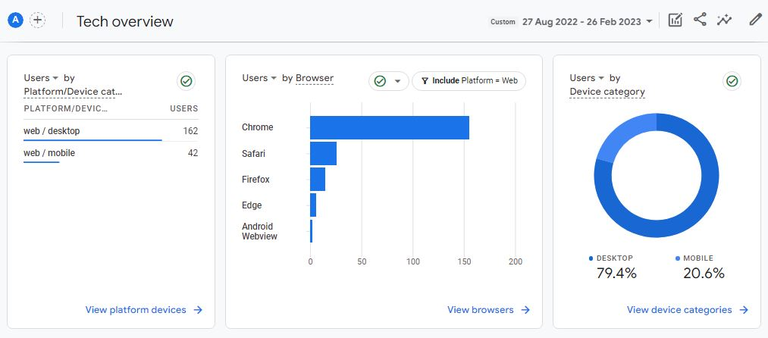

1. Most viewed content(s):

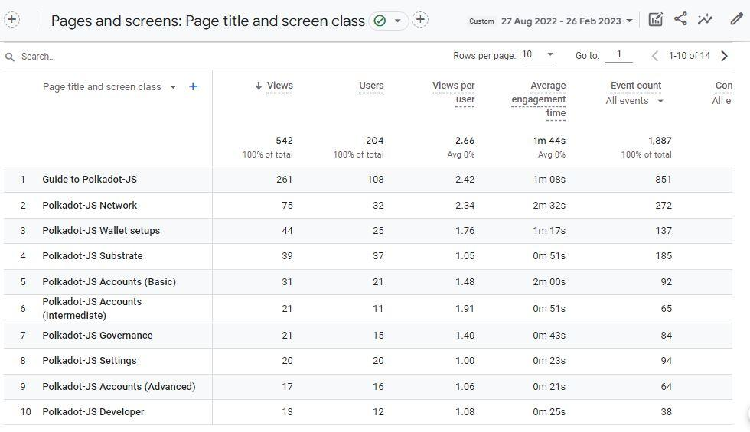

# Deliver new content in line with new/additional Polkadot-JS functionalities.

1. Nomination pools:

All basic operations have been covered with this update.

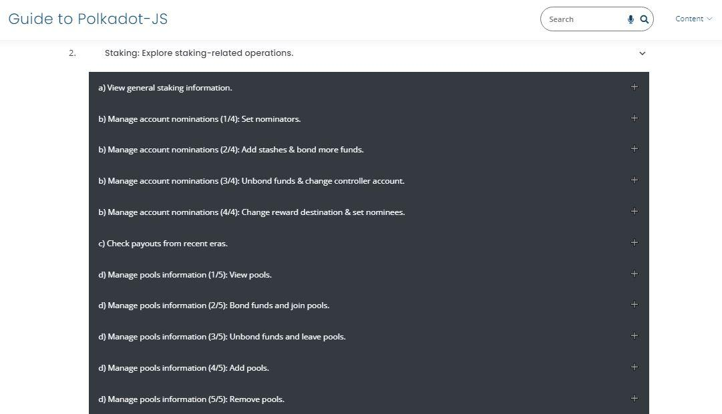

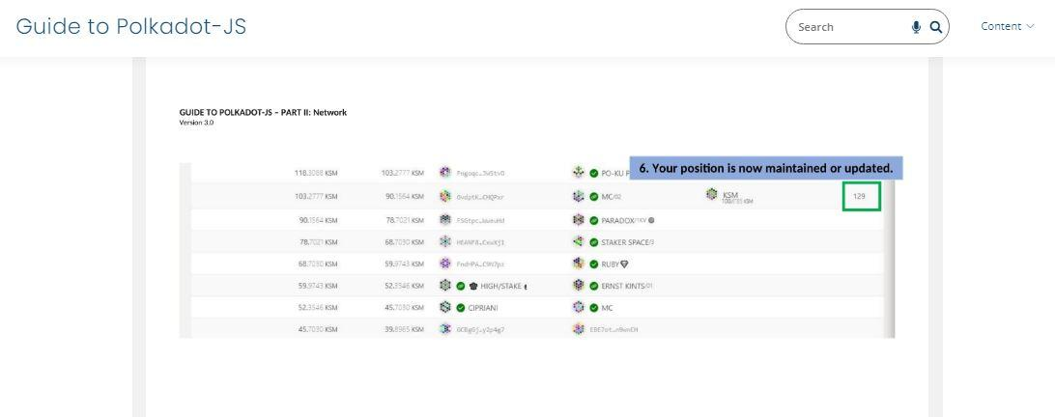

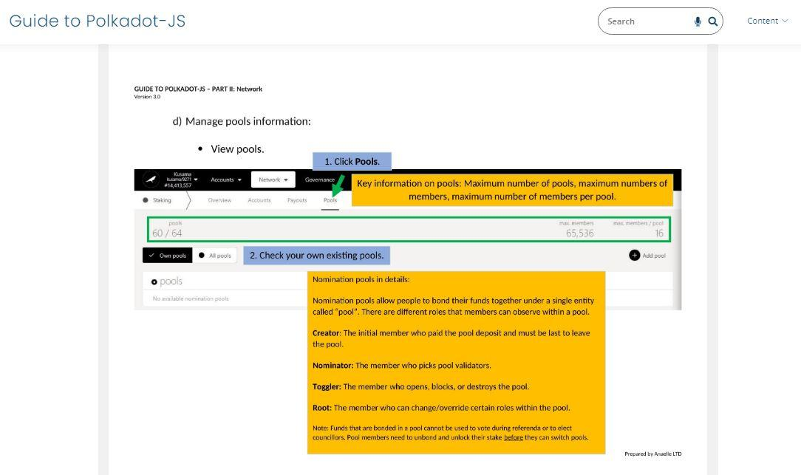

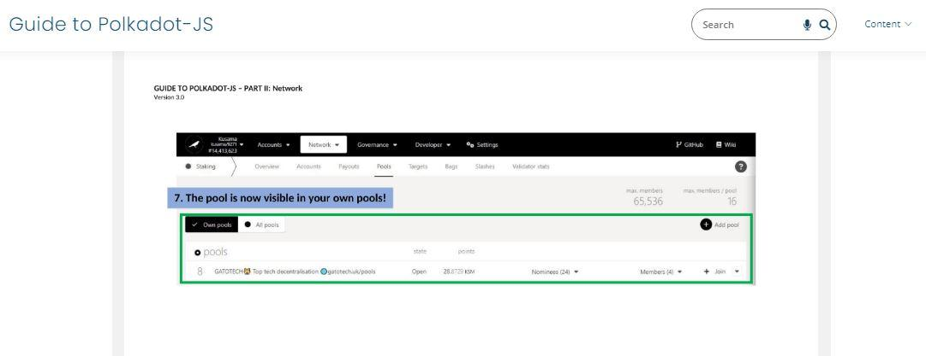

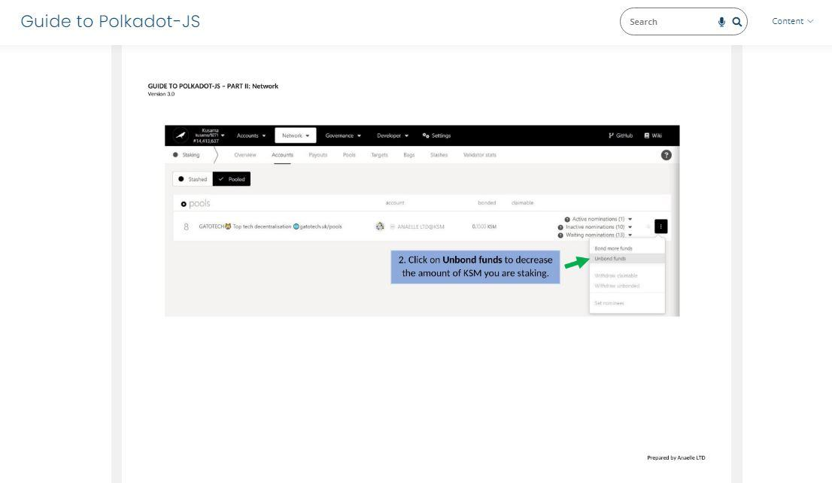

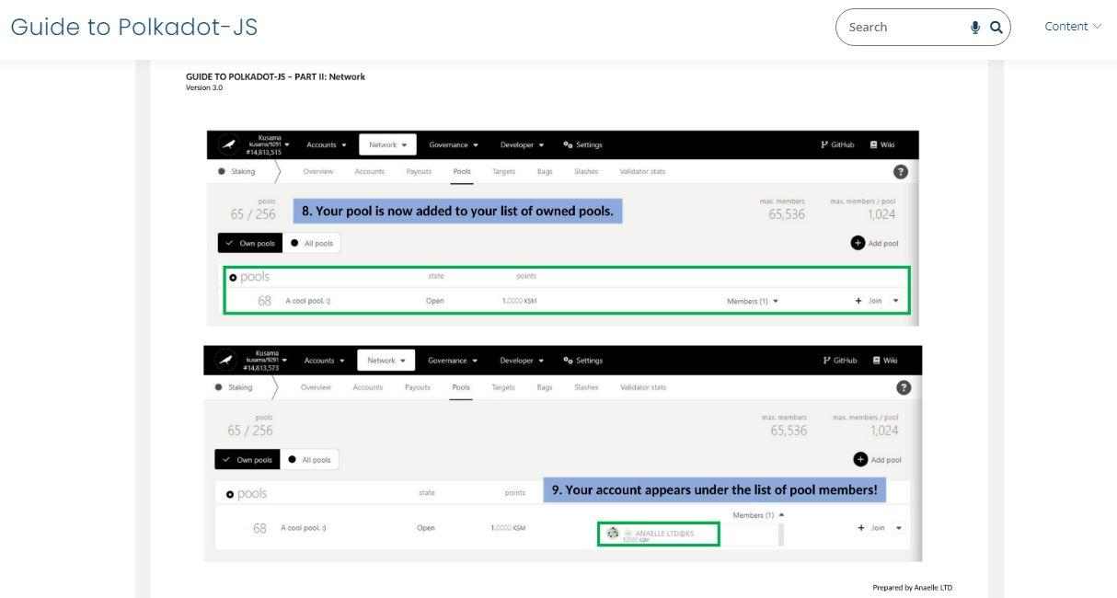

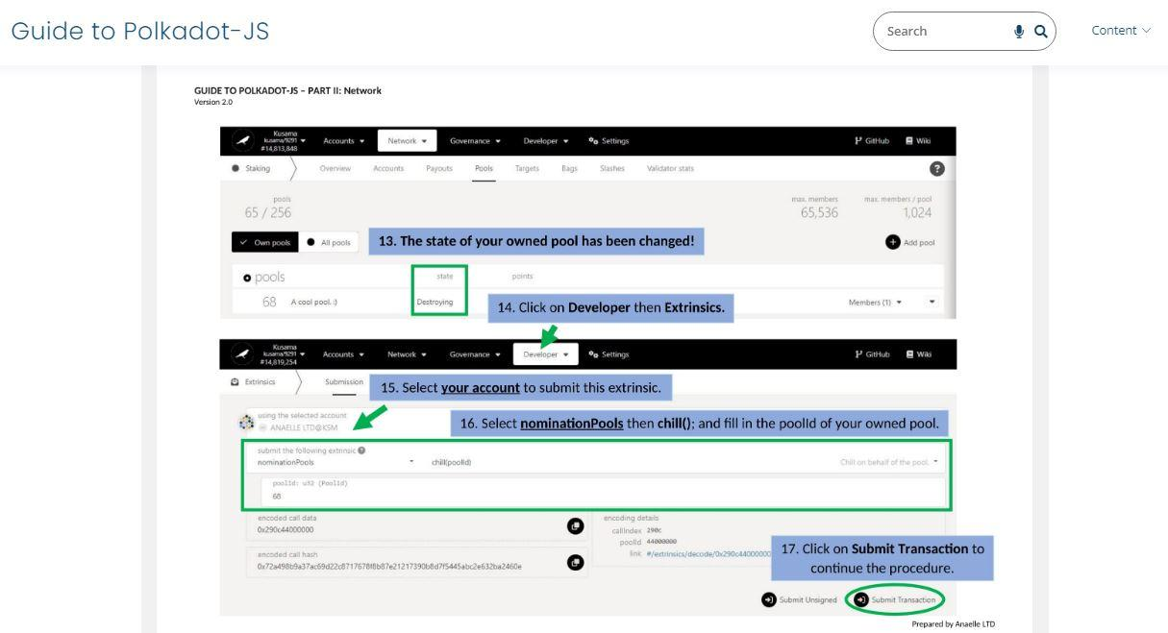

1. Bags:

All related operations have been covered with this update.

