**Proposal: Improvements and maintenance costs for** [***Guide to Polkadot-JS***](https://anaelleltd.github.io/polkadotjs-guide/)***.***

**2. UI improvements**

# Determine requirements

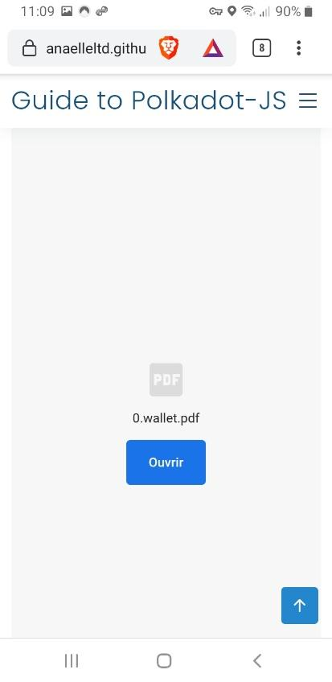

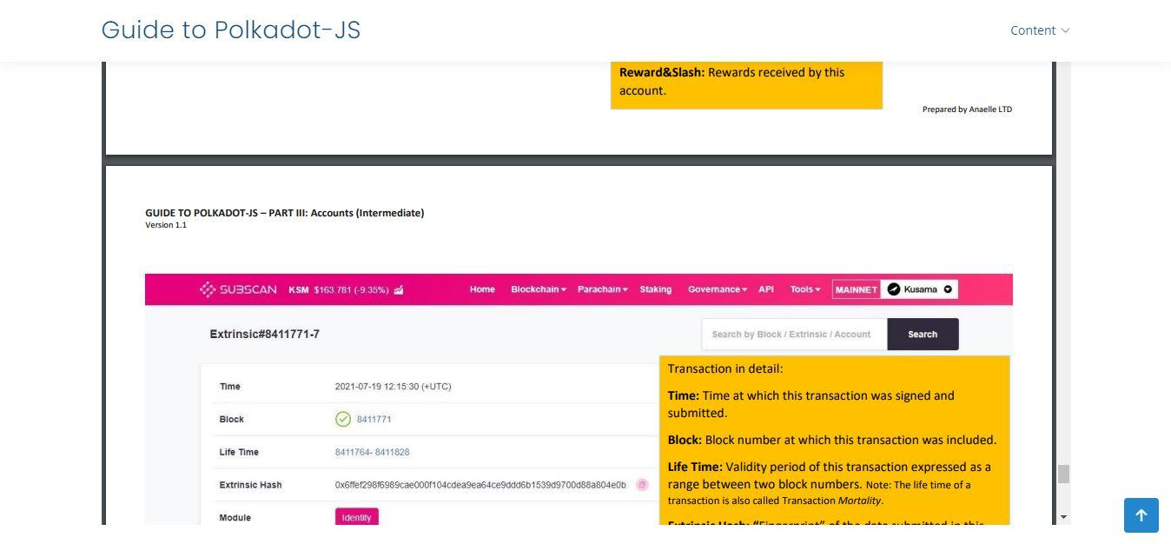

# Proposed & Approved designs

# Select & integrate coding tools and libraries