**Proposal: Improvements and maintenance costs for** [***Guide to Polkadot-JS***](https://anaelleltd.github.io/polkadotjs-guide/)***.***

**2. UI improvements**

# Determine requirements

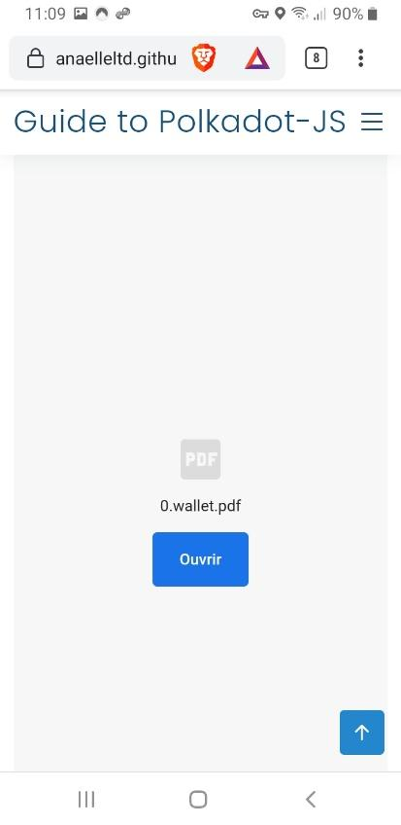

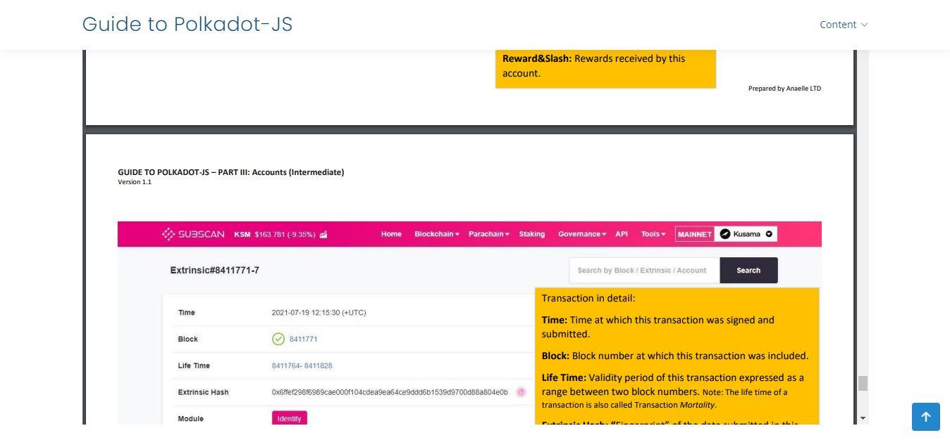

# Select & integrate coding tools and libraries

These need to:

* match the current flow of the website
* have no impact on the load time
* present no dependency-related security risk
* be flexible enough for the design of 3+ samples

These have been integrated as part of the review/bug fixes of the current website and the creation of samples for the new website.

# Propose sample designs for user tests

An initial survey has been conducted to familiarise testers with the website and collect some of their initial impressions/suggestions. Overall, users are able to find information around the website relatively easily and fast. This survey revealed that some users had display issues on a specific version of the FireFox browser: this was mitigated by altering the navigation menu and by reducing/enlarging the size of the browsing window. Further investigation was then needed.

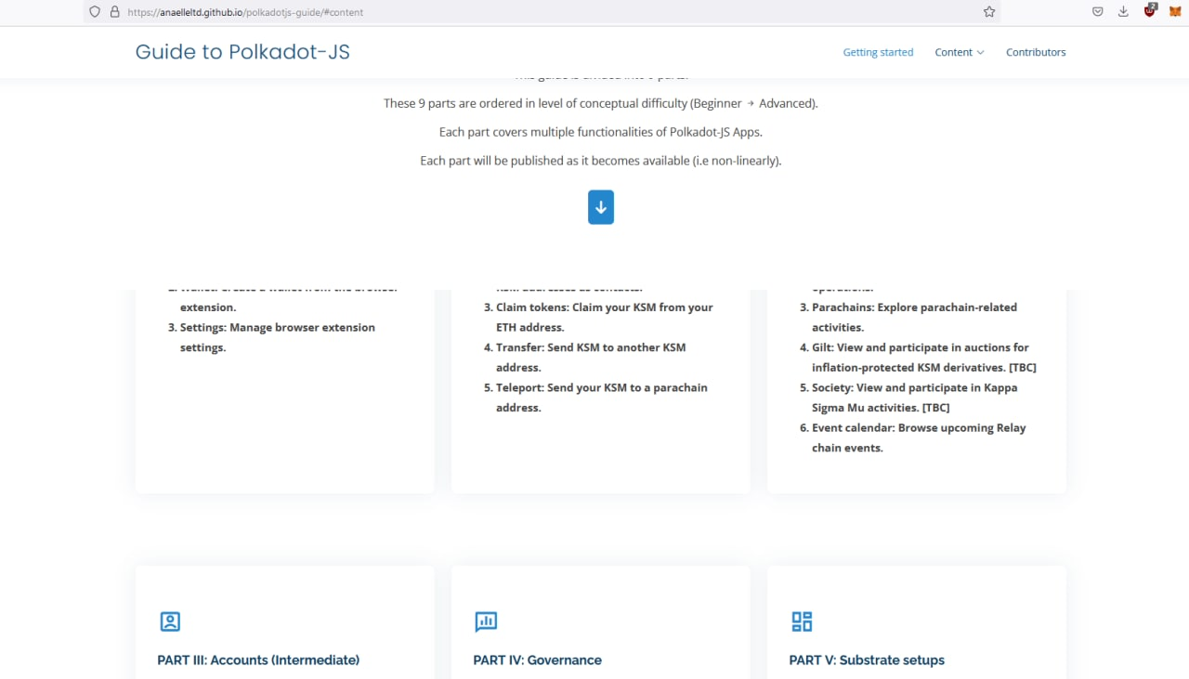

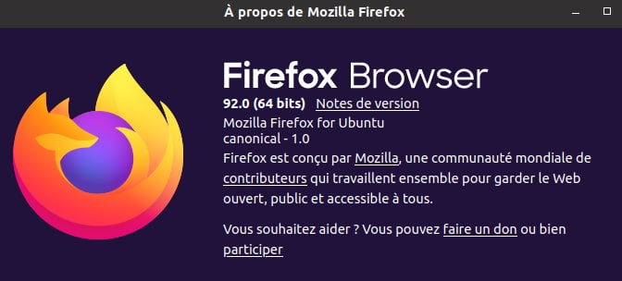

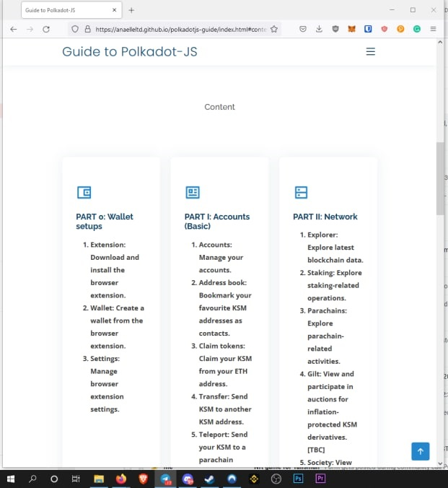

A second survey proposed 3 samples for review by 8 testers (including 3 from the first survey). Initially, sample 3 had a bug that altered its display: this was picked up by the 3rd reviewer and rectified. Overall, although users like the visual aspect of an image gallery in sample 2, they still preferred to have the content broken down into specific tags. There was no issue with accessing the content, but lack of compatibility, excessive clicking, and absence of labels were singled-out as major pain points on some of the designs.

### *Samples 1, 2 and 3 on Mobile*

1) 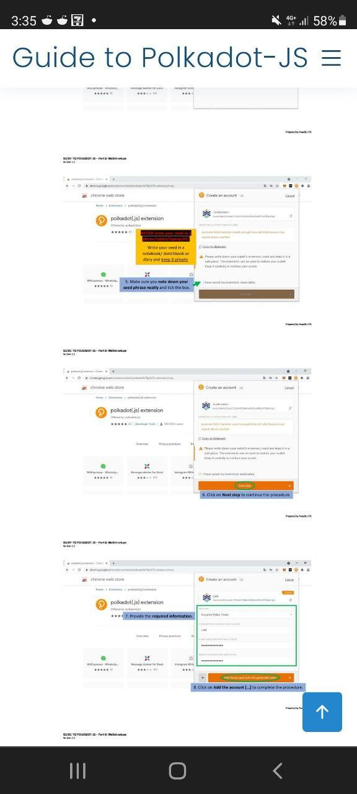 2) 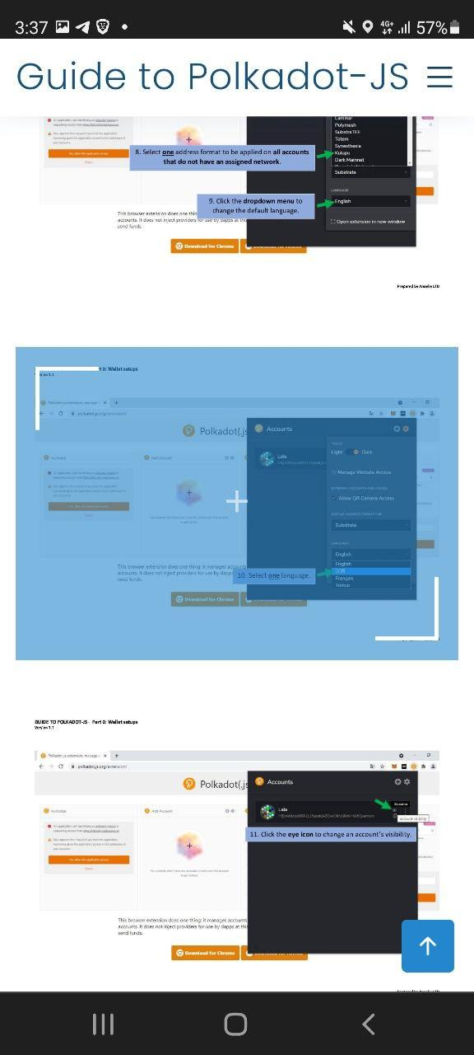 3) 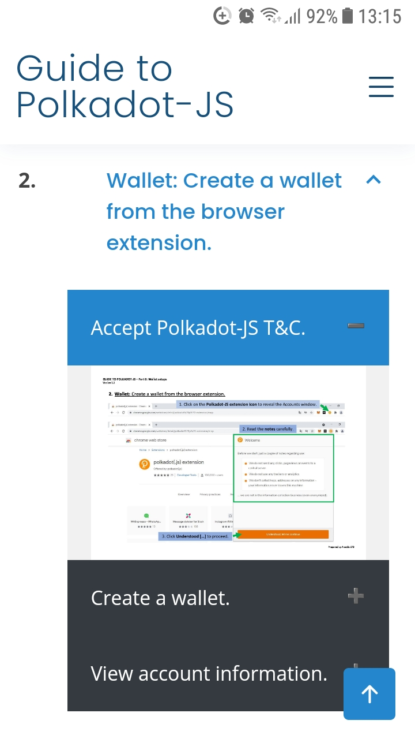

### *Samples 1, 2 and 3 on Desktop*

1. 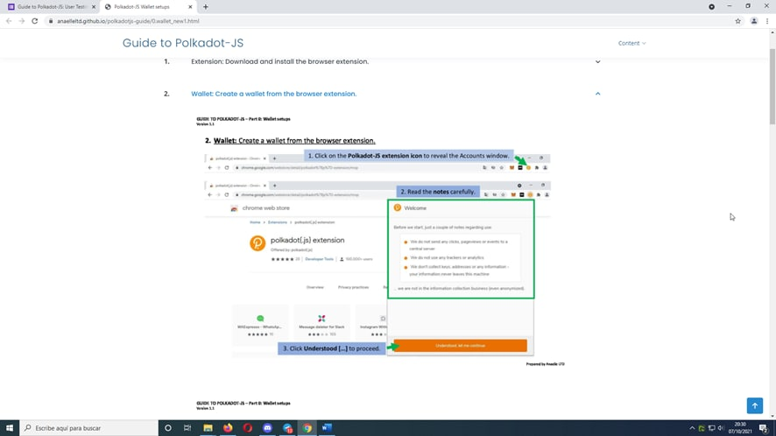
2. 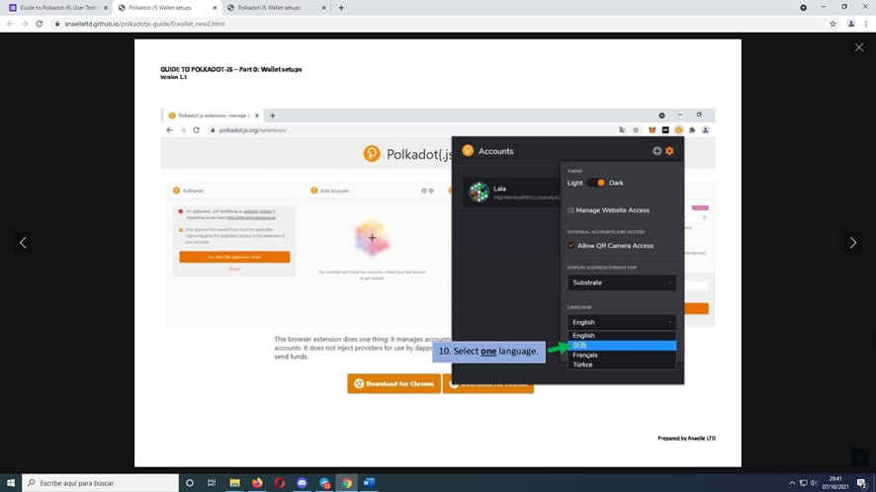
3. 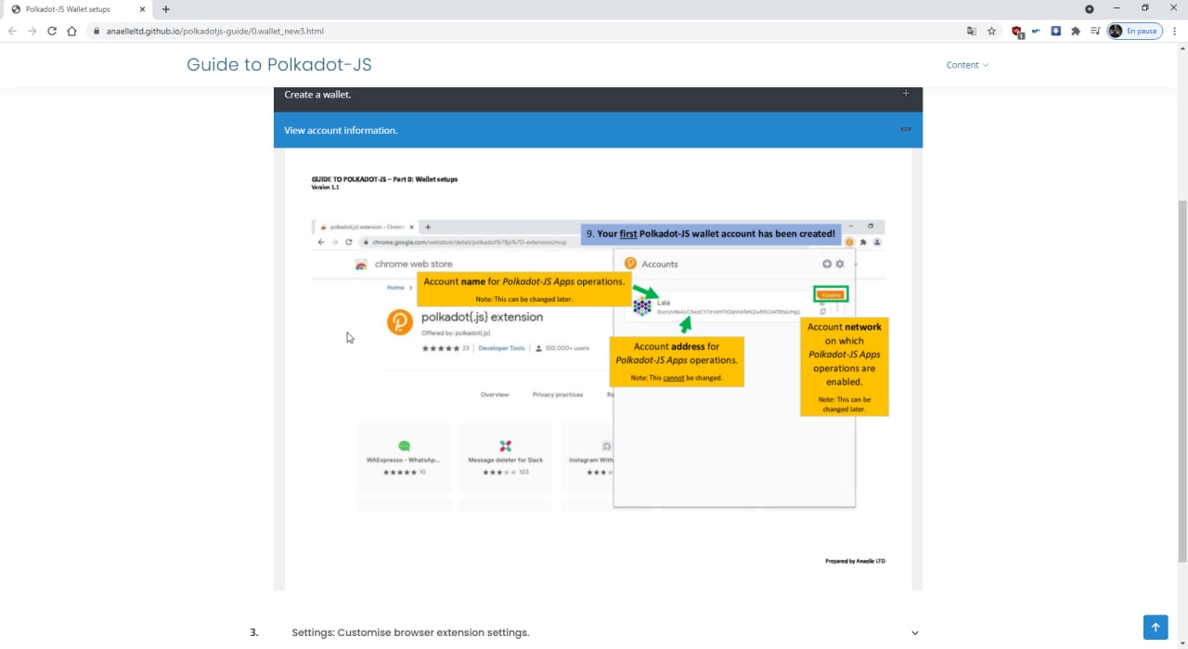

# Log approved designs from user surveys

Sample 2 received 3 positive comments and 5 negative comments, which hinders its overall suitability in our context. By contrast, sample 3 only received 1 negative comment which linked to the original bug in the display. Sample 3 was also chosen by 50% of testers as the most preferred layout, which indicates that it satisfies their overall expectations.

**Sample 3 was selected as the final design because it is:**

* **consistently displayed across devices**
* **well-supported across browsers**
* **lazy-loaded on-demand**
* **structured with sub-sections**

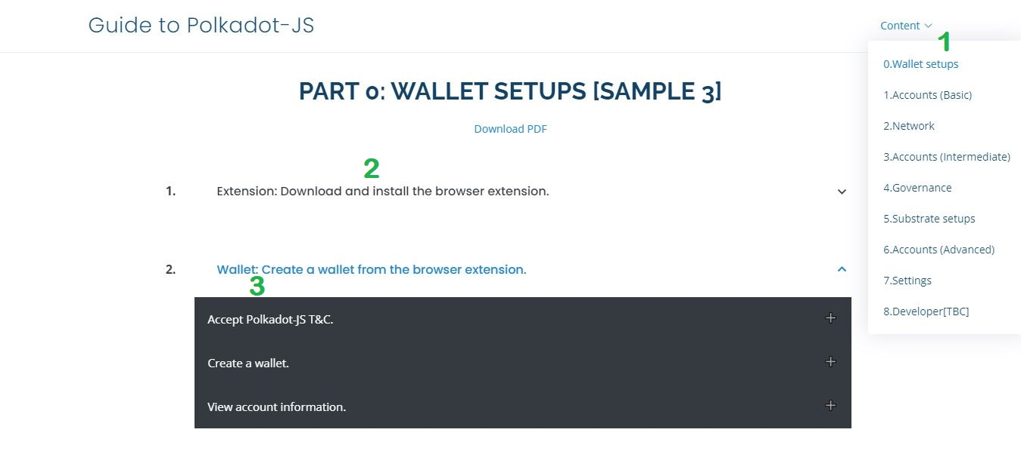

A final survey proposed an overview of the new website for review by 5 testers. Overall, testers found the new website better-structured and easier to navigate. Some display issues occurred on Brave and Firefox browsers, but these were fixed after scrupulous code review. Testers selected the search functionality as the feature most needed to make the website suitable for people who are completely new to Polkadot-JS Apps. This feature has now been added onto the new website, and will be expanded into image search as part of future maintenance.

