**Proposal: Improvements and maintenance costs for** [***Guide to Polkadot-JS***](https://anaelleltd.github.io/polkadotjs-guide/)***.***

**1. UX improvements**

# Review Information Architecture

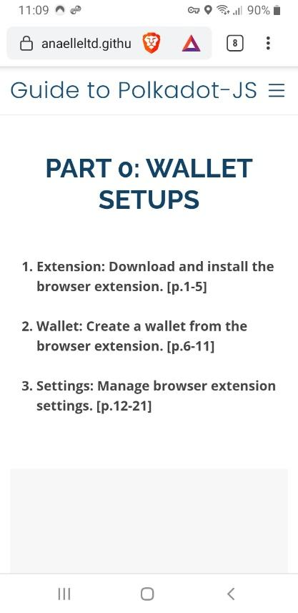 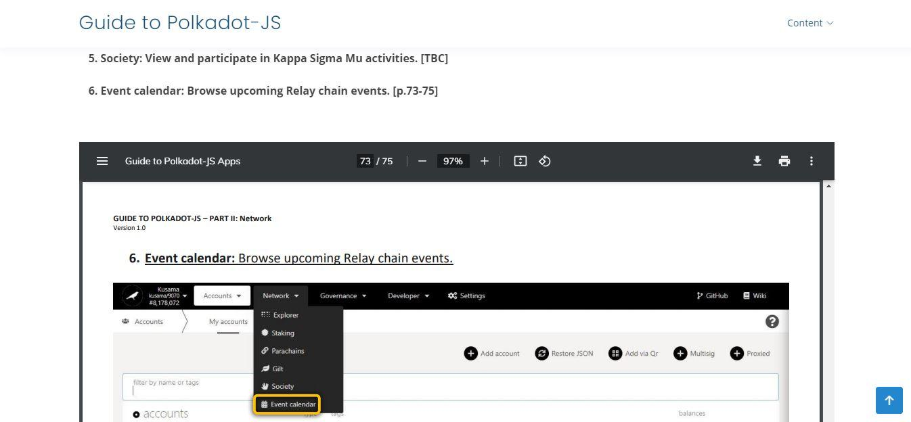

# Reformat content

# Walkthroughs & user tests