**Projeto para ser entregue do dia a dia de um QA**

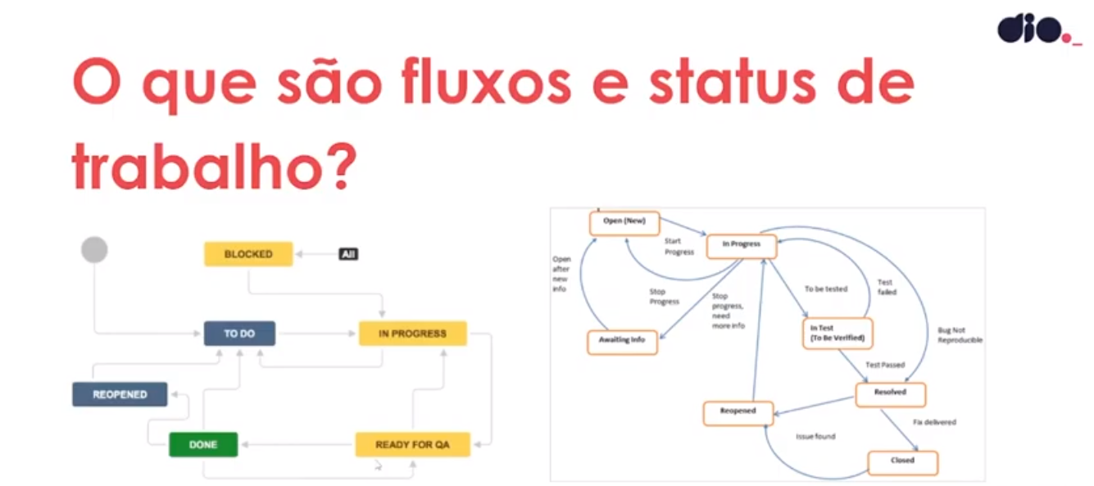

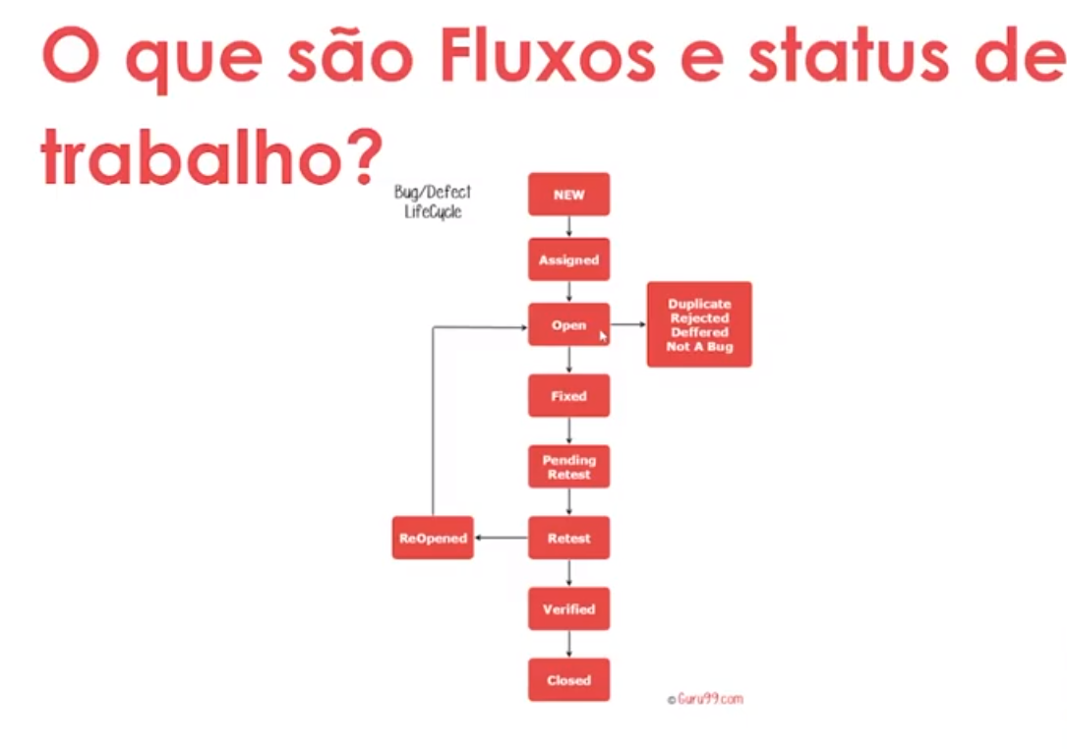

Worflow

1. Start – create- To Do
2. To do - It will no longer work – Closed
3. To do - Start work in Sprint – In Development
4. In Development - It will be reviewed and released for correction – Reopened
5. Reopened - Item validated and returned for correction – In Review
6. In Review - Item validated and released - Resolved
7. In Development - It will move up to QA implementation and validation – Ready For QA
8. Ready For QA - QA starts the activity – In Review
9. In Review - Item validated and released – Resolved
10. Resolved - Item went up to production successfully – Done

História do Usuário

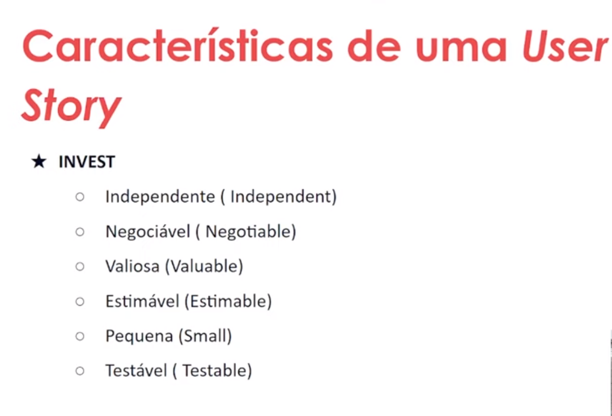

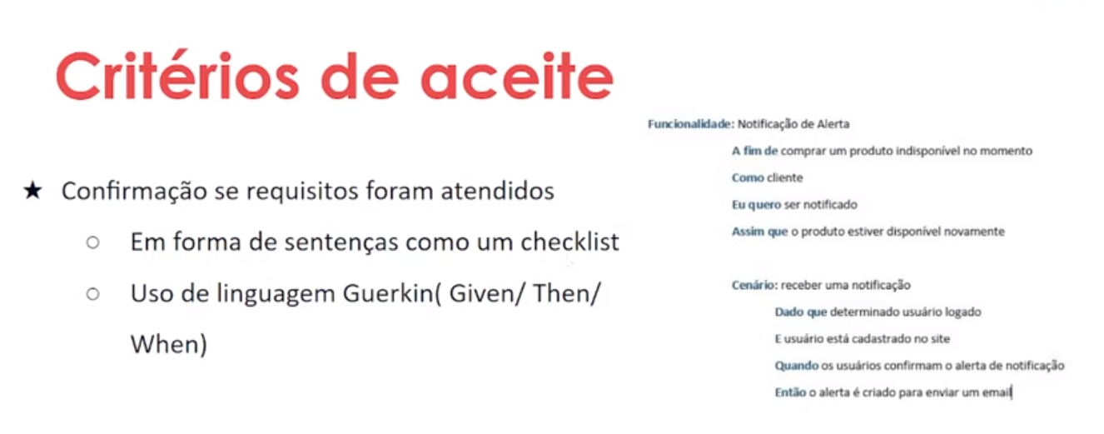

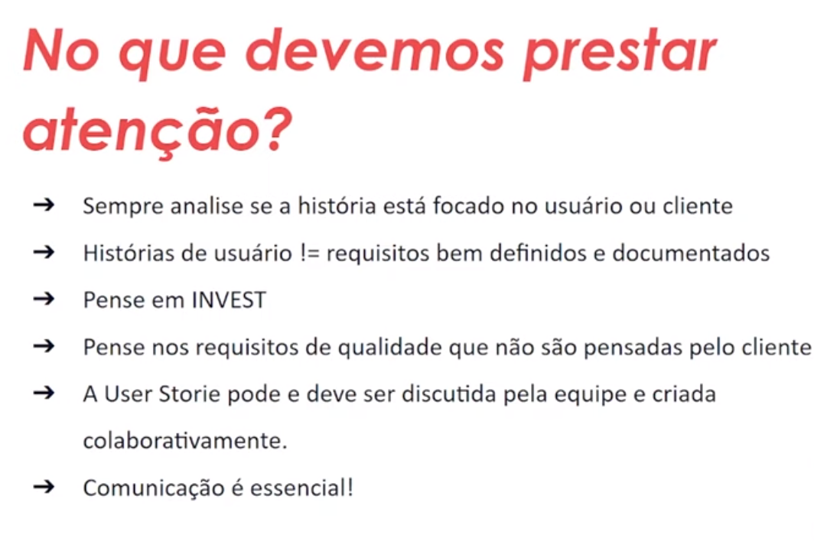

Exemplo de User History

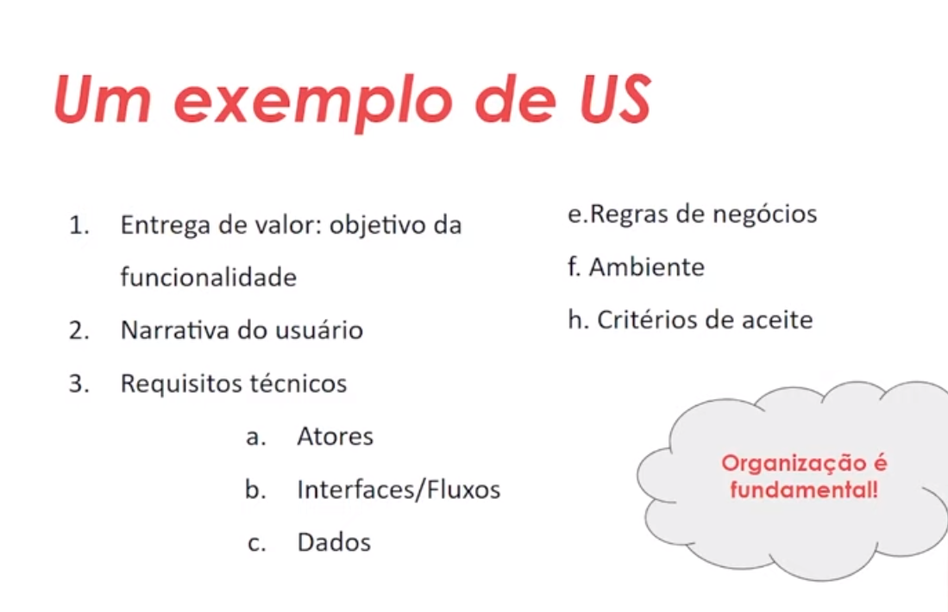

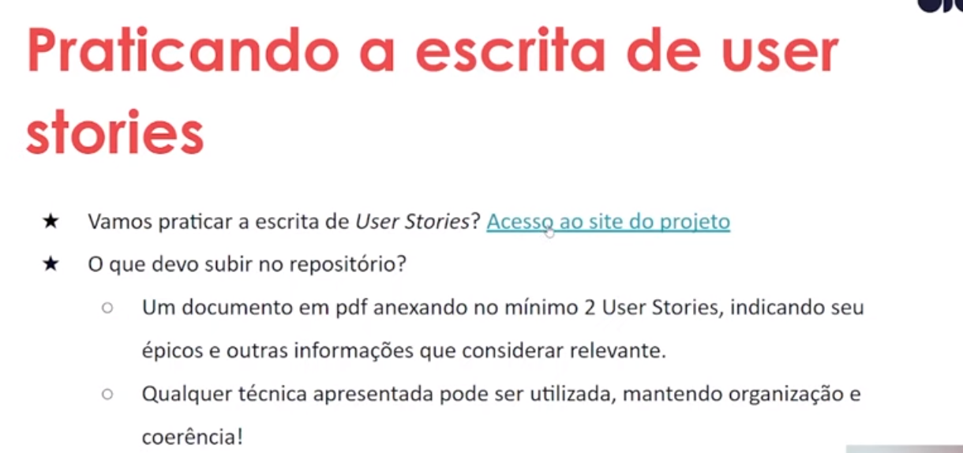

**Fontes**

**Bootcamp GFT Quality Assurance** – Disponível em: https://www.dio.me/ – Acesso em Janeiro de 2023.

**Regras de Negócio** – Disponível em: https://www.ateomomento.com.br/requisito-funcional-x-regra-de-negocio-quem-e-quem/ – Acesso em Janeiro de 2023.