MULTI-VENDOR MARKETPLACE
MINI PROJECT REPORT
Submitted by
23AK1A3645 – USHARANI.P
23AK1A3625 – NAVYA .A
23AK1A3602 – ANUPAMA .R

ABSTRACT
VendorVerse – Multi-Vendor Marketplace Platform
VendorVerse is a web-based Multi-Vendor Marketplace Platform designed to provide a centralized online marketplace where multiple vendors can register, manage, and sell their products through a single system. The platform addresses the challenges faced by small businesses and local sellers who often lack the resources and technical expertise to create and maintain independent e-commerce websites.
The system enables vendors to create accounts, add and manage products, track orders, and monitor sales through a dedicated vendor dashboard. Customers can browse products from various vendors, search for desired items, add products to their shopping cart, and place orders seamlessly. An administrative dashboard is provided to manage vendors, products, and platform activities efficiently.
VendorVerse is developed using modern web technologies including React.js for the frontend, Node.js and Express.js for the backend, MongoDB for database management, and JWT for secure authentication. The platform supports multiple product categories such as fashion, electronics, books, home essentials, beauty products, handmade crafts, toys, and sports equipment.
The proposed solution improves vendor visibility, expands customer reach, simplifies online selling, and enhances the shopping experience by bringing multiple sellers and customers together on a single platform. Future enhancements include payment gateway integration, product reviews and ratings, real-time notifications, mobile application support, and AI-based product recommendations to further improve functionality and user engagement..

INTRODUCTION
The rapid growth of e-commerce has transformed the way businesses sell products and customers make purchases. However, many small businesses, local sellers, and independent vendors face challenges in establishing their own online stores due to high development costs, technical complexities, and limited marketing resources. As a result, their products often fail to reach a wider customer base.
VendorVerse is a Multi-Vendor Marketplace Platform developed to address these challenges by providing a centralized online marketplace where multiple vendors can register, manage, and sell their products through a single platform. The system allows customers to browse products from different vendors, compare items, add products to their shopping cart, and place orders conveniently.
The platform offers dedicated dashboards for vendors and administrators. Vendors can manage product listings, monitor orders, and track sales, while administrators oversee vendor approvals, product management, and overall marketplace operations. By bringing multiple sellers and buyers together in one ecosystem, VendorVerse enhances product visibility, improves customer convenience, and simplifies online business management.
Developed using modern web technologies such as React.js, Node.js, Express.js, MongoDB, and JWT authentication, VendorVerse provides a secure, scalable, and user-friendly marketplace solution. The platform supports a wide range of product categories, making it suitable for various business domains and helping vendors expand their digital presence in the competitive e-commerce market.

OBJECTIVES

1. To develop a centralized online marketplace that enables multiple vendors to sell products through a single platform.
2. To provide vendors with a dedicated dashboard for managing products, inventory, and customer orders efficiently.
3. To enable customers to browse, search, compare, and purchase products from different vendors in one place.
4. To implement a secure user authentication and authorization system for customers, vendors, and administrators.
5. To simplify product management by allowing vendors to add, update, and remove product listings easily.
6. To provide a shopping cart and order management system that ensures a smooth purchasing experience.
7. To improve the online visibility and market reach of small businesses and local sellers.
8. To provide administrators with tools for vendor approval, product monitoring, and marketplace management.
9. To create a scalable and user-friendly platform capable of supporting multiple product categories and vendors.
10. To enhance customer satisfaction by offering a convenient, secure, and efficient online shopping experience.

EXISTING SYSTEM
The existing online shopping system primarily consists of individual e-commerce websites where each seller manages a separate platform for displaying and selling products. Small businesses and local vendors often need to invest significant time, money, and technical resources to create and maintain their own online stores.
In the current system, customers must visit multiple websites to search for products from different sellers, making the shopping process time-consuming and inconvenient. Vendors also face challenges in reaching a wider audience due to limited online visibility and marketing resources.
Limitations of the Existing System
- Sellers need separate websites to sell their products online.
- High development and maintenance costs for individual stores.
- Limited customer reach for small and local businesses.
- Customers must browse multiple websites to compare products.
- Lack of centralized product and order management.
- Difficulties in managing inventory and sales efficiently.
- Limited opportunities for new vendors to establish an online presence.

Due to these limitations, there is a need for a centralized marketplace that allows multiple vendors to sell products on a single platform while providing customers with a convenient and seamless shopping experience.

PROPOSED SYSTEM
The proposed system, VendorVerse – Multi-Vendor Marketplace Platform, is a centralized web-based marketplace that enables multiple vendors to register, list, and sell their products through a single platform. It provides an efficient and user-friendly environment for vendors, customers, and administrators.
In this system, vendors can create accounts, manage their product listings, update inventory, and track orders through a dedicated vendor dashboard. Customers can browse products from various vendors, search for specific items, add products to their shopping carts, and place orders securely. Administrators are responsible for approving vendors, monitoring products, and managing overall marketplace activities.

The platform is designed using modern web technologies such as React.js, Node.js, Express.js, MongoDB, and JWT authentication to ensure security, scalability, and high performance.
Advantages of the Proposed System
- Centralized platform for multiple vendors and customers.
- Easy vendor registration and product management.
- Secure authentication and authorization system.
- Convenient product browsing and searching.
- Efficient shopping cart and order management.
- Improved online visibility for vendors.
- Better customer experience through a single marketplace.
- Simplified administration and marketplace monitoring.
- Scalable architecture to support business growth.
- Supports multiple product categories and vendors.
The proposed system overcomes the limitations of traditional e-commerce platforms by providing a unified marketplace that benefits both sellers and customers.

TECHNOLOGIES USED
Frontend Technologies
React.js
- Used for building a responsive and interactive user interface.
- Provides reusable components and efficient rendering.
Tailwind CSS
- Used for designing modern and responsive web pages.
- Enables fast and customizable UI development.
Backend Technologies
Node.js
- Provides a server-side runtime environment for executing JavaScript.
- Handles application logic and server operations efficiently.
Express.js
- A lightweight web framework for Node.js.
- Used to create RESTful APIs and manage server-side routing.
Database
MongoDB
- A NoSQL database used to store user, product, vendor, and order information.
- Provides flexibility, scalability, and high performance.
Authentication & Security
JWT (JSON Web Token)
- Used for secure user authentication and authorization.
- Protects user sessions and API access.
Development Tools
Visual Studio Code
- Used as the primary code editor for development.
Git & GitHub
- Used for version control and project collaboration.
Web Technologies
HTML5
- Provides the structure of web pages.
CSS3
- Used for styling and visual presentation.
JavaScript (ES6+)
- Adds interactivity and dynamic functionality to the application.
Operating System- Windows / Linux
These technologies work together to create a secure, scalable, responsive, and efficient Multi-Vendor Marketplace Platform.

SYSTEM ARCHITECTURE
The VendorVerse Multi-Vendor Marketplace Platform follows a three-tier architecture consisting of the Presentation Layer, Application Layer, and Database Layer. This architecture ensures scalability, security, maintainability, and efficient communication between users and the system.
Components Description
1. Presentation Layer (Frontend)
- Developed using React.js and Tailwind CSS.
- Provides interfaces for Customers, Vendors, and Admins.
- Handles product browsing, shopping cart, dashboards, and order management.
2. Application Layer (Backend)
- Developed using Node.js and Express.js.
- Processes user requests and business logic.
- Handles authentication, product management, order processing, and vendor management through REST APIs.
3. Database Layer
- Implemented using MongoDB.
- Stores customer details, vendor information, product data, orders, and transaction records.
- Ensures efficient data retrieval and management.
Workflow
1. User logs into the platform.
2. Request is sent from the frontend to backend APIs.
3. Backend validates the request using JWT authentication.
4. Required data is retrieved or updated in MongoDB.
5. Backend sends the response back to the frontend.
6. User receives the requested information or confirmation.

Architecture Flow:
Customers/Vendors → React Frontend → Node.js + Express.js Backend → MongoDB Database
Customers & Vendors
↓
Frontend (React.js)
↓
Backend (Node.js + Express.js)
↓
Database (MongoDB Atlas)

MODULES DESCRIPTION
The Multi-Vendor Marketplace application consists of the following modules:
- Vendor Module
- Customer Module
- Product Management Module
- Cart Management Module
- Order Management Module

VENDOR MODULE
The Vendor Module allows vendors to register, log in, and manage their products through the Vendor Dashboard.
Functions of Vendor Module:
- Vendor Registration
- Vendor Login
- Add New Products
- Edit Existing Products
- Delete Products
- Upload Product Images
The Vendor Dashboard provides complete control over product management, enabling vendors to efficiently maintain their products.

CUSTOMER MODULE
The Customer Module enables customers to interact with the marketplace and perform shopping-related activities.
Functions of Customer Module:
- Customer Registration
- Customer Login
- Browse Products
- Search Products
- View Product Details
Customers can access the product catalog, search for required products, and perform shopping activities conveniently.

PRODUCT MANAGEMENT MODULE
The Product Management Module is responsible for handling all product-related operations.
Functions of Product Management Module:
- Add Products
- Update Product Information
- Delete Products
- Display Product List
- Store Product Images
This module ensures efficient management of product information within the marketplace.

CART MANAGEMENT MODULE
The Cart Management Module allows customers to add and manage products before placing an order.
Functions of Cart Management Module:
- Add Products to Cart
- View Cart Items
- Calculate Total Price
- Remove Products from Cart
The cart module helps customers review selected products before proceeding to checkout.

ORDER MANAGEMENT MODULE
The Order Management Module manages the complete order process.
Functions of Order Management Module:
- Checkout Process
- Place Orders
- Store Order Details
- View Order History.

DATABASE DESIGN
The Multi-Vendor Marketplace application uses MongoDB as the database to store and manage application data. MongoDB is a NoSQL database that stores data in the form of collections and documents.
The application consists of the following collections:

Customer Collection
The Customer collection stores customer registration and login information.
Fields:
Field Name | DataType | Description
_id | ObjectId | Unique identifier
name | String | Customer name
email | String | Customer email address
password | String | Customer password

8.2 Vendor Collection
The Vendor collection stores vendor registration and login information.
Fields:
Field Name | DataType | Description
_id | ObjectId | Unique identifier
name | String | Vendor name
email | String | Vendor email address
password | String | Vendor password
8.3 Product Collection
The Product collection stores product details added by vendors.
Fields:
Field Name | DataType | Description
_id | ObjectId | Unique identifier
name | String | Product name
Price | Number | Product price
Category | String | Product category
Image | String | Product image URL

8.4 Order Collection
The Order collection stores order information placed by customers.
Fields:
Field Name | DataType | Description
_id | ObjectId | Unique identifier
Customer Email | String | Customer email address
Products | Array | List of ordered products
Total price | Number | Total order amount
 |  | Order Date and Time
Created at | Date

The database design ensures efficient storage, retrieval, and management of customer, vendor, product, and order information.

IMPLEMENTATION SCREENSHOTS
This section presents the screenshots of various modules implemented in the Multi-Vendor Marketplace application.

Home Page
The Home Page serves as the entry point of the application. It provides navigation links for customers and vendors to access different modules such as registration, login, products, cart, and dashboard.
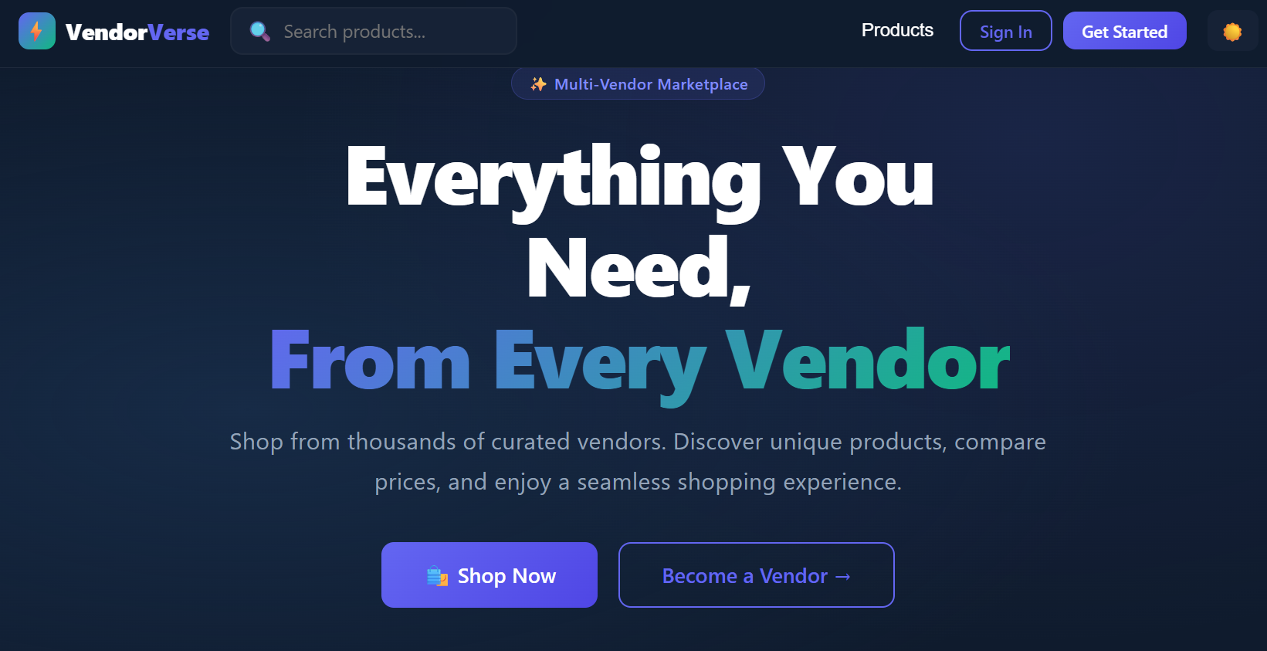

Customer Registration Page
The Customer Registration Page allows new customers to create an account by providing their details such as name, email, and password. After successful registration, customers can log in and access the marketplace features.
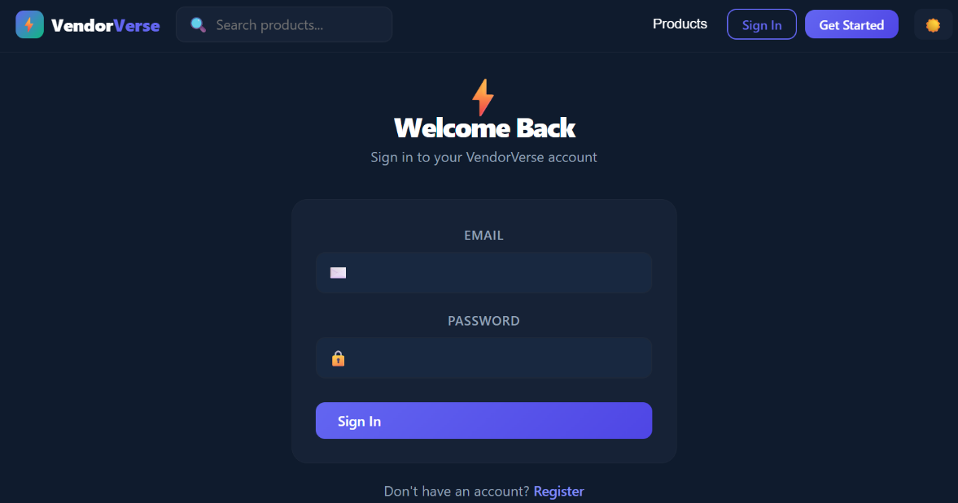

Customer Login Page
The Customer Login Page enables registered customers to securely access the application using their email and password credentials.
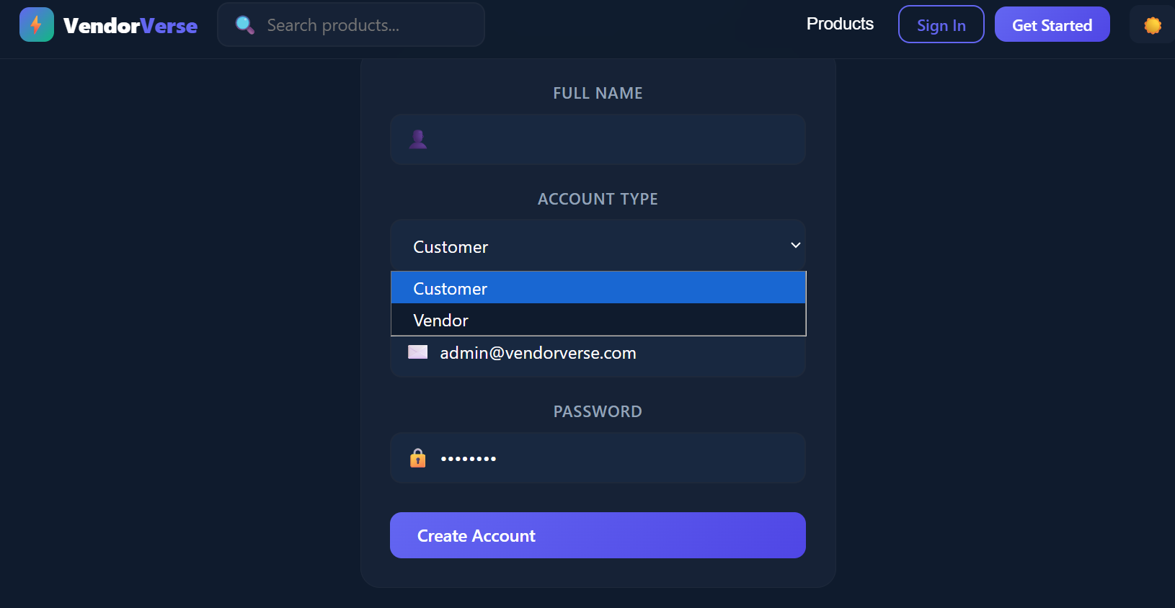

Vendor Login Page
The Vendor Login Page allows registered vendors to authenticate themselves and access the Vendor Dashboard for product management. 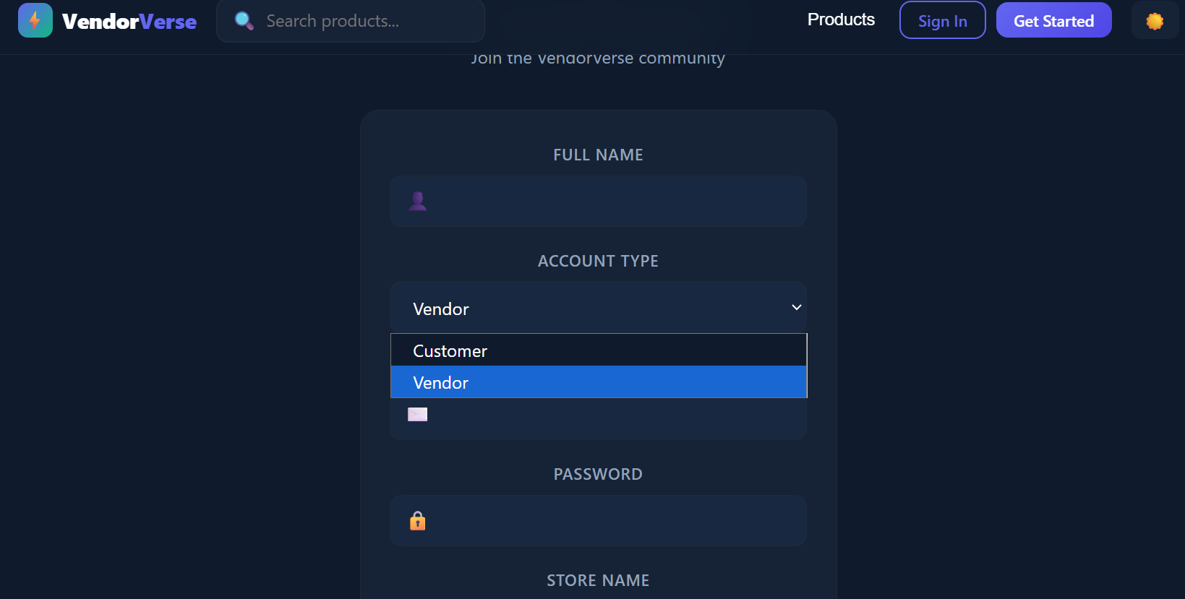

Vendor Dashboard
The Vendor Dashboard provides functionalities for vendors to manage products efficiently. Vendors can add new products, edit existing products, delete products, and upload product images. 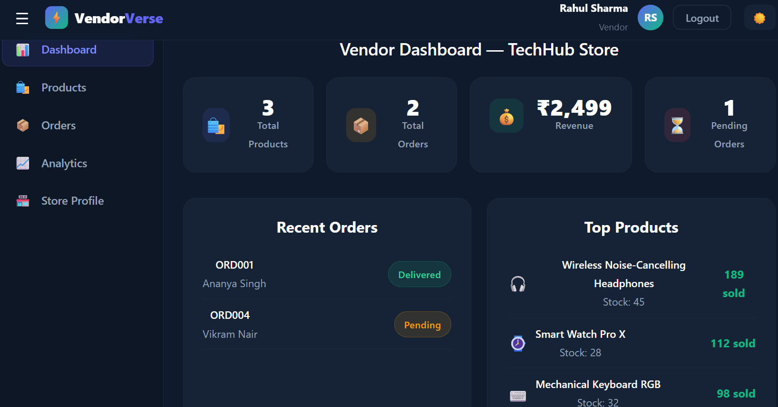

Products Page
The Products Page displays all available products in the marketplace. Customers can browse products, search for products, and add required products to the shopping cart.
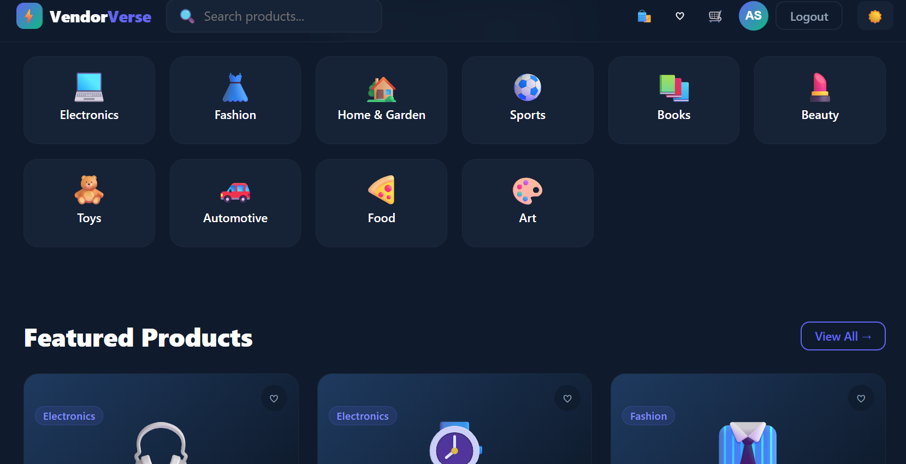

Shopping Cart Page
The Shopping Cart Page displays all products selected by the customer. It allows customers to review selected products and view the total amount before proceeding to checkout.
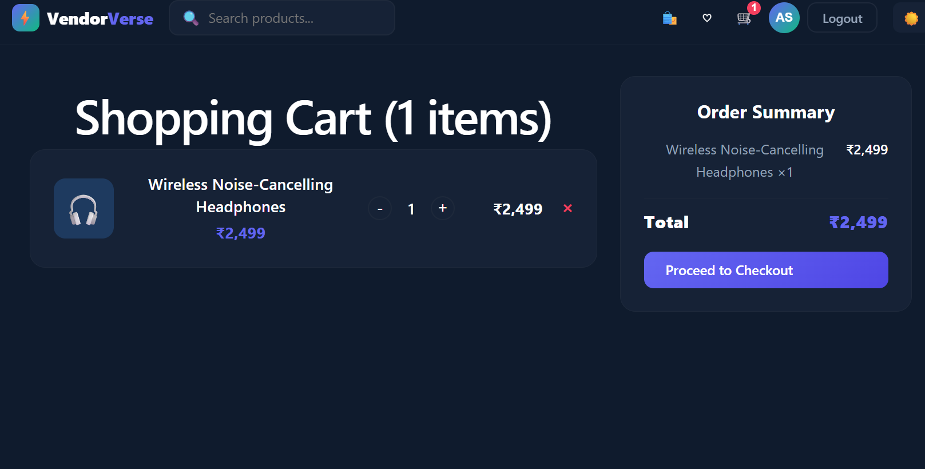

Checkout Page
The Checkout Page allows customers to place orders for the selected products. It displays order details and completes the purchasing process.
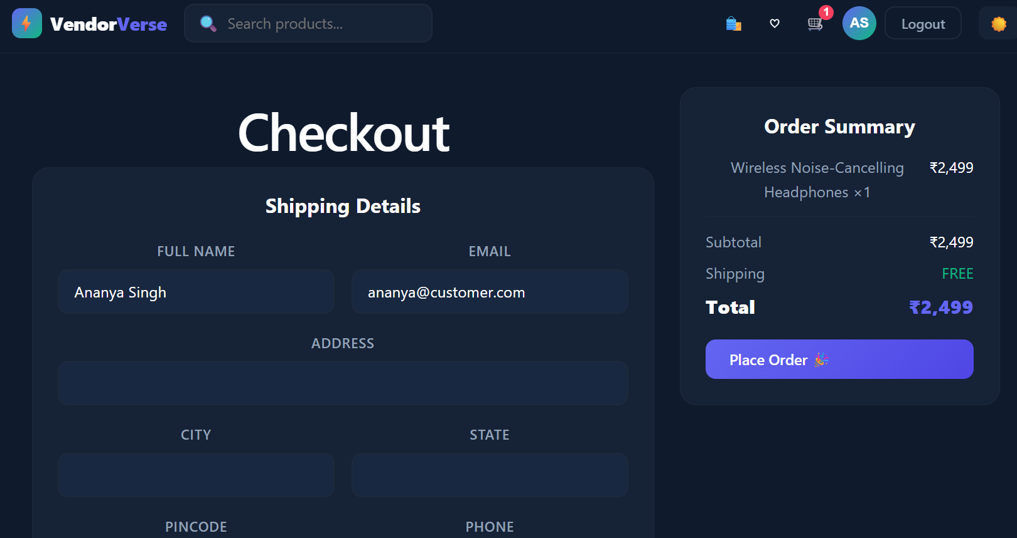

Order History Page
The Order History Page displays all previously placed orders of the customer. This feature helps customers track their purchase history.
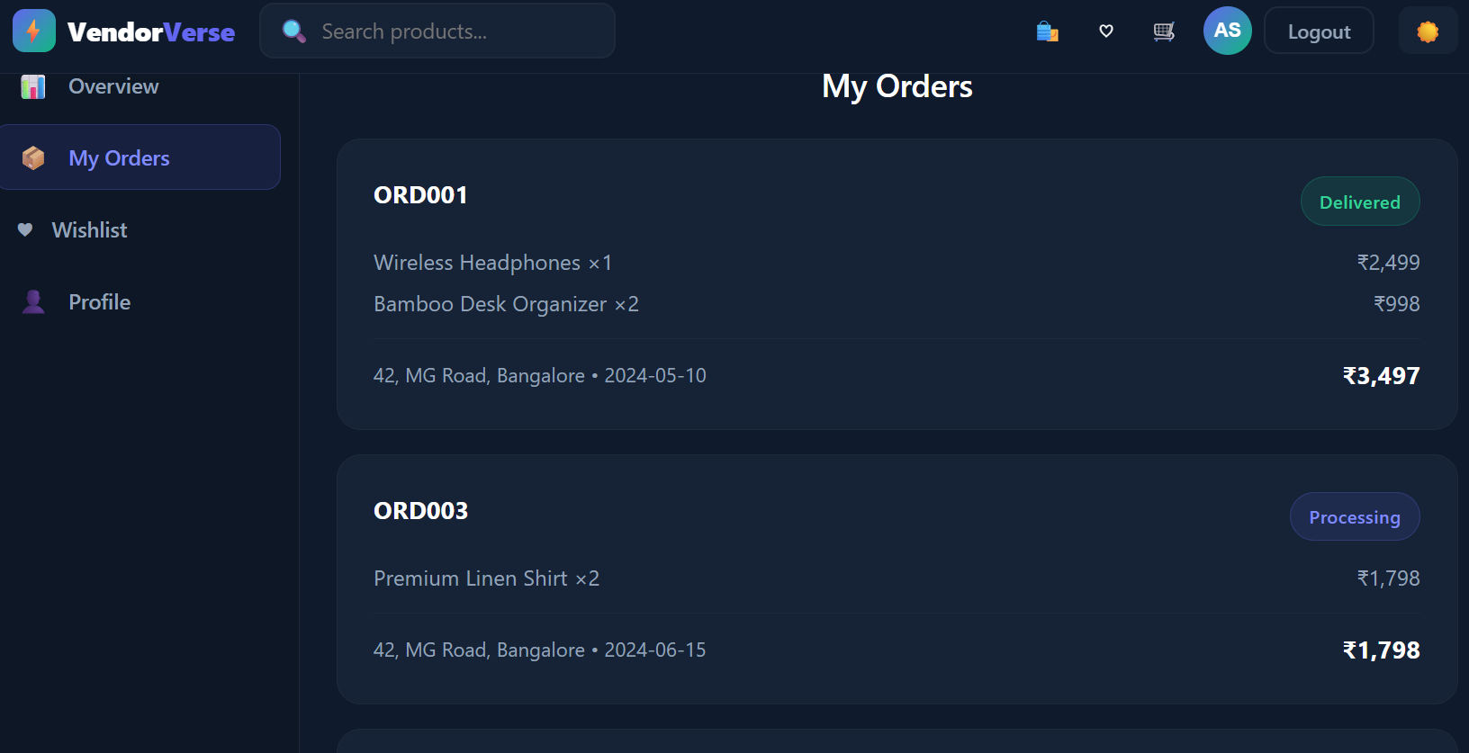

ADVANTAGES
The Multi-Vendor Marketplace system offers several advantages for both vendors and customers.
Advantages:
- Supports multiple vendors on a single platform.
- Provides secure authentication for users.
- Enables efficient product management.
- Offers a user-friendly interface.
- Allows customers to search and purchase products easily.
- Provides shopping cart and order management functionalities.
- Reduces manual effort in managing products and orders.
- Provides easy access to purchase history through the Order History feature.
- Ensures scalability and flexibility for future enhancements.

FUTURE ENHANCEMENTS
The current Multi-Vendor Marketplace application can be further enhanced by incorporating additional features to improve functionality and user experience.
Future Enhancements:
- Integration of online payment gateways such as Razorpay or PayPal.
- Implementation of product rating and review system.
- Addition of email notifications for order confirmations.
- Implementation of advanced product filtering and sorting options.
- Development of a wishlist feature for customers.
- Addition of real-time order tracking functionality.
- Generation of sales reports and analytics for vendors.
- Implementation of inventory management features.
These enhancements will make the system more efficient, secure, and suitable for real-world e-commerce applications.

CONCLUSION
The VendorVerse Multi-Vendor Marketplace Platform is designed with a clear three-tier architecture that separates the presentation, application, and database layers for better scalability, security, and maintainability. By using React.js and Tailwind CSS for the frontend, Node.js and Express.js for the backend, and MongoDB for data storage, the platform supports efficient communication between customers, vendors, and administrators. This architecture provides a strong foundation for a reliable, flexible, and high-performing multi-vendor marketplace.

REFERENCES
- React.js - https://react.dev/
- Node.js - https://nodejs.org/
- Express.js - https://expressjs.com/
- MongoDB O- https://www.mongodb.com/docs/
- MDN Web Docs - https://developer.mozilla.org/
- W3Schools - https://www.w3schools.com/

